Stage Manuscript Draft: Methods, Experiments, and Physical Deployment
Abstract, Introduction, Discussion, Conclusion, and References remain to be finalized.
Stage manuscript draft revised from `methodology_ieee_v2.46_zpd_statistics_mouse_clarity.md`. This version strengthens the conventional-controller motivation, adds citation placeholders for related controller families, and tightens Methodology prose for IEEE style.

II. SYSTEM OVERVIEW AND PROBLEM FORMULATION
We introduce a magnetically actuated, non-contact rehabilitation system for active upper-limb motor training. The user interacts with an unpowered magnetic microrobot on a tabletop workspace, while a robotic arm drives the microrobot indirectly through a permanent magnet placed below the surface. This layout preserves an active pursuit task for the user while avoiding rigid physical coupling between the robot and the human body. It places the user in a pursuit role rather than a passive following role, aligning the task with the need for active engagement in motor rehabilitation. We formulate the control problem as a reinforcement learning (RL) task in which the robot regulates interaction difficulty through the motion of the microrobot.

A. Hardware Platform
The platform separates actuation, interaction, and perception into three physical layers. In the actuation layer, a UR10 robotic arm is placed beneath the workspace, and a permanent magnet is mounted on its end-effector to drive the microrobot above. In the interaction layer, a 5-mm acrylic sheet supports the unpowered microrobot and forms a physical barrier between the robotic arm and the user. In the perception layer, an overhead red-green-blue (RGB) camera sends images to a host computer, which estimates the positions of the microrobot and the hand and transmits target pose commands to the UR10 over Ethernet.
This layout supports both safety and reproducibility. Fig. 1 summarizes the complete simulation-to-real workflow, from policy training in the pursuit-evasion simulator to camera-based observation construction and physical magnetic actuation. The acrylic sheet creates a fixed separation between the actuator and the user-side workspace, so the participant interacts only with the passive microrobot rather than with the robot arm. The microrobot is lightweight and unpowered, and commanded motion can be limited in software while the UR10 remains below the surface with its standard emergency stop available. The hardware also requires only a collaborative robot, a camera, a calibrated planar workspace, and a permanent magnet. It does not rely on wearable components, force sensors, onboard batteries, or custom actuators, which makes the setup easier to reproduce across sessions.
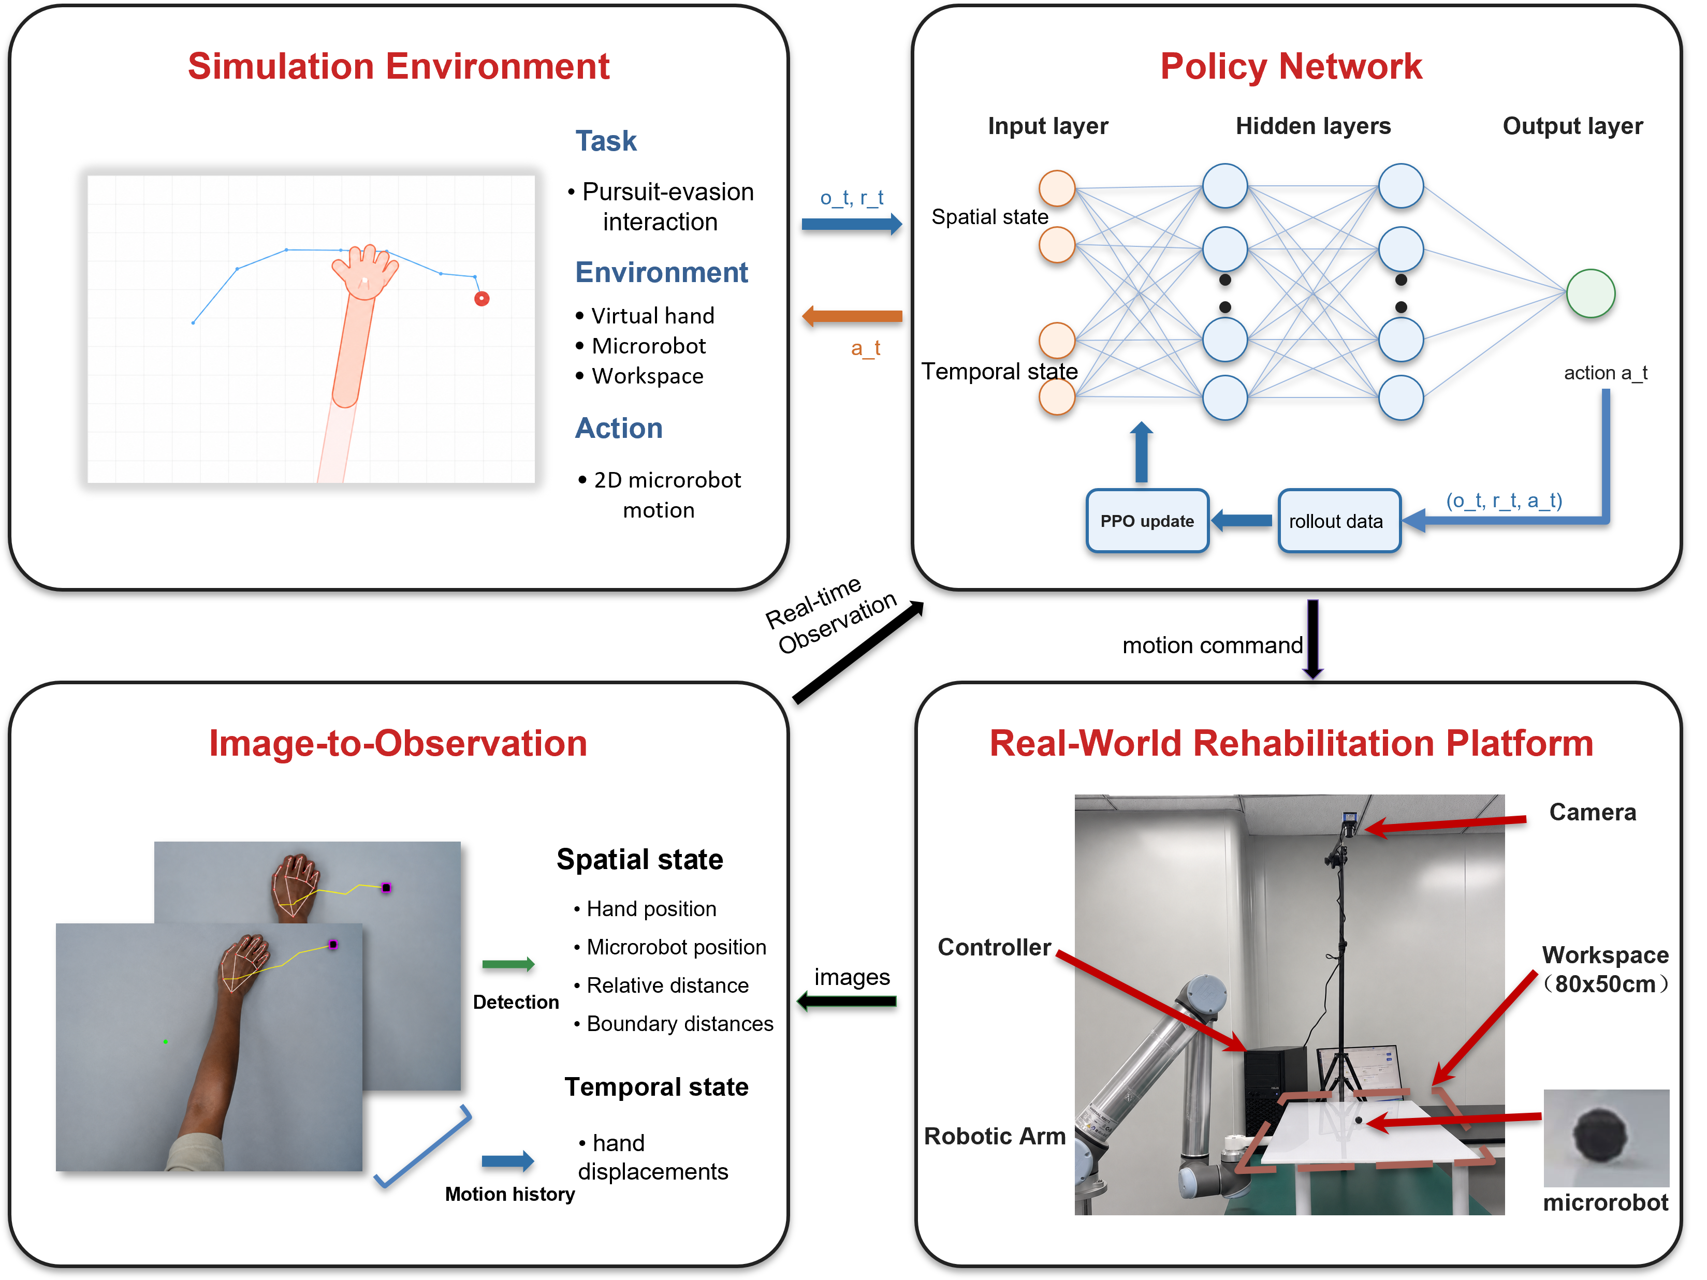
Fig. 1. System framework for simulation-to-real non-contact rehabilitation. The simulation environment defines the pursuit-evasion interaction, the policy network maps spatial and temporal observations to microrobot actions, the image-to-observation module converts camera measurements into policy inputs, and the physical platform executes the learned policy through magnetic actuation.

B. Problem Formulation
We cast the task as a closed-loop pursuit-evasion interaction on a flat workspace. The participant's hand is the pursuer, and the microrobot is a moving target driven beneath the acrylic surface. The participant attempts to approach and catch the microrobot while the robot adjusts target motion to keep the task challenging but reachable. Unlike static reaching, the target continues to move after the participant initiates a movement. The task requires continuous tracking, anticipation, and correction, creating an active visuomotor interaction rather than a single point-to-point reach [1].
The Zone of Proximal Development (ZPD) is defined operationally as a target hand-microrobot distance band [2]. In this study, the evaluation band is 3.5–5.5 cm after workspace calibration. The range was selected for the desktop pilot platform to leave enough separation to avoid immediate catch while keeping the microrobot visually and physically reachable. It is a platform-specific operating band, not a universal clinical threshold. Patient-facing use would require session-level calibration to each user's movement range, speed, and therapeutic goal. The robot should keep the interaction inside this band rather than escaping completely or yielding passively. Hand speed, pursuit strategy, response delay, and motion noise can all change during interaction, making fixed difficulty settings inadequate.
Classical artificial-potential-field controllers and impedance or assist-as-needed controllers provide useful baselines for obstacle avoidance and rehabilitation assistance [3]–[5]. Their assumptions are less well matched to this pursuit-evasion task. A distance-based potential field can drive the microrobot directly away from the hand, but it has no explicit model of where an intercepting hand will arrive next. When the hand cuts across the target path, a purely reactive field can respond after the interception geometry has already changed, producing oscillatory, boundary-seeking, or prematurely caught trajectories. Rule-based impedance control faces a complementary issue. It can modulate compliance around a desired trajectory or endpoint error, but its gains and reference behaviors must be hand designed. Under camera delay, noisy hand estimates, or abrupt shifts from direct pursuit to interception, the controller must distinguish deliberate strategy from motor lag or measurement noise. A fixed rule has limited ability to make that distinction and optimize the resulting ZPD objective over several future steps. These failure modes motivate an RL formulation that learns a long-horizon difficulty-regulation policy under variable hand behavior.
For robot training, the reward is written as the sum of four intuitive terms: distance regulation, action smoothness, workspace-boundary safety, and catch avoidance. Let d_t be the hand-microrobot distance, a_t be the robot action, and p_R,t be the microrobot position. The robot reward optimized by PPO is summarized as
$$r_{t} = r_{dist}(d_{t}) + r_{smooth}(a_{t}) + r_{bound}(p_{R,t}) + r_{catch}(d_{t}) (1)$$
Equation (1) groups the robot reward into four components. The distance component r_dist(d_t) encourages the hand-microrobot separation to remain inside the ZPD band and penalizes deviations on either side. The smoothness component r_smooth(a_t) discourages abrupt commanded motion. The boundary component r_bound(p_R,t) penalizes microrobot positions outside the valid workspace. The catch component r_catch(d_t) penalizes hand-microrobot contact. Episodes terminate after catch, workspace exit, or the maximum horizon.

III. METHODOLOGY
Difficulty regulation must remain stable while hand behavior changes in both strategy and motor execution. The method handles this variability across simulation, observation, and training distribution. The domain-randomization strategy separates movement intent from motor-execution constraints. The dual-stream encoder provides recent hand-motion history to the policy, and the auxiliary future-dynamics head supplies a direct learning signal for short-horizon motion prediction. Iterative league training exposes the robot to a growing hand-policy pool, reducing dependence on one fixed virtual user.

A. Cognitive-Motor Decoupled Domain Randomization
Hand behavior varies in intended pursuit strategy and execution accuracy. The proposed domain-randomization strategy separates these factors. A hand policy first generates the intended displacement, and the motor-execution layer then applies motion constraints, observation noise, and temporal delay. The strategy policy is sampled from a hand-policy pool containing the SPC and trained RL hand policies. The SPC provides a transparent pursuit model; learned hand policies can produce more anticipatory interception strategies.
For the stochastic scripted pursuit controller, let ρ_ep denote the episode-level stride length and q_t denote a planar unit direction. The intended displacement is
$$u_{t}^{SPC} = ρ_{ep}q_{t} (2)$$
The stride ρ_ep is sampled once at episode reset and then held fixed. The direction q_t follows an ε-greedy pursuit rule. With probability 1 - ε, q_t points from the current hand position toward the microrobot. With probability ε, q_t is sampled uniformly from all planar unit directions. In the experiments, ρ_ep is sampled uniformly between 0.45 and 0.70, and ε is fixed at 0.05. Learned hand policies output the intended displacement directly, and the same motor-execution model is applied afterward.
The raw desired displacement is first passed through a first-order low-pass filter to model motion inertia, as shown in (3).
$$x_{t} = αx_{t−1} + (1−α)u_{t} (3)$$
Here, u_t denotes the raw desired displacement, x_t denotes the filtered displacement, and alpha in (0,1) is the inertia coefficient. Acceleration clipping is applied componentwise to limit abrupt changes in motion, as shown in (4).
$$Δx_{t} = clip(x_{t}−x_{t−1}, −a_{max}, a_{max}) (4)$$
The delayed displacement is then applied to update the simulated hand position,
$$p_{H,t+1} = p_{H,t} + Δx_{t−δ} + η_{t} (5)$$
Here, delta is sampled from the delay range, and eta_t is zero-mean Gaussian position noise with covariance sigma^2 I. The delay buffer advances at 8 Hz in the motor-execution layer, so the 0–3 frame range in Table I corresponds to 0–375 ms. Table I lists the values and sampled ranges used for these constraints. This decoupled design exposes the robot policy to plausible hand-motion variations without tying training to a single simulated hand model.
TABLE I: MOTOR RANDOMIZATION PARAMETERS
Parameter | Symbol | Range
Motion inertia | alpha | 0.7
Maximum acceleration | a_max | 0.15
Gaussian observation noise | sigma | Uniform distribution over 0.01–0.08
Neural delay | delta | 0-3 frames (0-375 ms)
Uniform distribution denotes sampling uniformly over the stated interval.

B. Dual-Stream Encoder with Future Dynamics Head
The proposed domain-randomization scheme exposes the robot to diverse interaction behaviors during training. The robot does not observe the underlying behavior model directly. It must infer behavior patterns from the current interaction state and recent hand motion. Current hand position alone cannot distinguish deliberate pursuit from sensing noise, motor delay, or slow response. The observation is encoded with two streams, one for instantaneous geometric context and one for recent hand-motion history.
At each timestep, the 44-dimensional observation vector is divided into a 12-dimensional scalar vector and a 32-dimensional temporal buffer, as shown in (6).
$$o_{t} = [s_{t}; h_{t−T:t}] (6)$$
The scalar component represents the instantaneous geometry of the interaction and is defined in (7).
$$s_{t} = [p_{R}; p_{H}; d(R,H); b_{N}, b_{S}, b_{E}, b_{W}; stride; a_{t−1}] (7)$$
Here, p_R and p_H denote the two-dimensional positions of the microrobot and the hand. d(R,H) is their Euclidean distance. b_N, b_S, b_E, and b_W denote signed distances to the workspace boundaries. The variables stride and a_{t-1} represent the current movement step size and the previous robot action, respectively.
The temporal buffer h_{t-T:t} contains the T = 16 most recent relative hand displacement vectors, forming a 32-dimensional sequence. This sequence helps the encoder estimate motion direction, response delay, and oscillatory behavior that are unavailable from the current position alone. Relative displacements make the representation translation-invariant, so the recurrent stream focuses on how the hand is moving rather than where the interaction occurs in the workspace.
The scalar vector and temporal buffer are encoded in separate streams, as shown in Fig. 2. A multi-layer perceptron (MLP) extracts geometric information from the scalar state, while a gated recurrent unit (GRU) processes the displacement sequence. The two stream outputs are concatenated and passed through a fusion MLP to produce the shared representation used by the policy and value heads.
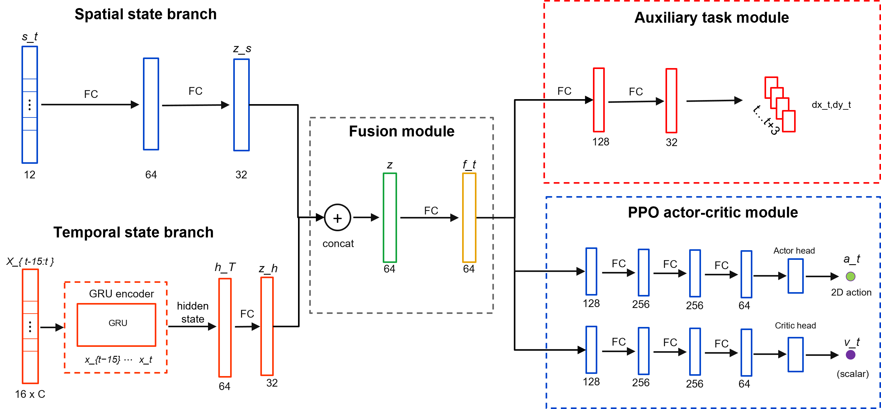
Fig. 2. Dual-stream policy architecture with auxiliary future dynamics. The spatial branch encodes the geometric state, the temporal branch encodes recent interaction history with a recurrent module, and the fused representation supports both the policy-value heads and the auxiliary future-motion prediction head.
The ZPD-based reward provides the main control signal, but it supervises the encoder only indirectly through policy optimization. A future-dynamics head adds a denser learning signal for motion representation. The head predicts relative hand displacement over an eight-step horizon. Future displacements are available from the rollout, so the auxiliary task is self-supervised and requires no additional annotation.
The trajectory prediction loss is given in (8).
$$L_{traj} = E[{‖{D̂}_{t+1:t+H}−D_{t+1:t+H}‖₂}^{2}], H=8 (8)$$
Here, D_hat_{t+1:t+H} is the predicted future displacement sequence, and D_{t+1:t+H} is the observed future displacement sequence. The full training objective combines the PPO loss with the auxiliary trajectory-prediction loss in (9).
$$L_{total} = L_{PPO} + λ_{traj}L_{traj} (9)$$
Here, lambda_traj controls the auxiliary loss weight. Because the future-dynamics head shares the encoder with the policy, its gradients also update the spatial and temporal streams. These gradients encourage the encoder to capture motion inertia, delay, and interaction dynamics, helping the policy anticipate near-future hand motion from recent history.

C. League Training
Stable difficulty regulation also depends on diversity in the training hand behaviors. A robot trained against a single hand policy may over-specialize and fail when the pursuit strategy changes. Simultaneous robot-hand training creates a different problem because both agents jointly determine the next state and return. Updating both policies together changes each agent's effective environment, violating the stationarity assumption used by PPO. In practice, the interaction can enter a cycle in which the robot exploits the current hand policy, the hand adapts, and the robot loses strategies that were useful against earlier hands.
The training schedule separates the two sides of learning and retains older hand behaviors in a shared pool. During robot training, sampled hand policies are fixed and treated as part of the environment. During hand training, the robot policy is fixed. The robot is trained against a hand-policy pool P containing the SPC and learned hand policies from previous stages. This pool exposes the robot to direct pursuit as well as more strategic interception patterns. It broadens the hand-behavior distribution without making the task purely adversarial, since the robot must maintain the ZPD interaction rather than simply maximize escape.
Algorithm 1 summarizes the iterative procedure. Each iteration first trains the robot against hands sampled from the fixed pool. It then trains a new hand policy against the frozen robot, initializes that hand from the previous learned hand when available, and adds the resulting policy to the pool for the next robot-training phase.
Algorithm 1: Iterative League Training
Input: initial robot policy π_R^(0), scripted pursuit controller π_H^SPC, number of league iterations N.
Initialize: hand-policy pool P ← {π_H^SPC}.
1. for n = 1, 2, ..., N do
2. Train robot policy π_R^(n) with PPO against hand policies sampled from P.
3. Initialize hand policy π_H^(n) from π_H^(n-1) when available.
4. Train π_H^(n) against the frozen robot policy π_R^(n).
5. Update hand-policy pool P ← P ∪ {π_H^(n)}.
6. end for
Uniform sampling from the learned-hand pool is inefficient because different learned hands challenge the current robot to different degrees. Recent episode length provides a simple competitiveness signal. Short episodes usually indicate that the hand quickly catches the microrobot or forces early termination, so the corresponding hand should be sampled more often during the next robot-training phase. For learned hand i, let l_bar_i be its recent mean episode length. The learned-hand sampling score is inversely related to this length and is smoothed with a uniform mixture.
$$s_{i} = \frac{1}{{ℓ̄}_{i} + ε_{ℓ}}, {p̃}_{i} = (1−μ)\frac{s_{i}}{∑s_{j}} + \frac{μ}{m} (10)$$
Here, m is the number of learned hand policies, ε_l is a small stabilizing constant, and μ controls the uniform exploration mass. The SPC remains in the pool with a fixed sampling probability, while the learned-hand portion follows the distribution in (10). This keeps the scripted pursuit behavior available and concentrates the remaining robot-training episodes on learned hands that still expose weaknesses in the current robot policy.

IV. EXPERIMENTS AND RESULTS
The evaluation combines simulation experiments with a physical deployment test. The simulation experiments measure robustness across hand behaviors and isolate the contribution of temporal hand-history encoding. The physical deployment test evaluates whether the learned policy can run inside the real-time perception-control stack on the UR10 platform and whether the realized motion responds coherently to measured hand movement.

A. Simulation Protocol and Metrics
The simulation study separates two sources of performance gain in the proposed framework. The league analysis tests whether expanding the hand-policy pool improves robustness across pursuit behaviors. The ablation analysis tests whether temporal hand-motion encoding and the auxiliary dynamics objective improve the learned robot representation. Both analyses use the pursuit-evasion environment described in Section II, with the robot controlling the microrobot and the hand motion generated by the behavior models described in Section III.
All simulation evaluations used the same planar workspace and the 3.5–5.5 cm ZPD band defined in Section II.B. A timestep was counted as in-zone when the hand-microrobot distance fell within this interval. The simulator and the physical workspace share the same calibrated coordinate convention, so one workspace unit corresponds to 1 cm after calibration and can be compared directly with physical rollout distances. The physical rollout in Section IV.D uses the same band for zero-shot consistency, not as a claim that this distance range is clinically optimal for every user.
Time-In-Zone (TIZ) is the primary metric. It measures the fraction of the full episode horizon for which the hand-microrobot distance remains inside the ZPD interval. Episode length is reported in simulation steps and measures how long the interaction remains active before catch, workspace exit, or the maximum horizon. For the league analysis, cross-hand robustness is summarized by mean TIZ across learned hand policies and by worst-hand TIZ. For the network ablation, TIZ is complemented by workspace coverage and mean jerk, which respectively measure task coverage and motion smoothness in the final policy evaluation.
The training-protocol comparison uses an SPC-only robot trained against the stochastic scripted pursuit controller, a single-hand robot trained against one learned hand policy, and a league-trained robot trained through iterative hand-pool expansion. These policies are evaluated through cross-generation learned-hand tests and through the scripted, learned-policy, and manual mouse interfaces used in Table II. The representation comparison keeps the training setting fixed while changing the policy encoder. The MLP baseline uses instantaneous geometry, the GRU policy adds recent relative hand displacement, and the auxiliary GRU policy adds the future-dynamics prediction objective.

B. League Training and Cross-Hand Robustness
The league evaluation asks whether an expanding hand-policy pool improves robustness across pursuit behaviors, rather than only improving performance against the most recent hand policy. After each robot generation is trained, it is evaluated against all learned hand generations in the pool, separating generalization across hand behaviors from progress against a single training opponent. In Fig. 3(a), each row fixes one robot generation and each column fixes one learned hand generation. Early robot generations perform well only for limited parts of the hand pool, whereas later generations maintain stronger TIZ over a broader set of learned hands, suggesting reduced specialization. Fig. 3(b) summarizes the same matrix through mean and worst-hand TIZ. The mean curve reflects typical performance, and the worst-hand curve tracks the most difficult learned hand for each robot generation; both improve from early to final generations despite local fluctuations.
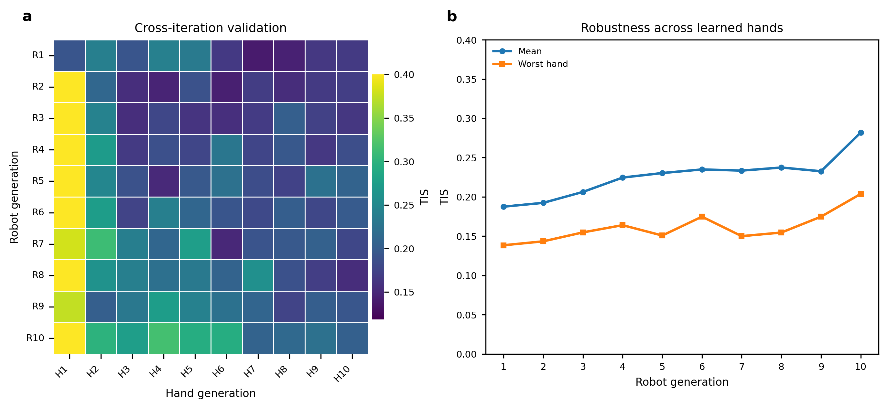
Fig. 3. Cross-hand validation of league-trained robot policies under the ZPD 3.5–5.5 simulation setting. (a) TIZ matrix obtained by evaluating each robot generation against each learned hand generation. Rows correspond to robot generations, and columns correspond to learned hand generations. (b) Mean and worst-hand TIZ across learned hand test policies for each robot generation.
Table II evaluates whether this robustness extends beyond the learned-hand pool used in Fig. 3. The final SPC-only, single-hand, and league-trained robot policies are tested against the stochastic scripted pursuit controller, a learned hand policy, and manual mouse pursuit. The manual mouse condition was completed by one healthy operator using the mouse interface to pursue and catch the simulated microrobot as quickly as possible. It introduces human reaction time and voluntary pursuit strategy, but it does not reproduce the biomechanics or perception noise of real hand tracking; it is therefore treated as a human-in-the-loop stress test rather than clinical validation. Higher TIZ and longer episode length indicate more sustained difficulty regulation.
TABLE II: POLICY COMPARISON ACROSS THREE HAND TEST SETS
Robot policy | Test set | TIZ | Length
SPC-only | SPC | 0.31 ± 0.06 | 52 ± 8
SPC-only | Learned hand | 0.19 ± 0.04 | 31 ± 5
SPC-only | Manual mouse | 0.14 ± 0.03 | 33 ± 9
Single-hand | SPC | 0.11 ± 0.02 | 25 ± 4
Single-hand | Learned hand | 0.49 ± 0.07 | 70 ± 7
Single-hand | Manual mouse | 0.19 ± 0.05 | 40 ± 11
League | SPC | 0.38 ± 0.06 | 67 ± 8
League | Learned hand | 0.48 ± 0.07 | 64 ± 8
League | Manual mouse | 0.49 ± 0.09 | 74 ± 13
Values are means ± approximate 95% confidence intervals estimated across evaluation episodes. SPC and learned-hand tests used 100 episodes per condition, and manual mouse tests used 20 episodes per robot policy. TIZ denotes the fraction of the full episode horizon spent in the ZPD, and Length denotes episode length in simulation steps.
The two non-league baselines show complementary forms of specialization. The SPC-only robot remains most suitable for the scripted pursuit controller but degrades under learned and manual pursuit. The single-hand robot performs well against the learned hand policy but loses robustness when the pursuit behavior changes to scripted or manual control. The league-trained robot gives the most balanced profile across all three test sets, preserving learned-hand performance while improving the scripted and manual-pursuit cases. This balance is the desired behavior for adaptive difficulty regulation, because hand behavior can change across controllers, sessions, and voluntary strategies.

C. Network Ablation and Auxiliary Dynamics Analysis
The league results evaluate the diversity of hand behaviors used during training, while the network ablation tests whether the robot policy can use temporal hand-motion information once that diversity is present. The MLP baseline uses the instantaneous geometric state only, the GRU policy adds the 16-frame relative-displacement history, and the auxiliary GRU further adds the future-dynamics prediction head described in Section III.B. The training curves in Fig. 4(a) and Fig. 4(b) show that temporal history improves optimization and interaction persistence. The GRU policies reach higher episode reward and longer episode length than the MLP baseline, indicating that current geometry alone is insufficient for stable difficulty regulation when hand motion changes over time. The auxiliary GRU gives the strongest training curve, suggesting that the prediction loss helps the recurrent stream form a more useful motion representation.
The auxiliary prediction examples in Fig. 4(c) provide a qualitative check on this representation: the predicted short-horizon displacement generally follows the direction and curvature of the observed future hand motion rather than only reconstructing the current position. The final normalized metrics in Fig. 4(d) summarize the control effect of these representation changes. Recurrent history improves in-zone behavior and workspace coverage relative to the MLP baseline, and adding the auxiliary prediction objective further improves these task-quality metrics while reducing mean jerk. Together, the ablation indicates that temporal hand history and auxiliary dynamics prediction contribute to smoother and more reliable difficulty regulation.
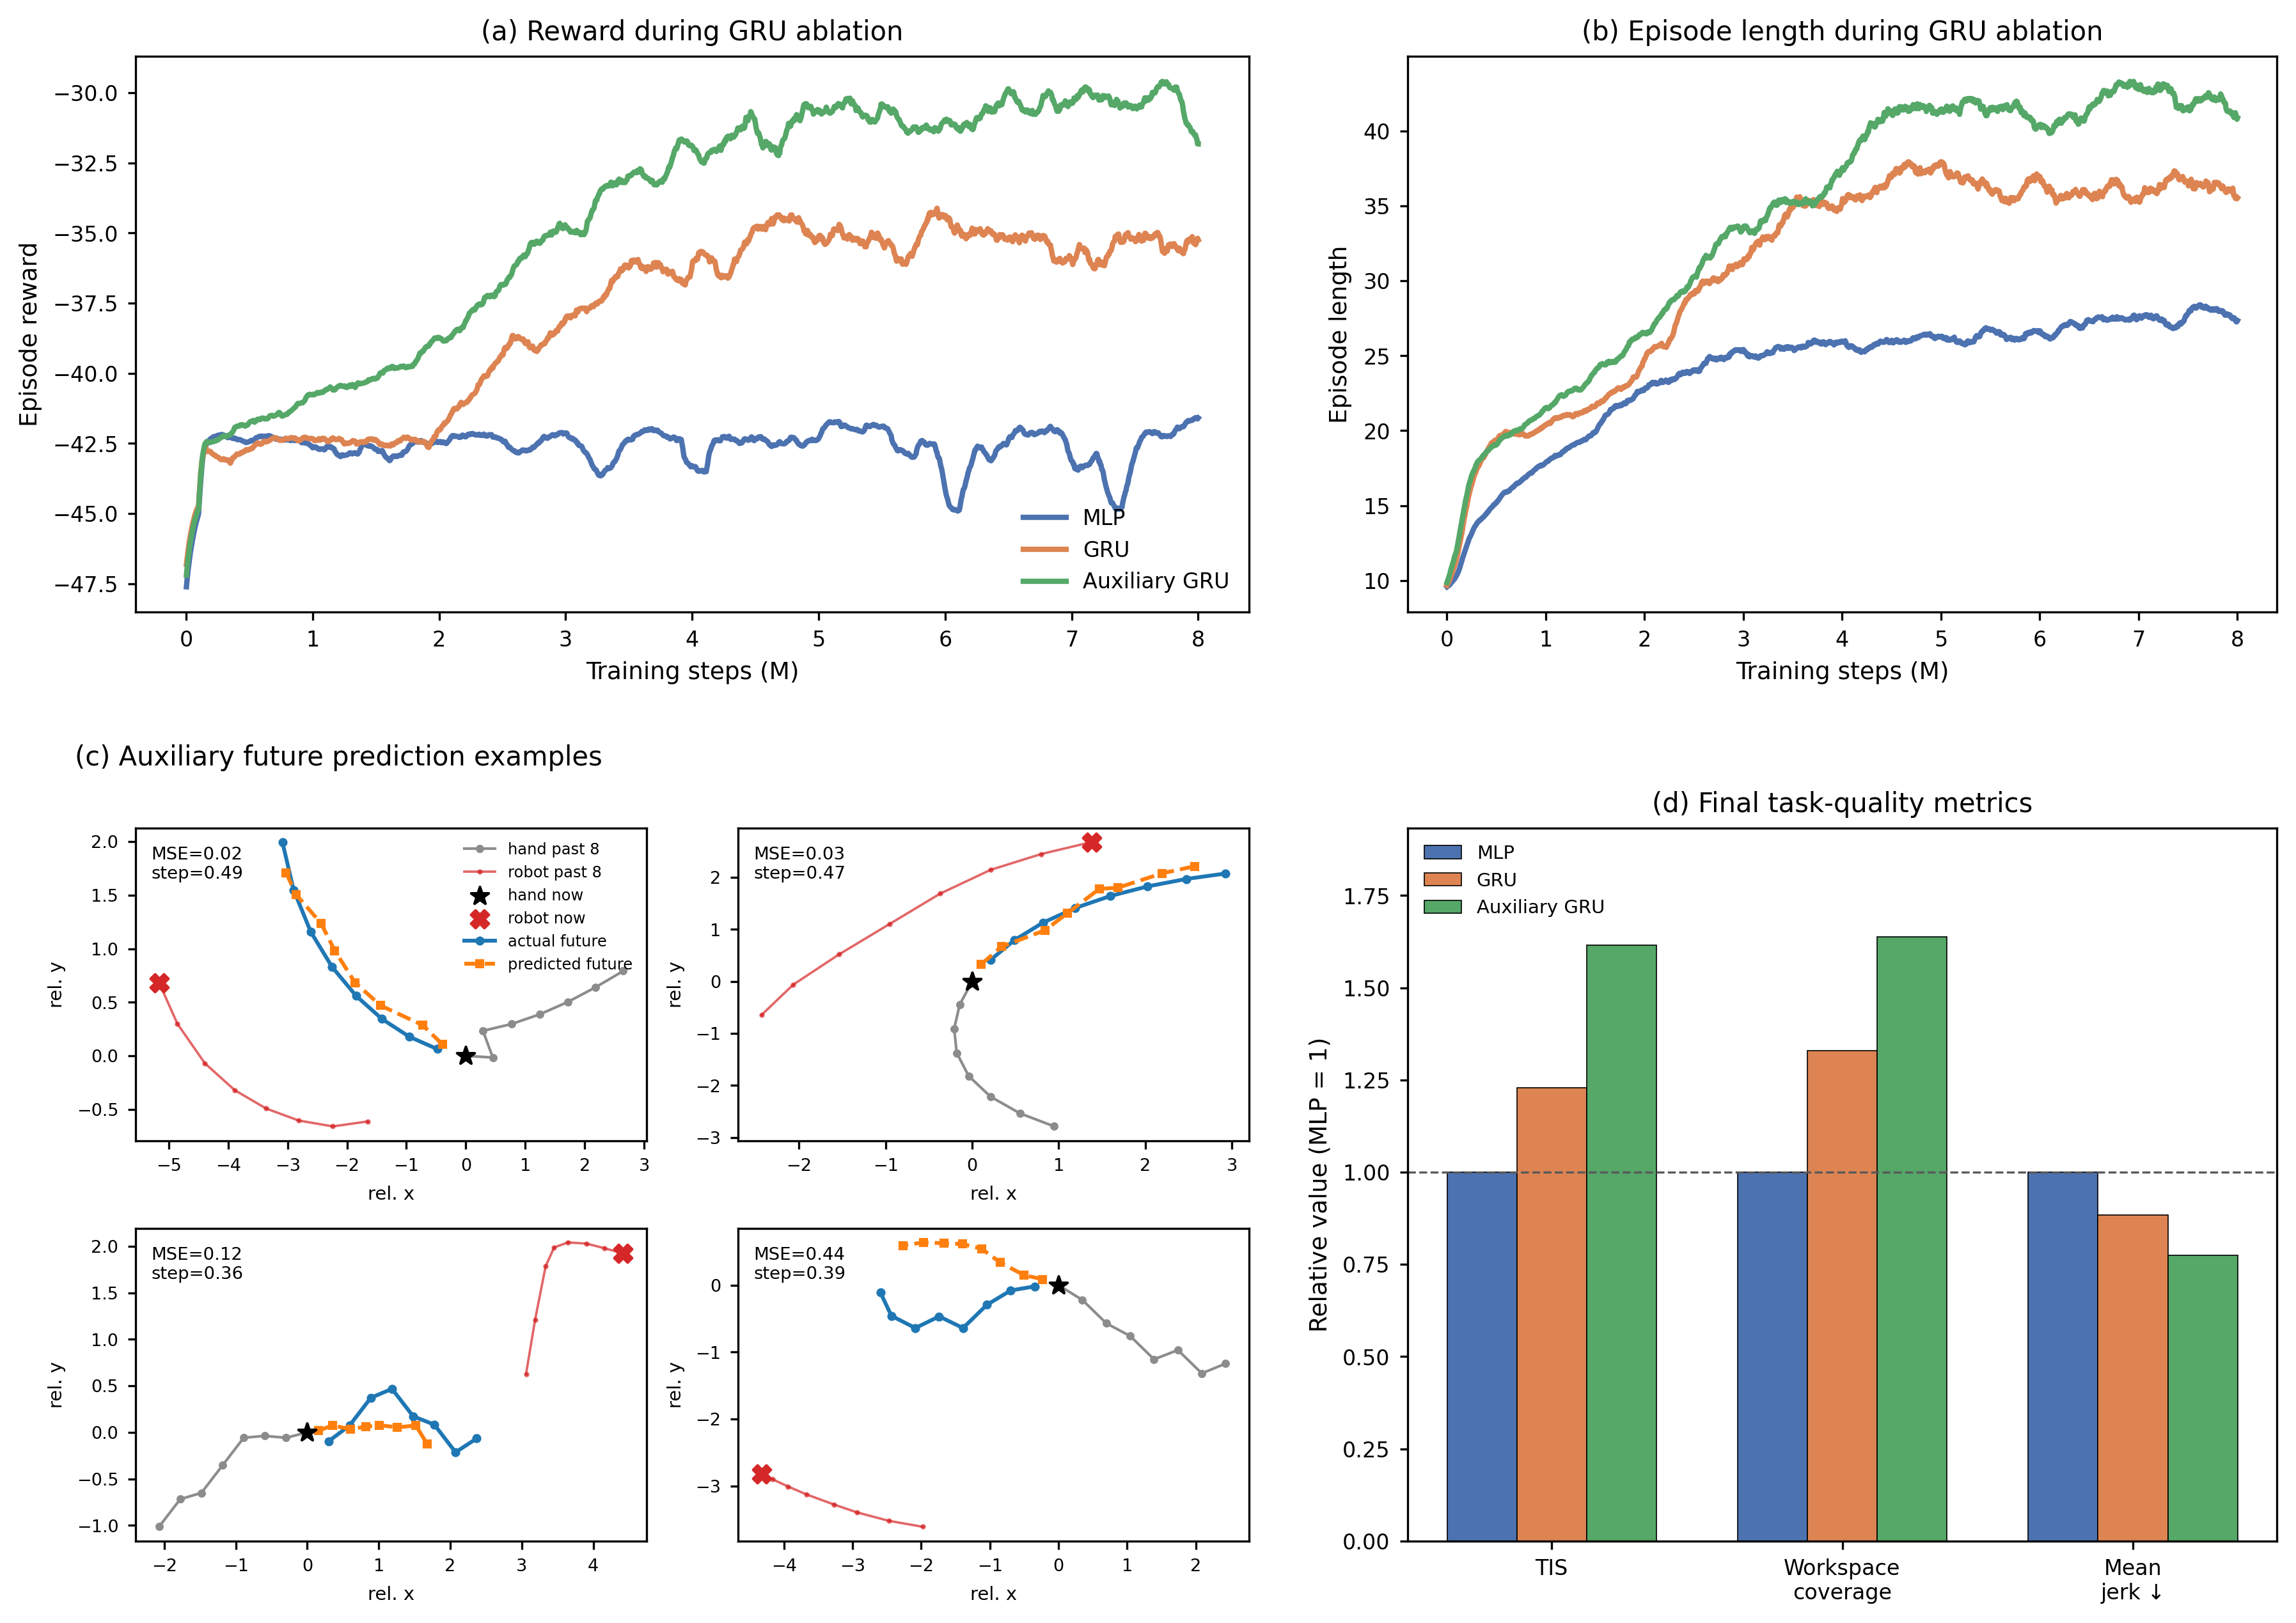
Fig. 4. Network ablation for temporal encoding and auxiliary dynamics prediction. (a) Smoothed episode reward during training for the MLP, GRU, and auxiliary GRU policies. (b) Smoothed episode length during training for the same policies. (c) Representative auxiliary-head predictions of short-horizon hand displacement compared with observed future motion. (d) Final task-quality metrics normalized to the MLP baseline; higher values are better for in-zone time and workspace coverage, whereas lower values are better for mean jerk.

D. Real-Time Physical Deployment
The simulation-trained policy was deployed on the UR10 microrobot platform to evaluate zero-shot execution with real hand input. In each rollout, a healthy pilot pursued the passive microrobot on the acrylic workspace while the UR10 moved the magnetic actuator beneath the surface. The policy was used without physical fine-tuning, and the physical dataset contains nine zero-shot rollouts from one pilot session. The camera and UR10 command loops operated in real time, and policy inference was fast enough to support online closed-loop interaction.
The deployment stack preserved the simulation observation format. Policy inputs were constructed from calibrated camera measurements of the hand and microrobot, workspace-boundary features, the previous executed robot command, and recent relative hand-displacement history, matching the categories in (6) and (7). UR10 telemetry and end-effector pose were not provided to the policy; RTDE pose readback was used only for Cartesian command execution and monitoring over Ethernet. Perception and calibration were handled by the camera-based tracking pipeline, which combined YOLO microrobot detection, MediaPipe-based hand tracking, and homography-based image-to-workspace calibration. During short hand-tracking gaps, the controller used dead-reckoning from the last measured hand velocity. Safety constraints included workspace clipping, command-step limiting, automatic stop-on-catch, UR10 servoStop on shutdown or interruption, and the standard hardware emergency stop available during testing.
Fig. 5 presents one representative zero-shot physical rollout. The image sequence in Fig. 5(a) and the dynamic traces in Fig. 5(b) come from the same trial, so they describe a single time-aligned interaction rather than separate examples. The selected frames cover the initial approach, steady pursuit, faster and slower hand movements, and the end of the rollout, showing that camera perception, hand pursuit, microrobot motion, and UR10 actuation operated as one closed loop. The distance trace remains near the target ZPD band for a substantial portion of the trial and returns toward this range after deviations, indicating that the controller neither simply moves the microrobot away from the hand nor keeps it static until catch. The hand- and robot-speed profiles support the same interpretation: changes in measured hand speed are reflected in the distance trace and in the robot-speed response. The deployment therefore evaluates the complete camera-policy-robot loop, rather than offline policy inference alone, and shows that the simulation-trained controller can sustain an online hand-microrobot interaction on the UR10 platform.
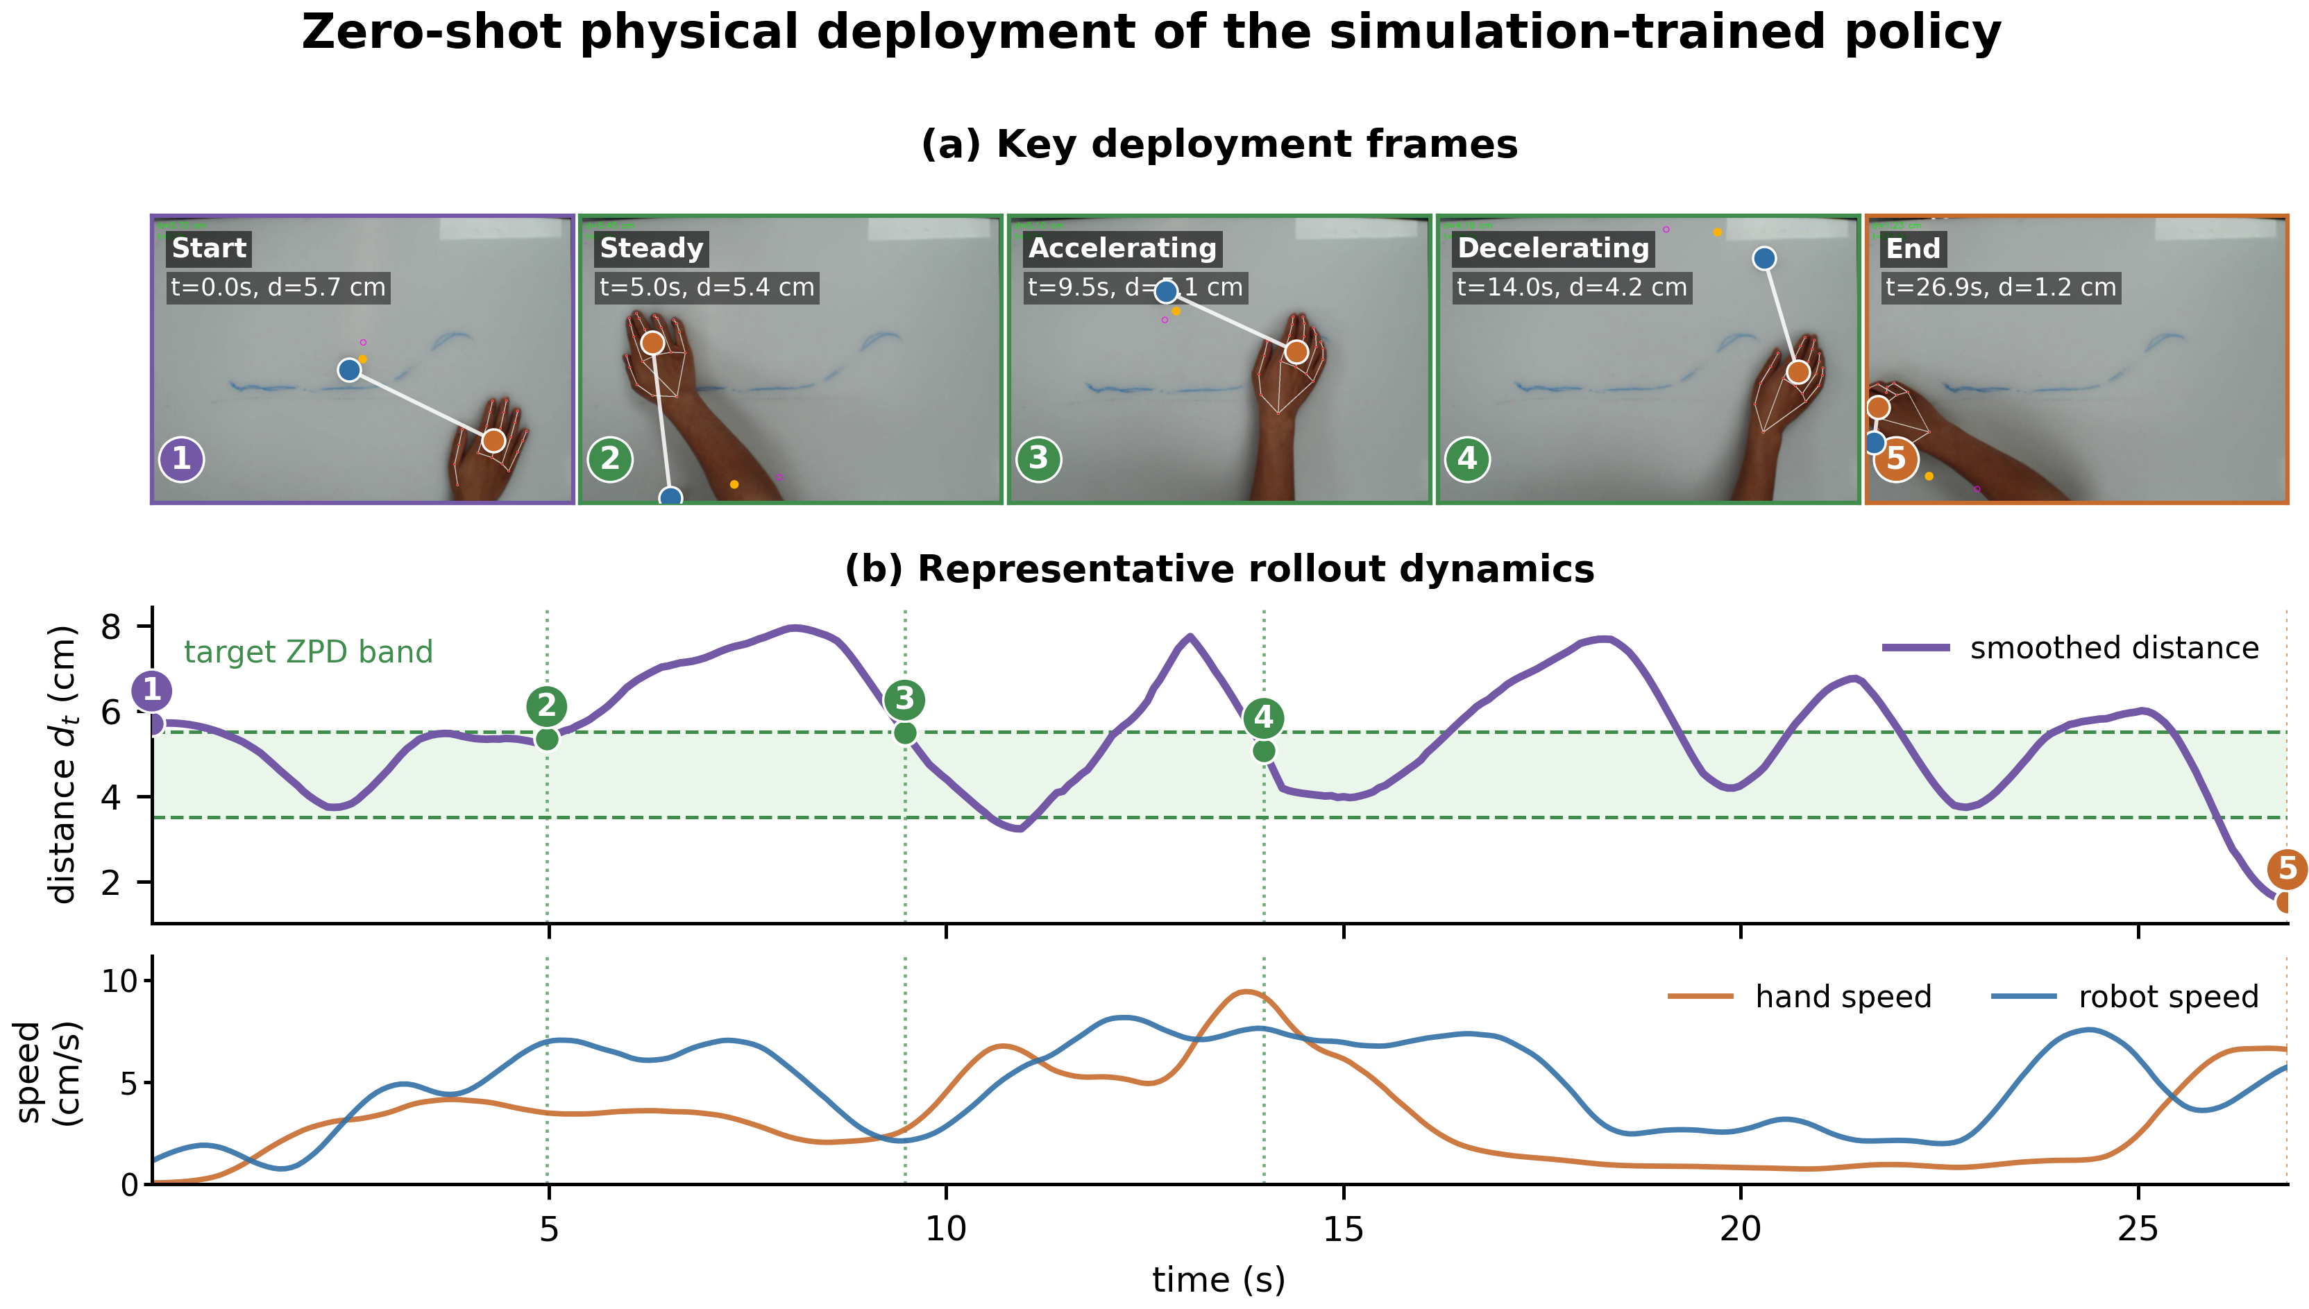
Fig. 5. Zero-shot physical deployment on the UR10 microrobot platform. (a) Key deployment frames from a representative rollout among nine physical trials. (b) Smoothed hand-microrobot distance, target ZPD band, and measured hand and robot speeds from the same rollout.

