Abstract— Adaptive rehabilitation requires a controller that keeps an exercise challenging without making it unattainable as user behavior changes. This paper presents an end-to-end reinforcement learning framework for a tabletop upper-limb pursuit task in which a UR10 robot drives an unpowered magnetic microrobot beneath an acrylic workspace and a participant attempts to catch it. The controller regulates the hand-microrobot distance around a platform-specific Zone of Proximal Development band. The framework combines decoupled randomization of pursuit intent and motor execution, a dual-stream encoder for current geometry and recent motion, self-supervised prediction of future hand displacement, and iterative league training with prioritized opponent sampling. In a ten-generation league without opponent identity, mean Time in Zone across learned hands increased from 0.188 for the initial robot to 0.282 for the final robot, while worst-hand Time in Zone increased from 0.138 to 0.204. In a separate representation ablation, the auxiliary GRU increased Time in Zone from 0.160 to 0.259 and reduced mean jerk from 0.165 to 0.127 relative to the feed-forward baseline. The final league policy also avoided the condition-specific collapse observed under scripted-only and single-opponent training. Nine zero-shot physical rollouts demonstrated online execution through the camera-to-robot loop and recovery toward the target band after transient changes in hand speed. These results show that behavior diversity and temporal motion encoding provide complementary mechanisms for robust adaptive difficulty regulation.
Index Terms— adaptive difficulty, domain randomization, league training, magnetic microrobot, reinforcement learning, robot-assisted rehabilitation, zero-shot transfer.

I. INTRODUCTION
Upper-limb function is central to self-care, work, and independent participation in daily life. Stroke and other neurological injuries can impair strength, coordination, and voluntary control, creating a need for sustained motor rehabilitation. Rehabilitation practice commonly emphasizes intensive repetition, task-oriented movement, and active participation because users must repeatedly generate, evaluate, and correct purposeful actions. Training volume alone is not sufficient. Tasks that are too easy provide limited stimulus for adaptation, whereas tasks that are consistently unattainable can reduce engagement and the quality of practice. Effective upper-limb rehabilitation should therefore remain repetitive and active while maintaining a level of challenge that is demanding but achievable. However, delivering intensive training at an appropriate difficulty remains difficult in practice.
Upper-limb training is delivered through several complementary approaches. Therapist-led task practice provides direct observation, manual guidance, and individualized progression. Traditional rehabilitation devices and tabletop exercises offer simple and accessible ways to repeat reaching, tracking, or coordination tasks. Contact-based rehabilitation robots, including exoskeleton and end-effector systems, can deliver repeatable motion, regulate assistance or resistance, and record quantitative interaction data. Virtual reality, motion-capture games, and screen-based tasks broaden the range of scenarios and can make repetitive practice more engaging. Each approach therefore supports a different aspect of rehabilitation, from clinical personalization to repeatability, measurement, and task variety. Despite their respective advantages, these approaches involve trade-offs among personalization, physical interaction, system complexity, and training accessibility.
These trade-offs leave room for a rehabilitation interface that preserves an active physical task while reducing user-side instrumentation. Therapist-led training depends on therapist availability and is difficult to provide continuously. Traditional devices often provide limited online adaptation or quantitative feedback. Contact-based robots may require wearing, grasping, strapping, or mechanical coupling, which adds setup complexity and constrains physical interaction. Fully virtual tasks are flexible but do not provide a directly visible and catchable physical target. The proposed magnetic tabletop system addresses this gap by using a robotic arm beneath the workspace to drive an unpowered microrobot above an acrylic surface. The participant actively pursues a visible physical target while remaining physically separated from the powered actuator. Overhead vision estimates the hand and microrobot states for closed-loop control, and software can reconfigure target motion and interaction difficulty without changing the user-side hardware. This arrangement combines noncontact actuation, minimal user-side instrumentation, hardware simplicity, and task flexibility. However, creating a noncontact pursuit task alone does not guarantee that the interaction remains appropriate for users with different movement capabilities.
Personalization on this platform is a continuous control problem. The microrobot should not escape at a speed that makes repeated success impossible, but it should not move so slowly or predictably that the task loses its challenge. Appropriate target motion depends on the hand’s speed, direction, response delay, and pursuit strategy, and these characteristics can change during an interaction. Fixed speeds and predetermined trajectories cannot respond to this variability. Reactive controllers based mainly on instantaneous distance also require manually selected thresholds and rules, while similar geometric states can demand different actions when recent motion trends differ. Their single-step responses do not explicitly optimize how a current action will affect difficulty over subsequent steps. Reinforcement learning is well suited to this setting because it can learn a state-to-action policy through interaction and optimize a cumulative objective over time. Related applications in robot control, human-robot interaction, and rehabilitation robotics further support its use for adaptive task or assistance regulation. Its effectiveness, however, depends on whether training covers sufficiently diverse hand behaviors and whether the policy can infer motion trends from recent observations.
This paper proposes an adaptive control framework for the magnetic tabletop pursuit task that combines diverse virtual hand generation, temporal state representation, and iterative league training. Strategy–execution decoupled randomization first generates intended pursuit motion from a scripted or learned hand policy and then applies an independent execution layer with inertia, bounded motion changes, observation noise, and delay. A dual-stream encoder processes the current geometric state with a spatial branch and recent relative hand displacement with a gated recurrent unit. An auxiliary head predicts short-horizon hand motion and provides an additional learning signal for the temporal representation. Iterative league training alternates optimization of the robot and hand policies, retains historical hand policies in a shared pool, and prioritizes opponents that remain difficult for the current robot. Simulation experiments evaluate robustness across hand policies, while ablations isolate the effects of temporal encoding and auxiliary prediction. Physical deployment evaluates the vision, policy inference, and magnetic actuation loop without additional training. The findings are interpreted in terms of adaptive difficulty regulation, robustness across pursuit behaviors, online responsiveness, and physical feasibility rather than clinical effectiveness or motor recovery.
The remainder of this paper is organized as follows. Section II describes the magnetic rehabilitation platform and formulates the adaptive pursuit problem. Section III presents strategy–execution randomization, the dual-stream architecture with auxiliary prediction, and iterative league training. Section IV reports the simulation evaluation and zero-shot physical deployment, Section V discusses the findings and translational scope, and Section VI concludes the paper.

II. SYSTEM OVERVIEW AND PROBLEM FORMULATION
We introduce a magnetically actuated, noncontact rehabilitation system for active motor training of the upper limb. The user interacts with an unpowered magnetic microrobot on a tabletop workspace, while a robotic arm drives the microrobot indirectly through a permanent magnet placed below the surface. This layout preserves an active pursuit task while avoiding rigid physical coupling between the robot and the human body. The user acts as the pursuer rather than a passive follower, which supports active engagement in motor rehabilitation. Because an appropriate challenge level requires the microrobot to adapt continuously to the participant’s changing pursuit behavior, we formulate its motion control as a reinforcement learning (RL) problem for regulating interaction difficulty.

A. Hardware Platform
The platform separates actuation, interaction, and perception into three physical layers. In the actuation layer, a UR10 robotic arm is placed beneath the workspace, and a permanent magnet is mounted on its end effector to drive the microrobot above. In the interaction layer, an acrylic sheet 5 mm thick supports the unpowered microrobot and forms a physical barrier between the robotic arm and the user. In the perception layer, an overhead RGB camera sends images to a host computer. The computer estimates the microrobot and hand positions and transmits target pose commands to the UR10 over Ethernet.
This layout emphasizes both interaction safety and hardware simplicity. Fig. 1 summarizes the workflow from simulation training to visual observation, policy inference, and physical magnetic actuation. The acrylic sheet provides a fixed physical separation between the participant and the robotic arm, such that the participant interacts only with the lightweight, unpowered microrobot on the tabletop workspace. The UR10 remains beneath the surface, with software motion limits and its standard emergency stop available during operation. The system forms a vision-based closed loop in which an overhead RGB camera tracks the hand and microrobot, the learned policy generates motion commands from these observations, and the robotic arm actuates the microrobot through the permanent magnet.
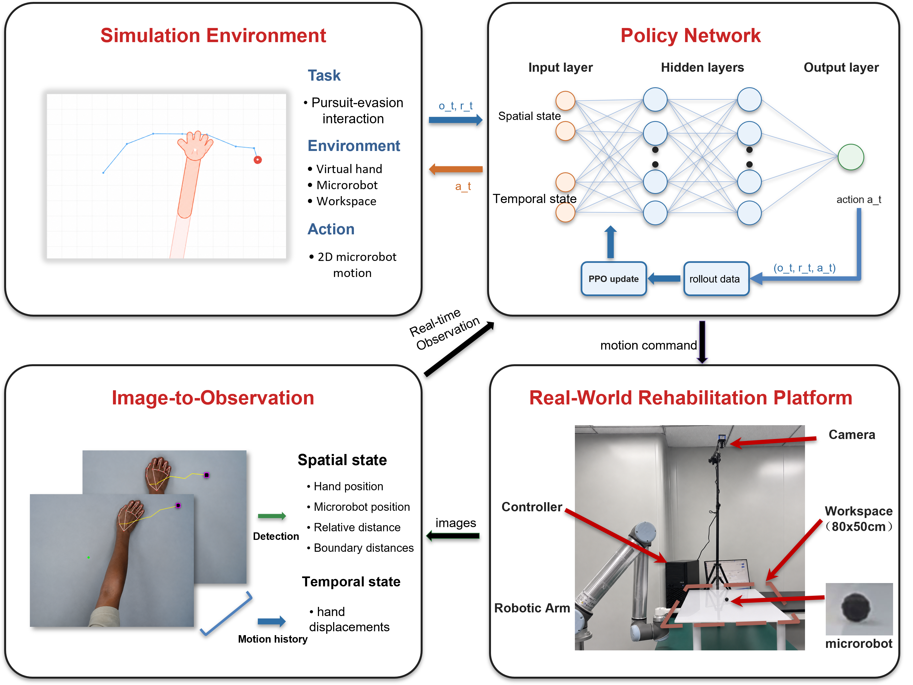
Fig. 1. System framework for noncontact rehabilitation from simulation to physical deployment. The simulation environment defines the pursuit interaction, the policy network maps spatial and temporal observations to microrobot actions, the observation module converts camera measurements into policy inputs, and the physical platform executes the learned policy through magnetic actuation.

B. Problem Formulation
We cast the task as a pursuit interaction with continuous feedback on a flat workspace. The participant's hand is the pursuer, and the microrobot is a moving target driven beneath the acrylic surface. The participant attempts to approach and catch the microrobot while the robot adjusts target motion to keep the task challenging but reachable. Unlike static reaching, the target continues to move after the participant initiates a movement. The task requires continuous tracking, anticipation, and correction rather than a single reaching movement.
The Zone of Proximal Development (ZPD) is defined operationally as a target range for the distance between the hand and microrobot. In this study, the target ZPD band was established after workspace calibration. It was selected for the desktop pilot platform to leave enough separation to avoid immediate catch while keeping the microrobot visually and physically reachable. This operating band is specific to the platform rather than a universal clinical threshold. Use with patients would require calibration during each session according to movement range, speed, and therapeutic goal. The robot should keep the interaction inside the target ZPD band rather than escaping completely or yielding passively. Hand speed, pursuit strategy, response delay, and motion noise can all change during interaction, making fixed difficulty settings inadequate.
Classical artificial potential field and rule-based reactive controllers provide intuitive solutions for regulating the motion of a target relative to a pursuer. However, their assumptions are not well matched to the present interactive pursuit task. A distance-based potential field can drive the microrobot away from the hand, but it does not explicitly account for the direction, velocity, or recent motion pattern of the pursuing hand. When the participant changes from direct pursuit to interception, a purely reactive controller may respond only after the relative geometry has already changed. This delayed response can produce oscillatory motion, drive the microrobot toward the workspace boundary, or result in an early catch. More generally, a rule-based controller requires manually specified thresholds, gains, and motion patterns. Under camera delay, noisy hand estimates, and abrupt changes in pursuit strategy, fixed rules have limited ability to distinguish transient measurement variation from meaningful changes in hand behavior. These limitations motivate an RL policy that uses both current geometry and recent motion history to regulate interaction difficulty over a longer horizon.
For robot training, the reward is written as the sum of four intuitive terms: distance regulation, action smoothness, workspace safety, and catch avoidance. Let d_t be the distance between the hand and microrobot, a_t be the robot action, and p_R,t be the microrobot position. The robot reward optimized by PPO is summarized as
$$r_{t} = r_{dist}(d_{t}) + r_{smooth}(a_{t}) + r_{bound}(p_{R,t}) + r_{catch}(d_{t}) (1)$$
Equation (1) groups the robot reward into four components. The distance component r_dist(d_t) encourages the separation between the hand and microrobot to remain inside the target ZPD band and penalizes deviations on either side. The smoothness component r_smooth(a_t) discourages abrupt commanded motion. The boundary component r_bound(p_R,t) penalizes microrobot positions outside the valid workspace. The catch component r_catch(d_t) penalizes contact between the hand and microrobot. Episodes terminate after catch, workspace exit, or the maximum horizon.

III. METHODOLOGY
The proposed framework is designed to improve robustness to variations in pursuit strategy and motor execution. It consists of three main components. First, decoupled domain randomization separates movement intent from motor execution constraints. Second, a dual-stream encoder combines instantaneous geometry with recent hand motion, while an auxiliary dynamics head encourages short-horizon motion prediction. Third, iterative league training exposes the robot to an expanding pool of hand policies, reducing overfitting to a single virtual user.

A. Decoupled Randomization of Cognitive and Motor Factors
To improve robustness to diverse hand behaviors, we apply domain randomization to both pursuit strategy and motor execution. Rather than perturbing the resulting hand trajectory as a single process, we separate intended motion generation from its execution. A hand policy first generates the intended displacement, and a motor execution layer then applies motion constraints, observation noise, and temporal delay. The hand policy is sampled from a pool containing the SPC and trained RL policies, representing direct pursuit and more anticipatory interception behaviors.
For the stochastic scripted pursuit controller, let ρ_ep denote the stride length sampled for each episode and q_t denote a planar unit direction. The intended displacement is
$$u_{t}^{SPC} = ρ_{ep}q_{t} (2)$$
The stride ρ_ep is sampled once at episode reset and then held fixed. The direction q_t follows a pursuit rule with ε exploration. With probability 1 - ε, q_t points from the current hand position toward the microrobot. With probability ε, q_t is sampled uniformly from all planar unit directions. In the experiments, ρ_ep is sampled uniformly between 0.45 and 0.70, and ε is fixed at 0.05. Learned hand policies output the intended displacement directly, and the same motor execution model is applied afterward.
Let u_t denote the intended hand displacement per simulation step, m_t denote the executed displacement, and m̃_t denote the filtered target displacement. The coefficient α controls temporal smoothing, with smaller values placing more weight on the preceding executed displacement. The filtered target is
$${m̃}_{t} = αu_{t} + (1-α)m_{t-1} (3)$$
The change from the preceding executed displacement is then limited by its Euclidean norm,
$$m_{t} = m_{t-1} + clip_norm({m̃}_{t}-m_{t-1}, c_{max}) (4)$$
Here, clip_norm(z, c) returns z when its Euclidean norm does not exceed c and otherwise rescales z to have norm c. The scalar c_max therefore bounds the Euclidean norm of the change in executed displacement between consecutive simulation steps. The resulting per-step displacement updates the simulated hand position.
$$p_{H,t+1} = p_{H,t} + m_{t} (5)$$
Equation (5) applies the executed displacement to the hand position. Delay and observation noise are introduced separately by the motor execution layer. Under a constant intended displacement, the filtered and executed increments converge to a constant value rather than decaying toward zero.
TABLE I: MOTOR RANDOMIZATION PARAMETERS
Parameter | Symbol | Range
Motion smoothing coefficient | alpha | 0.7
Maximum inter-step displacement change | c_max | 0.15
Gaussian observation noise | sigma | Uniform distribution over 0.01–0.08
Neural delay | delta | 0–3 frames (0–375 ms)
Uniform distribution denotes sampling uniformly over the stated interval.

B. Dual-Stream Encoder with Auxiliary Dynamics Prediction
Domain randomization exposes the robot to hand motions with different strategies, delays, and execution characteristics. Under this variability, the instantaneous interaction state alone may not be sufficient to determine the hand’s motion trend. We therefore use a dual-stream encoder that combines the current geometric state with a recent history of hand motion. An auxiliary dynamics prediction task further encourages the shared representation to capture short-term motion patterns.
At each timestep, the observation vector has 44 dimensions and is divided into a scalar vector with 12 dimensions and a temporal buffer with 32 dimensions, as shown in (6).
$$o_{t} = [s_{t}; h_{t-T:t}] (6)$$
The scalar component represents the instantaneous geometry of the interaction and is defined in (7).
$$s_{t} = [p_{R}; p_{H}; d(R,H); b_{N}, b_{S}, b_{E}, b_{W}; stride; a_{t-1}] (7)$$
Here, p_R and p_H denote the 2D positions of the microrobot and the hand. d(R,H) is their Euclidean distance. b_N, b_S, b_E, and b_W denote signed distances to the workspace boundaries. The variables stride and a_{t-1} represent the current movement step size and the previous robot action, respectively.
The temporal buffer h_{t-T:t} contains the T = 16 most recent relative hand displacement vectors, forming a sequence with 32 dimensions. This sequence helps the encoder estimate motion direction, response delay, and oscillatory behavior that are unavailable from the current position alone. Relative displacements make the representation invariant to translation, so the recurrent stream focuses on how the hand is moving rather than where the interaction occurs in the workspace.
The scalar vector and temporal buffer are encoded in separate streams, as shown in Fig. 2. A multilayer perceptron (MLP) extracts geometric information from the scalar state, while a gated recurrent unit (GRU) processes the displacement sequence. The two stream outputs are concatenated and passed through a fusion MLP to produce the shared representation used by the policy and value heads.
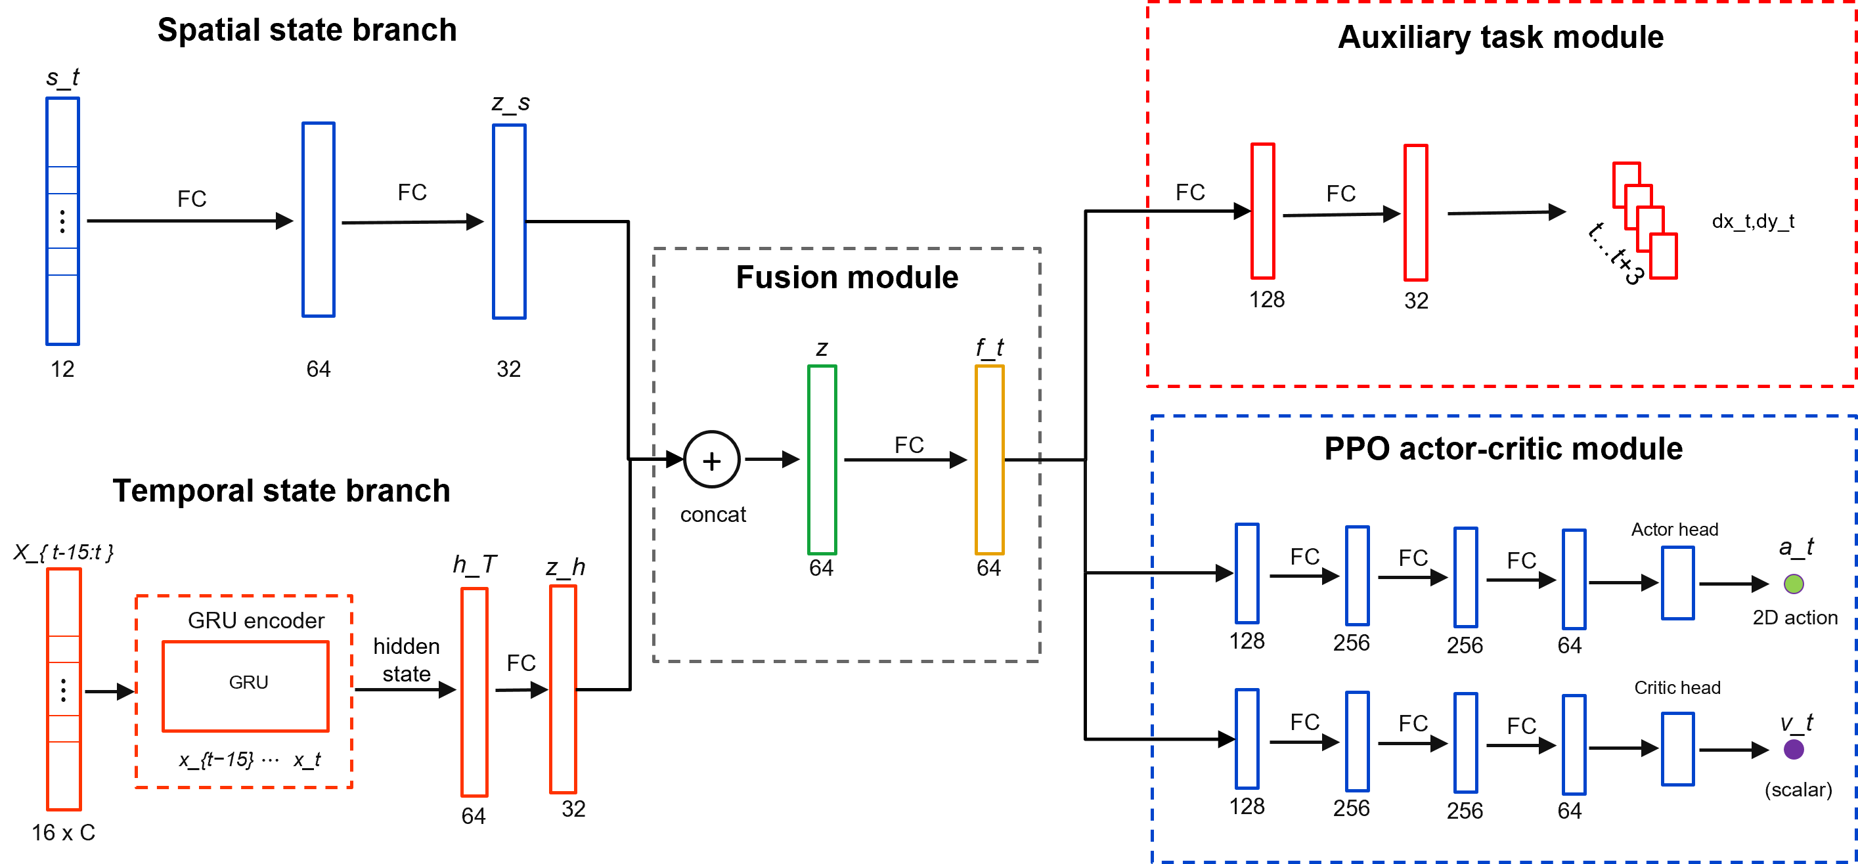
Fig. 2. Dual-stream policy architecture with auxiliary dynamics prediction. The spatial branch encodes the geometric state, the temporal branch encodes recent interaction history with a recurrent module, and the fused representation supports the policy head, value head, and auxiliary prediction head.
The ZPD reward provides the main control signal, but it supervises the encoder only indirectly through policy optimization. An auxiliary dynamics head adds a denser learning signal for motion representation. The head predicts relative hand displacement over a horizon of eight steps. Future displacements are available from the rollout, so this self-supervised auxiliary task requires no additional annotation.
The trajectory prediction loss is given in (8).
$$L_{traj} = E[{‖{D̂}_{t+1:t+H}-D_{t+1:t+H}‖₂}^{2}], H=8 (8)$$
Here, D_hat_{t+1:t+H} is the predicted future displacement sequence, and D_{t+1:t+H} is the observed future displacement sequence. The full training objective combines the PPO loss with the auxiliary trajectory prediction loss in (9).
$$L_{total} = L_{PPO} + λ_{traj}L_{traj} (9)$$
The coefficient lambda_traj controls the auxiliary loss weight. Because the auxiliary dynamics head shares the encoder with the policy, its gradients also update the spatial and temporal streams. These gradients encourage the encoder to capture motion inertia, delay, and interaction dynamics, helping the policy anticipate upcoming hand motion from recent history.

C. League Training
The preceding encoder addresses how recent hand motion is represented within an interaction. Generalization across pursuit behaviors also depends on which hand policies the robot encounters during training. A robot trained against a single hand policy may overspecialize and fail when the pursuit strategy changes. Simultaneous training of the robot and hand creates a different problem because both agents jointly determine the next state and return. Updating both policies together changes each agent's effective environment, violating the stationarity assumption used by PPO. In practice, the interaction can enter a cycle in which the robot exploits the current hand policy, the hand adapts, and the robot loses strategies that were useful against earlier hands.
The training schedule separates the two sides of learning and retains older hand behaviors in a shared pool. During robot training, sampled hand policies are fixed and treated as part of the environment. During hand training, the robot policy is fixed. The robot is trained against a pool P containing the SPC and learned hand policies from previous stages. This pool exposes the robot to direct pursuit as well as more strategic interception patterns. It broadens the distribution of hand behaviors without making the task purely adversarial, since the robot must maintain the ZPD interaction rather than simply maximize escape.
Algorithm 1 summarizes the iterative procedure. Each iteration first trains the robot against hands sampled from the fixed pool. It then trains a new hand policy against the frozen robot, initializes that hand from the previous learned hand when available, and adds the resulting policy to the pool for the next phase of robot training.
Algorithm 1: Iterative League Training
Input: initial robot policy π_{R}⁽⁰⁾, scripted pursuit controller π_{H}^{SPC}, number of league iterations N.
Initialize: pool of hand policies P ← {π_{H}^{SPC}}.
1. for n = 1, 2, ..., N do
2. Train robot policy π_{R}^{(n)} with PPO against hand policies sampled from P.
3. Initialize hand policy π_{H}^{(n)} from π_{H}^{(n-1)} when available.
4. Train π_{H}^{(n)} against the frozen robot policy π_{R}^{(n)}.
5. Update pool of hand policies P ← P ∪ {π_{H}^{(n)}}.
6. end for
Uniform sampling from the pool of learned hands is inefficient because different hands challenge the current robot to different degrees. Recent episode length provides a simple competitiveness signal. Short episodes usually indicate that the hand quickly catches the microrobot or forces early termination, so the corresponding hand should be sampled more often during the next phase of robot training. For learned hand i, let l_bar_i be its recent mean episode length. Its sampling score is inversely related to this length and is smoothed with a uniform mixture.
$$s_{i} = \frac{1}{{l̄}_{i} + ε_{l}}, {p̃}_{i} = (1-μ)\frac{s_{i}}{∑s_{j}} + \frac{μ}{m} (10)$$
Here, m is the number of learned hand policies, ε_l is a small stabilizing constant, and μ controls the uniform exploration mass. The SPC remains in the pool with a fixed sampling probability, while the probability assigned to learned hands follows (10). This keeps the scripted pursuit behavior available and concentrates the remaining episodes of robot training on learned hands that still expose weaknesses in the current robot policy.

IV. EXPERIMENTS AND RESULTS
The evaluation combines simulation experiments with a physical deployment test. The simulation experiments measure robustness across hand behaviors and isolate the contribution of temporal encoding of hand history. The physical deployment test evaluates whether the learned policy can run online within the perception and control stack of the physical robotic platform and whether the realized motion responds coherently to measured hand movement.

A. Simulation Protocol and Metrics
The simulation study separates two sources of performance gain in the proposed framework. The league analysis tests whether expanding the pool of hand policies improves robustness across pursuit behaviors. The ablation analysis tests whether temporal encoding of hand motion and the auxiliary dynamics objective improve the learned robot representation. Both analyses use the simulation environment described in Section II, with the robot controlling the microrobot and the hand motion generated by the behavior models described in Section III.
All simulation evaluations used the same planar workspace and the target ZPD band defined in Section II.B. A timestep was counted as within the zone when the distance between the hand and microrobot fell inside the target ZPD band. The simulator and the physical workspace share the same calibrated coordinate convention, so one workspace unit corresponds to 1 cm after calibration and can be compared directly with physical rollout distances. The physical rollout in Section IV.D used the same target ZPD band for zero-shot consistency, not to suggest that this operating setting is clinically optimal for every user.
Time in Zone (TIZ) is the primary metric. It measures the fraction of the full episode horizon for which the distance between the hand and microrobot remains inside the target ZPD band. Episode length is reported in simulation steps and measures how long the interaction remains active before catch, workspace exit, or the maximum horizon. For the league analysis, robustness across learned hand policies is summarized by mean TIZ and by the lowest TIZ among the tested hands. For the network ablation, TIZ is complemented by workspace coverage and mean jerk, which respectively measure task coverage and motion smoothness in the final policy evaluation.
The comparison of training protocols uses an SPC baseline trained only against the stochastic scripted pursuit controller, a single policy baseline trained against one learned hand policy, and a league policy trained through iterative expansion of the hand pool. The robot policies are evaluated across learned hand generations in Fig. 3 and under three representative pursuit conditions in Table II. The representation comparison keeps the training setting fixed while changing the policy encoder. The MLP baseline uses instantaneous geometry, the GRU policy adds recent relative hand displacement, and the auxiliary GRU policy adds the objective for future dynamics prediction.

B. League Training and Robustness Across Hand Policies
The league evaluation asks whether an expanding pool of hand policies improves robustness across pursuit behaviors, rather than only improving performance against the most recent hand policy. After each robot generation is trained, it is evaluated against all learned hand generations in the pool. This separates generalization across hand behaviors from progress against a single training opponent. In Fig. 3(a), each row fixes one robot generation and each column fixes one learned hand generation. Early robot generations perform well only for limited parts of the hand pool, whereas later generations maintain stronger TIZ over a broader set of learned hands, suggesting reduced specialization. Fig. 3(b) summarizes the same matrix through mean TIZ and the lowest TIZ across tested hands. The mean curve reflects typical performance, and the lower curve tracks the most difficult learned hand for each robot generation. Both improve from early to final generations despite local fluctuations.
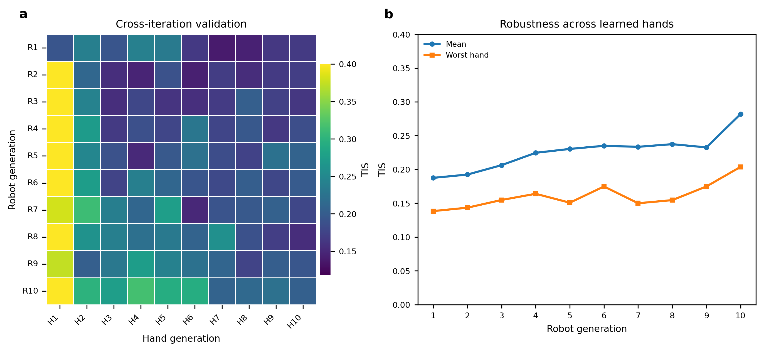
Fig. 3. Validation of robot policies trained through league across learned hand generations using the target ZPD band. (a) TIZ matrix obtained by evaluating each robot generation against each learned hand generation. Rows correspond to robot generations, and columns correspond to learned hand generations. (b) Mean TIZ and lowest TIZ across the learned hand test policies for each robot generation.
Table II extends the cross-generation analysis in Fig. 3 by comparing the SPC-only baseline, the single-opponent baseline, and the final league policy under SPC, learned-hand, and manual mouse pursuit. The learned-hand condition uses H1, the hand policy obtained after the first hand-training phase of the league procedure. The same H1 checkpoint is used to evaluate all three robot policies. H1 is also the sole training opponent for the single-opponent baseline and one member of the historical hand pool used for league training. For the automated SPC and H1 conditions, results are reported as the mean ± sample standard deviation across ten independently seeded evaluation trials, with 100 episodes per trial. The manual mouse condition was completed by one healthy operator who used the mouse interface to pursue and catch the simulated microrobot as quickly as possible. This condition introduces human reaction time and voluntary pursuit behavior but does not reproduce the biomechanics or perception noise of physical hand tracking. It is therefore treated as a human-in-the-loop stress test rather than clinical validation. Higher TIZ and longer episodes indicate that difficulty regulation was sustained for a larger portion of the interaction.
TABLE II: POLICY COMPARISON ACROSS THREE PURSUIT CONDITIONS
Robot policy | Pursuit condition | TIZ | Episode length (steps)
SPC-only baseline | SPC | 0.31 ± 0.06 | 52 ± 8
SPC-only baseline | Learned hand H1 | 0.19 ± 0.04 | 31 ± 5
SPC-only baseline | Manual mouse | 0.14 ± 0.03 | 33 ± 9
Single-opponent baseline | SPC | 0.11 ± 0.02 | 25 ± 4
Single-opponent baseline | Learned hand H1 | 0.49 ± 0.07 | 70 ± 7
Single-opponent baseline | Manual mouse | 0.19 ± 0.05 | 40 ± 11
League policy | SPC | 0.38 ± 0.06 | 67 ± 8
League policy | Learned hand H1 | 0.48 ± 0.07 | 64 ± 8
League policy | Manual mouse | 0.49 ± 0.09 | 74 ± 13

The two nonleague baselines exhibit clear condition-specific specialization. The SPC-only baseline performs relatively well under SPC pursuit but deteriorates under H1 and manual mouse pursuit. Conversely, the single-opponent baseline achieves its strongest result against its H1 training opponent but performs poorly under SPC and manual pursuit. The league policy avoids this narrow specialization. Although it does not exceed the single-opponent baseline under H1, it maintains strong performance under both automated pursuit conditions and achieves the highest TIZ and episode length in the manual mouse test. These results indicate that training against a broader distribution of hand policies produces more consistent difficulty regulation across scripted, learned, and human-controlled pursuit behaviors.

C. Network Ablation and Auxiliary Dynamics Analysis
The league results evaluate the diversity of hand behaviors used during training, while the network ablation tests whether the robot policy can use temporal information about hand motion once that diversity is present. The MLP baseline uses the instantaneous geometric state only, the GRU policy adds a history of relative displacement over 16 frames, and the auxiliary GRU further adds the dynamics prediction head described in Section III.B. The training curves in Fig. 4(a) and Fig. 4(b) show that temporal history improves optimization and interaction persistence. The GRU policies reach higher episode reward and longer episode length than the MLP baseline, indicating that current geometry alone is insufficient for stable difficulty regulation when hand motion changes over time. The auxiliary GRU gives the strongest training curve, suggesting that the prediction loss helps the recurrent stream form a more useful motion representation.
The auxiliary prediction examples in Fig. 4(c) provide a qualitative check on this representation. The predicted displacement over the short horizon generally follows the direction and curvature of the observed future hand motion rather than only reconstructing the current position. The final normalized metrics in Fig. 4(d) summarize the control effect of these representation changes. Recurrent history improves time within the ZPD and workspace coverage relative to the MLP baseline. Adding the auxiliary prediction objective further improves these performance metrics while reducing mean jerk. Together, the ablation indicates that temporal hand history and auxiliary dynamics prediction contribute to smoother and more reliable difficulty regulation.
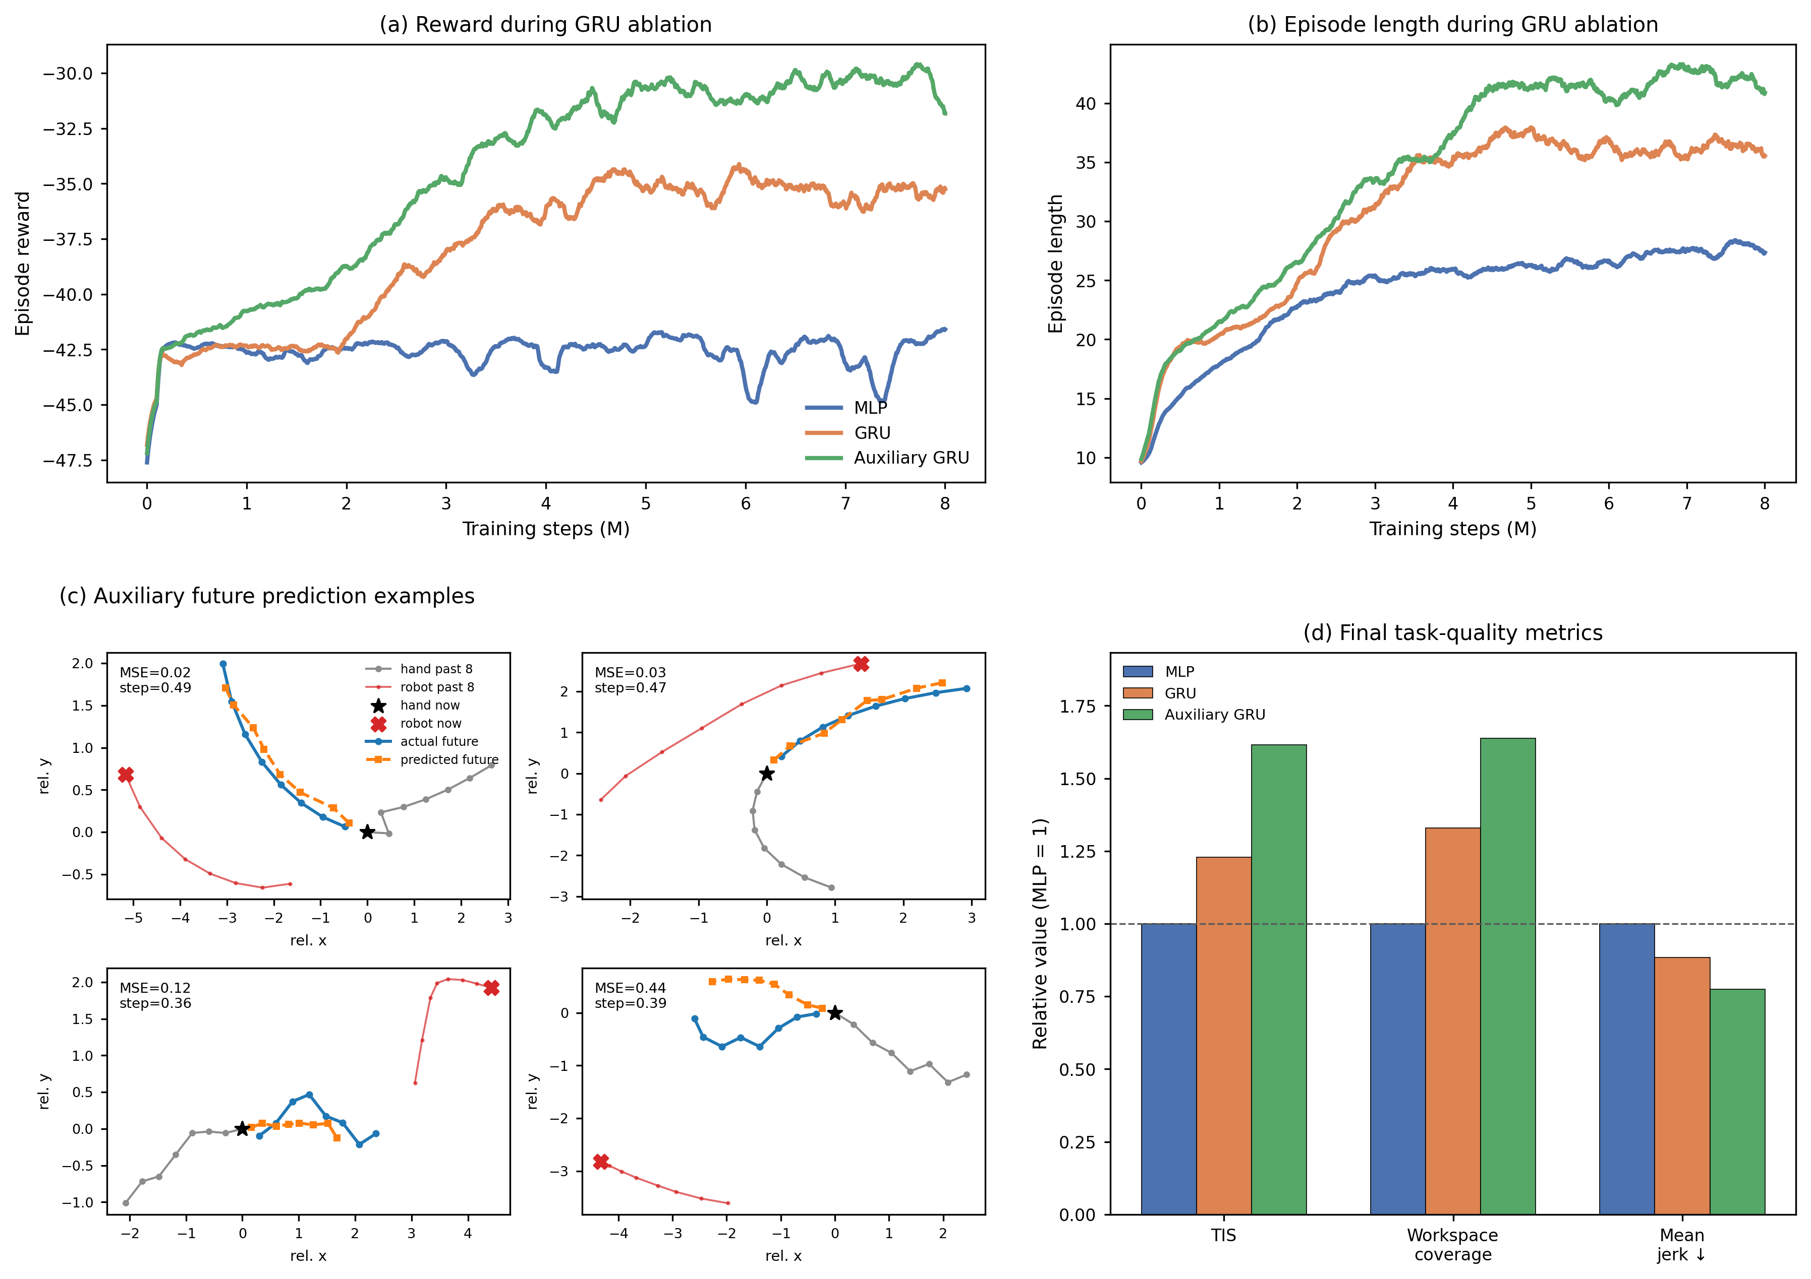
Fig. 4. Network ablation for temporal encoding and auxiliary dynamics prediction. (a) Smoothed episode reward during training for the MLP, GRU, and auxiliary GRU policies. (b) Smoothed episode length during training for the same policies. (c) Representative predictions from the auxiliary head over a short horizon compared with observed future hand motion. (d) Final performance metrics normalized to the MLP baseline; higher values are better for time within the ZPD and workspace coverage, whereas lower values are better for mean jerk.

D. Online Physical Deployment
To evaluate zero-shot transfer with real hand input, the simulation-trained policy was deployed on the physical microrobot platform without additional training. During each rollout, a healthy pilot pursued the passive microrobot across the acrylic workspace while the robotic arm moved the magnetic actuator beneath the surface. Nine rollouts were recorded during the deployment experiment. Camera observations and robot commands were processed online, allowing the policy to regulate microrobot motion under continuous feedback.
The deployment system retained the observation structure used in simulation. Calibrated camera measurements provided the hand and microrobot positions, while workspace-boundary features, the previously executed robot command, and the recent history of relative hand displacement completed the policy input defined in (6) and (7). Robot state measurements were used only for command execution and system monitoring and were not included in the policy observation. The perception pipeline combined YOLO-based microrobot detection, MediaPipe hand tracking, and a planar homography that mapped image coordinates to the workspace. When hand tracking was briefly interrupted, the controller extrapolated hand motion from the most recent velocity estimate. Safety was enforced through workspace limits, bounded command increments, automatic stopping after capture, controlled stopping during shutdown or interruption, and a hardware emergency stop.
Fig. 5 shows a representative zero-shot rollout with image frames and motion traces aligned in time. During steady pursuit, the hand-microrobot distance remains near the target ZPD band. A sharp increase in hand speed briefly reduces the separation below the target range. The policy responds by increasing microrobot speed, and the distance returns to the ZPD band over the following seconds. When the hand later slows, microrobot speed decreases accordingly and the separation again approaches the target range. Similar coupled responses appear throughout the rollout, showing that the policy adjusts microrobot motion to changes in pursuit dynamics rather than applying a fixed-speed escape command. The final decrease in distance corresponds to capture and episode termination. Overall, the rollout shows online adaptation to abrupt changes in hand motion and recovery toward the intended interaction range after transient deviations.
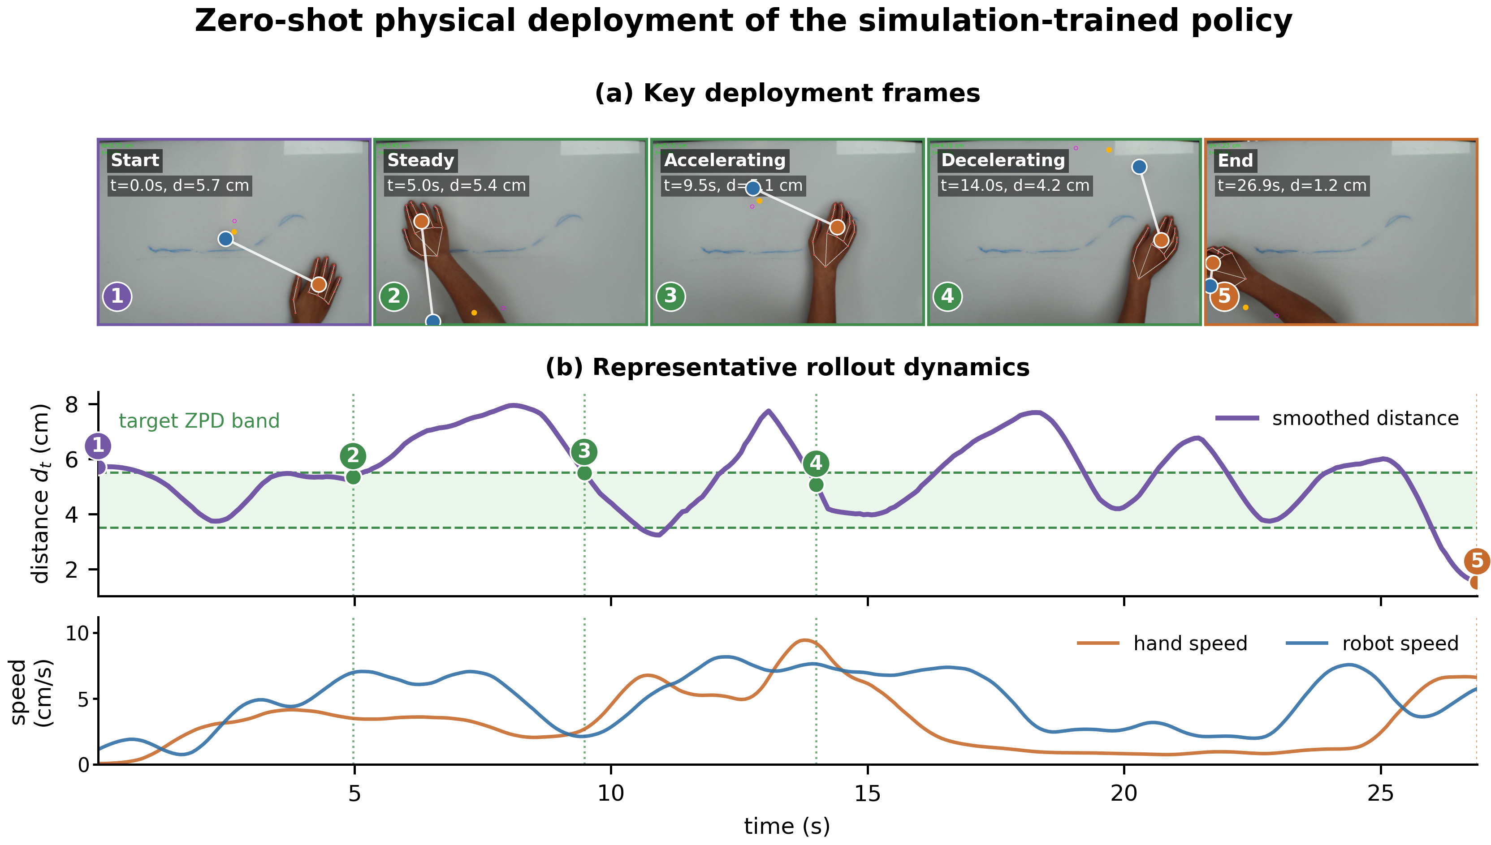
Fig. 5. Zero-shot physical deployment on the microrobot platform. (a) Representative frames from one of nine physical rollouts. (b) Smoothed hand-microrobot distance, target ZPD band, and measured hand and microrobot speeds from the same rollout.

V. DISCUSSION
The simulation and deployment results show that robust difficulty regulation depends on both the information available within an interaction and the diversity of behavior encountered across interactions. Temporal encoding reduces ambiguity in recent hand motion, while league training broadens the population of pursuit strategies used for policy optimization. These mechanisms address different failure modes and are most useful when considered together.

A. Complementary Effects of Temporal Encoding and League Training
The gated recurrent unit reduces uncertainty within an episode by summarizing recent hand motion, whereas the opponent pool expands the distribution of pursuit behaviors across episodes. Similar current positions can arise during direct pursuit, interception, delayed response, or recovery from a noisy observation. The recurrent stream provides context for these cases. League training addresses a separate weakness because a policy can still overfit even when it represents one opponent accurately. Retaining earlier hand policies forces the robot to preserve useful responses as new pursuit strategies enter the pool.
Cross-generation performance contains local fluctuations, which is expected in an iterative two-agent process and does not imply that every robot generation is uniformly stronger than its predecessor. The final generation nevertheless achieves the highest mean and worst-hand Time in Zone across the fixed learned-hand test set. The comparison across representative pursuit conditions provides a separate robustness check. The SPC-only and single-opponent policies each perform best near their training condition, whereas the league policy remains effective under scripted, H1, and manual pursuit. The main effect of the league is therefore broader population-level robustness rather than monotonic improvement against every individual hand.

B. Role of Auxiliary Dynamics Prediction
Temporal history provides the larger architectural gain over the feed-forward baseline, and auxiliary future prediction adds a complementary constraint on the shared encoder. The auxiliary trajectory examples follow the short-horizon direction of observed hand motion rather than reproducing only the current position. The final evaluation also improves Time in Zone and workspace coverage while reducing mean jerk relative to the multilayer perceptron baseline. The auxiliary head therefore supplies both dense supervision and an interpretable diagnostic of the temporal representation. Control performance remains the primary criterion for selecting a policy because low prediction error alone does not guarantee effective difficulty regulation.

C. Translational Scope and Future Work
The physical experiment demonstrates transfer of the complete feedback loop rather than offline inference alone. Camera measurements, calibrated workspace features, temporal history, policy inference, and magnetic actuation operate online with the same task semantics used in simulation. Transient departures from the target band occur when hand speed changes abruptly, but the representative rollout shows corresponding changes in microrobot speed and subsequent recovery toward the band. The experiment establishes the feasibility of zero-shot deployment under real sensing, communication, and actuation delays.
The present evidence does not establish clinical efficacy. The physical dataset contains nine rollouts from one healthy pilot, and the manual mouse condition represents voluntary pursuit rather than impaired hand biomechanics. The motor execution layer uses simplified inertia, displacement, noise, and delay models rather than parameters identified from a patient cohort. The fixed target band was calibrated for the desktop platform and should be individualized before clinical use.
Future work should estimate user-specific motor parameters from recorded trajectories, adapt the target band to session goals and fatigue, and evaluate the controller across repeated physical sessions. Comparisons with conventional reactive and assistance-as-needed controllers would clarify which gains arise from long-horizon optimization. Larger datasets should also quantify recovery time after disturbances, tracking dropouts, workspace safety, and between-user variability. Evaluation with patient participants will be required to determine whether the adaptive pursuit task improves engagement or motor outcomes.

VI. CONCLUSION
This paper presented an end-to-end reinforcement learning framework for adaptive difficulty regulation in a magnetically actuated upper-limb pursuit task. Decoupled randomization separates pursuit intent from motor execution, the dual-stream encoder combines current geometry with recent hand motion, auxiliary prediction shapes the temporal representation, and iterative league training exposes the robot to a growing population of pursuit policies. The final league generation improved both mean and worst-hand Time in Zone across learned opponents and produced the most balanced results across scripted, learned, and manual pursuit.
Zero-shot deployment on the physical microrobot platform further showed that the simulation-trained policy can operate online with vision-based hand input and respond to changing pursuit speed. The framework therefore provides a basis for noncontact, data-driven rehabilitation tasks whose difficulty is regulated through interaction rather than fixed trajectories. Patient-calibrated Zone of Proximal Development settings and broader physical evaluation are the next steps toward clinical validation.

