Adaptive Difficulty Regulation in Magnetic Microrobot-Based Upper-Limb Rehabilitation via League-Trained Reinforcement Learning
Abstract— Adaptive rehabilitation requires task difficulty to remain challenging and attainable as user behavior changes, which fixed trajectories and hand-tuned controllers cannot reliably achieve. This study presents an end-to-end reinforcement learning framework for a tabletop upper-limb pursuit task in which a participant attempts to catch an unpowered microrobot moved by noncontact magnetic actuation. The controller regulates the hand-microrobot distance within a platform-specific Zone of Proximal Development band. Decoupled randomization separates pursuit strategy from motor execution to generate diverse virtual hand behaviors. A dual-stream encoder combines current geometry with recent relative motion, and an auxiliary prediction task strengthens the representation of short-term hand dynamics. Iterative league training exposes the controller to an expanding pool of pursuit policies through prioritized opponent sampling. Simulation experiments showed that league training improved robustness across pursuit behaviors, while temporal encoding and auxiliary prediction supported smoother difficulty regulation. Transferred to the physical microrobot platform without additional training, the policy responded online to changes in hand motion through the complete vision-control loop. These results demonstrate the feasibility of learned, interaction-responsive difficulty regulation for noncontact upper-limb rehabilitation.
Index Terms— adaptive difficulty, domain randomization, league training, magnetic microrobot, reinforcement learning, robot-assisted rehabilitation, zero-shot transfer.

I. INTRODUCTION
Rehabilitation after neurological injury aims to restore upper-limb motor function, which supports independence in self-care, work, and daily activity. Stroke and related neurological conditions can impair voluntary control, coordination, movement speed, and purposeful action, often requiring prolonged rehabilitation [1], [2]. Repetitive task-oriented practice supports motor relearning by requiring users to generate movements, evaluate outcomes, and correct errors through repeated attempts [3]–[5]. However, the effectiveness of such practice depends not only on training volume but also on the difficulty of each trial. Tasks that are too easy may not elicit enough corrective effort, while tasks that are too difficult can produce repeated failure and reduce engagement [6], [7]. Upper-limb training therefore needs to keep users actively involved while preserving a challenge that is demanding but still attainable. Maintaining this balance is difficult because motor performance varies across individuals and can fluctuate within a single session.
Current upper-limb rehabilitation relies on several forms of training. Therapist-guided exercise gives clinicians direct access to movement quality, so task difficulty and feedback can be adjusted for each user. Conventional tabletop devices and rehabilitation equipment make repeated practice accessible across reaching, tracking, grasping, and coordination tasks. Robotic systems, including exoskeletons and end-effector devices, add repeatable task execution, programmable assistance or resistance, and quantitative measurement of movement and force [8]–[13]. Virtual reality systems, motion-capture games, and screen-based exercises broaden the training environment through visual feedback and staged progression [14]–[16]. Together, these approaches support individualized guidance, intensive repetition, objective assessment, and varied task practice.
Despite these advantages, each approach carries practical limits. Therapist-led training is adaptable, but therapist availability constrains both intensity and scale. Conventional devices are easy to use, but they usually provide limited sensing and little real-time adaptation or quantitative feedback. Contact-based robotic systems can precisely regulate physical interaction [17]. However, they often require the user to wear or hold mechanical components, which increases setup burden and narrows the available forms of interaction. Fully virtual systems are flexible, but they mainly act through visual interfaces rather than through physical target interaction. We therefore develop a noncontact tabletop system in which the user pursues a physical target without wearing or holding a powered device. The target is actuated remotely, and its behavior is defined in software, so the path and difficulty can be adjusted during interaction [18]–[20]. This design preserves physical interaction while reducing user-worn equipment and supporting programmable adaptive training.
The effectiveness of this interface depends on how the microrobot target is controlled during pursuit. The target should not simply escape the user, nor should it move so predictably that the task becomes trivial. Its motion should instead keep the hand-microrobot distance within a working Zone of Proximal Development (ZPD), where the task remains challenging but reachable [21], [22]. This requires continuous adjustment as the user’s speed, reaction delay, and pursuit strategy change over time. Prior work on dynamic difficulty adjustment in rehabilitation games similarly motivates adaptive controllers for variable user behavior [23]–[25]. Rule-based reactive controllers, such as artificial potential field (APF) methods, can respond to the current hand-microrobot geometry, but they depend on manually selected gains, thresholds, or reference motions and often do not represent recent pursuit dynamics. A short-term increase in distance can also create later failures, such as workspace exit or excessive task difficulty. These limitations make the task better suited to a learning-based controller that can use interaction data to optimize future consequences rather than only reacting to the current distance. Reinforcement learning (RL) provides such a framework, because it can learn state-dependent control policies through interaction and optimize long-term outcomes [26]. RL has been applied successfully to robotic manipulation, locomotion, human-robot interaction, and adaptive rehabilitation control [27]–[32]. However, this task also requires diverse simulated hand behaviors and a state representation that captures motion dynamics over time.
Accordingly, we develop an adaptive RL framework for regulating pursuit difficulty under variable hand behavior. The framework combines randomized virtual hands, temporal motion representation, and population-based policy training. To increase behavioral diversity in simulation, the hand model separates pursuit strategy from motor execution. Scripted and learned hand policies generate intended motion, while an execution layer adds inertia, motion-change limits, observation noise, and delay. The robot policy uses the current interaction geometry together with recent relative hand motion, allowing it to represent both workspace layout and short-term pursuit dynamics. An auxiliary prediction objective further encourages the policy encoder to learn these dynamics. Robustness across pursuit strategies is improved through iterative league training, where the robot is trained against a growing pool of scripted and learned hand policies. We evaluate the framework in simulation by testing robustness across pursuit behaviors and isolating the contributions of temporal encoding and auxiliary prediction. We then deploy the learned policy on the magnetic microrobot platform without additional physical training, testing the full loop from visual observation to physical actuation. The evaluation focuses on adaptive difficulty regulation, robustness, motion smoothness, system responsiveness, and physical deployment feasibility, rather than clinical effectiveness or motor recovery.
The remainder of this paper is organized as follows. Section II introduces the magnetic tabletop platform and formulates the adaptive pursuit control problem. Section III describes virtual hand modeling, policy architecture, and iterative league training. Section IV reports the simulation experiments, ablation studies, and zero-shot physical deployment results. Section V discusses the findings and limitations. Section VI concludes the paper.

II. SYSTEM OVERVIEW AND PROBLEM FORMULATION
We introduce a magnetically actuated noncontact rehabilitation system for active upper-limb training. In magnetic milli/microrobotics terminology, the interaction target is an unpowered magnetic body actuated across a desktop workspace, not a self-propelled onboard device. The user pursues the target on the tabletop as a robotic arm moves a permanent magnet below the surface. This layout preserves a physical pursuit task without rigid coupling between the robot and the human body. The user therefore remains an active pursuer rather than a passive follower, which supports engagement during motor training. Because the appropriate challenge level changes with the participant’s pursuit behavior, we formulate microrobot motion control as an RL problem for adaptive difficulty regulation.

A. Hardware Platform
The platform is organized into actuation, interaction, and perception layers. The actuation layer places a UR10 robotic arm beneath the workspace, with a permanent magnet mounted on the end effector to drive the microrobot above the surface [18]–[20]. The interaction layer uses a 5-mm acrylic sheet to support the unpowered microrobot and physically separate the robotic arm from the user. The perception layer uses an overhead camera connected to a host computer. The computer estimates the microrobot and hand positions, then sends target pose commands to the robotic arm through Ethernet.
This layout supports interaction safety while keeping the hardware simple. Fig. 1 summarizes the workflow from simulation training to visual observation, policy inference, and physical magnetic actuation. The acrylic sheet provides fixed separation between the participant and the robotic arm, so the participant interacts only with the lightweight unpowered microrobot on the tabletop. The robotic arm remains below the surface, with software motion limits and its standard emergency stop available during operation. The platform runs as a vision-based closed loop: the overhead camera tracks the hand and microrobot, the learned policy generates motion commands from these observations, and the robotic arm actuates the microrobot through the permanent magnet.
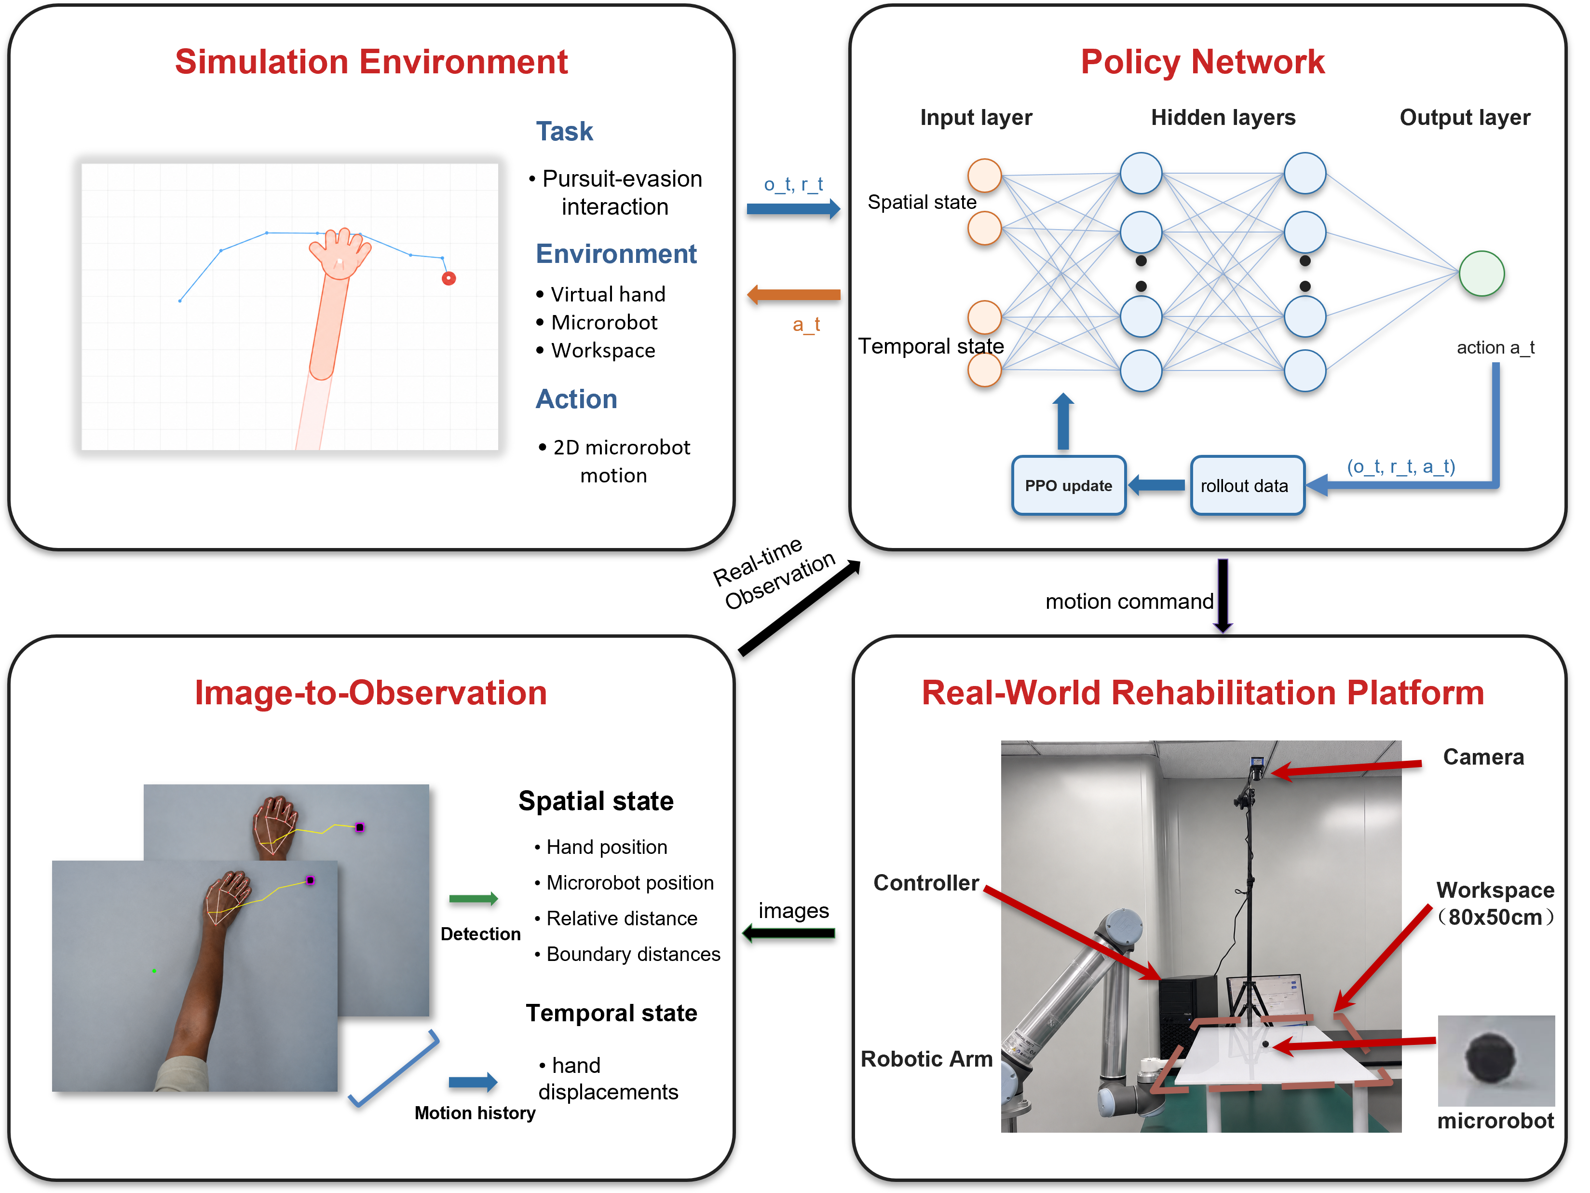
Fig. 1. System framework for noncontact rehabilitation from simulation to physical deployment. The simulation environment defines the pursuit interaction, the policy network maps spatial and temporal observations to microrobot actions, the observation module converts camera measurements into policy inputs, and the physical platform executes the learned policy through magnetic actuation.

B. Problem Formulation
The task is formulated as a pursuit interaction with continuous feedback on a flat workspace. The participant’s hand acts as the pursuer, and the microrobot serves as a moving target driven through magnetic actuation beneath the acrylic surface. The participant attempts to approach and catch the microrobot, while the controller adjusts target motion to keep the task challenging but reachable. Unlike static reaching, the target continues to move after the participant initiates movement. The task therefore requires continuous tracking, anticipation, and correction rather than a single reach.
To keep this pursuit task challenging but reachable, the hand-microrobot distance is regulated within an operational ZPD band [21], [22]. The term ZPD is used as a control analogy for maintaining the task between trivial pursuit and unreachable escape, not as a psychometric estimate of learning potential. In this study, the target band was set after workspace calibration. It was chosen for the desktop pilot platform to prevent immediate catch while keeping the microrobot visually and physically reachable. This band is platform specific, not a universal clinical threshold. Patient use would require session-level calibration based on movement range, speed, and therapeutic goal. The controller is intended to keep the interaction inside the target band rather than escaping completely or yielding passively. Because hand speed, pursuit strategy, response delay, and motion noise can change during interaction, fixed difficulty settings are inadequate.
A natural baseline for this pursuit problem is a rule-based reactive controller, with artificial potential fields as a representative example [33], [34]. Such controllers are intuitive because the target motion can be defined directly from the current hand-microrobot geometry. However, this reactive assumption is poorly matched to an interactive task in which the participant may change pursuit behavior over time. A distance-based potential field can push the microrobot away from the hand, but it does not explicitly represent the hand’s direction, velocity, or recent motion pattern. If the participant shifts from direct pursuit to interception, the controller may respond only after the relative geometry has already changed. This delay can produce oscillatory motion, push the microrobot toward the workspace boundary, or lead to an early catch. More broadly, rule-based control depends on manually specified gains, thresholds, and motion patterns. With camera delay, noisy hand estimates, and abrupt pursuit changes, fixed rules have limited ability to separate transient measurement variation from meaningful changes in hand behavior. These limitations motivate an RL policy that uses both current geometry and recent motion history to regulate interaction difficulty over a longer horizon.
For robot training, the environment provides a scalar reward that combines distance regulation, action smoothness, workspace safety, and catch avoidance. Let d_t denote the hand-microrobot distance, a_t denote the robot action, and p_R,t denote the microrobot position. The reward signal used for policy learning with proximal policy optimization (PPO) [28] is defined as follows:
$$r_{t} = r_{dist}(d_{t}) + r_{smooth}(a_{t}) + r_{bound}(p_{R,t}) + r_{catch}(d_{t}) (1)$$
Equation (1) defines the reward as four components. The distance term r_dist(d_t) encourages the hand-microrobot distance to remain inside the target ZPD band and penalizes deviations on either side. The smoothness term r_smooth(a_t) discourages abrupt commanded motion. The boundary term r_bound(p_R,t) penalizes microrobot positions outside the valid workspace, and the catch term r_catch(d_t) penalizes contact between the hand and microrobot. Episodes terminate when a catch occurs, when the microrobot exits the workspace, or when the maximum horizon is reached. Additional implementation details, including simulation settings, reward functions, and coefficient values, are provided in the Supplementary Material.

III. METHODOLOGY
To improve robustness against variations in pursuit strategy and motor execution, the framework combines three elements. Decoupled domain randomization separates movement intent from execution constraints, allowing virtual hands to differ in both strategy and motor behavior. A dual-stream encoder combines instantaneous geometry with recent hand motion, and an auxiliary dynamics head encourages short-horizon motion prediction. Iterative league training further exposes the robot to an expanding pool of hand policies, reducing overfitting to any single hand policy.

A. Decoupled Randomization of Cognitive and Motor Factors
To improve robustness to diverse hand behaviors, we apply domain randomization to both pursuit strategy and motor execution [35]–[39]. Rather than perturbing the resulting hand trajectory as a single process, we separate intended motion generation from its execution. A hand policy first generates the intended displacement, and a motor execution layer then applies motion constraints, observation noise, and temporal delay. The hand policy is sampled from a pool containing a stochastic scripted pursuit controller (SPC) and trained RL policies, representing direct pursuit and more anticipatory interception behaviors.
For the SPC, let ρ_ep denote the stride length sampled for each episode and q_t denote a planar unit direction. The intended displacement is
$$u_{t}^{SPC} = ρ_{ep}q_{t} (2)$$
Equation (2) scales the pursuit direction by the episode-specific stride. The stride ρ_ep is sampled once at episode reset and then held fixed. The direction q_t follows a pursuit rule with ε exploration. With probability 1 - ε, q_t points from the current hand position toward the microrobot. With probability ε, q_t is sampled uniformly from all planar unit directions. In the experiments, ρ_ep is sampled uniformly between 0.45 and 0.70, and ε is fixed at 0.05. Learned hand policies output the intended displacement directly, and the same motor execution model is applied afterward.
Let u_t denote the intended hand displacement per simulation step, m_t denote the executed displacement, and m̃_t denote the filtered target displacement. The coefficient α controls temporal smoothing, with smaller values placing more weight on the preceding executed displacement. The filtered target is defined in (3) as
$${m̃}_{t} = αu_{t} + (1-α)m_{t-1} (3)$$
The change from the preceding executed displacement is then limited by its Euclidean norm as shown in (4).
$$m_{t} = m_{t-1} + clip_norm({m̃}_{t}-m_{t-1}, c_{max}) (4)$$
Here, clip_norm(z, c) returns z when its Euclidean norm does not exceed c and otherwise rescales z to have norm c. The scalar c_max therefore bounds the Euclidean norm of the change in executed displacement between consecutive simulation steps. The resulting per-step displacement updates the simulated hand position.
$$p_{H,t+1} = p_{H,t} + m_{t} (5)$$
Equation (5) applies the executed displacement to the hand position. Delay and observation noise are introduced separately by the motor execution layer. Under a constant intended displacement, the filtered and executed increments converge to a constant value rather than decaying toward zero. The motor-execution randomization ranges are summarized in Table I.
TABLE I: MOTOR-EXECUTION RANDOMIZATION RANGES
Parameter | Range
Motion smoothing coefficient, α | 0.5–0.9
Maximum inter-step displacement change, c_max | 0.10–0.25 workspace units/step
Gaussian observation noise, σ | U(0.01, 0.08) workspace units
Neural delay, δ | 0–3 frames

B. Dual-Stream Encoder with Auxiliary Dynamics Prediction
Domain randomization exposes the robot to hand motions with different strategies, delays, and execution characteristics. Under this variability, the instantaneous interaction state alone may not be sufficient to determine the hand’s motion trend. We therefore use a dual-stream encoder that combines the current geometric state with a recent history of hand motion. An auxiliary dynamics prediction task further encourages the shared representation to capture short-term motion patterns.
At each timestep, the observation vector has 44 dimensions and is divided into a scalar vector with 12 dimensions and a temporal buffer with 32 dimensions, as shown in (6).
$$o_{t} = [s_{t}; h_{t-T:t}] (6)$$
The scalar component represents the instantaneous geometry of the interaction and is defined in (7).
$$s_{t} = [p_{R}; p_{H}; d(R,H); b_{N}, b_{S}, b_{E}, b_{W}; stride; a_{t-1}] (7)$$
Here, p_R and p_H denote the 2D positions of the microrobot and the hand. d(R,H) is their Euclidean distance. b_N, b_S, b_E, and b_W denote signed distances to the workspace boundaries. The variables stride and a_{t-1} represent the current movement step size and the previous robot action, respectively.
The temporal buffer h_{t-T:t} contains the T = 16 most recent relative hand displacement vectors, forming a sequence with 32 dimensions. This sequence helps the encoder estimate motion direction, response delay, and oscillatory behavior that are unavailable from the current position alone. Relative displacements make the representation invariant to translation, so the recurrent stream focuses on how the hand is moving rather than where the interaction occurs in the workspace.
The scalar vector and temporal buffer are encoded in separate streams, as shown in Fig. 2. A multilayer perceptron (MLP) extracts geometric information from the scalar state, while a gated recurrent unit (GRU) processes the displacement sequence [40]. The two stream outputs are concatenated and passed through a fusion MLP to produce the shared representation used by the policy and value heads.
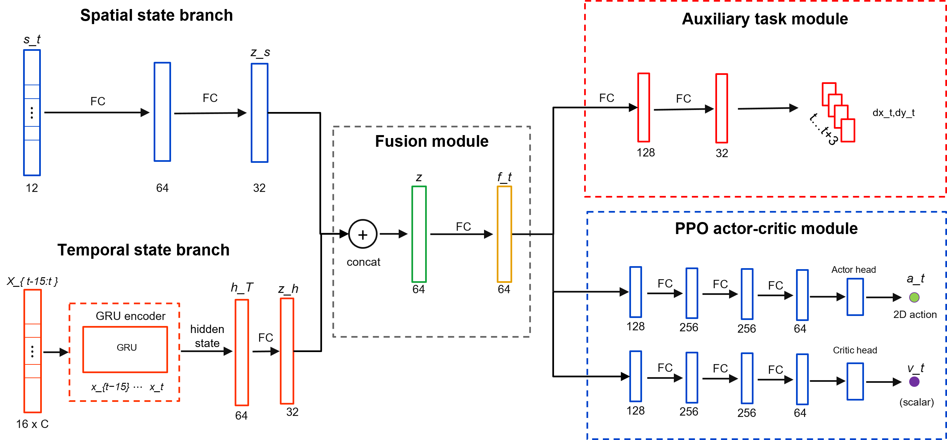
Fig. 2. Dual-stream policy architecture with auxiliary dynamics prediction. The spatial branch encodes the geometric state, the temporal branch encodes recent interaction history with a recurrent module, and the fused representation supports the policy head, value head, and auxiliary prediction head.
The environment reward provides the main control signal for policy learning, but the encoder receives this signal only indirectly through policy optimization. An auxiliary dynamics head adds a denser learning signal for motion representation [41], [42]. The head predicts relative hand displacement over a horizon of eight steps. Future displacements are available from the rollout, so this self-supervised auxiliary task requires no additional annotation [43].
The trajectory prediction loss is given in (8).
$$L_{traj} = E[{‖{D̂}_{t+1:t+H}-D_{t+1:t+H}‖₂}^{2}], H=8 (8)$$
Here, D_hat_{t+1:t+H} is the predicted future displacement sequence, and D_{t+1:t+H} is the observed future displacement sequence. The full training objective combines the PPO loss with the auxiliary trajectory prediction loss in (9).
$$L_{total} = L_{PPO} + λ_{traj}L_{traj} (9)$$
The coefficient lambda_traj controls the auxiliary loss weight. Because the auxiliary dynamics head shares the encoder with the policy, its gradients also update the spatial and temporal streams. These gradients encourage the encoder to capture motion inertia, delay, and interaction dynamics, helping the policy anticipate upcoming hand motion from recent history.

C. League Training
After defining the temporal encoder, the next issue is the range of hand behaviors used during training. Generalization across pursuit strategies depends not only on representation but also on the policies encountered by the robot. Training against a single hand policy can lead to overspecialization and poor transfer when the hand changes strategy. Training the robot and hand simultaneously creates a different difficulty. Because both policies influence the next state and return, updating them together makes each learner’s effective environment nonstationary, which is poorly matched to on-policy PPO updates. In practice, the interaction can cycle as the robot exploits the current hand policy, the hand adapts, and the robot loses strategies that were useful against earlier hands [44].
The training schedule addresses this nonstationarity by alternating the two sides of learning and retaining older hand policies in a shared pool [45], [46]. During robot training, sampled hand policies remain fixed and are treated as part of the environment. During hand training, the robot policy is fixed in the same way. The robot is trained against a pool P that contains the SPC and learned hand policies from previous stages. This pool exposes the robot to direct pursuit as well as interception-oriented behavior. It broadens the hand-behavior distribution without turning the task into pure evasion, because the robot is rewarded for maintaining the ZPD interaction rather than simply escaping from the hand.
Algorithm 1 summarizes this iterative schedule. In each iteration, the robot is first trained against hand policies sampled from the fixed pool. A new hand policy is then trained against the frozen robot, initialized from the previous learned hand when available, and added to the pool before the next robot-training phase. The experiments use N = 10 league iterations, producing a final pool that contains the SPC and ten learned hand policies. At this scale, policy storage and prioritized fictitious self-play sampling were not computational bottlenecks, since each rollout uses a single sampled hand policy. Larger leagues could prune or down-weight redundant policies based on behavioral similarity, persistently low sampling probability, or low exploitability against the current robot.
Algorithm 1: Iterative League Training
Input: initial robot policy π_{R}⁽⁰⁾, SPC policy π_{H}^{SPC}, number of league iterations N.
Initialize: pool of hand policies P ← {π_{H}^{SPC}}.
1. for n = 1, 2, ..., N do
2. Train robot policy π_{R}^{(n)} with PPO against hand policies sampled from P.
3. Initialize hand policy π_{H}^{(n)} from π_{H}^{(n-1)} when available.
4. Train π_{H}^{(n)} against the frozen robot policy π_{R}^{(n)}.
5. Update pool of hand policies P ← P ∪ {π_{H}^{(n)}}.
6. end for
After each pool update, hand policies are not sampled uniformly. Different learned hands challenge the current robot to different degrees [47], so the training schedule uses recent episode length as a simple competitiveness signal. Shorter episodes usually indicate that a hand policy catches the microrobot quickly or forces early termination. That policy is therefore sampled more often in the next robot-training phase. For learned hand i, let l̄_i denote its recent mean episode length. Its sampling score is inversely related to l̄_i and smoothed by a uniform mixture.
$$s_{i} = \frac{1}{{l̄}_{i} + ε_{l}}, {p̃}_{i} = (1-μ)\frac{s_{i}}{∑s_{j}} + \frac{μ}{m} (10)$$
In (10), m denotes the number of learned hand policies, ε_l is a small stabilizing constant, and μ controls the uniform exploration mass. The SPC remains in the pool with a fixed sampling probability, while learned-hand probabilities are assigned according to (10). This preserves the scripted pursuit behavior and allocates the remaining robot-training episodes toward learned hand policies that still expose weaknesses in the current robot policy. The Supplementary Material provides the PPO hyperparameters, together with the settings used for the auxiliary prediction loss and league sampling.

IV. EXPERIMENTS AND RESULTS
The evaluation combines simulation experiments with a physical deployment test. In simulation, the experiments assess robustness across hand behaviors and isolate the contribution of temporal hand-motion encoding. On the physical platform, the deployment test examines whether the learned policy can run online through the perception and control stack, and whether the resulting microrobot motion responds coherently to measured hand movement.

A. Simulation Protocol and Metrics
The simulation study separates two possible sources of performance gain. The league analysis examines whether expanding the hand-policy pool improves robustness across pursuit behaviors. The ablation analysis examines whether temporal hand-motion encoding and the auxiliary dynamics objective improve the robot policy representation. Both analyses use the simulation environment from Section II: the robot controls the microrobot, and hand motion is generated by the behavior models from Section III.
All simulation evaluations use the planar workspace and target ZPD band defined in Section II.B. A timestep is counted as within the zone when the hand-microrobot distance falls inside this band. The physical deployment in Section IV.D uses the same band to preserve zero-shot consistency between simulation and hardware. This choice does not represent a clinically optimal setting for every user. Further details on the evaluation and deployment protocols are provided in the Supplementary Material.
Time in Zone (TIZ) is the primary metric. It is defined as the fraction of the episode horizon during which the hand-microrobot distance remains inside the target ZPD band. Episode length is reported in simulation steps and measures how long the interaction remains active before catch, workspace exit, or the maximum horizon. In the league analysis, robustness across learned hand policies is summarized using the mean TIZ and the lowest TIZ among tested hands. In the network ablation, TIZ is reported together with workspace coverage and mean jerk. These two additional metrics measure task coverage and motion smoothness in the final policy evaluation.
The training-protocol comparison includes three robot policies. The SPC-only baseline is trained against the SPC alone. The single-opponent baseline is trained against one learned hand policy. The league policy is trained through iterative expansion of the hand pool. These policies are evaluated across learned hand generations in Fig. 3 and under three representative pursuit conditions in Table II. The representation comparison keeps the training setting fixed and changes only the policy encoder. The MLP baseline uses instantaneous geometry. The GRU policy adds recent relative hand displacement, and the auxiliary GRU policy further adds the future-dynamics prediction objective.

B. League Training and Robustness Across Hand Policies
The league evaluation tests whether expanding the hand-policy pool improves robustness across pursuit behaviors, rather than only improving performance against the most recent hand policy. After each robot generation is trained, it is evaluated against all learned hand generations in the pool. This evaluation separates cross-policy robustness from progress against a single training opponent. In Fig. 3(a), each row corresponds to one robot generation and each column to one learned hand generation. Early robot generations perform well only against limited parts of the hand pool. Later generations maintain higher TIZ across a broader set of learned hands, indicating reduced specialization. Fig. 3(b) summarizes the same matrix using the mean TIZ and the lowest TIZ across tested hands. The mean curve reflects typical performance, while the lower curve tracks the most difficult learned hand for each robot generation. Both curves improve from early to final generations despite local fluctuations.
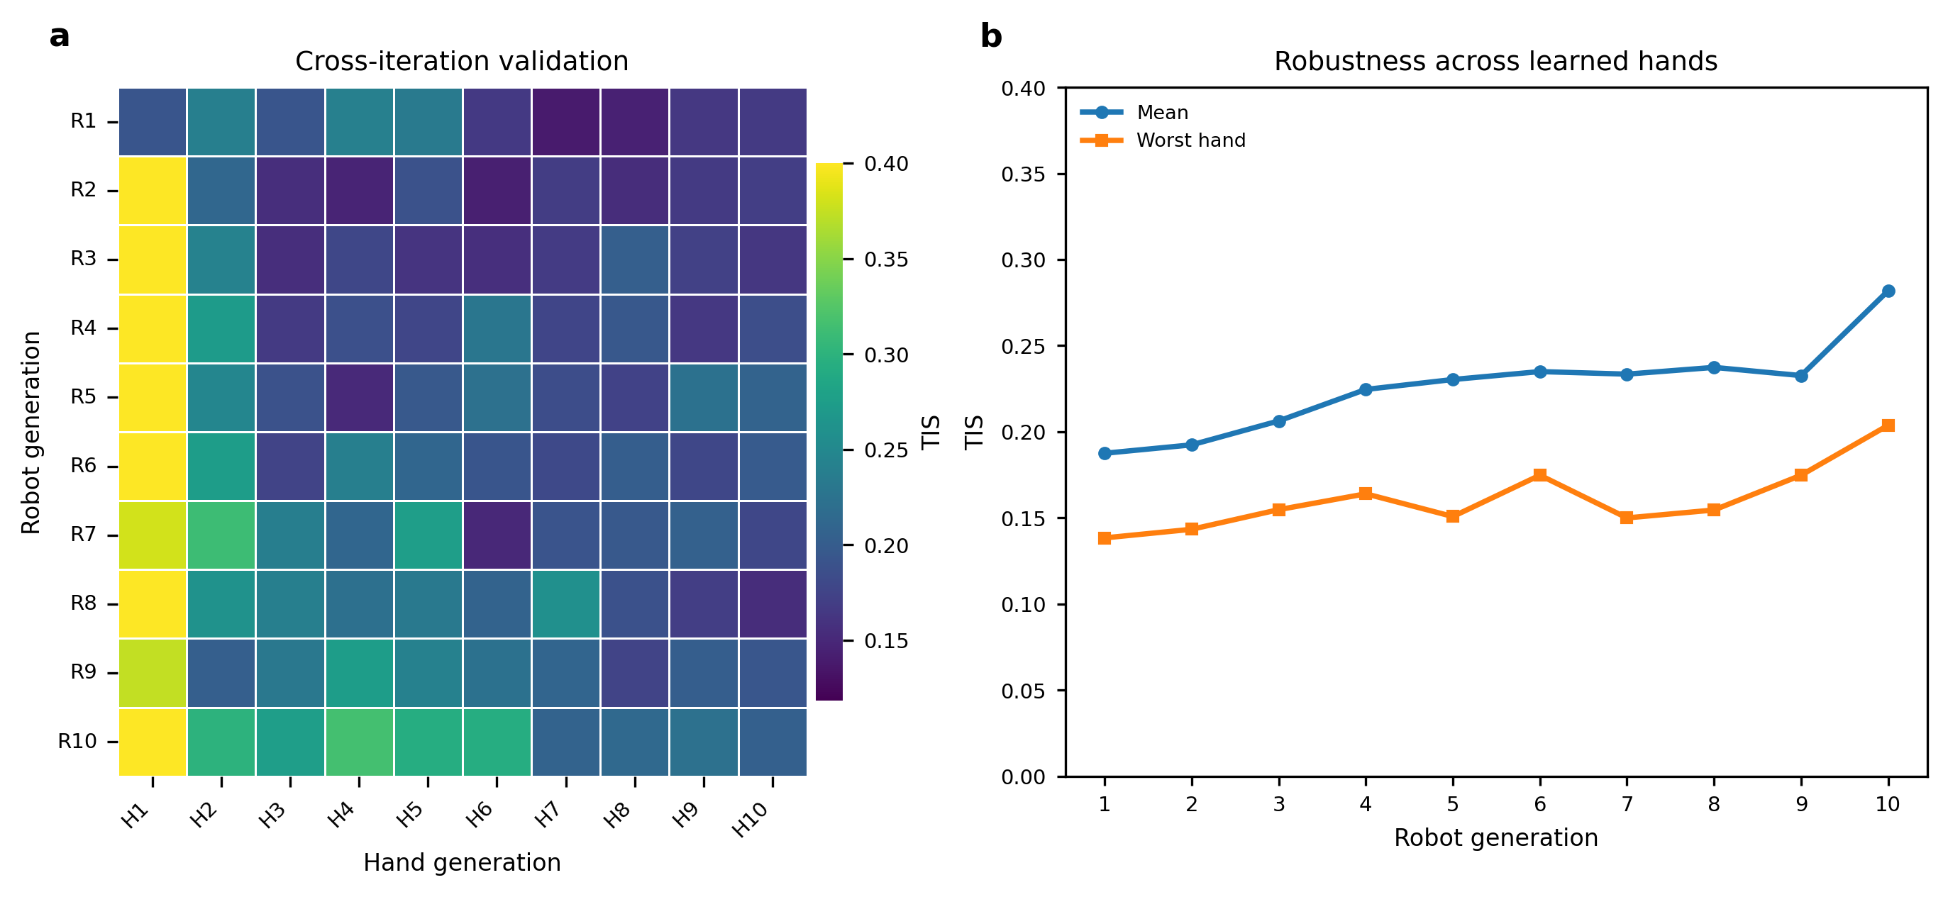
Fig. 3. Cross-generation evaluation of league-trained robot policies within the target ZPD band. (a) TIZ matrix for each robot generation evaluated against each learned hand generation. Rows denote robot generations, and columns denote learned hand generations. (b) Mean TIZ and lowest TIZ across learned hand test policies for each robot generation.
Table II complements Fig. 3 with a controlled comparison across representative pursuit conditions. The comparison includes the reactive APF baseline, the SPC-only baseline, the single-opponent baseline, and the final league policy. These policies are evaluated under scripted pursuit, learned-hand pursuit, and manual mouse pursuit. The learned-hand condition uses H1, which is the hand policy obtained after the first hand-training phase of the league procedure. The same H1 checkpoint is used for all learned robot policies, and it also serves as the sole training opponent for the single-opponent baseline. For the automated SPC and H1 conditions, results are reported as the mean ± sample standard deviation over 20 independently seeded evaluation trials, with 1000 episodes per trial. The APF baseline was evaluated only in simulation, so its manual-mouse entry is left blank. In the manual mouse condition, human operators pursued the simulated microrobot through the mouse interface. The resulting pursuit commands passed through the same motor-execution layer used for virtual hands. This condition introduces human reaction time and voluntary pursuit behavior under bounded execution dynamics, so it is treated as a human-in-the-loop stress test rather than clinical validation. Higher TIZ and longer episodes indicate that difficulty regulation was sustained for a larger portion of the interaction.
TABLE II: POLICY COMPARISON ACROSS THREE PURSUIT CONDITIONS
Robot policy | Pursuit condition | TIZ | Episode length (steps)
Reactive APF | SPC | 0.089 ± 0.001 | 18.7 ± 0.2
Reactive APF | Learned hand H1 | 0.170 ± 0.006 | 34.0 ± 0.9
Reactive APF | Manual mouse | — | —
SPC-only baseline | SPC | 0.295 ± 0.008 | 51.0 ± 1.2
SPC-only baseline | Learned hand H1 | 0.146 ± 0.006 | 23.7 ± 0.9
SPC-only baseline | Manual mouse | 0.14 ± 0.03 | 33 ± 9
Single-opponent baseline | SPC | 0.107 ± 0.003 | 24.9 ± 0.6
Single-opponent baseline | Learned hand H1 | 0.398 ± 0.007 | 63.4 ± 1.1
Single-opponent baseline | Manual mouse | 0.19 ± 0.05 | 40 ± 11
League policy | SPC | 0.349 ± 0.010 | 59.3 ± 1.3
League policy | Learned hand H1 | 0.358 ± 0.012 | 49.8 ± 1.4
League policy | Manual mouse | 0.49 ± 0.09 | 74 ± 13

The reactive APF controller serves as a non-learning geometric reference and performs poorly under direct scripted pursuit. The SPC-only baseline improves performance under scripted pursuit but remains weak against H1. In contrast, the single-opponent baseline performs best against its H1 training opponent but transfers poorly to SPC pursuit. The league policy avoids this narrow specialization. It achieves the strongest automated SPC result and remains competitive against H1, although it does not exceed the single-opponent baseline on the matched H1 condition. These results indicate that training against a broader distribution of hand policies produces more consistent difficulty regulation across scripted, learned, and human-controlled pursuit behaviors.

C. Network Ablation and Auxiliary Dynamics Analysis
The league results address the diversity of hand behaviors used during training. The network ablation then tests whether the robot policy can use temporal information about hand motion under this training setting. The MLP baseline uses only the instantaneous geometric state. The GRU policy adds a 16-frame history of relative displacement, and the auxiliary GRU adds the dynamics prediction head described in Section III.B. The training curves in Fig. 4(a) and Fig. 4(b) show that temporal history improves optimization and interaction persistence. The GRU policies reach higher episode reward and longer episode length than the MLP baseline, indicating that current geometry alone is insufficient for stable difficulty regulation when hand motion changes over time. The auxiliary GRU gives the strongest training curve, suggesting that the prediction loss helps the recurrent stream form a more useful motion representation.
The auxiliary prediction examples in Fig. 4(c) provide a qualitative check of the learned motion representation. The predicted short-horizon displacement generally follows the direction and curvature of the observed future hand motion, rather than merely reconstructing the current position. The normalized final metrics in Fig. 4(d) show how these representation changes affect control performance. Recurrent history increases TIZ and workspace coverage relative to the MLP baseline. The auxiliary prediction objective further improves these metrics and reduces mean jerk. Overall, the ablation indicates that temporal hand history and auxiliary dynamics prediction contribute to smoother and more reliable difficulty regulation.
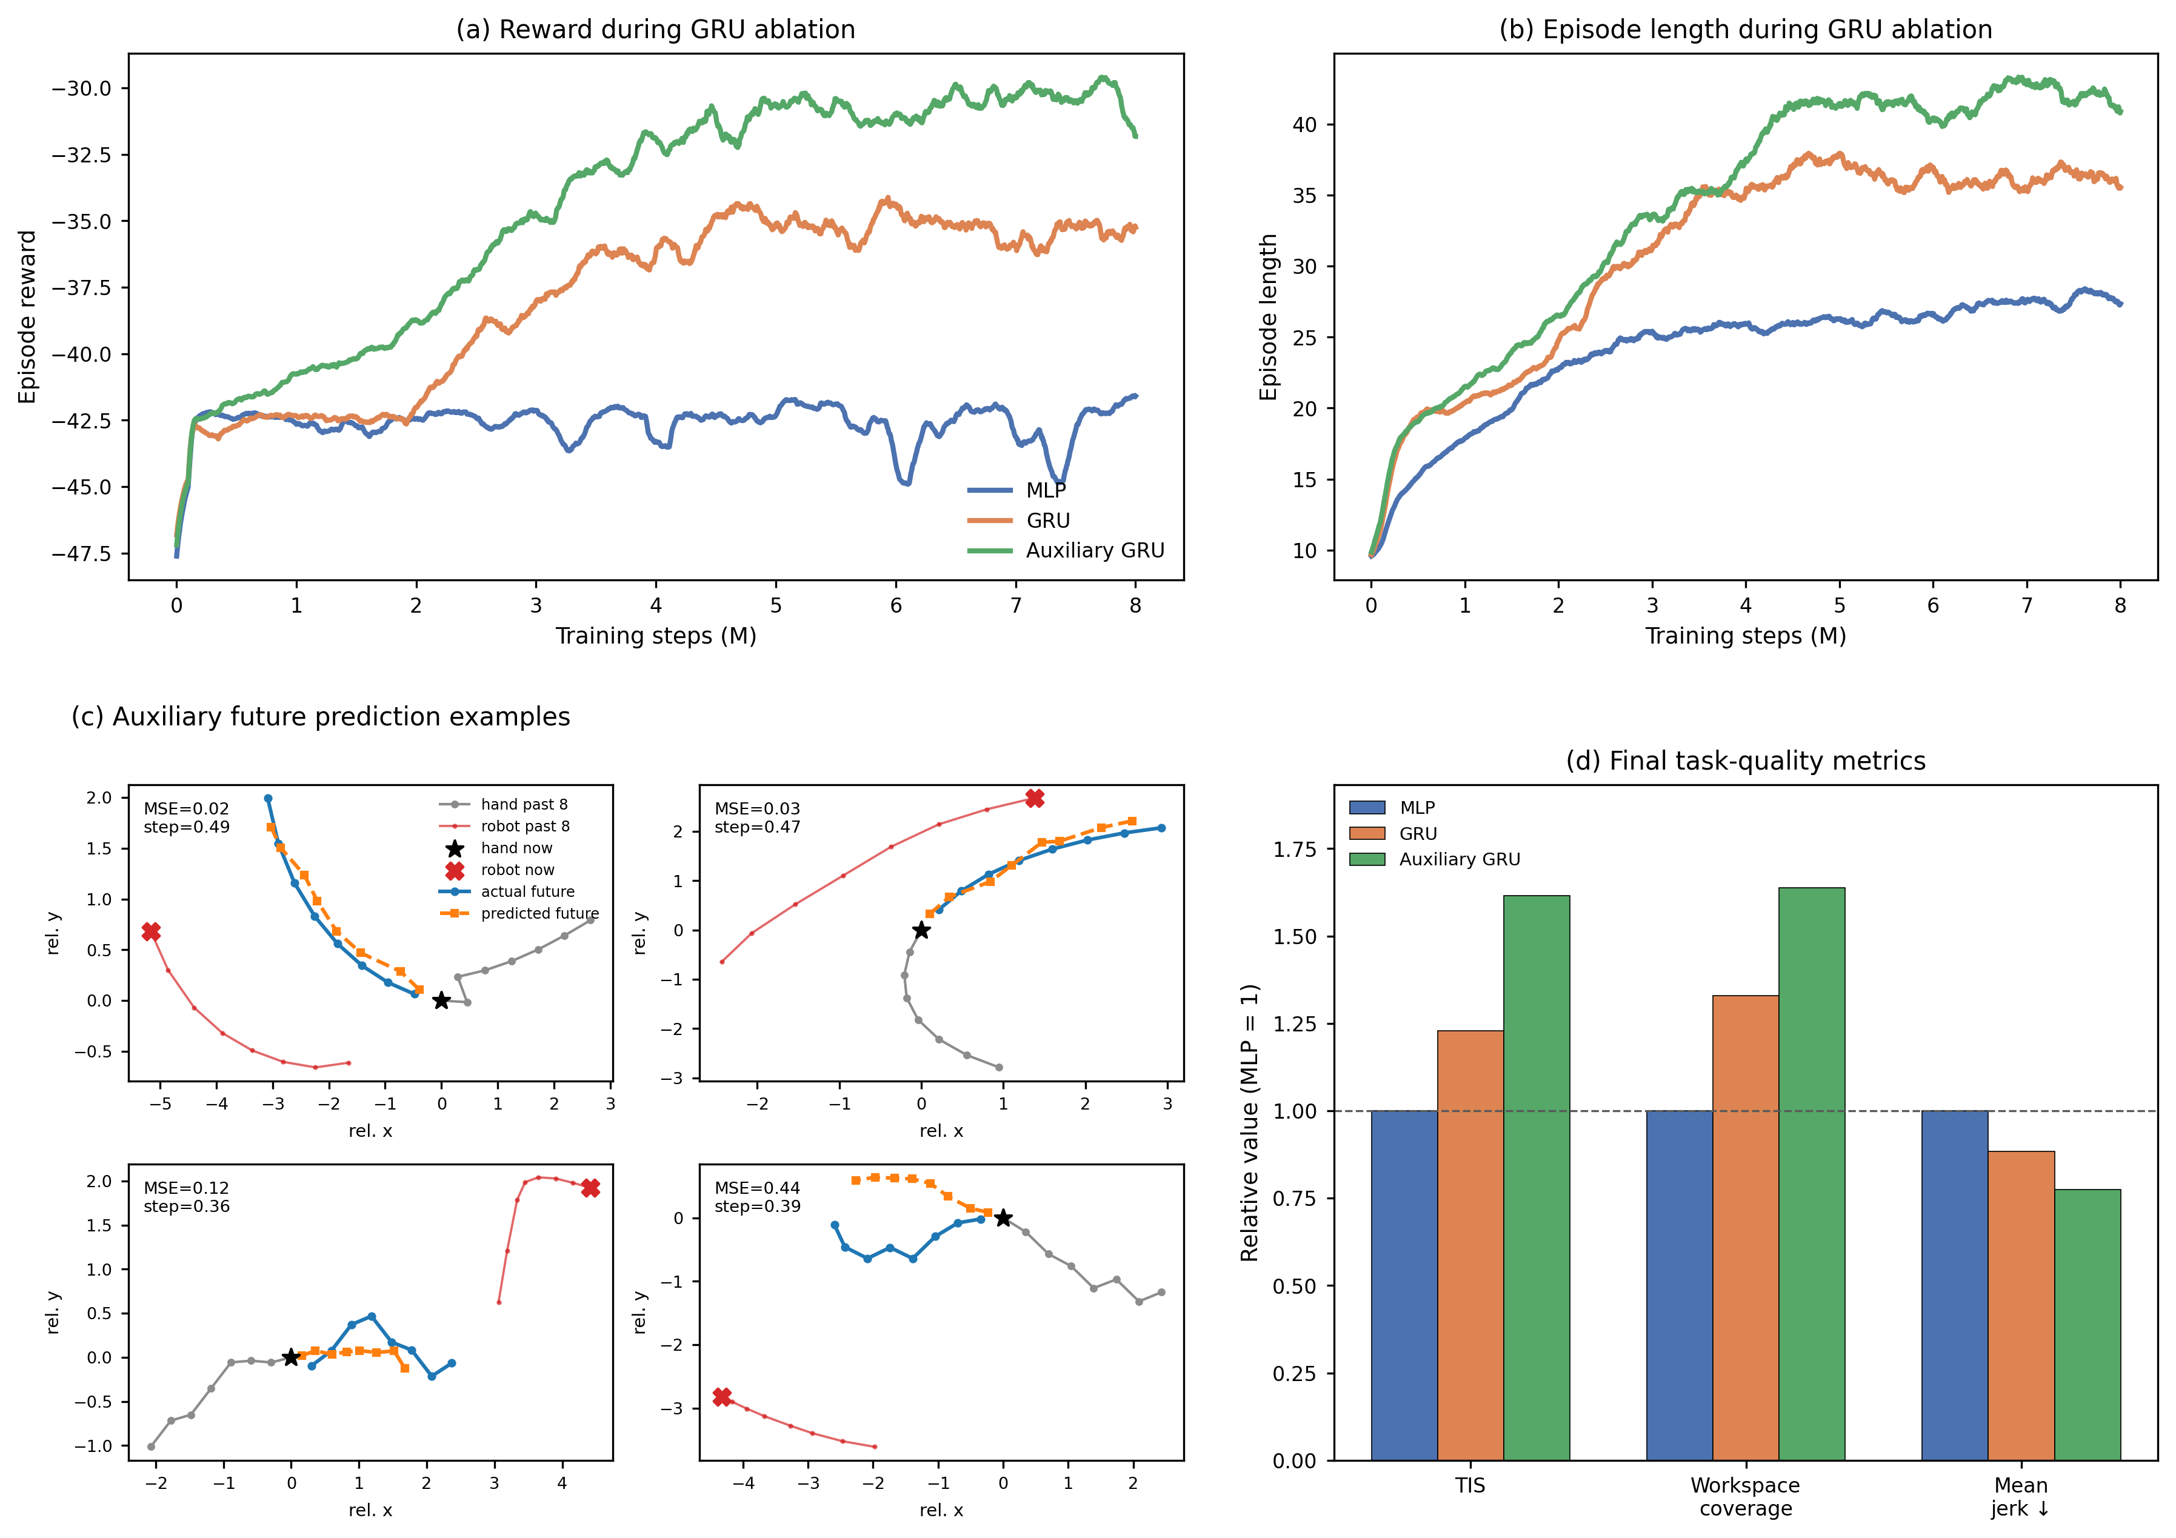
Fig. 4. Network ablation for temporal encoding and auxiliary dynamics prediction. (a) Smoothed episode reward during training for the MLP, GRU, and auxiliary GRU policies. (b) Smoothed episode length during training for the same policies. (c) Representative predictions from the auxiliary head over a short horizon compared with observed future hand motion. (d) Final performance metrics normalized to the MLP baseline; higher values are better for TIZ and workspace coverage, whereas lower values are better for mean jerk.

D. Online Physical Deployment
To evaluate zero-shot transfer with real hand input, the simulation-trained policy was deployed on the physical microrobot platform without additional training. During pilot deployment, human pursuit input was tracked across the acrylic workspace while the robotic arm moved the magnetic actuator beneath the surface. Physical rollouts were recorded during the deployment experiment. Camera observations and robot commands were processed online, allowing the policy to regulate microrobot motion under continuous feedback.
The deployment system retained the observation structure used in simulation. Calibrated camera measurements provided the hand and microrobot positions, while workspace-boundary features, the previously executed robot command, and the recent history of relative hand displacement completed the policy input defined in (6) and (7). Robot state measurements were used only for command execution and system monitoring and were not included in the policy observation. The perception pipeline combined YOLO-based microrobot detection [48], MediaPipe Hands tracking [49], camera calibration, and a planar homography that mapped image coordinates to the workspace [50]. When hand tracking was briefly interrupted, the controller extrapolated hand motion from the most recent velocity estimate. Safety was enforced through workspace limits, bounded command increments, automatic stopping after capture, controlled stopping during shutdown or interruption, and a hardware emergency stop.
Fig. 5 shows a representative zero-shot rollout with image frames and motion traces aligned in time. During steady pursuit, the hand-microrobot distance remains near the target ZPD band. A sharp increase in hand speed briefly reduces the separation below the target range. The policy responds by increasing microrobot speed, and the distance returns to the ZPD band over the following seconds. When the hand later slows, microrobot speed decreases accordingly and the separation again approaches the target range. Similar coupled responses appear throughout the rollout, showing that the policy adjusts microrobot motion to changes in pursuit dynamics rather than applying a fixed-speed escape command. The final decrease in distance corresponds to capture and episode termination. Overall, the rollout shows online adaptation to abrupt changes in hand motion and recovery toward the intended interaction range after transient deviations.
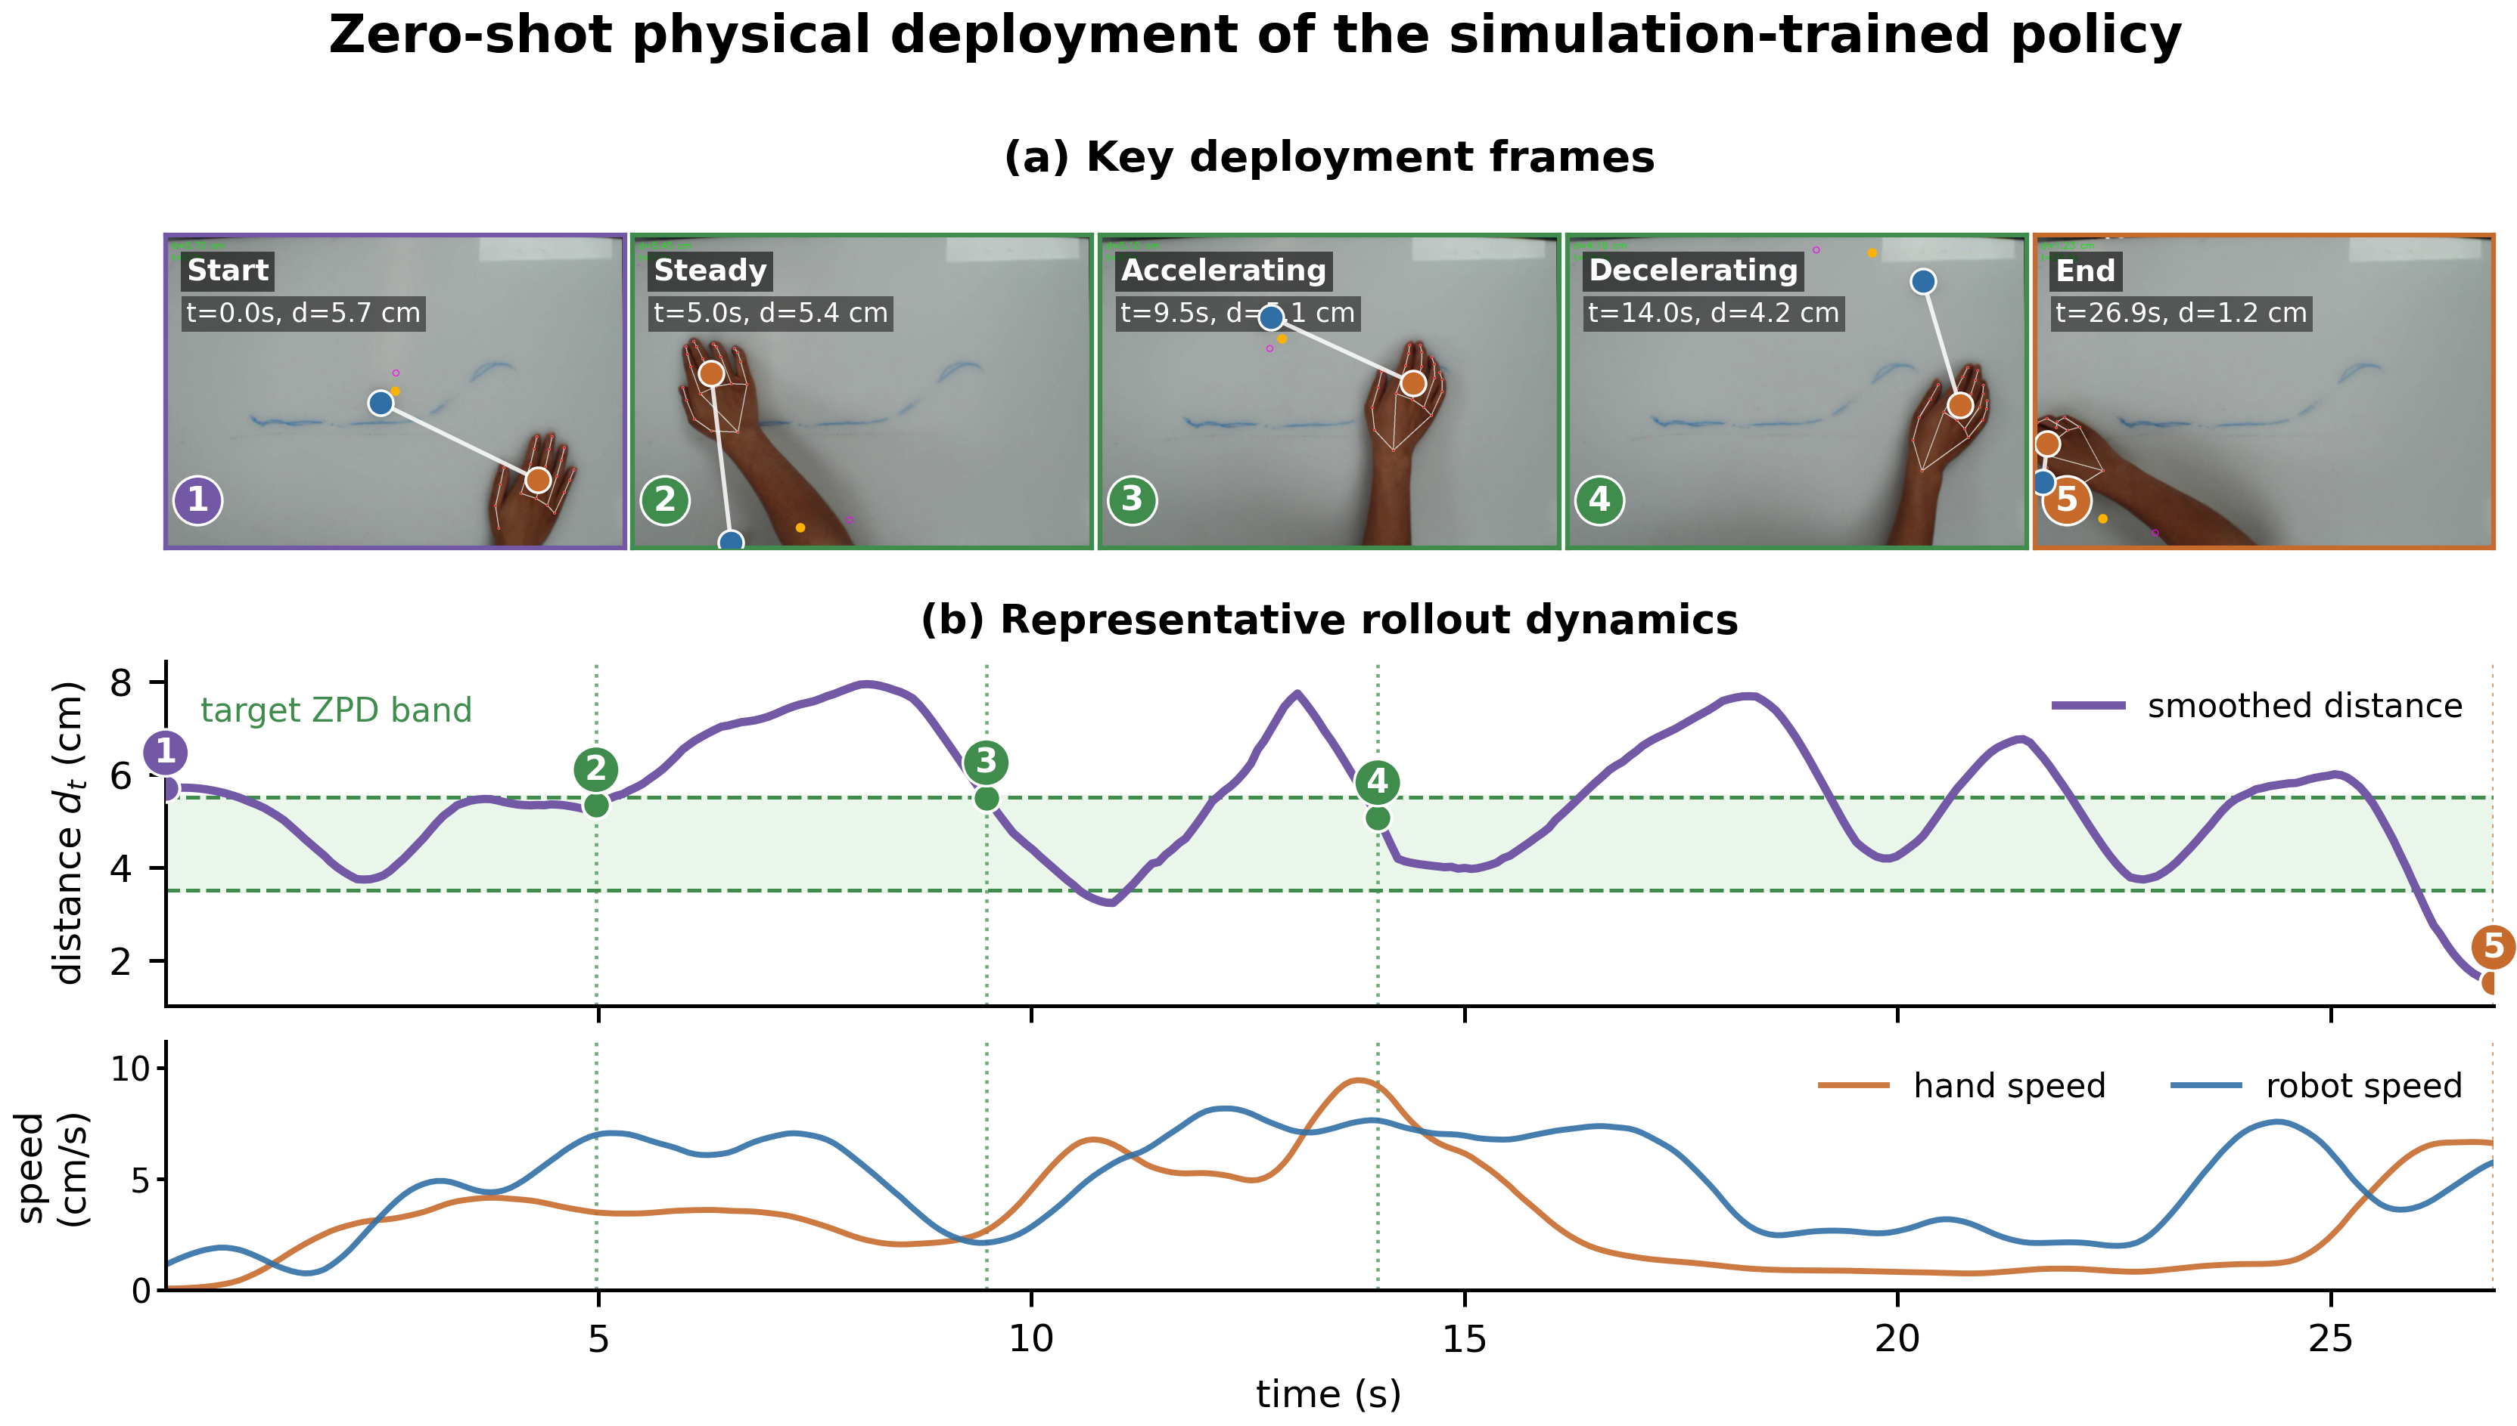
Fig. 5. Zero-shot physical deployment on the microrobot platform. (a) Representative frames from a physical rollout. (b) Smoothed hand-microrobot distance, target ZPD band, and measured hand and microrobot speeds from the same rollout.

V. DISCUSSION
In the proposed platform, task difficulty comes from target motion rather than direct mechanical assistance to the limb. The controller therefore has to adjust the pursuit challenge while keeping the microrobot reachable. The results suggest that this regulation depends on information at two scales. Within an episode, recent relative motion helps the policy infer how the hand-microrobot interaction is evolving. Across training, exposure to diverse pursuit strategies and execution styles reduces dependence on a single hand policy. The ablation results support the first role, and the league experiments support the second. Zero-shot deployment further shows that the learned policy can run through the physical vision-control loop and adjust target motion in response to measured changes in hand speed. Taken together, the results support adaptive target motion as a feasible way to regulate a noncontact physical task. However, the current evidence is limited to control robustness, online responsiveness, and system feasibility.
At the same hand-microrobot distance, the appropriate robot action can depend on the preceding motion. The hand may be accelerating toward the target, recovering after a failed approach, changing direction, or responding after a delay. These cases are difficult to distinguish from the instantaneous geometric state alone. Encoding recent relative displacement gives the policy access to motion direction and short-term interaction trends. This role is consistent with the ablation results. TIZ increased from 0.161 for the MLP baseline to 0.197 with the GRU and to 0.259 when auxiliary dynamics prediction was added. Workspace coverage followed the same trend, and mean jerk decreased [51]. The auxiliary objective appears to strengthen the temporal representation by encouraging the shared encoder to retain information useful for short-horizon hand-motion prediction. Prediction itself is not the control objective. Instead, it provides an additional training signal for learning motion features that support difficulty regulation. Policy performance remains the main criterion, because accurate motion prediction alone does not guarantee effective regulation of task difficulty [40]–[43].
Variability also arises from differences among pursuit behaviors. The scripted controller mainly produces direct pursuit, whereas learned hand policies can develop interception-oriented responses. Separating strategy generation from motor execution expands this variation through inertia, motion-change limits, observation noise, and delay. League training widens the strategy distribution further by adding new hand policies while retaining earlier ones in the pool. Performance across generations was not strictly monotonic, reflecting shifts in the training distribution as robot and hand optimization alternated. Even with these fluctuations, mean TIZ across learned hands increased from 0.188 for the first robot generation to 0.282 for the final generation. The lowest score across learned hands also increased from 0.138 to 0.204. Comparisons across individual conditions show the same pattern. A robot trained against a single learned hand performed well against the matched opponent but degraded under scripted pursuit. In contrast, the league-trained policy remained more balanced across scripted, learned, and manual pursuit. The main benefit of league training is therefore reduced specialization, rather than the highest score against any single behavior [44]–[47].
Deployment on the physical platform introduced measurement noise, brief tracking losses, communication delay, actuator dynamics, calibration error, and uncertainty in the magnetic drive [35]–[39]. The experiment evaluated the policy within the full physical loop, from overhead tracking and coordinate transformation to temporal-observation construction, policy inference, Cartesian command transmission, and magnetic actuation. Short gaps in hand detection were handled by extrapolating the most recent hand state from its estimated velocity, rather than pausing control immediately. Physical rollouts were completed without further policy training. In the representative rollout, a rapid increase in hand speed first reduced the distance to the microrobot. The robot then sped up, moving the distance back toward the target ZPD band. When the hand later slowed down, the microrobot slowed as well. This paired response suggests that the deployed policy was not simply executing a fixed escape behavior at constant speed. However, the experiment provides only preliminary evidence of online responsiveness and zero-shot closed-loop operation. It does not establish clinical safety, therapeutic value, or superiority over other rehabilitation interfaces.
Several factors limit the generalizability of these findings. One limitation concerns the simulated hand-execution model. Inertia, motion limits, observation noise, and delay were represented through simplified processes rather than parameters measured from people with motor impairment. This design broadens the training distribution, but it does not constitute a biomechanical or neurological model of a patient population. Future versions could estimate motor-execution distributions from recorded trajectories and include impairment-relevant features such as asymmetric movement range, tremor, intermittent control, fatigue-related slowing, and variable visuomotor delay. A second limitation concerns difficulty calibration. The target ZPD band was chosen for the current desktop platform and kept fixed across simulation and deployment for consistency. A clinically meaningful band would need session-level personalization based on impairment severity, reachable workspace, movement speed, response delay, fatigue, and therapeutic goal. Clinician input could define the initial safe range, while online adaptation could adjust the band according to recent TIZ, catch frequency, boundary events, recovery after speed changes, and fatigue-related slowing. The hardware also remains a proof-of-concept platform. The robotic arm provides accurate and flexible actuation for validating the control framework, but its size, cost, and installation requirements limit routine use in hospitals or community rehabilitation settings. A practical system would need a smaller actuation mechanism and tighter integration of the camera, computing unit, magnetic drive, and tabletop workspace. Finally, the physical evaluation was designed to test closed-loop feasibility rather than clinical efficacy. The current results therefore cannot establish engagement, motor learning, functional recovery, or clinical benefit [2], [7], [11], [15], [16].
The path toward clinical evaluation requires a tighter link between control performance, device design, and user-specific calibration. On the control side, repeated physical sessions need to test whether the policy can recover after sudden changes in hand speed, remain stable during brief tracking losses, avoid workspace boundaries, and preserve smooth target motion across different users. These tests would provide a clearer basis for calibrating the target ZPD band from recorded hand trajectories, including each user’s reachable workspace and typical movement speed. On the hardware side, the current robotic arm prototype remains useful for validating the control framework, but routine rehabilitation use requires a compact magnetic drive integrated with the tabletop, camera, and controller. Once the platform can deliver stable adaptive target motion in a deployable form, patient studies can compare this approach with fixed-speed target motion or therapist-selected difficulty under matched tasks. Those studies need to examine repeated-session tolerance, fatigue, engagement, movement quality, and task performance over time. Such evidence would determine whether the control robustness shown here can translate into measurable rehabilitation benefit.

VI. CONCLUSION
This paper presented an end-to-end reinforcement learning framework for adaptive difficulty regulation in a magnetically actuated upper-limb pursuit task. Decoupled randomization separates pursuit intent from motor execution, the dual-stream encoder combines current geometry with recent hand motion, auxiliary prediction shapes the temporal representation, and iterative league training exposes the robot to a growing population of pursuit policies. The final league generation improved both mean and minimum TIZ across learned opponents and produced the most balanced results across scripted, learned, and manual pursuit.
Zero-shot deployment on the physical microrobot platform further showed that the simulation-trained policy can operate online with vision-based hand input and respond to changing pursuit speed. The framework therefore provides a basis for noncontact, data-driven rehabilitation tasks whose difficulty is regulated through interaction rather than fixed trajectories. Patient-calibrated ZPD settings and broader physical evaluation are the next steps toward clinical validation.

REFERENCES
[1] GBD 2019 Stroke Collaborators, “Global, regional, and national burden of stroke and its risk factors, 1990–2019: a systematic analysis for the Global Burden of Disease Study 2019,” The Lancet Neurology, vol. 20, no. 10, pp. 795–820, 2021.
[2] C. M. Stinear, C. E. Lang, S. Zeiler, and W. D. Byblow, “Advances and challenges in stroke rehabilitation,” The Lancet Neurology, vol. 19, no. 4, pp. 348–360, 2020.
[3] M. Maier, B. Rubio Ballester, and P. F. M. J. Verschure, “Principles of neurorehabilitation after stroke based on motor learning and brain plasticity mechanisms,” Frontiers in Systems Neuroscience, vol. 13, art. 74, 2019.
[4] C.-Y. Lee and T.-H. Howe, “Effectiveness of activity-based task-oriented training on upper extremity recovery for adults with stroke: A systematic review,” American Journal of Occupational Therapy, vol. 78, no. 2, art. 7802180070, 2024.
[5] S. G. Rozevink, J. M. Hijmans, K. A. Horstink, and C. K. van der Sluis, “Effectiveness of task-specific training using assistive devices and task-specific usual care on upper limb performance after stroke: A systematic review and meta-analysis,” Disability and Rehabilitation: Assistive Technology, vol. 18, no. 7, pp. 1245–1258, 2023.
[6] M. A. Guadagnoli and T. D. Lee, “Challenge point: A framework for conceptualizing the effects of various practice conditions in motor learning,” Journal of Motor Behavior, vol. 36, no. 2, pp. 212–224, 2004.
[7] E. Gomes, G. Alder, F. A. S. Bright, and N. Signal, “Understanding task ‘challenge’ in stroke rehabilitation: An interdisciplinary concept analysis,” Disability and Rehabilitation, vol. 47, no. 3, pp. 560–570, 2025.
[8] J. Mehrholz, M. Pohl, T. Platz, J. Kugler, and B. Elsner, “Electromechanical and robot-assisted arm training for improving activities of daily living, arm function, and arm muscle strength after stroke,” Cochrane Database of Systematic Reviews, no. 9, art. CD006876, 2018.
[9] H. Rodgers et al., “Robot assisted training for the upper limb after stroke (RATULS): A multicentre randomised controlled trial,” The Lancet, vol. 394, no. 10192, pp. 51–62, 2019.
[10] T. Su, M. Wang, Z. Chen, and L. Feng, “Effect of upper robot-assisted training on upper limb motor, daily life activities, and muscular tone in patients with stroke: A systematic review and meta-analysis,” Brain and Behavior, vol. 14, no. 11, art. e70117, 2024.
[11] K. Boardsworth et al., “Upper limb robotic rehabilitation following stroke: A systematic review and meta-analysis investigating efficacy and the influence of device features and program parameters,” Journal of NeuroEngineering and Rehabilitation, vol. 22, art. 164, 2025.
[12] H. Wang, X. Wu, Y. Li, and S. Yu, “Efficacy of robot-assisted training on upper limb motor function after stroke: A systematic review and network meta-analysis,” Archives of Rehabilitation Research and Clinical Translation, vol. 7, no. 1, art. 100387, 2025.
[13] Q. Ai, Z. Liu, W. Meng, Q. Liu, and S. Q. Xie, “Machine learning in robot-assisted upper limb rehabilitation: A focused review,” IEEE Transactions on Cognitive and Developmental Systems, vol. 15, no. 4, pp. 2053–2063, 2023.
[14] I. Doumas, G. Everard, S. Dehem, and T. Lejeune, “Serious games for upper limb rehabilitation after stroke: A meta-analysis,” Journal of NeuroEngineering and Rehabilitation, vol. 18, art. 100, 2021.
[15] C. D. Kenea, T. G. Abessa, D. Lamba, and B. Bonnechère, “Immersive virtual reality in stroke rehabilitation: A systematic review and meta-analysis of its efficacy in upper limb recovery,” Journal of Clinical Medicine, vol. 14, no. 6, art. 1783, 2025.
[16] A. Al Tawil et al., “Machine learning-based adaptive personalization in virtual reality stroke rehabilitation: A systematic review,” Frontiers in Rehabilitation Sciences, vol. 7, art. 1827658, 2026.
[17] A. P. Arantes, N. Bressan, L. R. Borges, and C. A. McGibbon, “Evaluation of a novel real-time adaptive assist-as-needed controller for robot-assisted upper extremity rehabilitation following stroke,” PLOS ONE, vol. 18, no. 10, art. e0292627, 2023.
[18] M. Sitti et al., “Biomedical applications of untethered mobile milli/microrobots,” Proceedings of the IEEE, vol. 103, no. 2, pp. 205–224, 2015.
[19] Z. Yang and L. Zhang, “Magnetic actuation systems for miniature robots: A review,” Advanced Intelligent Systems, vol. 2, no. 9, art. 2000082, 2020.
[20] J. Miao and S. Sun, “Design, actuation, and functionalization of untethered soft magnetic robots with life-like motions: A review,” Journal of Magnetism and Magnetic Materials, vol. 586, art. 171160, 2023.
[21] L. S. Vygotsky, Mind in Society: The Development of Higher Psychological Processes. Cambridge, MA, USA: Harvard University Press, 1978.
[22] N. Hocine, A. Gouaïch, S. A. Cerri, D. Mottet, J. Froger, and I. Laffont, “Adaptation in serious games for upper-limb rehabilitation: An approach to improve training outcomes,” User Modeling and User-Adapted Interaction, vol. 25, pp. 65–98, 2015.
[23] Y. Shang, S. Bahrami, S. Gaardsmoe, A. Johnson, M. J. Johnson, and P. Diefenbach, “General purpose haptic/biometric-based dynamic difficulty adjustment for post-stroke upper-limb rehabilitation games,” in Proc. IEEE International Conference on Rehabilitation Robotics (ICORR), 2025, pp. 248–253.
[24] O. S. Ajani and R. Mallipeddi, “Pareto-based dynamic difficulty adjustment of a competitive exergame for arm rehabilitation,” International Journal of Human-Computer Studies, vol. 178, art. 103100, 2023.
[25] L. Víteková, C. Eichhorn, J. Pirker, and D. A. Plecher, “Dynamic difficulty adjustment in serious games: A literature review,” Information, vol. 17, no. 1, art. 96, 2026.
[26] R. S. Sutton and A. G. Barto, Reinforcement Learning: An Introduction, 2nd ed. Cambridge, MA, USA: MIT Press, 2018.
[27] J. Kober, J. A. Bagnell, and J. Peters, “Reinforcement learning in robotics: A survey,” The International Journal of Robotics Research, vol. 32, no. 11, pp. 1238–1274, 2013.
[28] J. Schulman, F. Wolski, P. Dhariwal, A. Radford, and O. Klimov, “Proximal policy optimization algorithms,” arXiv:1707.06347, 2017.
[29] R. Molle, C. Tamantini, C. Lauretti, E. M. Romano, and L. Zollo, “An online reinforcement learning method to improve control adaptability in robot-aided rehabilitation,” Engineering Applications of Artificial Intelligence, vol. 161, art. 112248, 2025.
[30] S. Pareek, H. Nisar, and T. Kesavadas, “AR3n: A reinforcement learning-based assist-as-needed controller for robotic rehabilitation,” IEEE Robotics & Automation Magazine, vol. 31, no. 3, pp. 74–82, 2024.
[31] Y. Zhang, S. Li, K. J. Nolan, and D. Zanotto, “Shaping individualized impedance landscapes for gait training via reinforcement learning,” IEEE Transactions on Medical Robotics and Bionics, vol. 4, no. 1, pp. 194–205, 2022.
[32] A. D. Pelosi, N. Roth, T. Yehoshua, D. Itah, O. Braun Benyamin, and A. Dahan, “Personalized rehabilitation approach for reaching movement using reinforcement learning,” Scientific Reports, vol. 14, art. 17675, 2024.
[33] O. Khatib, “Real-time obstacle avoidance for manipulators and mobile robots,” The International Journal of Robotics Research, vol. 5, no. 1, pp. 90–98, 1986.
[34] H. J. Lee, M.-S. Kim, and M. C. Lee, “Path planning based on artificial potential field with an enhanced virtual hill algorithm,” Applied Sciences, vol. 14, no. 18, art. 8292, 2024.
[35] J. Tobin et al., “Domain randomization for transferring deep neural networks from simulation to the real world,” in Proc. IEEE/RSJ International Conference on Intelligent Robots and Systems (IROS), 2017, pp. 23–30.
[36] X. B. Peng, M. Andrychowicz, W. Zaremba, and P. Abbeel, “Sim-to-real transfer of robotic control with dynamics randomization,” in Proc. IEEE International Conference on Robotics and Automation (ICRA), 2018, pp. 3803–3810.
[37] F. Muratore, F. Ramos, G. Turk, W. Yu, M. Gienger, and J. Peters, “Robot learning from randomized simulations: A review,” Frontiers in Robotics and AI, vol. 9, art. 799893, 2022.
[38] Y. Chebotar et al., “Closing the sim-to-real loop: Adapting simulation randomization with real world experience,” in Proc. IEEE International Conference on Robotics and Automation (ICRA), 2019, pp. 8973–8979.
[39] G. Tiboni, K. Arndt, and V. Kyrki, “DROPO: Sim-to-real transfer with offline domain randomization,” Robotics and Autonomous Systems, vol. 166, art. 104432, 2023.
[40] K. Cho et al., “Learning phrase representations using RNN encoder–decoder for statistical machine translation,” in Proc. Conference on Empirical Methods in Natural Language Processing (EMNLP), 2014, pp. 1724–1734.
[41] M. Jaderberg et al., “Reinforcement learning with unsupervised auxiliary tasks,” in Proc. International Conference on Learning Representations (ICLR), 2017.
[42] M. Schwarzer, A. Anand, R. Goel, R. D. Hjelm, A. Courville, and P. Bachman, “Data-efficient reinforcement learning with self-predictive representations,” in Proc. International Conference on Learning Representations (ICLR), 2021.
[43] D. Pathak, P. Agrawal, A. A. Efros, and T. Darrell, “Curiosity-driven exploration by self-supervised prediction,” in Proc. International Conference on Machine Learning (ICML), 2017, pp. 2778–2787.
[44] M. Lanctot et al., “A unified game-theoretic approach to multiagent reinforcement learning,” in Advances in Neural Information Processing Systems, vol. 30, 2017.
[45] O. Vinyals et al., “Grandmaster level in StarCraft II using multi-agent reinforcement learning,” Nature, vol. 575, pp. 350–354, 2019.
[46] M. Jaderberg et al., “Human-level performance in 3D multiplayer games with population-based reinforcement learning,” Science, vol. 364, no. 6443, pp. 859–865, 2019.
[47] R. Huang, X. Wu, H. Yu, Z. Fan, H. Fu, Q. Fu, and W. Yang, “A robust and opponent-aware league training method for StarCraft II,” in Advances in Neural Information Processing Systems, vol. 36, 2023.
[48] J. Redmon, S. Divvala, R. Girshick, and A. Farhadi, “You only look once: Unified, real-time object detection,” in Proc. IEEE Conference on Computer Vision and Pattern Recognition (CVPR), 2016, pp. 779–788.
[49] F. Zhang et al., “MediaPipe Hands: On-device real-time hand tracking,” arXiv:2006.10214, 2020.
[50] Z. Zhang, “A flexible new technique for camera calibration,” IEEE Transactions on Pattern Analysis and Machine Intelligence, vol. 22, no. 11, pp. 1330–1334, 2000.
[51] S. Balasubramanian et al., “On the analysis of movement smoothness,” Journal of NeuroEngineering and Rehabilitation, vol. 12, art. 112, 2015.

