Whitelisting Checklist

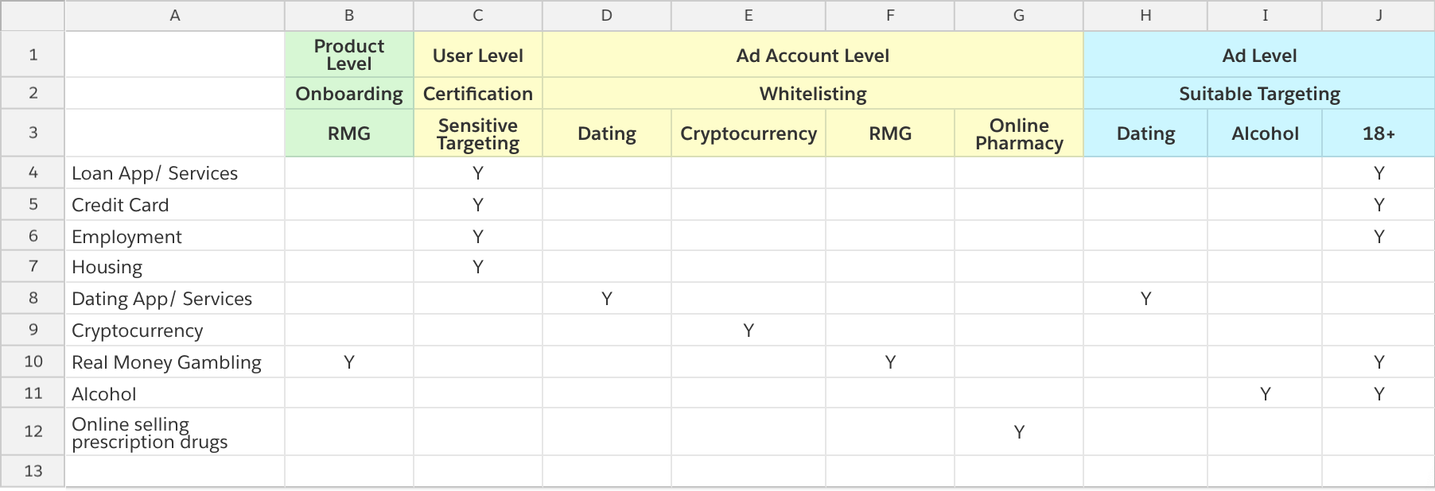

Certification - Sensitive Targeting
*Previously it was on ad account level, now changed to user level
Users placing HEC (Housing, Employment, Credit) ads must certify themselves for Sensitive Targeting
https://www.facebook.com/certification/nondiscrimination/

Whitelisting - Dating
Client needs to fill out our Facebook Blueprint Non-Disclosure Agreement for dating advertising first NDA.pdf

1. https://www.facebook.com/help/contact/1060028634014002/?ref=u2u

*This CF is open to external, advertiser/ reseller/ planning agency can fill the form
**Sales or CS can also help

Whitelisting - Cryptocurrency
https://www.facebook.com/help/contact/532535307141067
*This CF is open to external, advertiser/ reseller/ planning agency can fill the form
**Sales or CS can also help

Whitelisting - RMG
https://www.facebook.com/help/contact/839680462710872
*This CF is open to external, advertiser/ reseller/ planning agency can fill the form
**Sales or CS can also help

Whitelisting - Online Pharmacy
- Website URL
- Ad account ID
- Targeting country and age

Onboarding - RMG
Please note that each on-boarding is undertaken only for specific domains and regions.
https://www.facebook.com/help/contact/691814950897009/?ref=u2u
*This CF is open to external, advertiser/ reseller/ planning agency can fill the form
**Sales or CS can also help

Suitable Targeting - Dating
Follow Help Center instructions https://www.facebook.com/business/help/143949649021372

Suitable Targeting - Alcohol
Follow external policy targeting requirements https://www.facebook.com/policies/ads/restricted_content/alcohol

