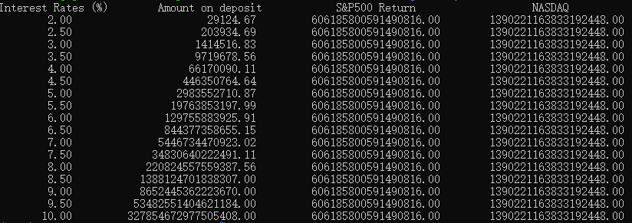

When the interest rate is above 5%, the interest rate on the deposit is much higher than the current value of the Mona Lisa painting.When the deposit rate is 10%, the difference with the S&P500 or NASDAQ rate is less than 0.5%, but the difference in investment returns is very large.So it's a very good investment.