Sample Answers for Problem Set 1

Problem 1.

(a) The nominal GDPs for 2018, 2019, and 2020 are

,
,
.

The real GDPs for 2018, 2019, and 2020 are

,
,
.

(b) The GDP deflators in 2019 and 2020 are

,

.

The Consumer Price Indexes in 2019 and 2020 are

,

.

Then the inflation rates in 2019 and 202 are

,

.

(c)

(d) inflation

Problem 2.

Write 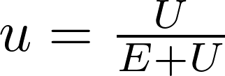 and 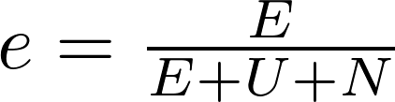, where E denotes the number of the employed, U denotes the number of the unemployed, and N denotes the number of those out of the labor force. Then the labor-force participation rate is

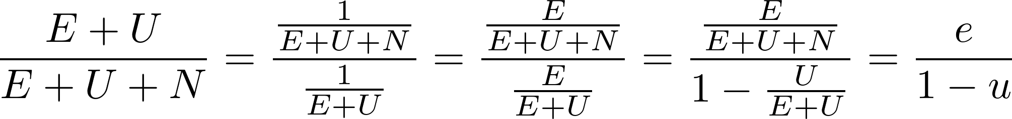.

Problem 3.

 | Most recent year  (2019) | Your birth year  ( 1989 ) | Start of “Post-War Period”  (1956)
Nominal GDP | $21,427,690 million | $5,641,580 million | $449,353 million
Real GDP | $19,073,056 million | $9,192,134 million | $2,932,388 million
Population | 328,527,000 | 247,387,000 | 168,221,000
Nominal GDP per capita (GDP / Population) | $65,224 | $22,805 | $2,671
Real GDP per capita  (GDP / Population) | $58,056 | $37,157 | $17,432
Implied Deflator  (Nominal GDP per capita / Real GDP per capita * 100) | 1.1234 | 0.6137 | 0.1532

