Sample Answers for Problem Set 2 Problem 2

(a) The total output Y of soybeans is the value of the production function F with , , and . Then

.

The marginal product of capital (MPK) is the additional output when the capital stock increases by one unit. That is,

Similarly, the marginal product of labor (MPL) is the additional output when the labor force increases by one unit. That is,

Alternatively, the exact MPK and exact MPL are given as

,

.

(b) When markets for factors of production (capital and labor) are competitive, their prices are equal to the marginal products. Thus, the rental price (R) of capital is equal to the marginal product of capital, 4/3. Similarly, the wage (W) is equal to the marginal product of labor, 1/3. Then
,
.
Thus, the total income is the capital income plus the labor income, which is 4,000 soybeans. Therefore, all output of soybeans are distributed to capital or labor income.

(c) Observe the consumption equation:

.

The equation means that households consume 500 soybeans if they have zero disposable income, 500.5 soybeans if they have 1 disposable income, 501 soybeans if they have 2 disposable income, and so on. Thus the marginal propensity to consume is one half.

By plugging in the values of Y and T, we have

.

By the expenditure approach, . Thus, the equilibrium requires

,

Equivalently,

,

meaning that the equilibrium interest rate  is 2 percent. Then the investment is . The consumption is 2300.

(d) The government budget is in surplus as . Under this tax, the investment is

,

which is smaller than before. Additionally, investment also is  in equilibrium, so the equilibrium real interest rate is

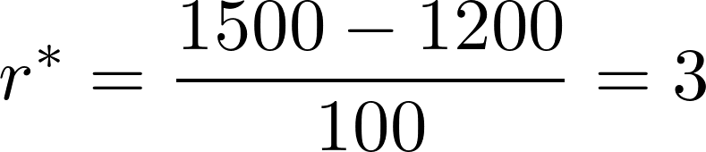 percent,

which is higher than before. The investment falls to . The consumption rises to . The intuition behind these results is that reduced taxation increases people's consumption and reduces the saving. The reduction in saving reduces the supply of loanable funds and drives up the price of borrowing for investment. The private saving is , larger than before. The public saving is , smaller than before.
In summary, a reduction in taxation as part of the COVID-19 stimulus package raises the real interest rate by 1 percentage point, lowers the investment by 100, raises the consumption by 100, lowers the national saving by 100, raises the private saving by 100, and lowers the public saving by 200.

(e) Let's use the new consumption function and do the same analysis as before. Under , the equilibrium condition is

,

which yields 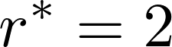 percent, , , , , and 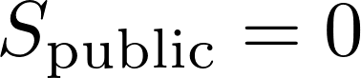. Under , the equilibrium condition is

,

which yields 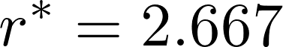 percent, 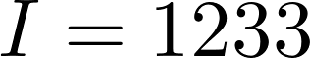, .
Therefore, the effect of the tax reduction under the new consumption function is to raise the real interest rate by 0.667 percentage point, lower the investment by 67, raise the consumption by 67, lower the national saving by 67, raise the private saving by 133, and lower the public saving by 200.
From this result, we see that the effects on the real interest rate, investment and consumption are smaller under the new consumption function. The effect on private saving is larger. The intuitive reason is that, under the new consumption function, people also care about the real interest rate when they make consumption decisions: higher interest rates discourage consumption. As a result, even as the tax falls and consumption increases, the fall in savings and the resulting rise in the real interest rate dampens the effect on consumption. The dampened effect on consumption makes the reduction in the saving smaller, dampening the effect on investment as well. Because the increase in consumption is not as large, the effect on private saving is larger than before.

