Sample Answers for Problem Set 1

Problem 1.

(a) The nominal GDPs for 2018, 2019, and 2020 are

,
,
.

The real GDPs for 2018, 2019, and 2020 are

,
,
.

(b) The GDP deflators in 2019 and 2020 are

,

.

The Consumer Price Indexes in 2019 and 2020 are

,

.

Then the inflation rates in 2019 and 202 are

,

.

(c)

(d) inflation

Problem 2.

Write 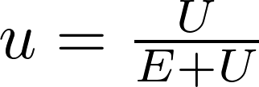 and 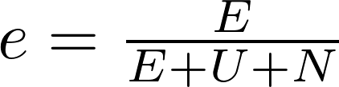, where E denotes the number of the employed, U denotes the number of the unemployed, and N denotes the number of those out of the labor force. Then the labor-force participation rate is

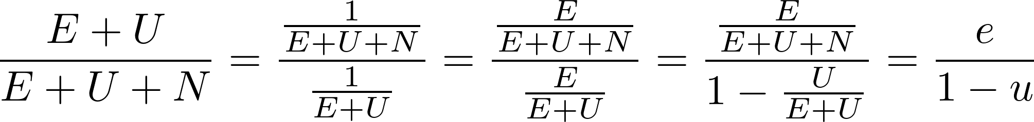.

Problem 3.
Real GDP: https://fred.stlouisfed.org/release/tables?rid=53&eid=41074#snid=41075
Nominal GDP:
https://fred.stlouisfed.org/release/tables?rid=53&eid=41047#snid=41048
Population: https://fred.stlouisfed.org/series/B230RC0A052NBEA

 | Most recent year  (2019) | Your birth year  ( 1989 ) | Start of “Post-War Period”  (1956)
Nominal GDP | $21372582 million | $5641580 million | $449353 million
Real GDP | $19032672 million | $9197997 million | $2934391 million
Population | 330513000 | 247387000 | 168221000
Nominal GDP per capita (GDP / Population) | $64664.88 | $22804.67 | $2671.21
Real GDP per capita  (GDP / Population) | $57585.24 | $37180.60 | $17443.67
Implied Deflator  (Nominal GDP per capita / Real GDP per capita * 100) | 112.29 | 61.33 | 15.31

