**Dynamic Webpage Design Midterm Project**

1. Functions of your project

* User can add/delete/edit notes and also they can marked the notes is processing/ completed or deleted.
* The Add/Edit/Delete function You can use click or button to build up these functions
* Show the selected note title and its detail of this note.
* The “Status” & “Brief Content” of all the notes
  + - Status include **Processing** Notes, **Completed** Notes and **Deleted** Notes
    - Brief Content contains the title, first line of the content and the updated time of each note

1. Flowchart of your project，mapping function(s) of each process (as detail as possible)

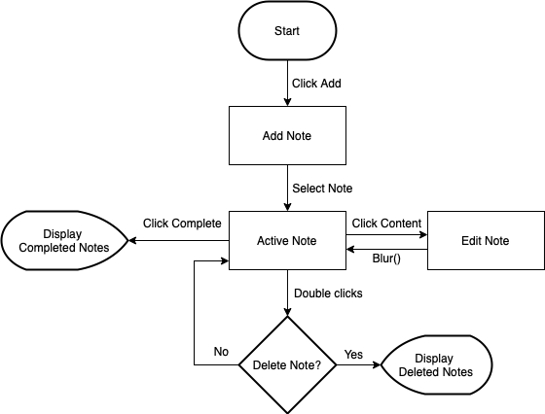

1. Other functions

* A button (garbage can) which can clear all notes.

1. Feedback/Advise for this course

感想就是覺得這門課真的很棒，上課速度可能對初學的人有點快，例如我，但這也是優點，因為一學期下來會覺得非常充實。而且課程都有錄影，每次進度有不懂的地方會回去看第二遍，作業的部分現在好像平均二週一次，老師也會提供程式碼讓學生自由發揮，讓我這種初學和對於設計沒有想法的人來說更容易上手。