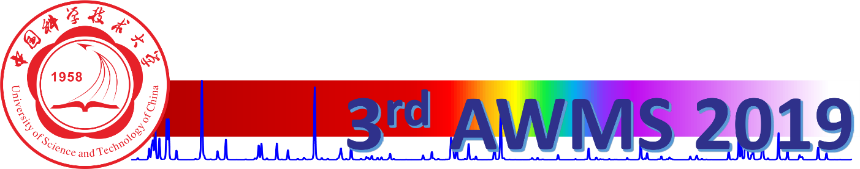

# AWMS 2019

The 3rd Asian Workshop on Molecular Spectroscopy