Paleo TC: Examine the role of tropical cyclones in equable climates

Project overview:
During the Paleocene – Eocene, ~55 million years ago, the climate was much warmer. The equator to pole meridional temperature gradient was also much weaker than today, and it’s unclear what mechanisms provided sufficient heat fluxes to maintain this weak gradient. The weak gradient and the strong fluxes pose a paradox.
Tropical cyclones can induce strong mixing in the upper ocean, altering the upper ocean heat content and meridional heat transport, which tends to cool the equator and warm the high latitudes. Therefore, TCs are proposed as a potential explanation for the Eocene paradox.
In Li et al., 2023, we impose tropical cyclone winds extracted from high-resolution (25km) climate models to low-resolution (1 deg) models to examine the impact of TC wind forcing on the global climate. We find evidence of TCs’ modulation on SST, ocean circulation, heat transport etc. Here we aim to apply the same methodology to Eocene climate to investigate the role of tropical cyclone wind forcings in equable climates.
We have a set of high-resolution(HR) Eocene simulations with 25km atmosphere and 0.1 degree ocean and a low-resolution counterpart (LR-cntl) with 1 deg atmosphere and 1 deg ocean. We will extract TC winds from HR and impose these TCs in another LR simulation, called LR-TC. Comparisons between LR-cntl and LR-TC would reveal the impact of TC winds on the global climate in low resolution model. Comparisons between LR-TC and HR would reveal how much of the difference between these two resolutions are owing to TCs’ impact.

Methodology overview
From Li et al., 2023:
“To explore the impacts of transient TC winds within the coupled system, we designed an experiment where we extract TC winds from HR and prescribe the corresponding TC wind stress into the coupled low-resolution model. This low-resolution model with added TC wind forcing is branched from the 101th year of LR-cntl and is named LR-TC. In otherwords, LR-TC is the same as LR-cntl except for the added TC wind forcing. Comparing LR-TC and LR-cntl would therefore reveal the impact of TC winds on the coupled climate. LR-TC is designed to mimic the TC–ocean interactions in HR, so that the results can help us infer how the model’s self-generated TCs in HR can inherently impact the simulated climate.”
“TC tracking and TC wind extraction: We use the TempestExtremes tracking algorithm to detect and track TCs from 30 years of HR. TC tracking is applied to 3-hourly instantaneous model output and is based on warm core temperature, sea surface pressure, and near-surface wind speed. The tracked TC statistics are in general agreement with the observations. For each detected TC day, we take 20x20 deg snapshots of the atmospheric bottom-level wind surrounding each detected TC center and calculate the corresponding surface wind stress offline. The offline TC wind stress calculation is conducted on the ocean model grid (gx1v6) to be consistent with the default settings of the fully coupled configuration. The TC wind stress snapshots are then used to create a 30-yr-long TC wind stress inventory, which preserves the timings and locations of each TC exactly as in the HR.”
“Prescribing TC forcing into LR-TC: The TC wind stress inventory is then used to prescribe TC wind forcing into the low-resolution (1˚ atmosphere) coupled model to formulate the LR-TC. TC wind stress snapshots are added to the model’s coupler component as the model integrates forward in time: At each coupling time step, the model checks for any TC snapshot in the TC wind inventory with the same timestamp; if one exists, the corresponding 20˚ x 20 ˚snapshot of TC wind stress is added to the model’s coupler, while the rest of the global wind stress is unaffected. We chose the 20 ° × 20 ° snapshot domain, larger than the typical sizes, to cover the background wind stress at the periphery of TCs to achieve a smooth blending. Despite having different atmosphere resolutions, the HR and LR-TC share the same ocean model grid. Adding localized, transient TC wind stress into the model’s coupler allows the ocean model in LR-TC to perceive TC winds the same way as in the HR. The choice of the coupling grid may affect the surface fluxes under TCs (Zarzycki et al. 2016). For consistency, all the atmosphere–ocean fluxes (surface wind stress, sensible and latent heat fluxes) in HR and LR-TC are calculated on the ocean grid. LR-TC also uses the same default daily coupling frequency as in HR and LR-cntl, meaning that the ocean receives the impact of TC winds once every 24 during which the surface fluxes are held fixed. Since the prescribed TCs are added directly to the model’s coupler as surface wind stress, the atmospheric winds are unaffected, and the initial forcing does not modify the bulk aerodynamic fluxes (i.e., latent heat and sensible heat). The impact of TC wind stress is first perceived by the ocean while hidden to the atmosphere. As a result, the model does not account for the thermodynamic coupling processes during TC genesis and development, which involve strong convection and rapid heat extraction from the warm sea surface; rather, it captures the two-way air–sea coupling in response to TC wind forcing. In other words, this model experiment differs from the real world as it focuses on the response of the coupled climate system to wind forcing from mature storms, rather than the entire TC life cycle. In addition, since the TC winds are added as external forcings, the prestorm environmental condi-tions (such as SST) and the prescribed TC winds do not neces-sarily match exactly. For example, the local environmentalconditions in the LR-TC may not be particularly conducive toTCs at the exact time and location when TC winds are pre-scribed. Rather, the relationship is climatologically sound(i.e., the prescribed TCs have realistic TC seasons when theSST is warmer).”

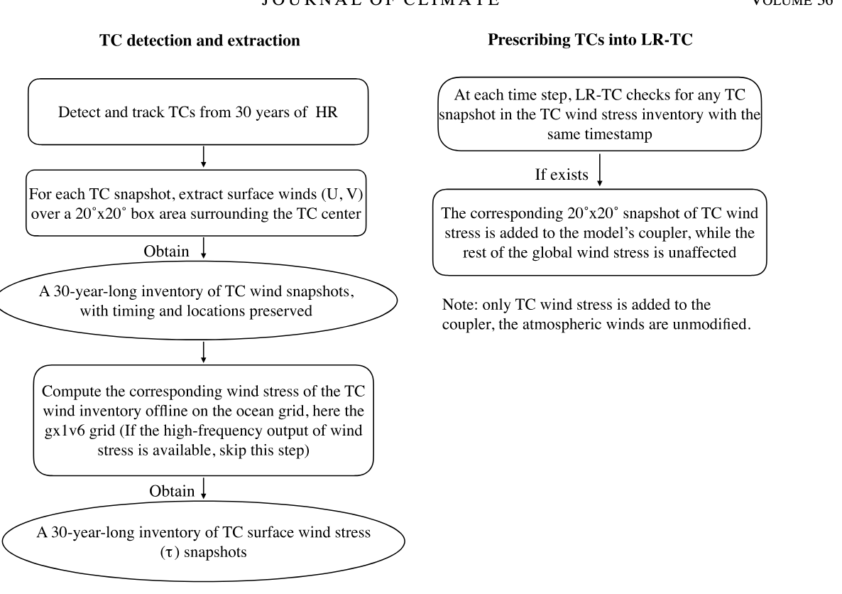

Reference code and notes from Li et al., 2023
- “extract_tcbot_origrid.ncl”: to extract UBOT, VBOT, and U10 under TCs from the 3-hr model output, for a single year. TC location, time, and other information is read in from a track file created by TempestExtreme tracking software.
- “extract_tcbot_batch.ncl” is written to run parallel for different years, used together with “sub-batch.sh”
- “get_tau_dask.ipynb” are used to calculate TAUX and TAUY based on the bottom wind files.
- “get_tau_dask.ipynb” calculates wind stress based on the CESMs source code. The source code is in “shr_flux_mod.F90” under csm_share/
  - Shr_flux_atmOcn: use ubot, vbot, zbot, us, vs, ts, to output taux, tauy, evap, etc.

!------------------------------------------------------------
! first estimate of Z/L and ustar, tstar and qstar
!------------------------------------------------------------

!--- neutral coefficients, z/L = 0.0 ---
stable = 0.5_R8 + sign(0.5_R8 , delt)
vmag = max(umin, sqrt( (ubot(n)-us(n))**2 + (vbot(n)-vs(n))**2) )

rdn = sqrt(cdn(vmag))
rhn = (1.0_R8-stable) * 0.0327_R8 + stable * 0.018_R8
ren = 0.0346_R8

!--- ustar, tstar, qstar ---
ustar = rdn * vmag
tstar = rhn * delt
qstar = ren * delq

!--- compute stability & evaluate all stability functions ---
hol = shr_const_karman*shr_const_g*zbot(n)* &
(tstar/thbot(n)+qstar/(1.0_R8/shr_const_zvir+qbot(n)))/ustar**2
hol = sign( min(abs(hol),10.0_R8), hol )
stable = 0.5_R8 + sign(0.5_R8 , hol)
xsq = max(sqrt(abs(1.0_R8 - 16.0_R8*hol)) , 1.0_R8)
xqq = sqrt(xsq)
psimh = -5.0_R8*hol*stable + (1.0_R8-stable)*psimhu(xqq)
psixh = -5.0_R8*hol*stable + (1.0_R8-stable)*psixhu(xqq)

!--- shift wind speed using old coefficient ---
rd = rdn / (1.0_R8 + rdn/shr_const_karman*(alz-psimh))
u10n = vmag * rd / rdn

!--- update transfer coeffs at 10m and neutral stability ---
rdn = sqrt(cdn(u10n))
ren = 0.0346_R8
rhn = (1.0_R8-stable)*0.0327_R8 + stable * 0.018_R8

!--- shift all coeffs to measurement height and stability ---
rd = rdn / (1.0_R8 + rdn/shr_const_karman*(alz-psimh))
rh = rhn / (1.0_R8 + rhn/shr_const_karman*(alz-psixh))
re = ren / (1.0_R8 + ren/shr_const_karman*(alz-psixh))

!--- update ustar, tstar, qstar using updated, shifted coeffs --
ustar = rd * vmag
tstar = rh * delt
qstar = re * delq

!------------------------------------------------------------
! iterate to converge on Z/L, ustar, tstar and qstar
!------------------------------------------------------------

!--- compute stability & evaluate all stability functions ---
hol = shr_const_karman*shr_const_g*zbot(n)* &
(tstar/thbot(n)+qstar/(1.0_R8/shr_const_zvir+qbot(n)))/ustar**2
hol = sign( min(abs(hol),10.0_R8), hol )
stable = 0.5_R8 + sign(0.5_R8 , hol)
xsq = max(sqrt(abs(1.0_R8 - 16.0_R8*hol)) , 1.0_R8)
xqq = sqrt(xsq)
psimh = -5.0_R8*hol*stable + (1.0_R8-stable)*psimhu(xqq)
psixh = -5.0_R8*hol*stable + (1.0_R8-stable)*psixhu(xqq)

!--- shift wind speed using old coeffs ---
rd = rdn / (1.0_R8 + rdn/shr_const_karman*(alz-psimh))
u10n = vmag * rd/rdn

!--- update transfer coeffs at 10m and neutral stability ---
rdn = sqrt(cdn(u10n))
ren = 0.0346_R8
rhn = (1.0_R8 - stable)*0.0327_R8 + stable * 0.018_R8

!--- shift all coeffs to measurement height and stability ---
rd = rdn / (1.0_R8 + rdn/shr_const_karman*(alz-psimh))
rh = rhn / (1.0_R8 + rhn/shr_const_karman*(alz-psixh))
re = ren / (1.0_R8 + ren/shr_const_karman*(alz-psixh))

!--- update ustar, tstar, qstar using updated, shifted coeffs ---
ustar = rd * vmag
tstar = rh * delt
qstar = re * delq

!------------------------------------------------------------
! compute the fluxes
!------------------------------------------------------------

tau = rbot(n) * ustar * ustar

!--- momentum flux ---
taux(n) = tau * (ubot(n)-us(n)) / vmag
tauy(n) = tau * (vbot(n)-vs(n)) / vmag

!--- heat flux ---
sen (n) = cp * tau * tstar / ustar
lat (n) = shr_const_latvap * tau * qstar / ustar
lwup(n) = -shr_const_stebol * ts(n)**4

!--- water flux ---
evap(n) = lat(n)/shr_const_latvap

!------------------------------------------------------------
! compute diagnositcs: 2m ref T & Q, 10m wind speed squared
!------------------------------------------------------------
hol = hol*ztref/zbot(n)
xsq = max( 1.0_R8, sqrt(abs(1.0_R8-16.0_R8*hol)) )
xqq = sqrt(xsq)
psix2 = -5.0_R8*hol*stable + (1.0_R8-stable)*psixhu(xqq)
fac = (rh/shr_const_karman) * (alz + al2 - psixh + psix2 )
tref(n) = thbot(n) - delt*fac
tref(n) = tref(n) - 0.01_R8*ztref ! pot temp to temp correction
fac = (re/shr_const_karman) * (alz + al2 - psixh + psix2 )
qref(n) = qbot(n) - delq*fac

duu10n(n) = u10n*u10n ! 10m wind speed squared

Tasks for Claude
- Overall goal is to build a nice project repo and clean workflow to extract TC winds, calculate wind stress, and organize the output.
- Write code for this project with the following requirements:
  - Rewrite the extract_tcbot_batch.ncl in Python and adapt the code for the Paleo simulations. Find a clean and efficient way for parallelization.
  - The 6-hourly model output for UBOT, VBOT, and U10 is located here: /glade/campaign/cesm/community/palwg/ASD_paleoWeather/b.e13.B1850C5.ne120_t12.icesm13_ihesp.eocene_03x.002/atm/proc/tseries/hour_6/
  - The TC track file containing track info for years 31-60 is here: /glade/campaign/cgd/ppc/brady/paleoweather/TCs/Eo3x/F3/tracks/TC_Eo3x.002_F3tracks_yrs31-60.txt

  - Check if get_tau_dask.ipynb correctly calculates the wind stress as the model source code.
  - Any suggestions to improve the code in get_tau_dask.ipynb to facilitate parallelization?

Other info
Paleo Case directory:
LR: /glade/u/home/jiangzhu/cesm/cases/b.e13.B1850C5.ne30_g16.icesm13_ihesp.eocene_03x.004
HR: /glade/campaign/cesm/development/palwg/paleoweather/runs/b.e13.B1850C5.ne120_t12.icesm13_ihesp.eocene_03x.002

References:
Zhu et al., : More equable past and future warm climates in unprecedented high-resolution simulations
Korty, R. L., Emanuel, K. A., & Scott, J. R. (2008). Tropical Cyclone–Induced Upper-Ocean Mixing and Climate: Application to Equable Climates, 21(4). https://doi.org/10.1175/2007jcli1659.1

