Installation of Copley Controllers in SPEC

Precondition:
Copley Controller TangoDS are running before openning SPEC.

Installation:
1. Install SPEC
2. Configuration in SPEC. In the initial configuration of SPEC, a file “site.mac” under “/usr/local/spec/lib” is needed. Put the macro controller programs under “/home/specadm/macros/”. Here 3 files are needed for copley controller: “spec_utils.mac”, “copley.mac” and “init.mac”.
3. Open SPEC using “/usr/local/spec/bin/spec”.

Add macro controllers and motors in SPEC:
1. use command “config” in spec. Set the motors and controllers here.
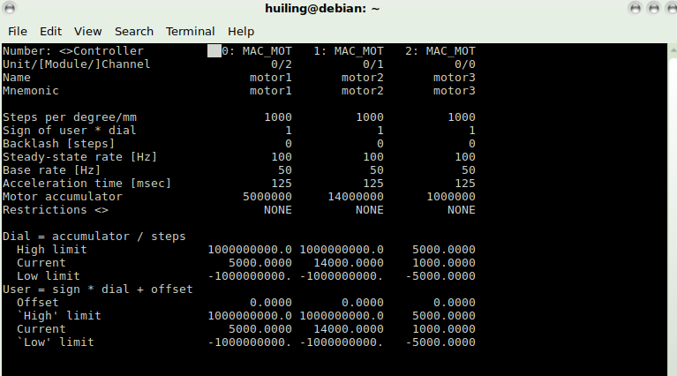
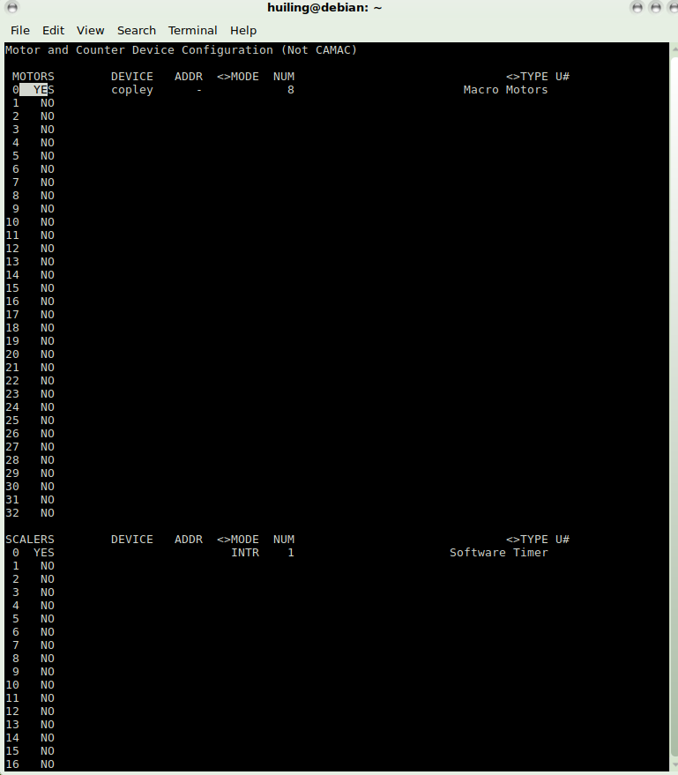
2. Define the motors to be connected with the Tango Device, then restart SPEC

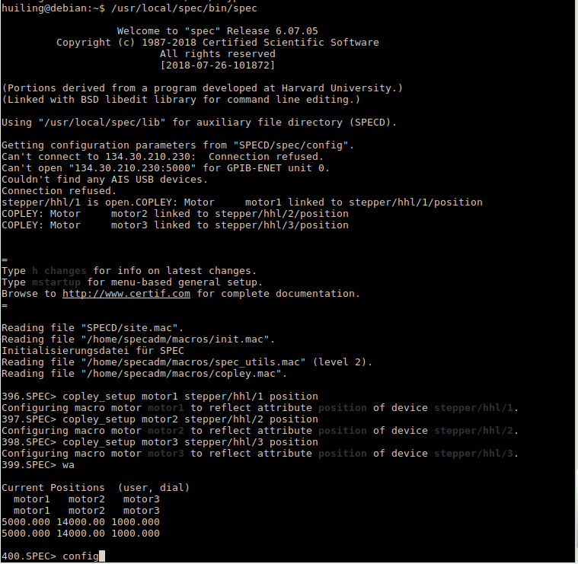

SPEC Manual
https://certif.com/spec_manual/idx.html

