Introduction of

CopleyControl Tango Device Server

Start the TangoDS

1. Download the files von my Git-hub repository
Terminal 1:

>>> git clone https://github.com/huilinghe19/CopleyControlProgramsHHL.git

2. Start PySerial Tango Device Server

Terminal 1:

>>> cd CopleyControlProgramsHHL

>>> python PySerial.py copleyCtrlSerialLine

(Note: copleyCtrlSerialLine is user-defined name.)

Terminal 2:

>>> jive

Add tango device “pyserial/copleyctrl/1” under the PySerial server in jive. (steps below)

3. Start CopleyControl Tango Device Server

Terminal 3:

>>> cd CopleyControlProgramsHHL
>>> python CopleyControl.py beamline
Add tango devices “stepper/hhl/1”, “stepper/hhl/2”, “stepper/hhl/3” in jive. (steps below)

Steps to add tango devices in jive:

1. Add Tango Devices based on the PySerial Tango DS

Make sure the PySerial Tango Device Server is opened at first, open jive.

In jive >> Tools >> Server Wizard >> Server Registration >> Server name: PySerial , Instance name: copleyCtrlSerialLine >> Start the server : Next (start the server again if the server is not started. For the first time, the registration must be done before the server starts)>> Class Selection : choose PySerial >> Declare device >> Device Name: pyserial/copleyctrl/1 >> Configuration done >> finish
The class is PySerial. Instance name is copleyCtrlSerialLine. The instance name is user-defined. The instance name must be as same as the instance name that the server PySerial starts with. Here the copleyCtrlSerialLine is an example. In the Attributes of the device pyserial/copleyctrl/1, check the Port, and set the Timeout as 1.

2. Add Tango Devices based on the CopleyControl Tango DS

Add the tango devices with jive. The node ID is the unique identification for a certain copley controller. Open Jive.
In jive >> Tools >> Server Wizard >> Server Registration >> Server name: CopleyControl , Instance name: beamline(This is what you start with) >> Start the server : Next (start the server again if the server is not started. For the first time, the registration must be done before the server starts) >> Class Selection : choose CopleyControl >> Declare device >> Device Name: stepper/hhl/1 (user-defined name)>> Property: ConnectedDeviceName: pyserial/copleyctrl/1 (the connected pyserial device name)>> Property: NodeId 0 (Here the stepper/hhl/1 is connected with Node ID 0. If the Node ID of the amplifier is different, then the Node Id must be different. ) >> Property: ReferenceVelocity 15001 (The default value must be changed so that it can be saved in Tango Database. For example 15000 must be changed to 15001 here) >> Property: DesiredState 31 ( 0=Disabled, 21 = Programmed Position Mode, Servo, 31 = Programmed Position Mode, Stepper ) >> Property: ReferenceAcceleration 200000 (The default value must be changed so that it can be saved in Tango Database. For example 200000 here) >> Property: ProfileType 256 (0 = Absolute move, trapezoidal profile. 1 = Absolute move, S-curve profile. 256 = Relative move, trapezoidal profile. 257 = Relative move, S-curve profile. 2 = Velocity move.) >> Property: ReferenceDeceleration 200000 (The default value must be changed so that it can be saved in Tango Database.) >> Configuration done>> finish

The connection with the PySerial Server and the CopleyControl tango devices is the name of the created tango device:”pyserial/copleyctrl/1”. The same name ”pyserial/copleyctrl/1” can not be given with any other tango devices in jive.

Restart the server
Restart the server, open jive and stepper/hhl/1 tango device exits in jive. Right-click on the device name “stepper/hhl/1”. Using “Test device” we can get the commands and attribute interface.

How to move the motors and set Home in Jive?

Move the motors

Define the software negative limit(such as -1000000) and software positive limit(such as 1000000), then the motor can be moved in this range. The motor position, acceleration, deceleration are defined in the amplifier ebene. The relevant values of the specific motor can be got in the server terminal. If the software limits are not set, the motor moves in open loop.
There are 2 methods to move the motor. One is using “Position”, the other one is using “SetPoint”. The Position is the target position in the amplifier ebene. Position = DialPosition * Conversion. The current position can be got by the Read of the Position attribute. When the target position is 3000, then Write 3000 in Position attribute, Then using the Command “Move”, the motor will move to the target position 3000. The 3000 Position must be in the range of the software limits if there are software limits.
For Relative Move(Profile Type 256, 257), the SetPoint is the position difference in the amplifier ebene. For example, the current position is 2000, we want to move the motor to 3000, so set the SetPoint as 1000, then “Move”, the motor will move to the 3000 Position.
For Absolute Move(Profile Type 0, 1), the SetPoint is target position in the amplifier ebene. For example, the current position is 2000, we want to move the motor to 3000, so set the SetPoint as 3000, then “Move”, the motor will move to the 3000 Position.
Profile Type can only be set as 0, 1, 256, 257 by the initialization of the Tango DS. Here is an example, which shows how to set the Position and SetPoint to move the motor to a certain position. If you are used to using setPoint or Position to move the motors, please don't change it. Using only one(either Position or SetPoint) can reduce confusion.
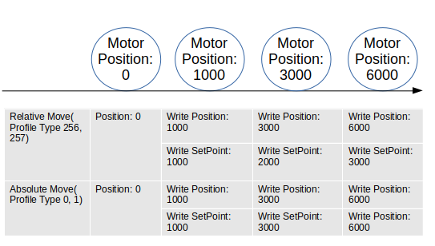

2. Home
The input of the HomingMethod can be one of the 29 home methods for the amplifier (See Page 39 in “ASCII_ProgrammersGuide.pdf”), Such as 512, 513, 514, 529.
For example, move the motor to a expected home position, make sure this location is the future home location, set the HomingMethod as 512, then MoveHome. Then this location is the home location(0 position location). Once home is done, it is better not to change it for a certain motor in practical.

Some Screenshots

Start the PySerial TangoDS:
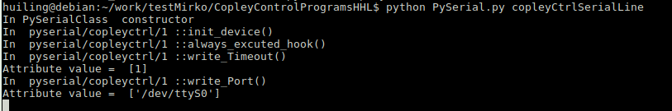

Start the CopleyControl TangoDS
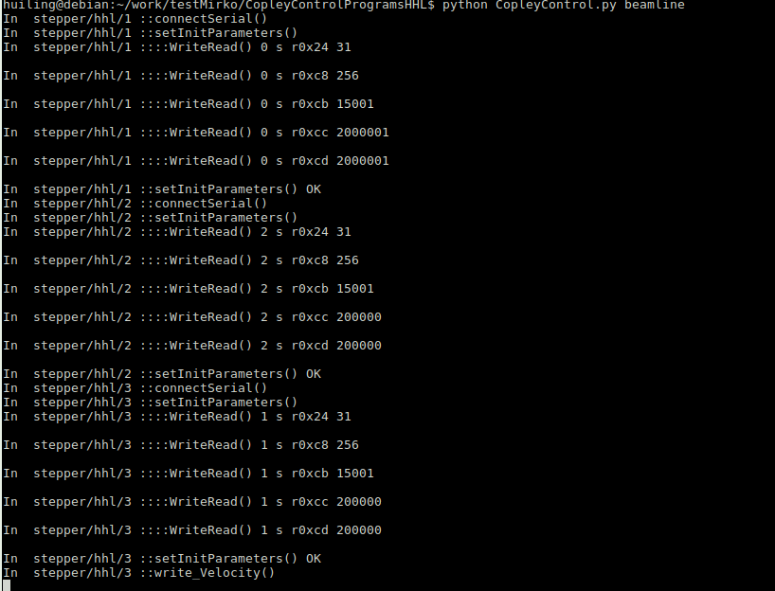

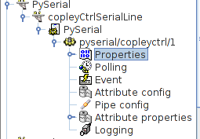
PySerial TangoDS in jive:

CopleyControl TangoDS in jive:
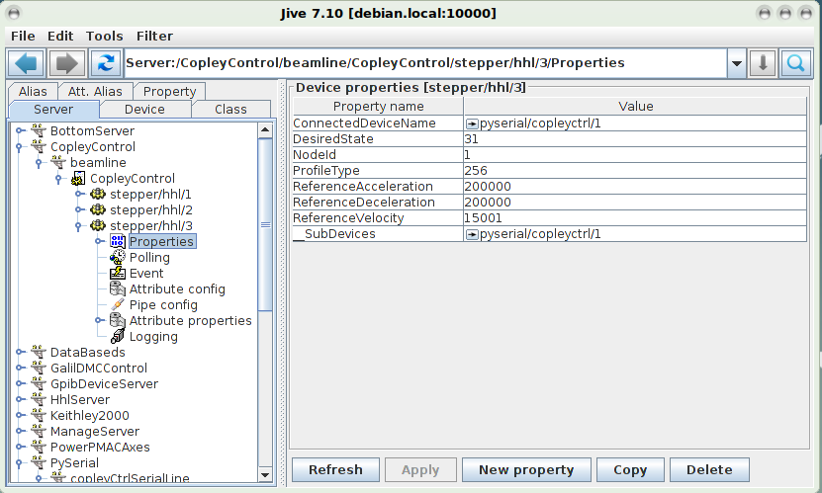

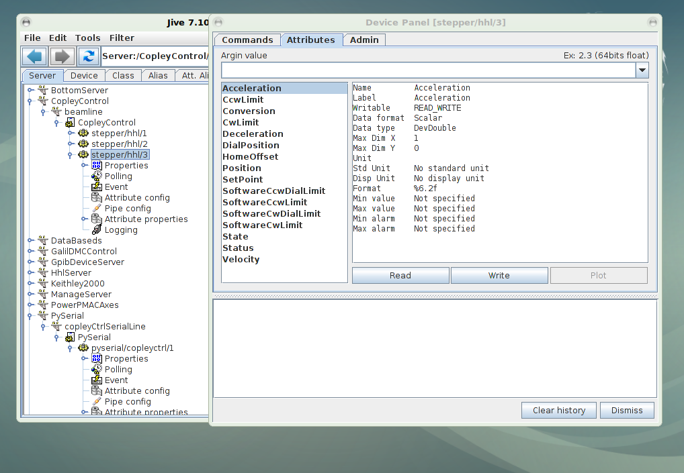

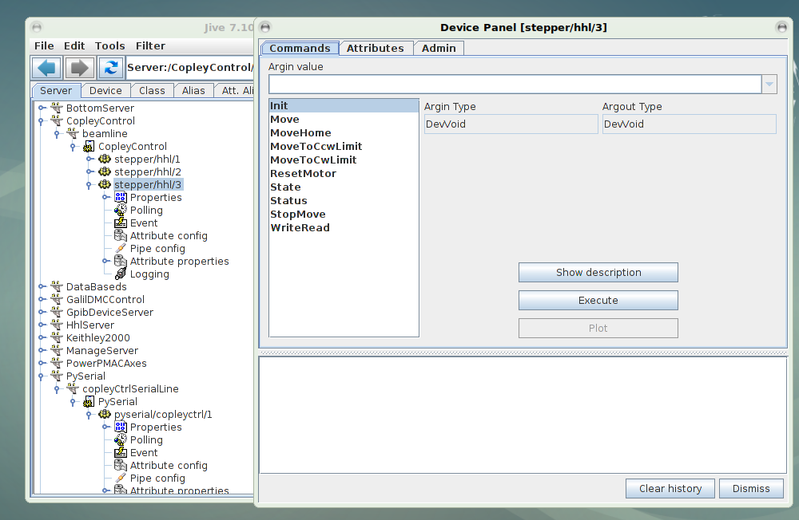

Install Tango und jive:
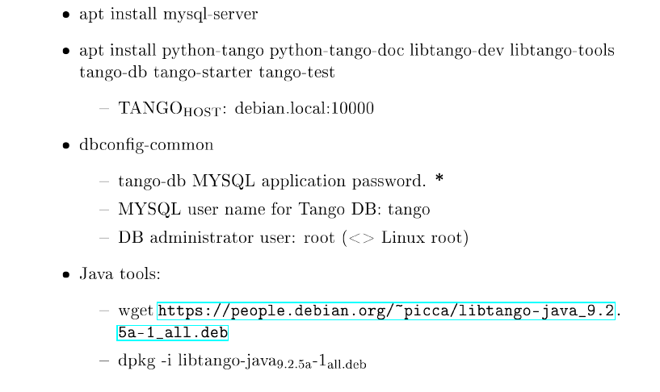

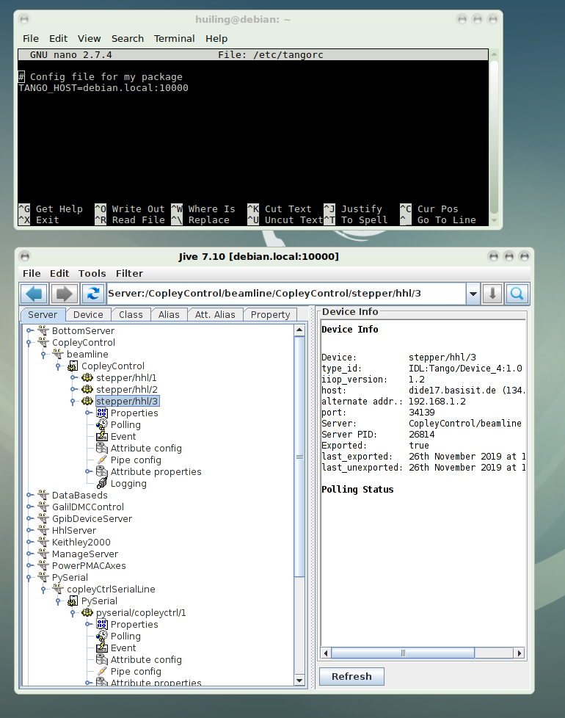
Tango Host:

