**Download the files von my Git-hub repository**

Terminal 1:

>>> git clone <https://github.com/huilinghe19/CopleyControlProgramsHHL.git>

**Start PySerial Tango Device Server**

Terminal 1:

>>> cd CopleyControlProgramsHHL

>>> python PySerial.py copleyCtrlSerialLine

Note: copleyCtrlSerialLine is user-defined name.

**Add tango device “pyserial/copleyctrl/1” under the PySerial Tango DS in jive.**

Terminal 2:

>>> jive

add tango device “pyserial/copleyctrl/1” under the PySerial server in jive. (steps below)

**Start CopleyControl Tango Device Server**

Terminal 3:

>>> cd CopleyControlProgramsHHL

>>> python CopleyControl.py beamline

add tango devices “stepper/hhl/1”, “stepper/hhl/2”, “stepper/hhl/3” in jive. (steps below)

**Steps to add tango devices in jive:**

1. Add Tango Devices based on the PySerial Tango DS with jive

Make sure the PySerial Tango Device Server is opened at first, open jive.

Steps in Jive:

In jive >> Tools >> Server Wizard >> Server Registration >> Server name: PySerial , Instance name: copleyCtrlSerialLine >> Start the server : Next (start the server again if the server is not started. For the first time, the registration must be done before the server starts)>> Class Selection : choose PySerial >> Declare device >> Device Name: pyserial/copleyctrl/1 >> Configuration done >> finish

The class is PySerial. Instance name is copleyCtrlSerialLine. The instance name is user-defined. The instance name must be as same as the instance name that the server PySerial starts with. Here the copleyCtrlSerialLine is an example. In the Attributes of the device pyserial/copleyctrl/1, check the Port, and set the Timeout as 1.

2. Add Tango Devices based on the CopleyControl Tango DS with jive

Add the tango devices with jive. The node ID is the unique identification for a certain copley controller. Open Jive.

In jive >> Tools >> Server Wizard >> Server Registration >> Server name: CopleyControl , Instance name: beamline(This is what you start with) >> Start the server : Next (start the server again if the server is not started. For the first time, the registration must be done before the server starts) >> Class Selection : choose CopleyControl >> Declare device >> Device Name: stepper/hhl/1 (user-defined name)>> Property: ConnectedDeviceName: pyserial/copleyctrl/1 (the connected pyserial device name)>> Property: NodeId 0 (Here the stepper/hhl/1 is connected with Node ID 0. If the Node ID of the amplifier is different, then the Node Id must be different. ) >> Property: ReferenceVelocity 15001 (The default value must be changed so that it can be saved in Tango Database. For example 15000 must be changed to 15001 here) >> Property: DesiredState 31 ( 0=Disabled, 21 = Programmed Position Mode, Servo, 31 = Programmed Position Mode, Stepper ) >> Property: ReferenceAcceleration 200000 (The default value must be changed so that it can be saved in Tango Database. For example 200000 here) >> Property: ProfileType 256 (0 = Absolute move, trapezoidal profile. 1 = Absolute move, S-curve profile. 256 = Relative move, trapezoidal profile. 257 = Relative move, S-curve profile. 2 = Velocity move.) >> Property: ReferenceDeceleration 200000 (The default value must be changed so that it can be saved in Tango Database.) >> Configuration done>> finish

## The connection with the PySerial Server and the CopleyControl tango devices is the name of the created tango device:”pyserial/copleyctrl/1”. The same name ”pyserial/copleyctrl/1” can not be given with any other tango devices in jive.

3. Restart the server

Restart the server, open jive and stepper/hhl/1 tango device exits in jive. Right-click on the device name “stepper/hhl/1”. Using “Test device” we can get the commands and attribute interface.

**How to move the motors and set Home?**

1. Move the motors

Define the software negative limit(SoftwareCcwLimit) such as -1000000 and software positive limit(SoftwareCwLimit) for example 1000000, then the motor can be moved in this range. The motor position, acceleration, deceleration are defined in the amplifier ebene. The relevant values of the specific motor can be seen in the server terminal. If software nagetive limit and software positive limit are not set, then the motor moves in open loop.

There are 2 methods to move the motor. One is using “Position”, the other one is using “SetPoint”. These are just two expressions, and the final implementation method is the same one in the amplifier. The Position is the target position in the amplifier ebene. Position = DialPosition * Conversion. The current position can be got by the Read of the Position attribute. When the target position is 3000, then Write 3000 in Position attribute, Then using the Command “Move”, the motor will move to the target position 3000. The 3000 Position must be in the range of the software limits.

For Relative Move(Profile Type 256, 257), the SetPoint is the position difference in the amplifier ebene. For example, the current position is 2000, we want to move the motor to 3000, so set the SetPoint as 1000, then “Move”, the motor will move to the 3000 Position.

For Absolute Move(Profile Type 0, 1), the SetPoint is target position in the amplifier ebene. For example, the current position is 2000, we want to move the motor to 3000, so set the SetPoint as 3000, then “Move”, the motor will move to the 3000 Position.

Profile Type can only be set as 0, 1, 256, 257 by the initialization of the Tango DS.

2. Home

The input of the MoveHome can be one of the 29 home methods for the amplifier (See Page 39 in “ASCII_ProgrammersGuide.pdf”), Such as 512, 513, 514, 529.

For example, move the motor to a expected home position, make sure this location is the future home location, set the HomingMethod as 512, then MoveHome. Then this location is the home location(0 position location). In fact, Once Home is done for a motor, it keeps always the same for a certain motor and it is better not to be changed any more.

3. Some Screenshots

Start the PySerial TangoDS:

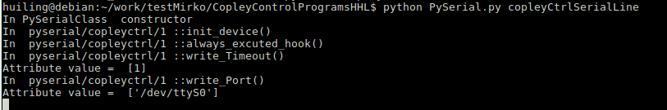

Start the CopleyControl TangoDS

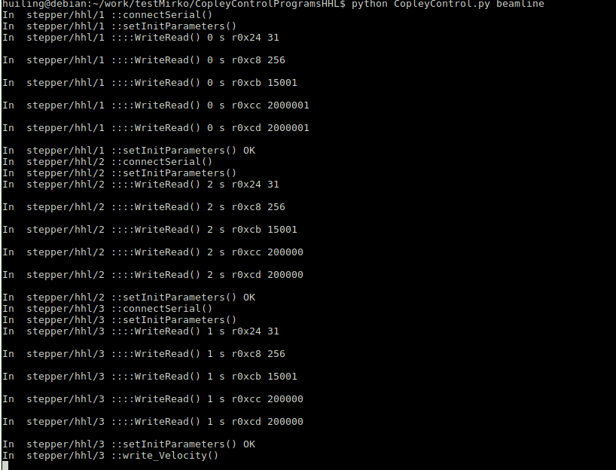

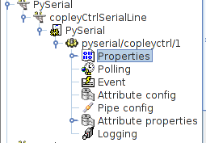PySerial TangoDS in jive:

CopleyControl TangoDS in jive:

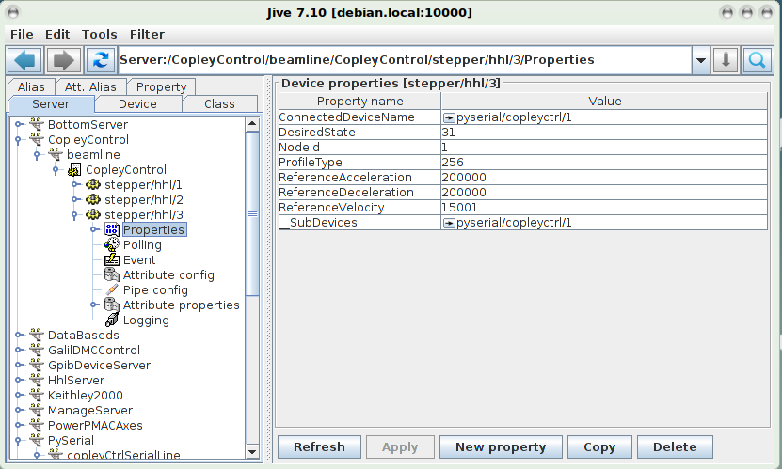

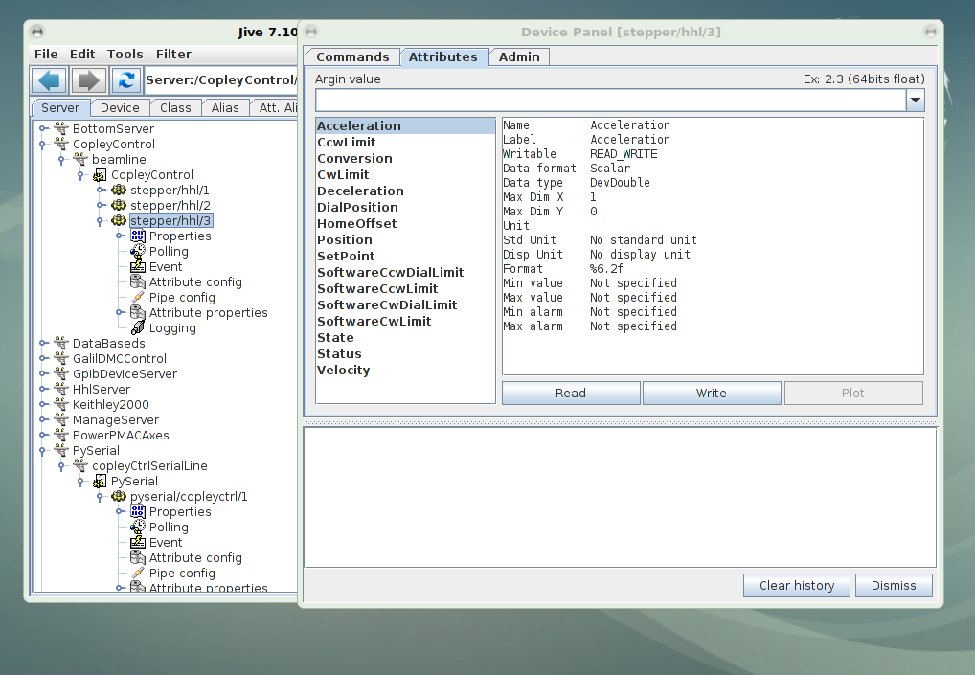

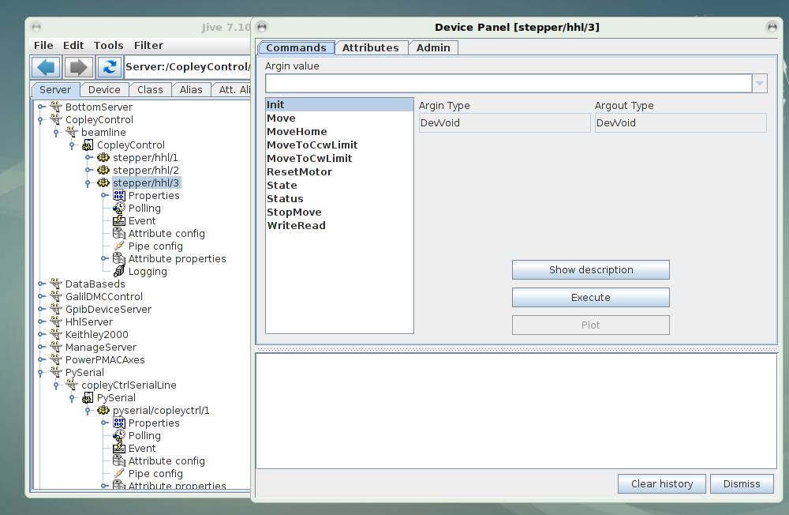

Install Tango und jive:

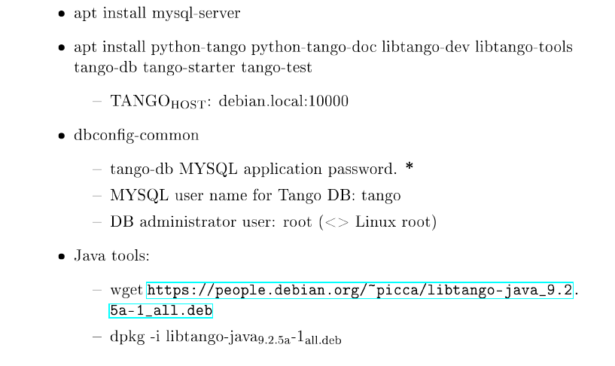

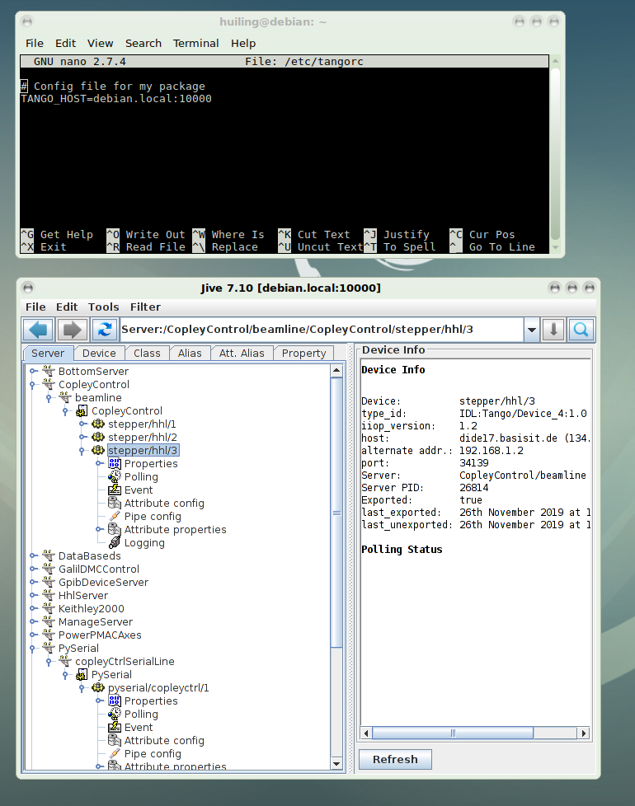Tango Host: