Sardana Configuration on Linux Mint System

1. Tango Part:
# Install tango db
>>> sudo apt-get install mysql-server
>>> sudo apt install tango-db tango-starter tango-test
>>> sudo apt install libtango-dev libtango-tools
Tango Configuration (fotos attached in the end):
TANGO_HOST=edono:10000
(computername:edono, port:10000, standard input, do not change.)
password for tango-db: tango
(standard input, do not change.)
>>> sudo apt install python3-pytango
# Test tangodb:
>>> sudo systemctl status tango-db.service (test tango db status: running)

# Install java 8 and libtango-java in oder to use jive
>>> java -version (openjdk version “1.8.0_252” is right, other java versions like java 11 must be degraded to java 8)
>>> sudo apt install liblog4j1.2-java
>>> sudo apt install libtango-java (already exist, otherwise must be installed)
# Test jive:
Terminal 1: >>> /usr/lib/tango/TangoTest test
Terminal2: >>> jive
Jive interface can be opened. TangoTest DeviceServer is running.

2. Taurus Part:
# Install pip3
>>> sudo apt-get update
>>> sudo apt-get upgrade
>>> sudo apt-get install python3-pip
# Install git
>>> sudo apt install git
# Install taurus dependencies like python3-setuptools, python3-future, python3-pyside, python3-wheel, spyder3, python3-pyqt4, python3-pyqt5, python3-guiqwt. There are many extra libraries for taurus installation in the Mint system.
>>> sudo apt-get install build-essential
>>> sudo apt-get install g++
>>> sudo apt python3-setuptools python3-future python3-pyside python3-wheel python3-lxml spyder3
>>> sudo apt install python3-pyqt4 python3-pyqt5 python3-guiqwt
# Install taurus
>>> cd /usr/lib/python3/dist-packages
>>> git clone https://github.com/taurus-org/taurus.git

>>> sudo pip3 install -e ./taurus

# Install taurus_pyqtgraph
>>> git clone https://github.com/taurus-org/taurus_pyqtgraph.git

>>> sudo pip3 install -e ./taurus_pyqtgraph
Note: python3-taurus and python3-taurus-pyqtgraph packages are already built in https://salsa.debian.org , but are not yet part of the official debian repositories. This is also a good method. I have not used this way.
# Test taurus
>>> taurus trend

3. Sardana Part:
# Install sardana
>>> pip3 install sardana
# Test sardana:
Terminal 1: >>> Sardana test
Terminal 2: >>> spock

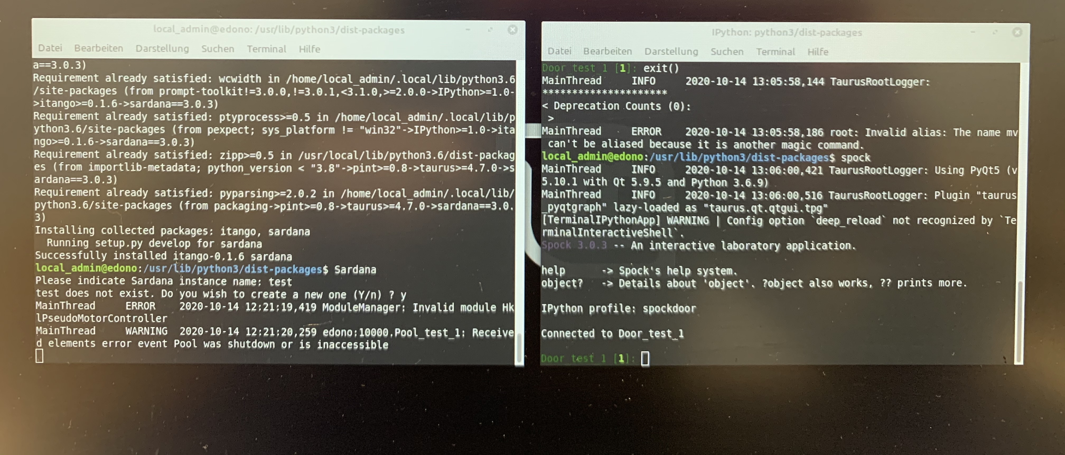

4. Notes:
Because there are so many parts, some parts are becoming different as before, such as PyTango can not be installed with Itango since PyTango9. Different systems have different standard libraries, therefore various extra libraries must be installed on different system platforms. For example, On Debian buster system there is no mysql-server. Even when I habe already installed sardana successfully, after opening Spock interface, there is a message in spock to remind apt me: “ No module named ‘matplotlib’ “. So I should also install matplotlib.
At the same time, since many libraries are followed with python2, basically all python libraries are meant python2 libraries. When installing the libraries, we must be very careful. For example, Once PyTango is connected to python2, then sardana cannot be installed successfully. PyTango < 9 is compatible with itango >= 0.0.1 and < 0.1.0, while higher versions with itango >= 0.1.6.
There is also a point to be mentioned. There is a strong connection between Tango Database and network. Reboot after installation is a must. Wenn something unusual conneted with Tango DB happen, we can try reboot.
When installing Sardana using pip3 install -e ./sardana , problems occur with <<boost/python.hpp>>, we must install “libboost-all-dev”, then “sphinx_rtd_theme” should be also installed. When an error occurs in any step, we will be reminded during the installation process. We need to install what is missing.
>>> sudo apt-get install libboost-all-dev
>>> pip3 install sphinx_rtd_theme
>>> sudo apt install python3-matplotlib

Tango Installation:
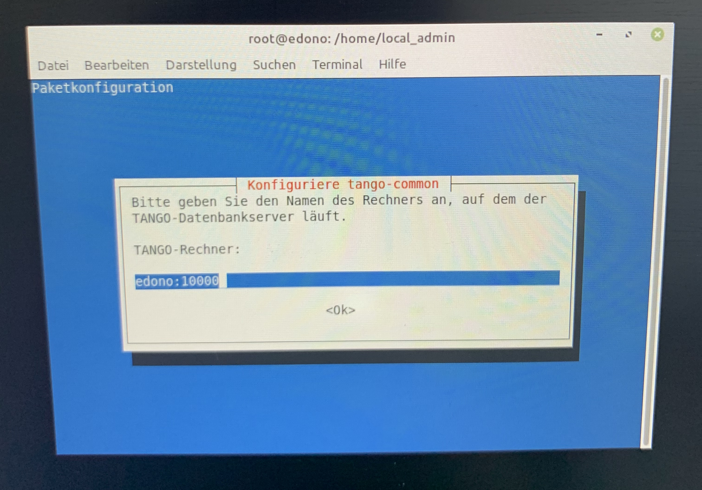
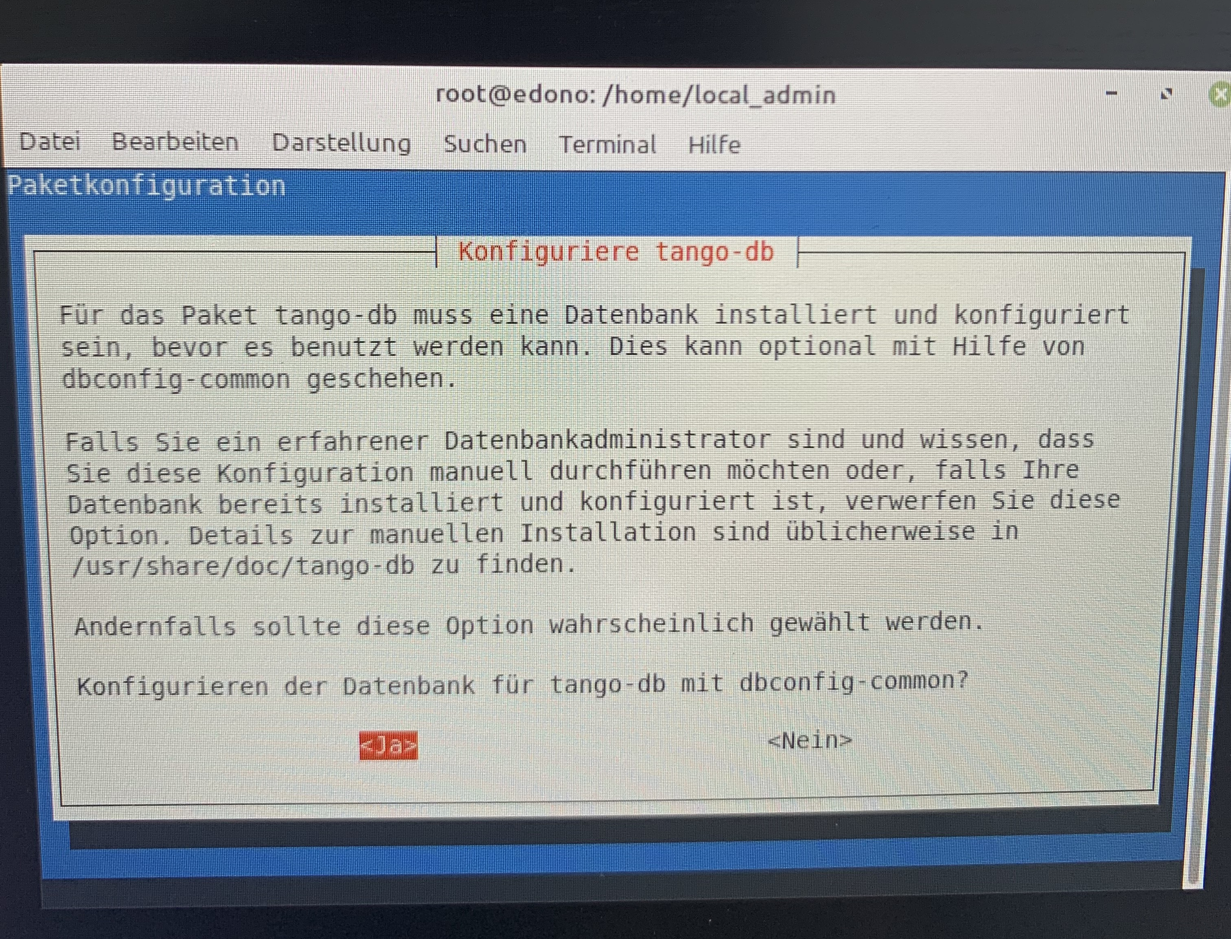
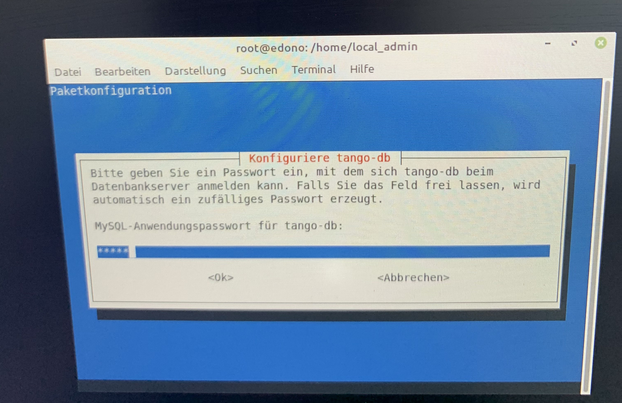
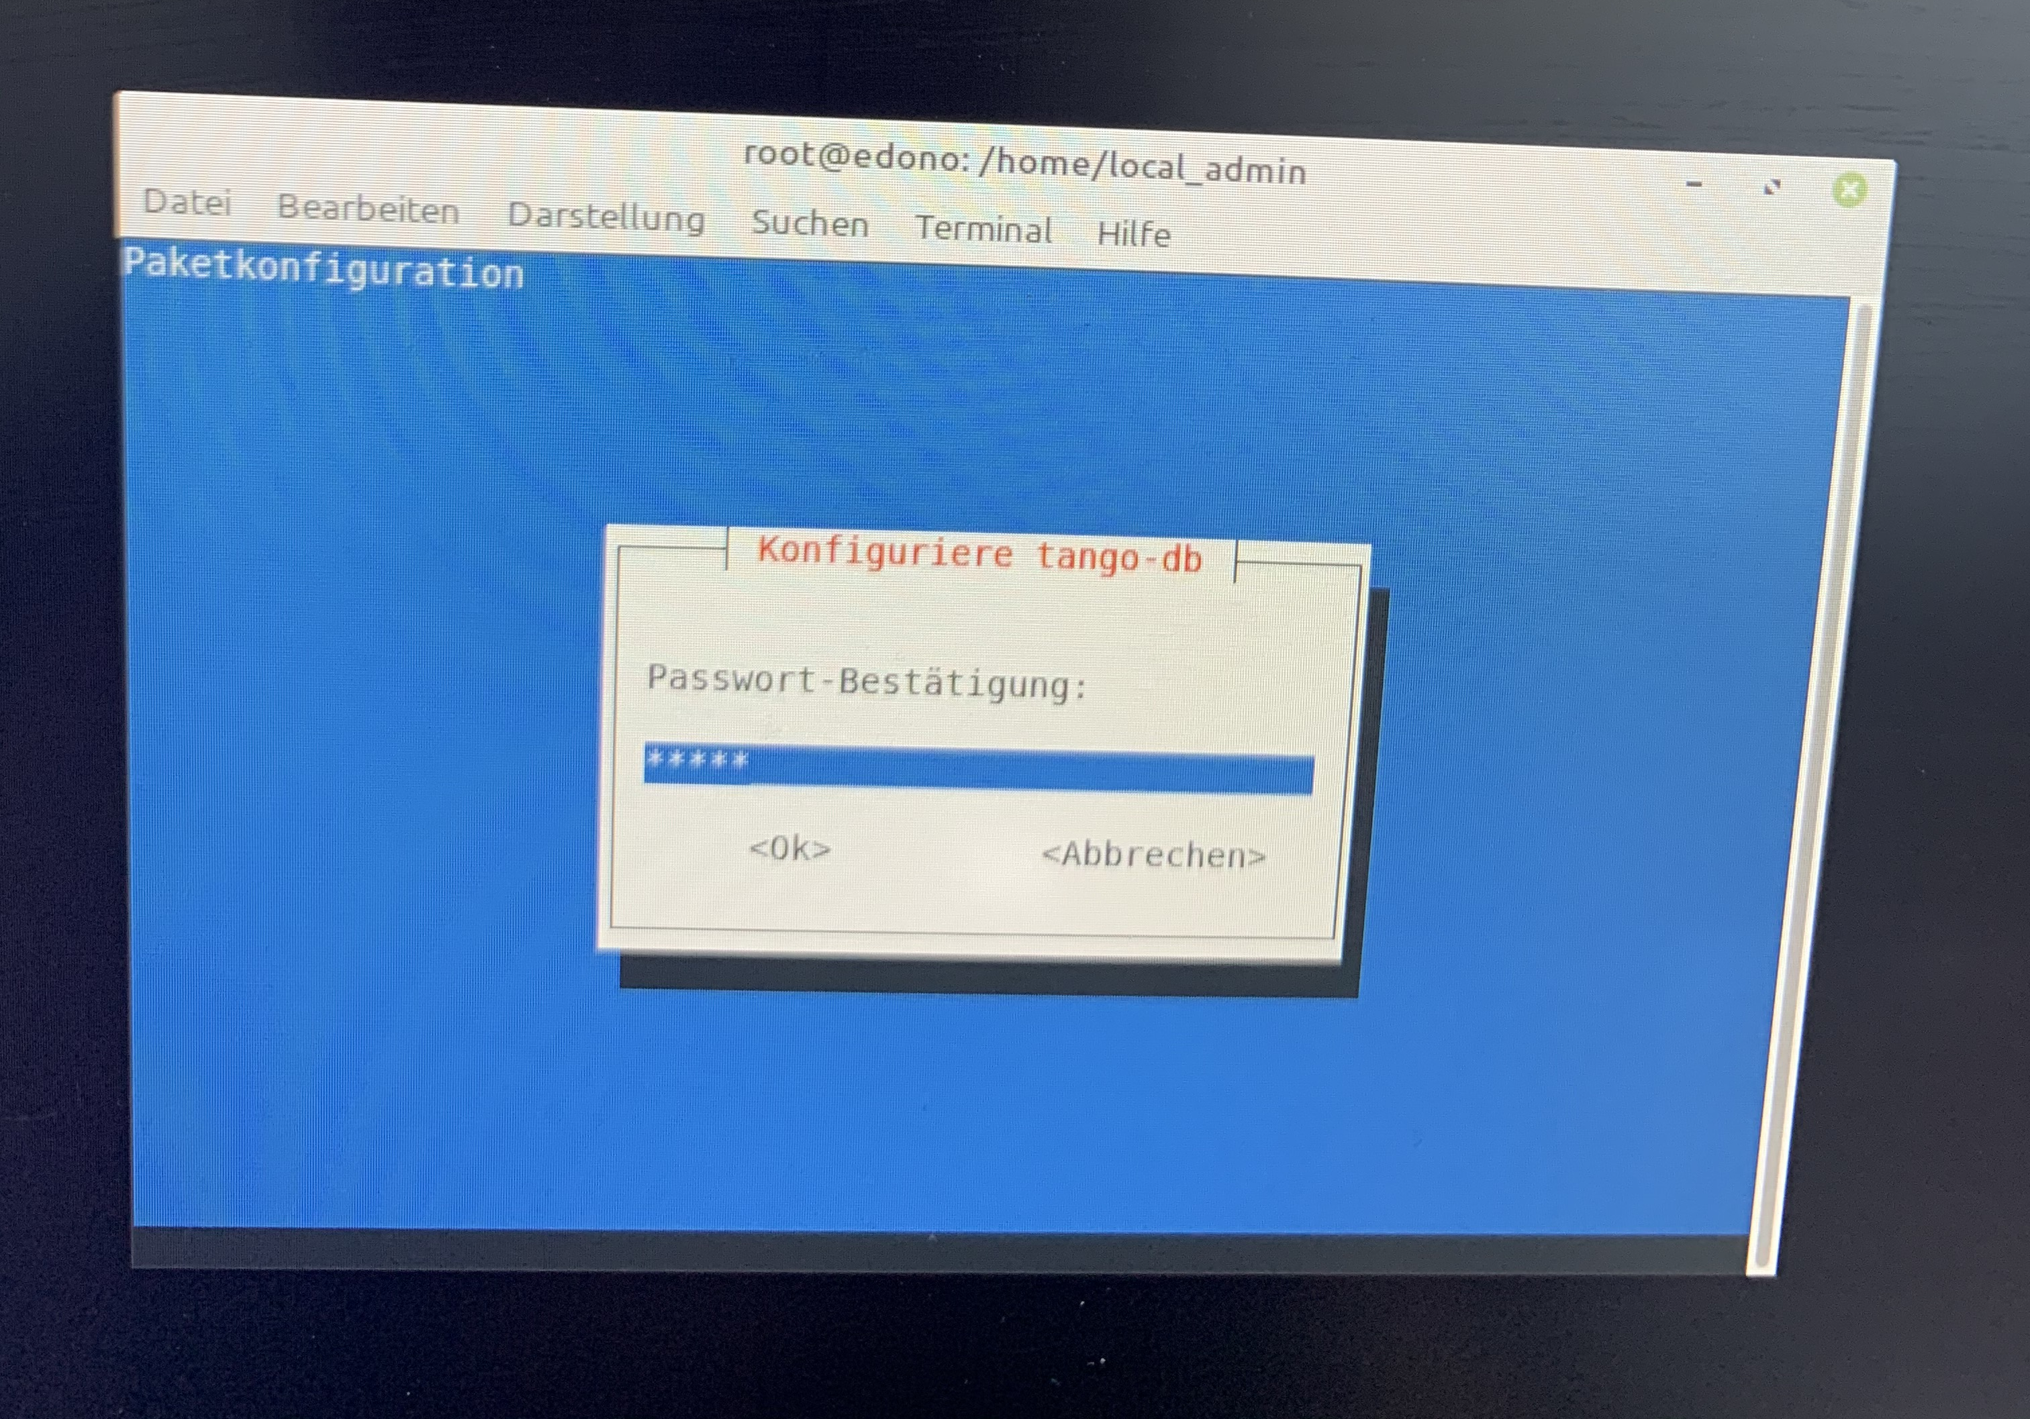
Commands:
sudo apt-get update
sudo apt-get upgrade
sudo apt-get install mysql-server
sudo apt install tango-db tango-starter tango-test
sudo apt install libtango-dev libtango-tools
sudo apt install python3-pytango
java -version (openjdk version must be “1.8.0_252”)
sudo apt install libtango-java
sudo apt-get install python3-pip
sudo apt install git
sudo apt-get install build-essential

sudo apt-get install g++
sudo apt python3-setuptools python3-future python3-pyside python3-wheel python3-lxml spyder3
sudo apt install python3-pyqt4 python3-pyqt5 python3-guiqwt
cd /usr/lib/python3/dist-packages
git clone https://github.com/taurus-org/taurus.git

sudo pip3 install -e ./taurus

git clone https://github.com/taurus-org/taurus_pyqtgraph.git

sudo pip3 install -e ./taurus_pyqtgraph
sudo apt-get install libboost-all-dev

pip3 install sphinx_rtd_theme
sudo apt install python3-matplotlib
sudo pip3 install sardana

