Sardana Configuration on Debian 10 System

Upgrade Debian 9 to Debian 10:
https://www.cyberciti.biz/faq/update-upgrade-debian-9-to-debian-10-buster/

Software Configuration Steps:
(Tango Part >>>>>>>>>> Taurus Part >>>>> Sardana Part)

Tango Part:
https://tango-controls.readthedocs.io/en/latest/installation/tango-on-linux.html#debian-ubuntu
1. Install mariadb-server
Either mysql-server or mariadb-server exist, then ok.
>>> apt search mysql-server
>>> apt search mariadb-server
In Buster system, mysql-server does not exist in apt repository. default-mysql-server, mariadb-server, mariadb-server-10.3, mariadb-server-core-10.3 are in apt repository. On the updated buster system on dide17, the default-mysql-server, mariadb-server, mariadb-server-10.3, mariadb-server-core-10.3 are installed.
>>> sudo apt install mariadb-server mariadb-server-10.3 mariadb-server-core-10.3
2. Install Tango
>>> sudo apt install tango-db tango-starter tango-test
>>> sudo apt install libtango-dev libtango-tools
>>> sudo apt install python3-pytango

check the packages:
>>> dpkg -L tango-db

3. Tango Configuration, install dbconfig-common
DB administrator user: root(<> Linux root)
MySQL password for Tango DB: tango

There will be some configuration with MySQL, The username and password for TangoDB will be chosen as “tango”, “tango”.
4. Check Tango Host
>>> sudo nano /etc/tangorc
The /etc/tangorc file contains following content:
TANGO_HOST=diaz07:10000(on diaz07, metrixs computer)
5. Test Tango DB
>>> /etc/init.d/tango-db status
If tango DB does not work well, try systemctrl tools to change the Tango DB status and restart tango-db and tango-starter. You can also try reboot.
>>> sudo systemctl status tango-db.service
>>> sudo systemctl status tango-starter.service

6. Install other Tookit: jive, astor
6.1 Update Java 11 to Java 8 using the CLI (in oder to use jive)
https://linuxize.com/post/install-java-on-debian-10/
6.2 Install this java debian package using CLI:
>>> wegt https://people.debian.org/~picca/libtango-java_9.2.5a-1_all.deb
>>> dpkg -i libtango-java9.2.5a-1all.deb
6.3 Test Jive and Tango Device Server
Open Tango Device Server TangoTest using CLI:
Terminal 1:
>>> /usr/lib/tango/TangoTest test
Terminal 2:
>>> jive
On jive, right click “sys/tg_test/1”, choose “Test device”
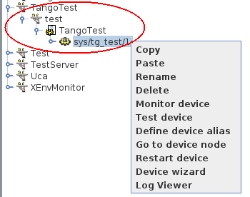
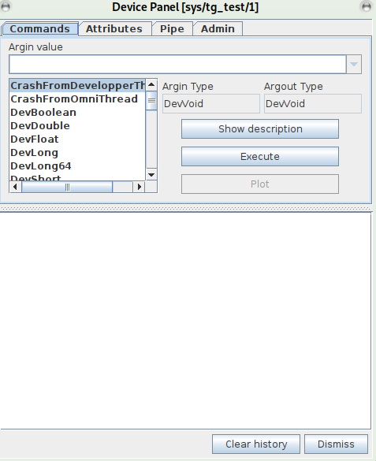

Taurus Part:
https://taurus-scada.org/users/getting_started.html

# Install pip3
>>> sudo apt install update
>>> sudo apt install upgrade
>>> sudo apt-get install python3-pip
>>> pip3 –version
# Install taurus

>>> cd /usr/lib/python3/dist-packages
>>> git clone https://github.com/taurus-org/taurus.git

>>> sudo pip3 install -e ./taurus

# install taurus_pyqtgraph

>>> git clone https://github.com/taurus-org/taurus_pyqtgraph.git

>>> sudo pip3 install -e ./taurus_pyqtgraph
Note: python3-taurus and python3-taurus-pyqtgraph packages are already built in https://salsa.debian.org , but are not yet part of the official debian repositories. This is also a good method to try. I have not used this way.

Sardana Part:
https://sardana-controls.org/users/getting_started/installing.html

1. Check the dependences
1.1 PyTango 9.2.5 or later
>>> python3 -c 'import tango; print(tango.__version__)'

1.2 Taurus 4.5.4 or later
>>> python3 -c 'import taurus; print(taurus.Release.version)'

1.3 lxml library 2.3 or later
>>> python3 -c 'import lxml.etree; print(lxml.etree.LXML_VERSION)'

1.4 install python3-itango, python3-spyder
>>> sudo apt install python3-itango
>>> sudo apt install python3-spyder
2. Install sardana under python3 environment.
>>> cd /usr/lib/python3/dist-packages
>>> git clone https://github.com/sardana-org/sardana.git sardana
>>> sudo pip3 install -e ./sardana

>>> python3 -c "import sardana; print(sardana.Release.version)"
3. Test Sardana and Spock
Terminal 1:
>>> Sardana demo1
Terminal 2:
>>> spock

