Homework No.5

Xingye Ke

February 28, 2018

## Q(a)

1. Make a time series plot of the data and make a comment about trend and seasonal effect.

setwd('c:/users/n886528/desktop/hw')  
  
dat <- read.table('unemployment.dat',header = T)  
ts.obj <- ts(dat,start = c(1963,1),end = c(2004,12), frequency = 12)  
  
plot(stl(ts.obj[,1],s.window = 'periodic'))

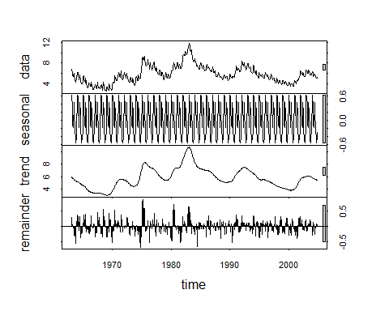 As we can see from the right side of the graphic:

1.The grey rectangles of trend and the data series have the similar size, so the trend actually dominates the series;

2.If we look into the seasonal’s grey rectangle, we could find the relative large size, which means variation in the seasonality is a much smaller component of the variation exhibited in the original series;

## Q(b)

1. Fit the exponential smoothing model without trend and seasonal factor and show the results from R (including the coefficient estimates, SSE, RMSE, and the smooth curve).

exp.smooth <- HoltWinters(dat,beta=FALSE,gamma = FALSE)  
exp.smooth

## Holt-Winters exponential smoothing without trend and without seasonal component.  
##   
## Call:  
## HoltWinters(x = dat, beta = FALSE, gamma = FALSE)  
##   
## Smoothing parameters:  
## alpha: 0.9999268  
## beta : FALSE  
## gamma: FALSE  
##   
## Coefficients:  
## [,1]  
## a 5.199993

print('**')

## [1] "**"

cat('Sum Square Error is ',exp.smooth$SSE,'\n')

## Sum Square Error is 107.302

cat('RMSE is ', sqrt(mean(exp.smooth$SSE)))

## RMSE is 10.35867

plot(exp.smooth)

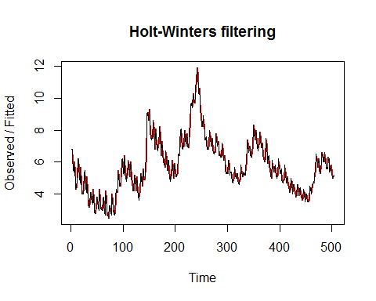

## Q(C)

1. Fit the additive seasonal model and show the results from R. (including the coefficient estimates, SSE, RMSE, and the smooth curve).

add.model<- HoltWinters(ts.obj,seasonal = 'additive')  
add.model

## Holt-Winters exponential smoothing with trend and additive seasonal component.  
##   
## Call:  
## HoltWinters(x = ts.obj, seasonal = "additive")  
##   
## Smoothing parameters:  
## alpha: 0.8397681  
## beta : 0.005878874  
## gamma: 1  
##   
## Coefficients:  
## [,1]  
## a 5.365832778  
## b -0.003738564  
## s1 0.591546569  
## s2 0.468471923  
## s3 0.389181929  
## s4 -0.134599116  
## s5 -0.087719108  
## s6 0.352443561  
## s7 0.342321602  
## s8 0.080297869  
## s9 -0.143127183  
## s10 -0.217817133  
## s11 -0.181757136  
## s12 -0.165832778

print('**')

## [1] "**"

cat('Sum Square Error is ',add.model$SSE,'\n')

## Sum Square Error is 31.51901

cat('RMSE is ', sqrt(mean(add.model$SSE)),'')

## RMSE is 5.614179

plot(add.model)

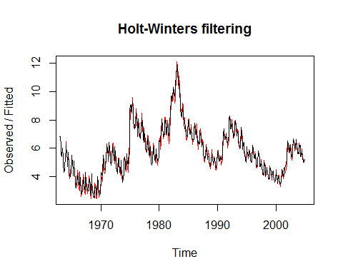

## Q(d)

1. Fit the multiplicative seasonal model and show the results from R. (including the coefficient estimates, SS1PE, RMSE, and the smooth curve).

mul.model<- HoltWinters(ts.obj,seasonal = 'multiplicative')  
mul.model

## Holt-Winters exponential smoothing with trend and multiplicative seasonal component.  
##   
## Call:  
## HoltWinters(x = ts.obj, seasonal = "multiplicative")  
##   
## Smoothing parameters:  
## alpha: 0.6248778  
## beta : 0.004373313  
## gamma: 1  
##   
## Coefficients:  
## [,1]  
## a 5.097871812  
## b -0.006448745  
## s1 1.153493172  
## s2 1.138560490  
## s3 1.141306185  
## s4 1.032321758  
## s5 1.045781017  
## s6 1.128175355  
## s7 1.124259994  
## s8 1.058862411  
## s9 1.016921116  
## s10 1.002103319  
## s11 1.018269317  
## s12 1.020033495

print('**')

## [1] "**"

cat('Sum Square Error is ',mul.model$SSE,'\n')

## Sum Square Error is 39.78779

cat('RMSE is ', sqrt(mean(mul.model$SSE)),'')

## RMSE is 6.307756

plot(mul.model)

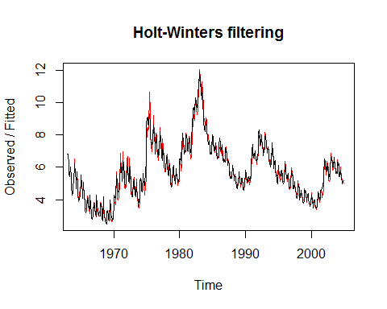

## Q(e)

We could find out that additive seasonal model(c) has the lowest RMSE value, which is 5.614179.Based on the reference to the RMSE, we could say (c) is a best fit.

The result is pretty intuitive in that what we could learn from the time series plot is that the magnitude of variation of the series does not obviously vary with the series. Futhermore, the trend and seasonality part should be considered into the modeling procedure because they are not trivial, which we could see from the decomposition.

## Q(f)

1. Use the selected model from part (e), write down the forecast equations and calculate the predicted values for the unemployment rates from January, 2005 to December, 2005.

As we can see from the result of fitted model:

## Coefficients:  
## [,1]  
## a 5.365832778  
## b -0.003738564  
## s1 0.591546569  
## s2 0.468471923  
## s3 0.389181929  
## s4 -0.134599116  
## s5 -0.087719108  
## s6 0.352443561  
## s7 0.342321602  
## s8 0.080297869  
## s9 -0.143127183  
## s10 -0.217817133  
## s11 -0.181757136  
## s12 -0.165832778

The calculation equation:

$\tilde{x_{DEC2004+k}}=a_{DEC2004}+ {k*b}_{DEC2004}+ s_{DEC2004+k-p}$, where $a_{DEC2004}=5.365832778$, $b_{DEC2004}=-0.003738564$

So for JAN2005:

$x_{JAN2005}= a_{DEC2004}+{1*b}_{DEC2004}+ s_{DEC2004+1-12}$ = $5.365832778+1*\left(-0.003738564\right)+s_{JAN2004}$ = $5.365832778+1*\left(-0.003738564\right)+$ 0.591546569 = 5.953641

$x_{FEB2005}= a_{DEC2004}+{2*b}_{DEC2004}+ s_{DEC2004+2-12}$ = $5.365832778+2*\left(-0.003738564\right)+s_{FEB2004}$ = $5.365832778+2*\left(-0.003738564\right)+$ 0.468471923= 5.826828

$x_{MAR2005}= a_{DEC2004}+{3*b}_{DEC2004}+ s_{DEC2004+3-12}$ = $5.365832778+3*\left(-0.003738564\right)+s_{MAR2004}$ = $5.365832778+3*\left(-0.003738564\right)+$ 0.389181929= 5.743799

$x_{APR2005}= a_{DEC2004}+{4*b}_{DEC2004}+ s_{DEC2004+4-12}$ = $5.365832778+4*\left(-0.003738564\right)+s_{APR2004}$ = $5.365832778+4*\left(-0.003738564\right)$-0.134599116= 5.216279

$x_{MAY2005}= a_{DEC2004}+{5*b}_{DEC2004}+ s_{DEC2004+5-12}$ = $5.365832778+5*\left(-0.003738564\right)+s_{MAY2004}$ = $5.365832778+5*\left(-0.003738564\right)-0.087719108$ = 5.259421

$x_{JUN2005}= a_{DEC2004}+{6*b}_{DEC2004}+ s_{DEC2004+6-12}$ = $5.365832778+6*\left(-0.003738564\right)+s_{JUN2004}$ = $5.365832778+6*\left(-0.003738564\right)-0.352443561$ = 5.695845

$x_{JUL2005}= a_{DEC2004}+{7*b}_{DEC2004}+ s_{DEC2004+7-12}$ = $5.365832778+7*\left(-0.003738564\right)+s_{JUL2004}$ = $5.365832778+7*\left(-0.003738564\right)+$ 0.342321602 = 5.681984

$x_{AUG2005}= a_{DEC2004}+{8*b}_{DEC2004}+ s_{DEC2004+8-12}$ = $5.365832778+8*\left(-0.003738564\right)+s_{AUG2004}$ = $5.365832778+8*\left(-0.003738564\right)+$ 0.080297869= 5.416222

$x_{SEP2005}= a_{DEC2004}+{9*b}_{DEC2004}+ s_{DEC2004+9-12}$ = $5.365832778+9*\left(-0.003738564\right)+s_{SEP2004}$ = $5.365832778+9*\left(-0.003738564\right)-0.143127183$ = 5.189059

$x_{OCT2005}= a_{DEC2004}+{10*b}_{DEC2004}+ s_{DEC2004+10-12}$ = $5.365832778+10*\left(-0.003738564\right)+s_{OCT2004}$ = $5.365832778+10*\left(-0.003738564\right)-0.217817133$ = 5.110630

$x_{NOV2005}= a_{DEC2004}+{11*b}_{DEC2004}+ s_{DEC2004+11-12}$ = $5.365832778+11*\left(-0.003738564\right)+s_{NOV2004}$ = $5.365832778+11*\left(-0.003738564\right)-0.181757136$ = 5.142951

$x_{DEC2005}= a_{DEC2004}+{12*b}_{DEC2004}+ s_{DEC2004+21-12}$ = $5.365832778+12*\left(-0.003738564\right)+s_{DEC2004}$ = $5.365832778+12*\left(-0.003738564\right)-0.165832778$ = 5.155137

## Q(g)

addmodel.predict <- predict(add.model,n.ahead = 12)  
addmodel.predict

## Jan Feb Mar Apr May Jun Jul  
## 2005 5.953641 5.826828 5.743799 5.216279 5.259421 5.695845 5.681984  
## Aug Sep Oct Nov Dec  
## 2005 5.416222 5.189059 5.110630 5.142951 5.155137

## Q(h)

ts.plot(ts.obj,addmodel.predict,lty=1:2,col = c('blue','red'))

