The Role of Ethical Hacking in Modern Cybersecurity Practices: A Focus on Penetration Testing, Bug Bounty Programs, and CTF Challenges
Khegai Olga
Tp069365@mail.apu.edu.my

Abstract
Increased sophistication in hacking attacks has increased emphasis on ethical hacking in modern cybersecurity. This research analysis delves into how ethical hacking, especially penetration testing, bug bounty initiatives, and Capture the Flag challenges are utilized in vulnerability detection in digital infrastructure and how to defend against them. Ethical hacking, also white-hat hacking, uses similar techniques to nefarious hackers but in legitimate and helpful fashion. The research attempts to test how effective these methods are, how they fit in organizational security processes, and how they impact cybersecurity talent development more broadly. Through examining ethical hacking initiatives' structure, impact, and challenges, this research discusses how important proactive defense is, along with community-driven vulnerability identification. The investigation concludes that ethical hacking not only increases cybersecurity robustness, but also makes for an active ecosystem of ongoing learning, threat simulation, and responsible disclosure.

Key terms
Ethical Hacking, Penetration Testing, Bug Bounty, CTF, Cybersecurity, Vulnerability Assessment, White Hat, Information Security, Cyber Defense, Responsible Disclosure.

Introduction
Cybersecurity is not anymore in the domain of enterprise IT departments but is now part of infrastructure security in general. In an era of increasing sophistication in good as well as negative forms of hacking, ethical hacking is now regarded as an active and dynamic way of searching for vulnerabilities before malicious hackers even considered attacking. In contrast to black-hat hackers who use systems for personal enrichment or for criminal activity, ethical hackers are legitimate and work constructively in most cases under agreements or community-based initiatives, including penetration testing, bug bounty platforms, or CTF (Capture the Flag) cybersecurity challenges.
These processes help organizations emulate actual attacks, learn more about their online vulnerabilities, and improve their defense system consistently. Amidst growing instances of data breaches, zero-day attacks, and ransomware attacks, ethical hackers are working to establish progressively safer online environments (EC-Council, 2023).
This work delves into how ethical hacking techniques are put into practice and how they are used to build modern cybersecurity resiliency. Particular emphasis is placed on the development of bug bounty environments, organized penetration testing, and CTF-based skill development, which have all combined to change how security vulnerabilities are uncovered and remediated.
The subsequent sections of this paper present an overall description of the problem, goals, research questions, system focus, and expected contribution to cybersecurity.

Problem Statement
Despite the rise in investment in cybersecurity tools and monitoring systems, organizations remain vulnerable to sophisticated threats that exploit human error, unknown system flaws, and configuration weaknesses. Traditional security assessments often fail to replicate real-world attack vectors, leading to blind spots in defense strategies (Mell et al., 2022).
Moreover, the cybersecurity talent gap continues to widen, with many companies struggling to find professionals who can think like attackers. Ethical hacking fills this void by offering a practical, adversarial perspective — revealing exploitable flaws that automated scanners might miss (Ransome & Misra, 2018).
Yet, organizations are not always prepared or structured to effectively integrate ethical hacking practices into their risk management workflows. Questions remain about legal implications, data privacy, and quality control in community-driven approaches such as bug bounty programs (Zhou et al., 2020).
This study aims to investigate the practical impact, challenges, and value of ethical hacking initiatives, and how they can be better aligned with organizational security goals and cybersecurity education.

Research Aim
One of the prime objectives of this research is to analyze how ethical hacking techniques, particularly penetration testing, bug bounty initiatives, and CTFs, contribute to elevating current cybersecurity practice and resilience.

Research Objectives
- To examine the current role of ethical hacking in cybersecurity frameworks.
- To assess how penetration testing, bug bounty programs, and CTFs are performing.
- To identify important challenges and legal implications in launching ethical hacking programs.
- To propose a strategic integration model of ethical hacking into cybersecurity operations.
- To explore how CTFs contribute to skill-building and talent development in cybersecurity.

Research Questions
- How do ethical hacking practices improve cybersecurity readiness in organizations?
- What are the advantages and limitations of penetration testing and bug bounty programs?
- What legal, ethical, or technical concerns arise when implementing ethical hacking?
- How can Capture the Flag competitions contribute to real-world cybersecurity preparedness?
- What strategies can organizations adopt to effectively integrate ethical hacking into their security lifecycle?

Research Significance
This work is important in that it highlights the increasing role of ethical hacking as an active security response to more complex threats. Conventional reactive methodologies are frequently unable to identify actual-world weaknesses, which means ethical hacking techniques such as penetration testing and bug bounty policies are paramount in present defense initiatives (Mell et al., 2008; Zhou et al., 2020).
Penetration testing enables organizations to see their vulnerabilities from an attacker's viewpoint, whereas bug bounty initiatives use the international community of hackers to crowd-source vulnerability discovery in an efficient and scalable manner (HackerOne, 2023). CTF events have also become powerful training grounds for cybersecurity professionals, bridging gaps in skillsets through hands-on, scenario-based training (Bratus et al., 2021).
The results of this research will give organizations strategic guidance regarding how these practices can be deployed to their security lifecycle, in addition to supporting responsible disclosure frameworks as well as cybersecurity education models (EC-Council, 2023). It ultimately encourages a culture of ongoing security evaluation as well as community-led innovation in cybersecurity.

Proposed System Overview
In place of a traditional system, this research suggests an integrated ethical hacking ecosystem model that organizations may use to enhance their cybersecurity position. The model includes:
Penetration Testing Process:
Third-party or internal red teams replicate attacks in order to assess security inside the system. Testing is defined, carried out, and then remediated.
Bug Bounty Program Structure:
- Define scope: web applications, APIs, cellular applications, etc.
- Establish rewards and disclosure policies.
- Utilize platforms such as HackerOne or in-house initiatives.
CTF-Directed Training Pipeline:
- Hosting in-house CTFs or inviting participation by employees.
- Connecting CTF performance to career paths.
- Using platforms such as TryHackMe, Hack The Box, or picoCTF.
These components create a cycle of ongoing evaluation, development of skills, and vulnerability handling, transforming security into an engaged and dynamic process.

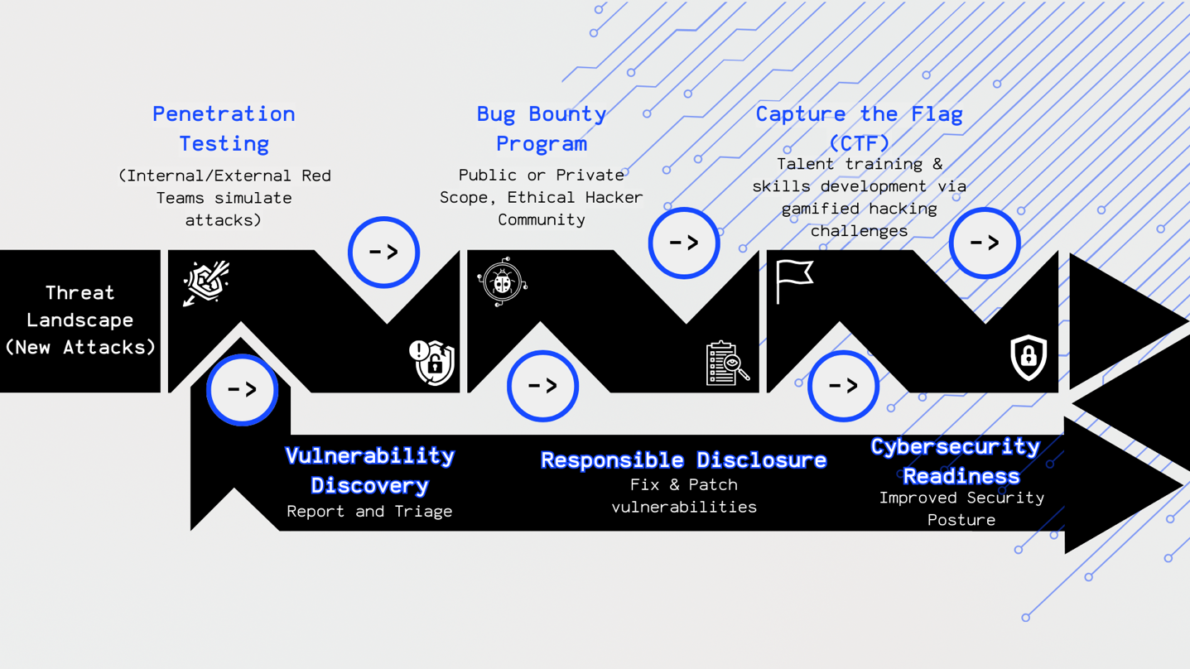Figure 1: Workflow Diagram: Ethical Hacking in Cybersecurity Lifecycle

References
EC-Council. (2025, April 16). CEH Certification | Certified Ethical Hacker Course | EC-Council. https://www.eccouncil.org/train-certify/certified-ethical-hacker-ceh/​
Mell, P., Scarfone, K., & Romanosky, S. (2008). Technical guide to information security testing and assessment (NIST Special Publication 800-115). National Institute of Standards and Technology. https://csrc.nist.gov/publications/detail/sp/800-115/final​
Ransome, J., & Misra, A. (2018). Core software security: Security at the source. CRC Press. https://www.routledge.com/Core-Software-Security-Security-at-the-Source/Ransome-Misra/p/book/9781466560963​
Zhou, Y., Sharma, A., & Luo, X. (2020). Bug bounty programs: Hackers’ motivation and corporations’ security strategies. Journal of Cybersecurity, 6(1). https://academic.oup.com/cybersecurity/article/6/1/tyaa004/5867189​
HackerOne. (2024). Hacker-powered security: The 2023 HackerOne report. https://www.hackerone.com/resources/reporting/8th-hacker-powered-security-report​HackerOne+1HackerOne+1
SANS Institute. (2022). CTF and cyber ranges: Training for real-world cybersecurity. https://www.sans.org/cyber-ranges/​
Assal, H., & Chiasson, S. (2019). Security in the software development lifecycle: A systematic literature review. Empirical Software Engineering, 24(1), 1–43. https://link.springer.com/article/10.1007/s10664-018-9610-4​
MITRE. (2023). MITRE ATT&CK framework: Understanding adversary tactics and techniques. https://attack.mitre.org/​
Bratus, S., Shubina, A., Locasto, M. E., & Liffiton, M. H. (2021). From CTF to cyber defense education: Lessons learned. IEEE Security & Privacy, 19(5), 82–87. https://ieeexplore.ieee.org/document/9545321​
Bugcrowd. (2023). The state of bug bounty 2023. https://www.bugcrowd.com/resources/reports/state-of-bug-bounty-2023/

