#Name: Hui Lyu

# Main topic: Using the "apply" family function

#Q1 (5 pts)

# Given a function below,

myfunc <- function(z) return(c(z,z^2, z^3%/%2))

#(1) Examine the following code, and briefly explain what it is doing.

y = 2:8

myfunc(y)

matrix(myfunc(y),ncol=3)

### Your explanation

# First generate a vector named y of seven consecutive integers from 2 to 8

# Then pass the value of y to the established function myfunc to compute corresponding return values

# Finally reformat the values into a matrix of 3 columns

# The first column represents the value of y, the second column represents y^2, the third column represents y^3%/%2.

# Each row of the matrix contains three return values based on myfunc of each element in y.

> y = 2:8

> myfunc(y)

[1] 2 3 4 5 6 7 8 4 9 16 25 36 49 64 4 13 32 62 108 171 256

> matrix(myfunc(y),ncol=3)

[,1] [,2] [,3]

[1,] 2 4 4

[2,] 3 9 13

[3,] 4 16 32

[4,] 5 25 62

[5,] 6 36 108

[6,] 7 49 171

[7,] 8 64 256

#(2) Simplify the code in (1) using one of the "apply" functions and save the result as m.

###code & result

m = t(sapply(2:8, myfunc))

> m = t(sapply(2:8, myfunc))

> m

[,1] [,2] [,3]

[1,] 2 4 4

[2,] 3 9 13

[3,] 4 16 32

[4,] 5 25 62

[5,] 6 36 108

[6,] 7 49 171

[7,] 8 64 256

#(3) Find the row product of m.

###code & result

apply(m,1,prod)

> apply(m,1,prod)

[1] 32 351 2048 7750 23328 58653 131072

#(4) Find the column sum of m in two ways.

###code & result

apply(m,2,sum)

colSums(m)

> apply(m,2,sum)

[1] 35 203 646

> colSums(m)

[1] 35 203 646

#(5) Could you divide all the values by 2 in two ways?

### code & result

m/2

apply(m, 1:2, function(x) x/2)

> m/2

[,1] [,2] [,3]

[1,] 1.0 2.0 2.0

[2,] 1.5 4.5 6.5

[3,] 2.0 8.0 16.0

[4,] 2.5 12.5 31.0

[5,] 3.0 18.0 54.0

[6,] 3.5 24.5 85.5

[7,] 4.0 32.0 128.0

> apply(m, 1:2, function(x) x/2)

[,1] [,2] [,3]

[1,] 1.0 2.0 2.0

[2,] 1.5 4.5 6.5

[3,] 2.0 8.0 16.0

[4,] 2.5 12.5 31.0

[5,] 3.0 18.0 54.0

[6,] 3.5 24.5 85.5

[7,] 4.0 32.0 128.0

#Q2 (8 pts)

#Create a list with 2 elements as follows:

l <- list(a = 1:10, b = 11:20)

#(1) What is the product of the values in each element?

lapply(l,prod)

> lapply(l,prod)

$a

[1] 3628800

$b

[1] 670442572800

#(2) What is the (sample) variance of the values in each element?

lapply(l,var)

> lapply(l,var)

$a

[1] 9.166667

$b

[1] 9.166667

#(3) What type of object is returned if you use lapply? sapply? Show your R code that finds these answers.

> class(lapply(l,var))

[1] "list"

> class(sapply(1,var))

[1] "numeric"

# lapply returns a list, while sapply returns a vector whose type is numeric for this variable

# Now create the following list:

l.2 <- list(c = c(21:30), d = c(31:40))

#(4) What is the sum of the corresponding elements of l and l.2, using one function call?

mapply(sum, l$a, l$b, l.2$c, l.2$d)

> mapply(sum, l$a, l$b, l.2$c, l.2$d)

[1] 64 68 72 76 80 84 88 92 96 100

#(5) Take the log of each element in the list l:

sapply(l, log)

> sapply(l, log)

a b

[1,] 0.0000000 2.397895

[2,] 0.6931472 2.484907

[3,] 1.0986123 2.564949

[4,] 1.3862944 2.639057

[5,] 1.6094379 2.708050

[6,] 1.7917595 2.772589

[7,] 1.9459101 2.833213

[8,] 2.0794415 2.890372

[9,] 2.1972246 2.944439

[10,] 2.3025851 2.995732

#(6) First change l and l.2 into matrixes, make each element in the list as column,

### your code here

l = matrix(unlist(l), ncol = 2)

l.2 = matrix(unlist(l.2), ncol = 2)

> l = matrix(unlist(l), ncol = 2)

> l.2 = matrix(unlist(l.2), ncol = 2)

> l

[,1] [,2]

[1,] 1 11

[2,] 2 12

[3,] 3 13

[4,] 4 14

[5,] 5 15

[6,] 6 16

[7,] 7 17

[8,] 8 18

[9,] 9 19

[10,] 10 20

> l.2

[,1] [,2]

[1,] 21 31

[2,] 22 32

[3,] 23 33

[4,] 24 34

[5,] 25 35

[6,] 26 36

[7,] 27 37

[8,] 28 38

[9,] 29 39

[10,] 30 40

#Then, form a list named mylist using l,l.2 and m (from Q1) (in this order).

### your code here

mylist = list(l=l,l.2=l.2,m=m)

> mylist = list(l=l,l.2=l.2,m=m)

> mylist

$l

[,1] [,2]

[1,] 1 11

[2,] 2 12

[3,] 3 13

[4,] 4 14

[5,] 5 15

[6,] 6 16

[7,] 7 17

[8,] 8 18

[9,] 9 19

[10,] 10 20

$l.2

[,1] [,2]

[1,] 21 31

[2,] 22 32

[3,] 23 33

[4,] 24 34

[5,] 25 35

[6,] 26 36

[7,] 27 37

[8,] 28 38

[9,] 29 39

[10,] 30 40

$m

[,1] [,2] [,3]

[1,] 2 4 4

[2,] 3 9 13

[3,] 4 16 32

[4,] 5 25 62

[5,] 6 36 108

[6,] 7 49 171

[7,] 8 64 256

#Then, select the first column of each elements in mylist in one function call (hint '[' is the select operator).

### your code here

lapply(mylist, function(l) l[,1])

> lapply(mylist, function(l) l[,1])

$l

[1] 1 2 3 4 5 6 7 8 9 10

$l.2

[1] 21 22 23 24 25 26 27 28 29 30

$m

[1] 2 3 4 5 6 7 8

#Q3 (3 pts)

# Let's load our friend family data again.

load(url("http://courseweb.lis.illinois.edu/~jguo24/family.rda"))

#(1) Find the mean bmi by gender in one function call.

tapply(family$bmi,family$gender,mean)

> tapply(family$bmi,family$gender,mean)

m f

25.73898 23.02564

#(2) Could you get a vector of what the type of variables the dataset is made of?

sapply(family, class)

> sapply(family, class)

firstName gender age height weight bmi overWt

"factor" "factor" "integer" "numeric" "integer" "numeric" "logical"

#(3) Could you sort the firstName in height descending order?

family$firstName[order(family$height, decreasing = TRUE)]

> family$firstName[order(family$height, decreasing = TRUE)]

[1] Joe Tom Tom Liz Jon Tim Bob Ann Dan Art Sal May Sue Zoe

Levels: Ann Art Bob Dan Joe Jon Liz May Sal Sue Tim Tom Zoe

#Q4 (2 pts)

# There is a famous dataset in R called "iris." It should already be loaded

# in R for you. If you type in ?iris you can see some documentation. Familiarize

# yourself with this dataset.

#(1) Find the mean petal length by species.

### code & result

tapply(iris$Petal.Length, iris$Species, mean)

> tapply(iris$Petal.Length, iris$Species, mean)

setosa versicolor virginica

1.462 4.260 5.552

#(2) Now obtain the sum of the first 4 variables, by species, but using only one function call.

### code & result

by(iris[, 1:4], iris$Species, colSums)

> by(iris[, 1:4], iris$Species, colSums)

iris$Species: setosa

Sepal.Length Sepal.Width Petal.Length Petal.Width

250.3 171.4 73.1 12.3

------------------------------------------------------------------------

iris$Species: versicolor

Sepal.Length Sepal.Width Petal.Length Petal.Width

296.8 138.5 213.0 66.3

------------------------------------------------------------------------

iris$Species: virginica

Sepal.Length Sepal.Width Petal.Length Petal.Width

329.4 148.7 277.6 101.3

#Q5 (2 pts)

#Below are two statements, their results have different structure,

lapply(1:4, function(x) x^3)

sapply(1:4, function(x) x^3)

# Could you change one of them to make the two statements return the same results (type of object)?

unlist(lapply(1:4, function(x) x^3))

> lapply(1:4, function(x) x^3)

[[1]]

[1] 1

[[2]]

[1] 8

[[3]]

[1] 27

[[4]]

[1] 64

> sapply(1:4, function(x) x^3)

[1] 1 8 27 64

> unlist(lapply(1:4, function(x) x^3))

[1] 1 8 27 64

> class(unlist(lapply(1:4, function(x) x^3)))

[1] "numeric"

> class(sapply(1:4, function(x) x^3))

[1] "numeric"

#Q6. (5 pts) Using the family data, fit a linear regression model to predict

# weight from height. Place your code and output (the model) below.

lm(family$weight ~ family$height, data = family)

> lm(family$weight ~ family$height, data = family)

Call:

lm(formula = family$weight ~ family$height, data = family)

Coefficients:

(Intercept) family$height

-455.666 9.154

# The model is: weight = -455.666 + 9.154*height

# How do you interpret this model?

# The weight has a positive correlation with height since the slope 9.154>0. As height goes up,

# the corresponding weight also goes up. This conforms to our common sense. The intercept is below 0,

# which means the value of weight is below 0 when height equals 0. This is a sort of parallel movement

# to make it adjust to the data.

# Create a scatterplot of height vs weight. Add the linear regression line you found above.

plot(family$height, family$weight, xlab = "height", ylab = "weight", main = "plot of weight ~ height")

abline(lm(family$weight ~ family$height, data = family), col='red')

> plot(family$height, family$weight, xlab = "height", ylab = "weight", main = "plot of weight ~ height")

> abline(lm(family$weight ~ family$height, data = family), col='red')

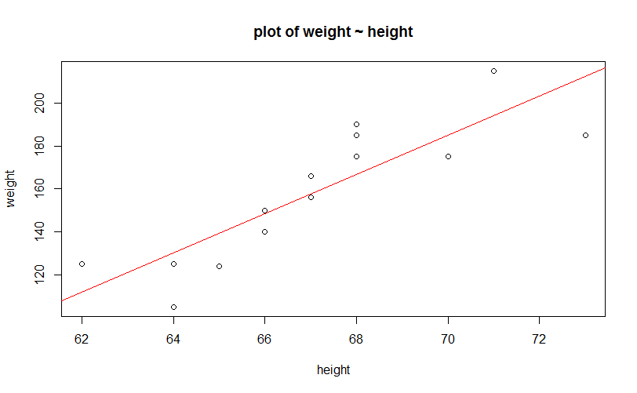

# Provide an interpretation for your plot.

# In the plot, the scattered spots are true values of 14 objects in the family dataset. The x

# axis is height, and the y axis is weight. Basically, as height goes up, his or her weight

# also goes up. The red line is the linear regression line based on the 14 objects. As can be

# seen, the number of spots under the line is equal to the number of spots above the line. All

# the spots are basically close to the line, which means the residuals are not too large. There

# is no outlier in the plot. In general, it is a good linear model based on true observations.

> summary(lm(family$weight ~ family$height, data = family))

Call:

lm(formula = family$weight ~ family$height, data = family)

Residuals:

Min 1Q Median 3Q Max

-27.554 -9.689 -0.055 11.944 23.214

Coefficients:

Estimate Std. Error t value Pr(>|t|)

(Intercept) -455.666 107.029 -4.257 0.00111 **

family$height 9.154 1.594 5.741 9.29e-05 ***

---

Signif. codes: 0 ‘***’ 0.001 ‘**’ 0.01 ‘*’ 0.05 ‘.’ 0.1 ‘ ’ 1

Residual standard error: 16.94 on 12 degrees of freedom

Multiple R-squared: 0.7331, Adjusted R-squared: 0.7109

F-statistic: 32.96 on 1 and 12 DF, p-value: 9.287e-05

# P-value is also very small, which means a good linear model.