### Part 1: Linear Regression Concepts

## These questions do not require coding but will explore some important concepts from lecture 5.

## "Regression" refers to the simple linear regression equation:

## y = B0 + B1*x

## This homework will not discuss any multivariate regression.

## 1. (1 pt)

## What is the interpretation of the coefficient B1?

## (What meaning does it represent?)

## Your answer

## B1 is the slope of the regression line. B1 > 0 means positive correlation between y and x.

## B1 < 0 means negative correlation. B1 = 0 means no correlation between y and x.

## 2. (1 pt)

## If the residual sum of squares (RSS) of my regression is exactly 0, what does

## that mean about my model?

## Your answer

## It means there is no discrepancy between the data and the estimation model.

## The model is a perfect fit of the data. There is no error.

## 3. (2 pt)

## Outliers are problems for many statistical methods, but are particularly problematic

## for linear regression. Why is that? It may help to define what outlier means in this case.

## (Hint: Think of how residuals are calculated)

## Your answer

## Because extreme values of observed variables can distort estimates of regression coefficients.

## A point which lies far from the line (and thus has a large residual value) is known as an outlier.

## Such points may represent erroneous data, or may indicate a poorly fitting regression line.

## Residuals are the deviations from the fitted line to the observed values.

## If an outlier lies far from the other data especially in the horizontal direction, it may have a

## significant impact on the slope of the linear regression line. So outliers are particularly

## problematic for linear regression.

### Part 2: Sampling and Point Estimation

## The following problems will use the ggplot2movies data set and explore

## the average movie length of films in the year 2000.

## Load the data by running the following code

install.packages("ggplot2movies")

library(ggplot2movies)

data(movies)

## 4. (2 pts)

## Subset the data frame to ONLY include movies released in 2000.

> movies2000 = movies[movies$year==2000,]

## Use the sample function to generate a vector of 1s and 2s that is the same

## length as the subsetted data frame. Use this vector to split the 'length' variable into two vectors, length1 and length2.

## IMPORTANT: Make sure to run the following seed function before you run your sample

## function. Run them back to back each time you want to run the sample function.

## Check: If you did this properly, you will have 1035 elements in length1 and 1013 elements

## in length2.

> dim(movies2000)

[1] 2048 24

> set.seed(1848)

> length.vector = sample(1:2, size = 2048, replace = TRUE)

> length1 = movies2000$length[which(length.vector==1)]

> length2 = movies2000$length[which(length.vector==2)]

> length(length1)

[1] 1035

> length(length2)

[1] 1013

## 5. (3 pts)

## Calculate the mean and the standard deviation for each of the two

## vectors, length1 and length2. Use this information to create a 95%

## confidence interval for your sample means. Compare the confidence

## intervals -- do they seem to agree or disagree?

## Your answer here

> mean1 = mean(length1)

> sd1 = sd(length1)

> mean2 = mean(length2)

> sd2 = sd(length2)

> interval1 = c(mean1 - 1.96 * sd1/sqrt(length(length1)), mean1 + 1.96 * sd1/sqrt(length(length1)))

> interval2 = c(mean2 - 1.96 * sd2/sqrt(length(length2)), mean2 + 1.96 * sd2/sqrt(length(length2)))

> interval1

[1] 75.89484 80.77762

> interval2

[1] 77.59924 82.44222

## The 95% confidence interval of length1 is [75.89484, 80.77762].

## The 95% confidence interval of length2 is [77.59924, 82.44222].

## The two confidence intervals seem to agree. Though there are about 2 minutes’ difference

## between them, they are mostly overlapping.

## 6. (4 pts)

## Draw 100 observations from a standard normal distribution. Calculate the sample mean.

## Repeat this 100 times, storing each sample mean in a vector called mean_dist.

## Plot a histogram of mean_dist to display the sampling distribution.

## How closely does your histogram resemble the standard normal? Explain why it does or does not.

## Your answer here

mean_dist = rep(0, 100)

for (i in 1:100){

mean_dist[i] = mean(rnorm(100))

}

hist(mean_dist)

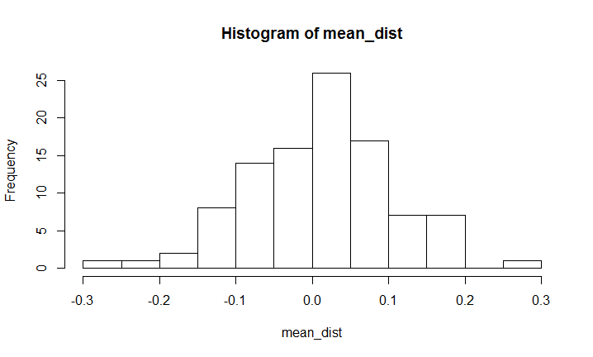

## My histogram basically resembles the standard normal. According to central limit theorem,

## the distribution of sample means is approximately normal distribution when the sample size

## is large enough. The mean of the sample means is equal to the mean of the original population, which is 0.

## The standard deviation of the sample means is equal to 1/sqrt(100) in this case. So the

## histogram of sample means resembles normal distribution, but not exactly standard. The mean is still 0,

## but the standard deviation is 1/sqrt(100). It is obvious to get a normal distribution because of randomness.

## 7. (3 pts)

## Write a function that implements Q6.

## Your answer here

HW.Bootstrap=function(distn=rnorm,n,reps){

set.seed(1848)

#more lines here

mean_dist = rep(0, reps)

for (i in 1:reps){

mean_dist[i] = mean(distn(n))

}

hist(mean_dist)

}

HW.Bootstrap(n=100, reps = 100)

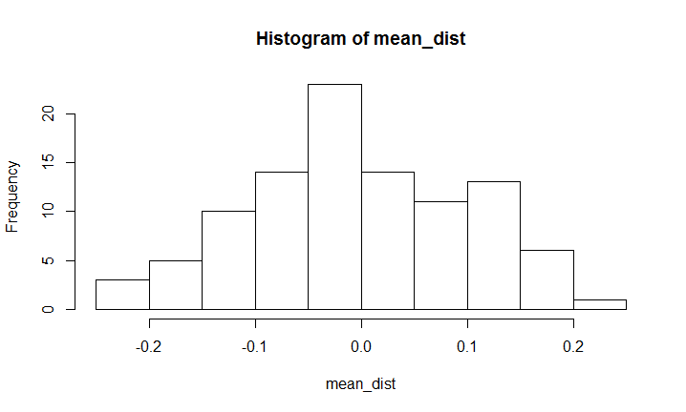

### Part 3: Linear Regression

## This problem will use the Boston Housing data set.

## Before starting this problem, we will declare a null hypothesis that the

## crime rate has no effect on the housing value for Boston suburbs.

## That is: H0: B1 = 0

## HA: B1 =/= 0

## We will attempt to reject this hypothesis by using a linear regression

# Load the data

housing <- read.table(url("https://archive.ics.uci.edu/ml/machine-learning-databases/housing/housing.data"),sep="")

names(housing) <- c("CRIM","ZN","INDUS","CHAS","NOX","RM","AGE","DIS","RAD","TAX","PTRATIO","B","LSTAT","MEDV")

## 7. (2 pt)

## Fit a linear regression using the housing data using CRIM (crime rate) to predict

## MEDV (median home value). Examine the model diagnostics using plot(). Would you consider this a good model or not? Explain.

lm(formula = housing$MEDV ~ housing$CRIM, data = housing)

> lm(formula = housing$MEDV ~ housing$CRIM, data = housing)

Call:

lm(formula = housing$MEDV ~ housing$CRIM, data = housing)

Coefficients:

(Intercept) housing$CRIM

24.0331 -0.4152

plot(lm(formula = housing$MEDV ~ housing$CRIM, data = housing))

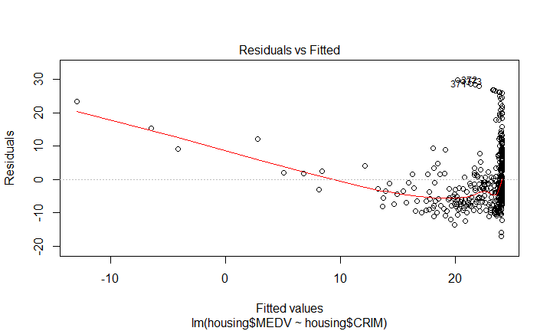

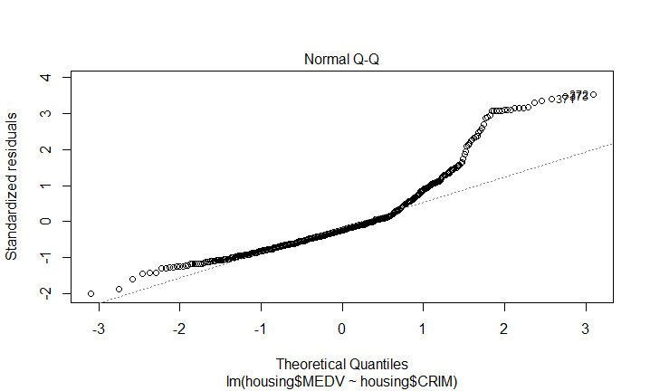

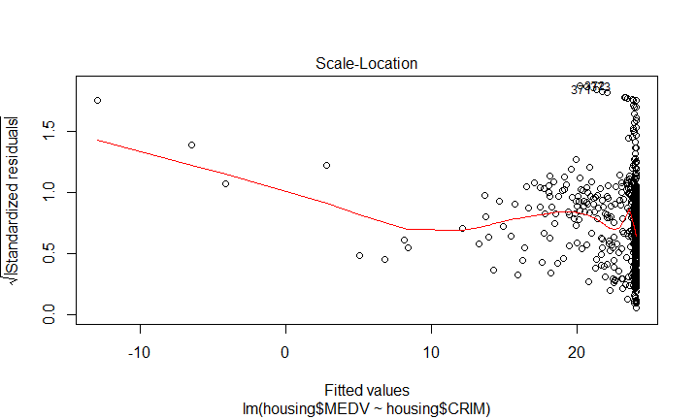

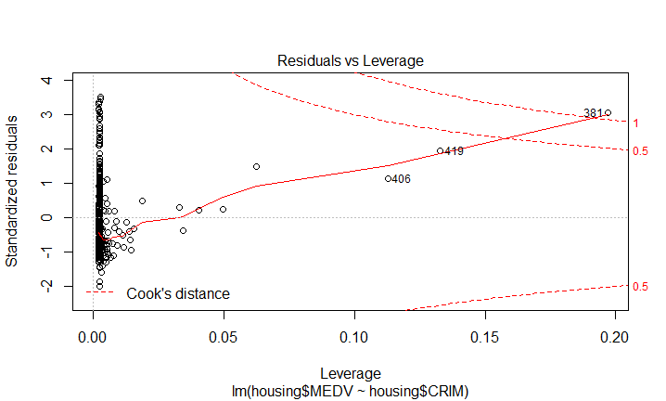

## The model is MEDV = 24.0331 - 0.4152*CRIM

## I think it is not a good model. In the Residuals vs Fitted graph, the red line is not close to

## the zero line and it is not parallel to the zero line. Some are obviously positive residuals

## and others are obviously negative residuals. In the Normal Q-Q graph, half values of data

## fit well with the line. But half obviously deviate from the line. In the Scale-Location graph,

## most data gather in the right edge of the graph and disperse. So from the Residuals vs Fitted

## graph and the Scale-Location graph, we can see that several values on the left might be regarded

## as outliers. The model might be well generated when leaving out those outliers. And in the Residuals

## vs Leverage graph, one value is beyond the 1 cook's distance line, which is not good.

## 8. (2 pts)

## Using the information from summary() on your model, create a 95% confidence interval

## for the CRIM coefficient

> summary(lm(formula = housing$MEDV ~ housing$CRIM, data = housing))

Call:

lm(formula = housing$MEDV ~ housing$CRIM, data = housing)

Residuals:

Min 1Q Median 3Q Max

-16.957 -5.449 -2.007 2.512 29.800

Coefficients:

Estimate Std. Error t value Pr(>|t|)

(Intercept) 24.03311 0.40914 58.74 <2e-16 ***

housing$CRIM -0.41519 0.04389 -9.46 <2e-16 ***

---

Signif. codes: 0 ‘***’ 0.001 ‘**’ 0.01 ‘*’ 0.05 ‘.’ 0.1 ‘ ’ 1

Residual standard error: 8.484 on 504 degrees of freedom

Multiple R-squared: 0.1508, Adjusted R-squared: 0.1491

F-statistic: 89.49 on 1 and 504 DF, p-value: < 2.2e-16

> CRIM.coefficient = -0.41519

> CRIM.sd = 0.04389

> CRIM.interval = c(CRIM.coefficient - 1.96 * CRIM.sd/sqrt(506), CRIM.coefficient + 1.96 * CRIM.sd/sqrt(506))

> CRIM.interval

[1] -0.4190143 -0.4113657

## The 95% confidence interval of CRIM coefficient is [-0.4190143, -0.4113657].

## 9. (2 pts)

## Based on the result from question 8, would you reject the null hypothesis or not?

## (Assume a significance level of 0.05). Explain.

## Your answer

## I would reject the null hypothesis because the p-value is far less than 0.05. It means

## a significant correlation. Besides, the 95% confidence interval of CRIM coefficient does

## not have any overlap with zero.

## 10. (1 pt)

## Pretend that the null hypothesis is true. Based on your decision in the previous

## question, would you be committing a decision error? If so, which one?

## Your answer

## If the null hypothesis is true, I would be committing a decision error. That's Type 1 Error.

## 11. (1 pt)

## Use the variable definitions from this site:

## https://archive.ics.uci.edu/ml/machine-learning-databases/housing/housing.names

## Discuss what your regression results mean in the context of the data (using appropriate units)

## (Hint: Think back to Question 1)

## Your answer

## My regression results reflect a significant negative correlation between MEDV and CRIM.

## That means as the per capita crime rate by town goes up, the median value of

## owner-occupied homes in $1000's goes down. Based on the regression line, for example, the per capita

## crime rate rises from 0.5% to 1%, the median value of owner-occupied homes drops from

## $23826 to $23618.

## 12. (2 pt)

## Describe the LifeCycle of Data for Part 3 of this homework.

## In a data lifecycle, we could first think about data collection. For Part 3, housing dataset

## was collected in 1978 by Harrison, D. and Rubinfeld, D.L. Then after data cleaning and preprocessing,

## Boston Housing Data was taken from the StatLib library of Carnegie Mellon University in 1993.

## Loading the housing data to R Studio can be regarded as a data exploration. It has 506 observations

## and 14 variables. Then we choose MEDV and CRIM two columns from the dataset to make mathematical

## computation for the interest of the correlation between crime rate and median home value.

## Then, to make data inference and prediction, we establish a linear regression model to find the

## correlation and coefficients. Plot of the model is a data visualization and presentation part.

## Then the summary, hypothesis testing and confidence interval are further data analysis.

## Finally, the regression model can draw a qualitative and quantitative conclusion of the correlation

## and make knowledge discovery. This correlation conclusion idea should be shared and re-used

## for future data analysis in the whole lifecycle.