Pre-PPDEM V1.0

The program functions as a Pre-Processor for users to customize the shape (in this case, five options are available: circle, ellipse, triangle, rectangle and pentagon) and grading of specimens and generate output files which can be directly used as input files for PPDEM.

Users are expected to provide .txt files to describe grading composition of specimens following some rules. In each line users are requested to list one diameter and the percentage finer than it and split them by one space, and the unit of length is millmeter.

#example#

10 100

5 95

1 75

0.5 60

#example#

This software is designed for creating input files for a discrete element simulation package PPDEM (Polyarc Parallel-processing Discrete Element Modeling) developed by Pengcheng, Fu. The focus of this software is laid on customized grading and shape characteristics. There are basically two shape parameters for polygons. One is angular limit and the other one is roundness. Here take pentagon as an example. The angular position of a vertex k of a standard pentagon can be determined by θk = θ0 + 2πk/5 where θ0 is the position of the first vertex. Pentagons with different shape characteristics can then be generated by disturbing randomly the position of vertex k within an angular limit ±π/5. It should be noted that large angular limit may contribute to incorrect shape. Roundness describes the scale of major surface features and here can be quantified as the average radius of curvature of each edge of the particle. The particle shape evolves from a standard pentagon to a circle with roundness r varying from 0.1 to 1.

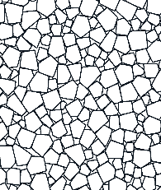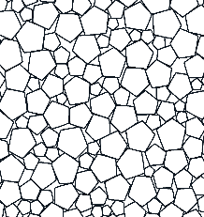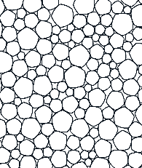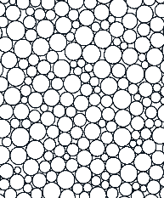

Angular Limit=π/5, r=0.1; Angular Limit=0, r=0; Angular Limit=0, r=0.5; Angular Limit=0, r=1

Fu, Pengcheng, O. R. Walton, and J. T. Harvey. "Polyarc discrete element for efficiently simulating arbitrarily shaped 2D particles." International Journal for Numerical Methods in Engineering89.5(2012):599–617.

Developed by Huinan Huang, Yuxuan Che, Fang Liu. Tongji University

All Rights Reserved.