Answer ALL questions in this section.

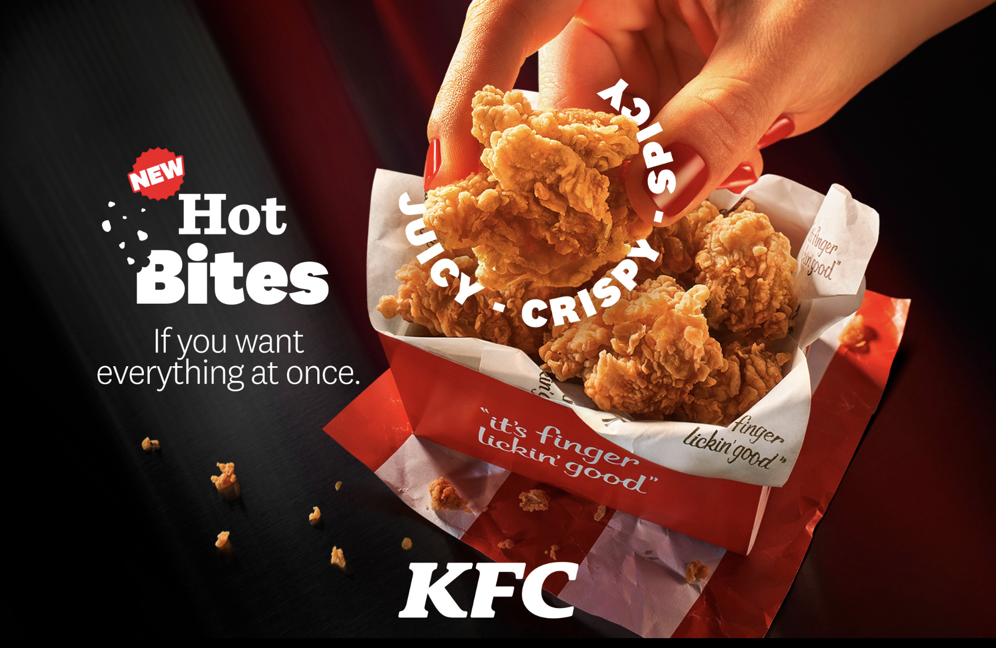
Figure 1: KFC

KFC is one of the largest fast-food restaurants in the world, serving more than one billion delicious means annually in more than 100 countries. With the enhancement of technology, KFC have been using many platforms in advertising as well as serving the customer in buying their product online. In keeping up with multiple competitors in the market, KFC have decided to redesign their website to improve the usability and user experience.

In the initial stage of the development in redesigning the application, the design team, have executed the data gathering activities to acquire relevant data in building the requirements needed. After the activities have been executed completely, the team analyses the data, and the user personas below summarizes the findings of the user profile and some of the user requirements for the website redesign.

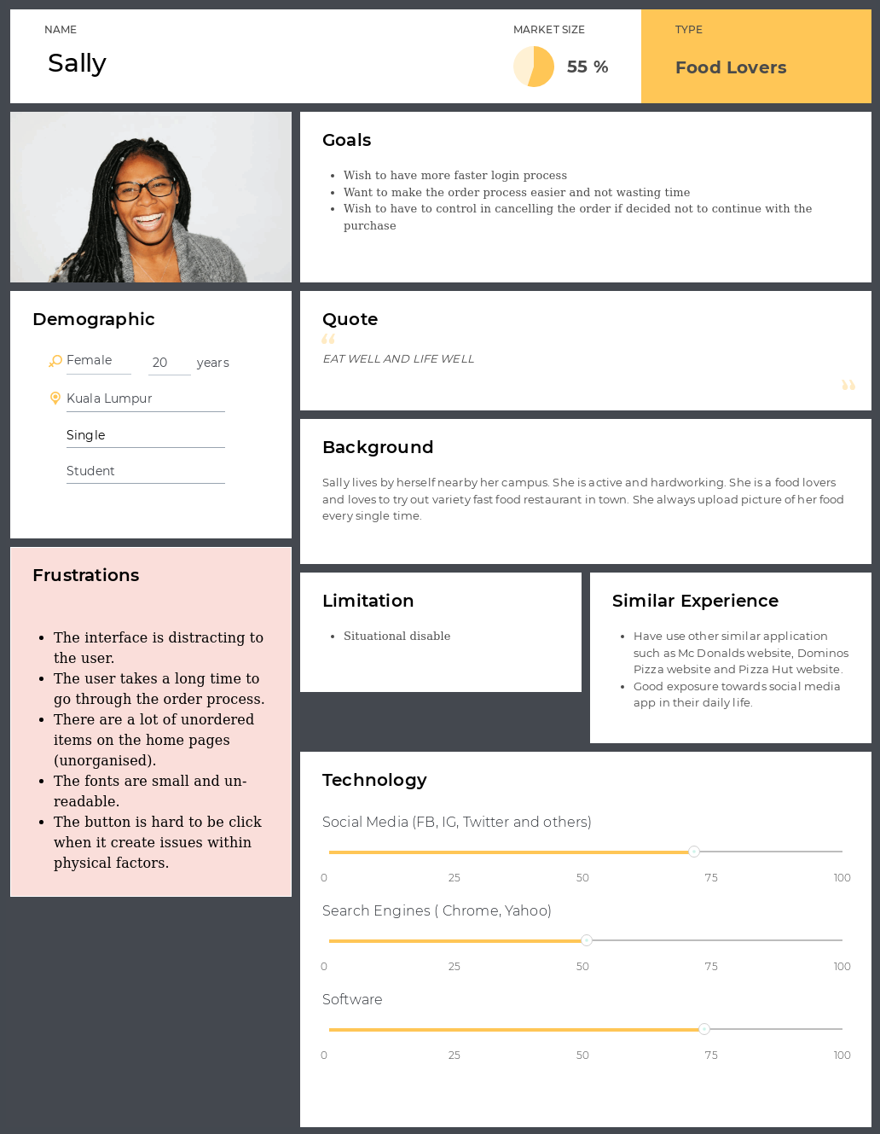

Figure 2: KFC User Personas

Question 1

From the user persona given in the scenario, identify ONE (1) human factor that can be observed and discussed with justifications, what are the issues that you are able to identify under the mentioned factor that can influence the performance of the targeted audience.

(5 marks)

Question 2
Critically discuss THREE (3) suitable solutions for the human factor identified above.

(6 marks)

Question 3

In order to analyse further towards the order process, the activities of tasks analysis need to take place. Produce the Hierarchical Task Analysis (HTA) in the form of textual representation for the task mentioned.
(6 marks)

Question 4

Based on the data shown in the user persona, critically discuss ONE (1) main usability goal that is suitable to be the aim and direction in redesigning the KFC website for the targeted audience.
(5 marks)

Question 5

Critically discuss any THREE (3) suitable design guidelines to be used in achieving the usability goal mentioned above in designing the new interface for the KFC website.
(15 marks)

Question 6

From your observation and experience towards the current KFC website, what kind of metaphor is being used in the design? Identify and justify your answer.
(3 marks)

(Total 40 marks)

