**1. Introduction**

It partitions a GPS data collection of cows into three periods (**pre-day, daytime, post-day**) based on a given time file.

1. **Put the files into the folder**
2. Create a new folder in your Desktop or where you desire to put the GRAZEPARTITION program.
3. Put the jar file “GRAZEPARTITION.jar” into the folder.
4. Put the coordinate file and time file into the folder, which **default name is data.csv and time.csv respectively**.

The format of the file is showed as following:

1) Convert your **GPS data** into the CSV format and use the comma as the delimiter. In total, the CSV file should have 5 columns of basic information. They are: **CowID, date, time, northing, easting**. The CowID is the unique id of each cow. It’s could be an integer or a string of text. The format of Date is **yyyy-MM-dd**. The format of time is **HH:mm:dd**. The northing and easting are **float** numbers that represents the location of the cow at the time.

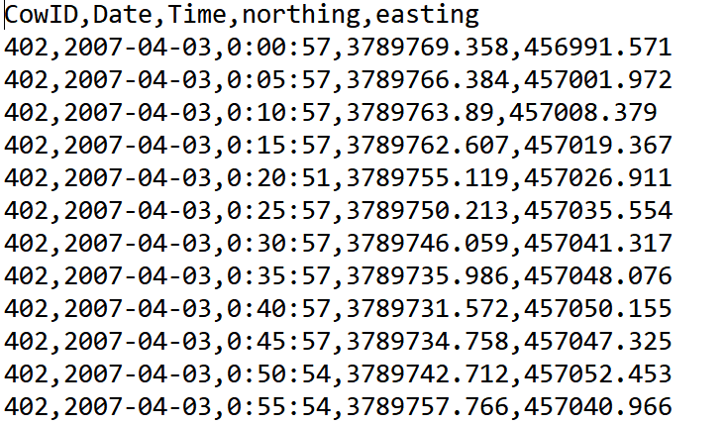

1. Convert your **time data** into the CSV format and use the comma as the delimiter. In total, the CSV file should have 3 columns of basic information. They are: **Date, Sunrise, Sunset.** The format of Date is **yyyy-MM-dd**. The format of Sunrise and Sunset is **HH:mm:dd**.

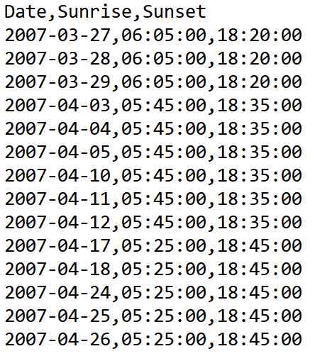

1. **Run The Code**

You could run the code from the Command line on Windows/Linux/MacOS.

The results will put in the same folder as the input files and the java program.

**The parameters:**

• input file of **coordination data**: the GPS data, default is named coordinate points.csv.

• input file of **time data**: the time data, default is named time.csv.

1. **Results of the Code**

The time file contains the information of the time of sunrise and sunset. All the GPS records are divided into pre.csv, day.csv, and post.csv, which contains the time of the GPS records that is before the sunrise, between the sunrise and sunset, and after the sunset, respectively.

**Sample pre.csv:**

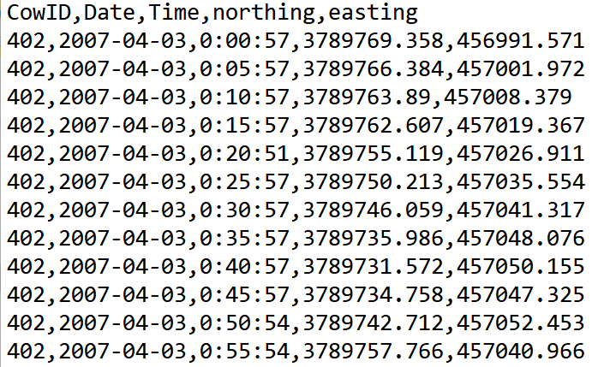

**Sample day.csv:**

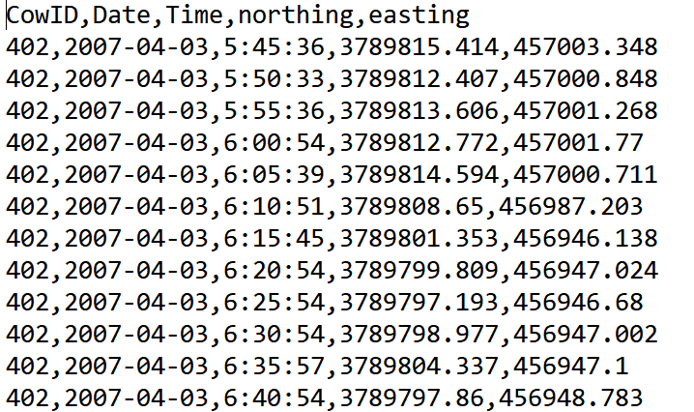

**Sample post.csv:**

