**在根目录下安装 hexo-wordcount,运行：**

**$ npm install hexo-wordcount --save**

**然后在主题的配置文件中，配置如下：**

**# Post wordcount display settings**

**#Dependencies:https://github.com/willin/hexo wordcount**

**post_wordcount:**

**item_text: true**

**wordcount: true**

**min2read: true**

**totalcount: true**

**统计本站字数默认是英文的，如想更改：**

**可在themes\next\layout\_partial\footer.swig搜索**

**post-meta-item-text字段,修改,如：**

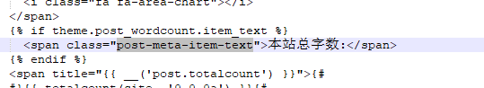

**同时，修改每篇文章统计字段**

**用 Sublime Text 工具打开 post.swig 文件，路径如下：xxx_blog/themes/next/layout/_macro/post.swig**

**修改【字数统计】，找到如下代码：**

**<span title="{{ __('post.wordcount') }}">**

**{{ wordcount(post.content) }}**

**</span>**

**添加 “字” 到 {{ wordcount(post.content) }} 后面，修改后为：**

**<span title="{{ __('post.wordcount') }}">**

**{{ wordcount(post.content) }} 字**

**</span>**

**同理，我们修改【阅读时长】，修改后如下：**

**<span title="{{ __('post.min2read') }}">**

**{{ min2read(post.content) }} 分钟**

**</span>**