**UNIVERSITI TUNKU ABDUL RAHMAN**

**Faculty of Information and Communication Technology**



**UCCD3084 Graphics Programming For Extended Reality**

**Title: Fire Extinguisher Training VR Simulation in a Factory**

**Group Name: SuperHero**

**Submission Date: 8 September 2025**

|  |  |  |  |
| --- | --- | --- | --- |
| **Name** | **Student ID** | **Course** | **Practical Group** |
| Eng Xian Yu | 22ACB07101 | CS | P2 |
| Lai Chin Hin | 21ACB03868 | CS | P4 |
| Lip Zhen Yi | 21ACB06737 | CS | P4 |
| Saw Hui Loo | 21ACB05280 | CS | P2 |

Table of Contents

1.Project Scope and Environment Design 3

2.Flowchart of Simulation 5

3.Screenshots of Key Scenes 8

4.Member Responsibilities 13

5.Appendices 14

# 1.Project Scope and Environment Design

The factory chosen for this project is an **electronic factory** focused on automated electronics manufacturing, designed to produce electronic components such as printed circuit boards (PCBs) and consumer electronics devices. The factory is equipped with machines used in PCB production, such as **robotic arms** that handle assembly, soldering, and component placement; **conveyor belt systems** are used to transport materials and products along the production line; **forklifts and automated machines** assist in moving raw materials components, and packed goods between storage and production areas.

The production flow of the factory begins with **raw material input**, where electronic components and printed circuit boards (PCBs) are unloaded and stored in organized areas. From there, the materials are transferred onto **conveyor systems** that guide them through the assembly process. **Pick-and-place machines** and **surface mount technology (SMT) equipment** place components onto PCBs with precision, after which **robotic arms** perform soldering and additional assembly tasks. Once assembled, the products move through **testing machines** and **quality control stations**, where defects are detected and corrected at an early stage.

The **electrical box explosion** has been modeled as the **main cause of fire** in the factory because in real-world electronic manufacturing environments, faulty wiring, overloaded circuits, or poor maintenance of electrical panels are among the leading causes of industrial fires. The **electrical box explosion** has been modeled as the **main cause of fire** in the factory because in real-world electronic manufacturing environments, faulty wiring, overloaded circuits, or poor maintenance of electrical panels are among the leading causes of industrial fires. When the fire is triggered, an **alarm system** is automatically activated. This immediate notification ensures that workers can stop operations, evacuate through emergency exits, and follow fire safety protocols without delay.

To control and prevent the spread of fire, a **fire extinguisher** is placed in the factory near high-risk areas, specifically the power box. This placement allows quick access for trained personnel to use the extinguisher and apply the PASS method to control the flames before they spread further. Together with the alarm system, the extinguisher acts as a first line of defense, ensuring that the fire can be managed safely and efficiently.

The simulation is also designed to look and feel realistic. The factory floor has colliders to stop objects from falling through the ground. Fire extinguishers and PCBs are given Rigidbody and Box Collider components so they can be picked up, carried, and used without dropping into the floor or disappearing. This makes the training more practical and interactive.

The project includes the PASS method for fire extinguisher training. PASS stands for **Pull, Aim, Squeeze, and Sweep**. In the simulation, users practice pulling the pin, aiming the nozzle at the base of the fire, squeezing the handle, and sweeping side to side to put out the flames. This helps users learn how to use a fire extinguisher correctly.

# 2.Flowchart of Simulation

MainMenu

|  |
| --- |
|  |

SampleScene

|  |
| --- |
|  |

|  |
| --- |
|  |

# 3. Screenshots of Key Scenes

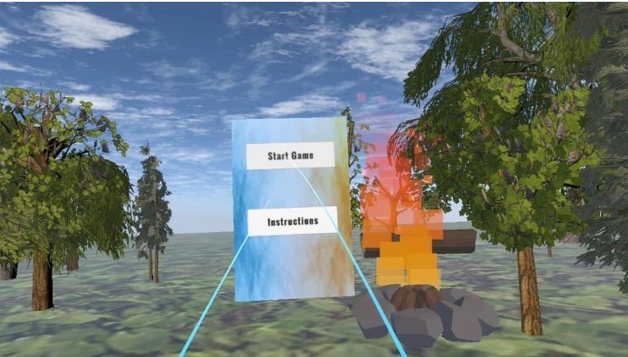Figure 3.1: Main Menu Scene User Panel

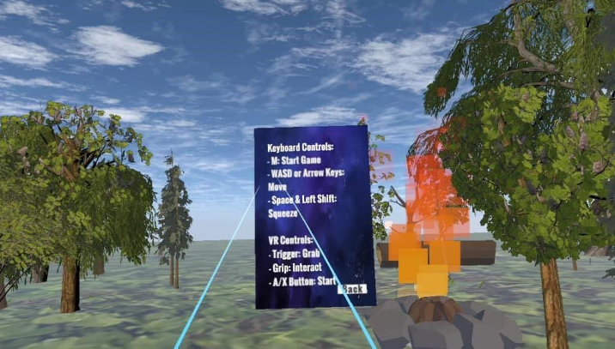Figure 3.2: Instructions Panel

Figure 3.3 Factory Interior and Factory Machine

Figure 3.4 Fire Extinguisher with alarm and Electrical Box

Figure 3.5: Circuit box grabbable

Figure 3.6 Alert Message and Machine

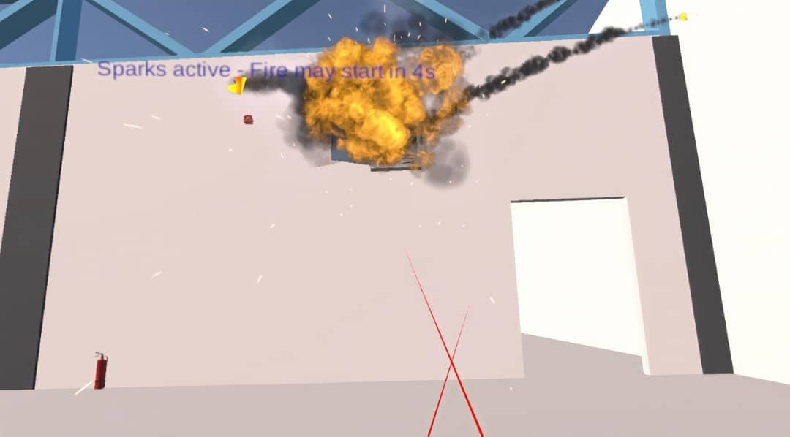Figure 3.7 Explosion of Electrical Box

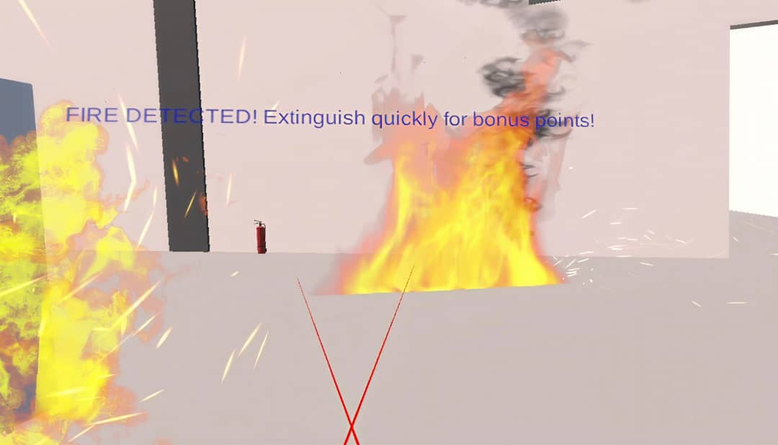Figure 3.8 Spreading of Fires

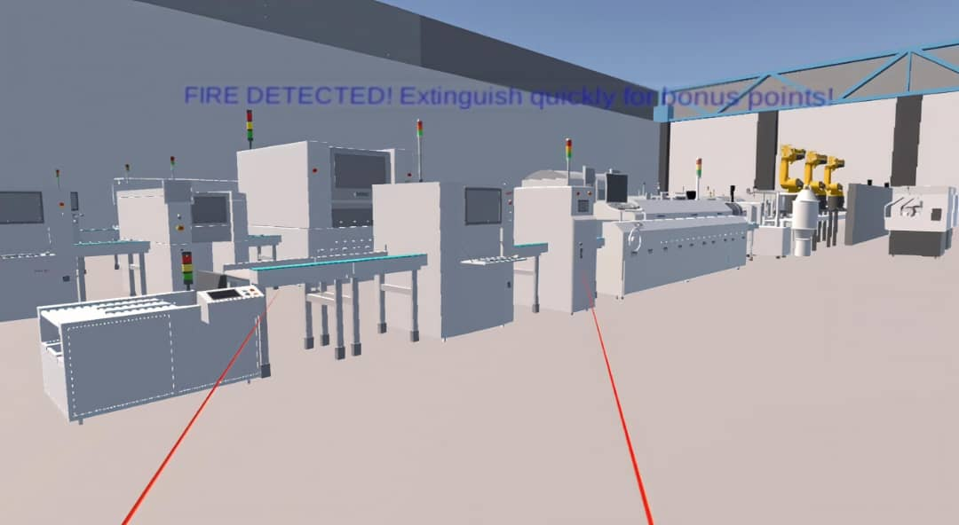Figure 3.9: Alert Message Tutorial

Figure 3.10: PASS Method - Pull the Pin

Figure 3.11: PASS Method - Aim the nozzle at the base of the fire

Figure 3.12: PASS Method - Squeeze the Handle and Sweep the Nozzle from Side to Side

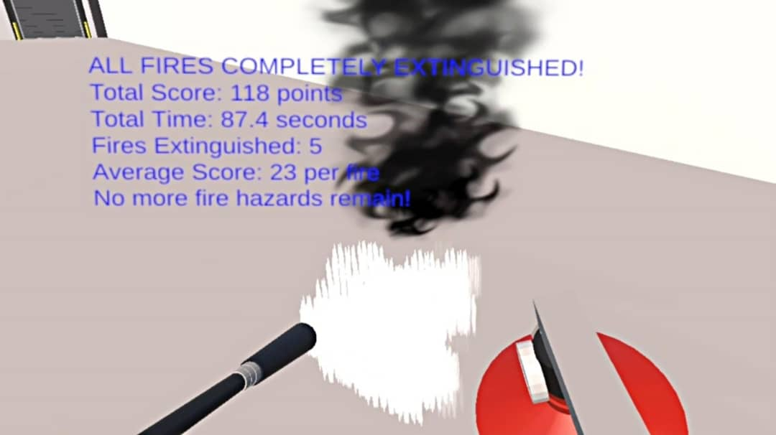Figure 3.13: Fire Extinguished and Mark Awarded

# 4.Member Responsibilities

|  |  |
| --- | --- |
| **Member** | **Contribution** |
| Eng Xian Yu | * Implemented the Squeeze functionality for the extinguisher. * Developed the Main Menu Scene. * Connected the **VR headset** to the project. * Combined presentation video. |
| Lai Chin Hin | * Implemented Squeeze with CO2 particles to extinguish fire. * Added Fire with Smoke particle effect. * Connected the **VR headset** to the project. * Drew a flowchart for the whole simulation flow. * Compiled the project report. * Completed real-time tracking and feedback features. |
| Lip Zhen Yi | * Connected the **VR headset** to the project. * **Assisted in scene setup** * Assisted in flowchart drawing * Assisted in completing real-time tracking and feedback features |
| Saw Hui Loo | * Designed the **Factory Scene**. * Implemented **Pull Pin** functionality. * Implemented **Power Box Explosion** effect. * Connected the **VR headset** to the project. * Added **Fire Alarm** system. * Cut presentation video. |

# 5.Appendices

|  |  |
| --- | --- |
| **1. Main Menu Scene** | |
| No. | Asset - Website Link |
| 1 | Floor - https://assetstore.unity.com/packages/2d/textures-materials/nature/yughues-free-ground-materials-13001 |
| 2 | SkyBox material -https://assetstore.unity.com/packages/2d/textures-materials/sky/skybox-series-free-103633 |
| 3 | Tree prefabs - https://assetstore.unity.com/packages/3d/vegetation/trees/european-forests-realistic-trees-229716 |
| 4 | Bonfire - https://assetstore.unity.com/packages/3d/environments/low-poly-nature-260306 |

|  |  |
| --- | --- |
| **2. Factory Scene** | |
| Figure No. | Asset - Website Link |
| 2.1 | Factory Interior - https://sketchfab.com/3d-models/dhp-b27-test-v12-59853d2fbefb406fa358fff9047c15ae |
| 2.2 | Factory Machine -https://3d.3d66.com/reshtmla/model/items/2R/2Raao15syVboYnHEB08p.html?sof=CCI070120819176523&sign=b2daafe68954c234 |
| 2.3 | Fire Extinguisher - https://sketchfab.com/3d-models/fire-extinguisher-be13188592f34cd39b872d10d546b839 |
| 2.4 | Electric Distribution Box - https://sketchfab.com/3d-models/electric-distribution-box-b5e233fbe3bf49b2a21fd186b07b190b |
| 2.5 | Fire - https://assetstore.unity.com/packages/vfx/particles/fire-explosions/free-fire-vfx-urp-266226 |
| 2.6 | Printed Circuit Board (PCBs) - https://sketchfab.com/3d-models/pcb-board-1c70e1e167c6480a9ec34007f0a41224 |
| 2.7 | Fire Alarm - https://sketchfab.com/3d-models/yodalarm-0727b5436d5846ea88ca281c2fa4617d |
| 2.8 | Free Stylized Smoke Effects Pack - https://assetstore.unity.com/packages/vfx/particles/fire-explosions/free-stylized-smoke-effects-pack-226406 |