1. Step 1. Open the nd2 images from ‘File’

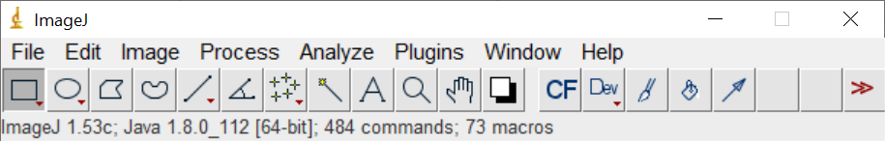

1. Step 2. Choose ‘Grayscale’ on Color mode

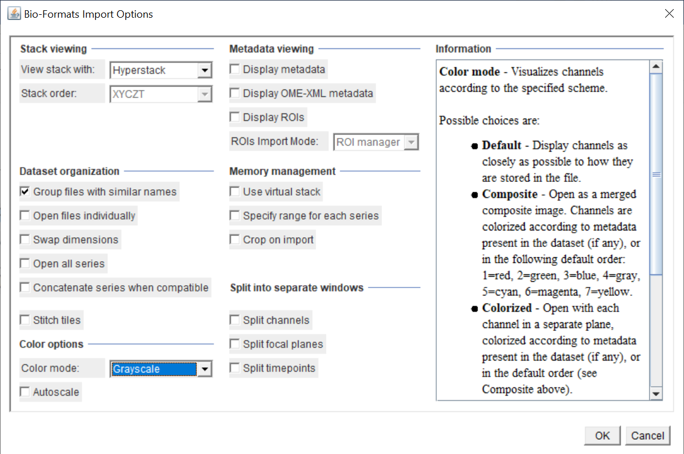

1. Step 3. A box prompts require you to fill in File Name, ignore it and press ‘OK’

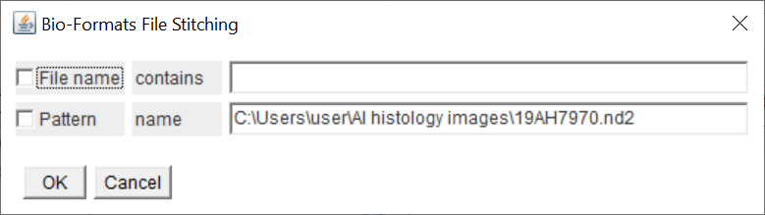

1. Finally a prom

