Session: Interaction Techniques and Frameworks ASSETS'17, Oct. 29–Nov. 1, 2017, Baltimore, MD, USA

**Epidemiology as a Framework for Large-Scale**

**Mobile Application Accessibility Assessment**

Anne Spencer Ross1, Xiaoyi Zhang1, James Fogarty1, Jacob O. Wobbrock2

1Computer Science & Engineering, 2The Information School

DUB Group, University of Washington Seattle, WA 98195 USA

{ansross, xiaoyiz, jfogarty}@cs.washington.edu, wobbrock@uw.edu

**ABSTRACT**   
Mobile accessibility is often a property considered at the level of a single mobile application (app), but rarely on a larger scale of the entire app “ecosystem,” such as all apps in an app store, their companies, developers, and user influences. We present a novel conceptual framework for the accessibility of mobile apps inspired by epidemiology. It considers apps within their ecosystems, over time, and at a population level. Under this metaphor, “inaccessibility” is a set of *diseases* that can be viewed through an epidemiological lens. Accordingly, our framework puts forth notions like *risk* and *protective factors*, *prevalence,* and *health indicators* found within a *population* of apps. This new framing offers terminology, motivation, and techniques to reframe how we approach and measure app accessibility. It establishes how app accessibility can benefit from multi-factor, longitudinal, and population-based analyses. Our epidemiology-inspired conceptual framework is the main contribution of this work, intended to provoke thought and inspire new work enhancing app accessibility at a systemic level. In a preliminary exercising of our framework, we perform an analysis of the *prevalence* of common *determinants* or accessibility barriers. We assess the *health* of a stratified sample of 100 popular Android apps using Google’s Accessibility Scanner. We find that 100% of apps have at least one of nine accessibility errors and examine which errors are most common. A preliminary analysis of the frequency of co-occurrences of multiple errors in a single app is also presented. We find 72% of apps have five or six errors, suggesting an interaction among different errors or an underlying influence.

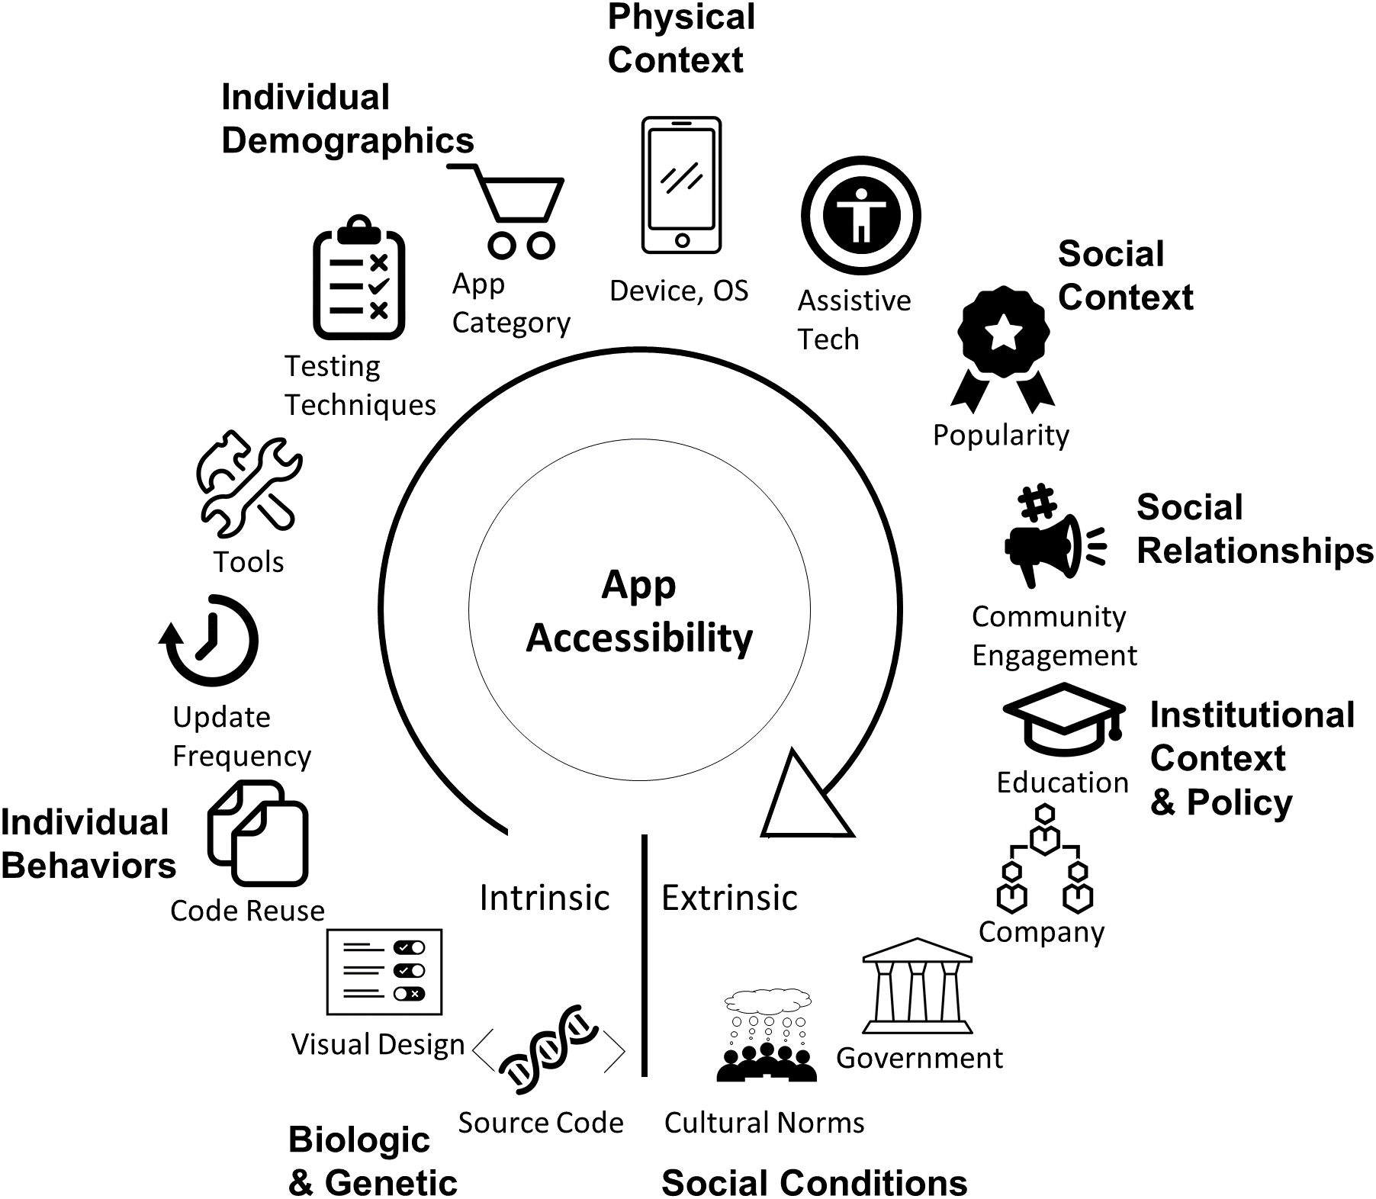

**Figure 1.** As a systems science, epidemiology can serve as a metaphor that changes the way we think and work with mobile app accessibility. Here, the concept of a multi-factor ecosystem from epidemiology has been applied to mobile app accessibility. An app’s accessibility is a product of many factors ranging from individual and intrinsic to population-level and extrinsic. These factors include: source code and design, behaviors, demographics, physical context,

|  |  |
| --- | --- |
| **CCS Concepts** • **Human-Centered Computing**➝**Accessibility**➝**Accessibility** | social context and relationships, institutional context and policies, and cultural norms. Accessibility is affected by factors at all levels. Figure inspired by [34]. |

**Theory, Concepts and Paradigms**

**Keywords**   
Mobile computing; mobile accessibility; app accessibility; accessibility assessment; conceptual framework; epidemiology.

**1. INTRODUCTION**   
Mobile applications (apps) play increasingly important roles in many aspects of life, including personal finances, communication, community engagement, and transportation. Supporting access to

Permission to make digital or hard copies of all or part of this work for personal or classroom use is granted without fee provided that copies are not made or distributed for profit or commercial advantage and that copies bear this notice and the full citation on the first page. Copyrights for   
components of this work owned by others than the author(s) must be honored. Abstracting with credit is permitted. To copy otherwise, or   
republish, to post on servers or to redistribute to lists, requires prior specific permission and/or a fee. Request permissions from [permissions@acm.org.](mailto:permissions@acm.org)

*ASSETS '17*, October 29-November 1, 2017, Baltimore, MD, USA © 2017 Copyright is held by the owner/author(s). Publication rights licensed to ACM.

ACM 978-1-4503-4926-0/17/10...$15.00 https://doi.org/10.1145/3132525.3132547

2

Session: Interaction Techniques and Frameworks

might address the inaccessibility of an individual app, but a population perspective on app accessibility might reveal the causes of systemic problems and suggest potential solutions. An example would be discovering that a widely-used interface toolkit was responsible for inaccessible widgets used in many apps.

ASSETS'17, Oct. 29–Nov. 1, 2017, Baltimore, MD, USA

app accessibility. Our framework highlights wide-ranging intrinsic and extrinsic factors that influence app accessibility, motivates the collection and analysis of large-scale data, and guides opportunities for enhancing treatments for app “diseases” of inaccessibility.

|  |  |  |
| --- | --- | --- |
| We propose an epidemiology-inspired framework for the examination | • | Empirical results from a framework-guided analysis of a |
| stratified sample of 100 apps from the Google Play Store. |
| of mobile app accessibility. We emphasize that this metaphor |
| Motivated to determine the extent of the disease in the |
| supports the social model of disability [29]. App accessibility is a |
| population, we found high *prevalence* with 100% of apps |
| community responsibility, as captured by our multi-factor framing |
| having an “inaccessibility disease” based on the nine |
| (see Figure 1) that guides how different parts of the community can |
| *determinants* scanned for*.* |
| contribute to app accessibility. As more companies invest resources |

into accessibility and more researchers investigate app accessibility, it becomes increasingly beneficial to have a conceptual framework from which to guide thought and action. Conceptual frameworks (e.g., [7]) give a common vocabulary to ground discussion, guide efforts to improve accessibility with known strategies, and illuminate opportunities not previously considered. We acknowledge that the concepts in our framework are numerous, but we believe that this is indicative of the richness of the framework and of its potential to inspire and inform thought and action.

Adapting a model from epidemiology [34], Figure 1 illustrates many factors that act upon an app during its creation, distribution, maintenance, and usage. These factors range from *intrinsic factors* that are tightly encapsulated within each individual app to *extrinsic factors* that indirectly but influentially affect app populations. Example factors, listed from intrinsic to extrinsic, include source code, visual design, development and testing tools, operating systems, assistive technologies used, app popularity, company and government policies, and public opinions. As this framing exemplifies, apps do not exist independently of one another or of their environments. A natural extension is to recognize that neither do their accessibility strengths or weaknesses. Understanding how these factors interact and influence the accessibility of apps over time can help in improving app accessibility through development of preventative measures and post-release repairs [37].

Developing an understanding of how a variety of factors contribute to app accessibility requires recognizing the value of varying levels of analysis, from individual entities to populations at specific moments and over time. Many well-established scientific disciplines have benefitted from longitudinal population-level analyses, such as ecology [33], oceanography [22], and computer security [9]. As stated, we chose epidemiology [20] as our metaphor for our app accessibility framework. We construct our epidemiology-inspired framework and, although no metaphor is perfect or without limitations, we advance the claim that the study of app accessibility can benefit from epidemiology’s well-developed language and approach to collecting, analyzing, and acting upon longitudinal multi-factor population-based data. To the best of our knowledge, ours is the first attempt to frame app accessibility as a “population science.”

To put our conceptual framework through its paces, we apply it in an analysis of accessibility barriers in popular Android apps available on the Google Play Store. We analyze a sample of 100 apps for nine *determinants*, or causes, of a variety of “inaccessibility diseases” using Google’s Accessibility Scanner [19]. We present the *prevalence* of different determinants, motivated by the objective of “Determining the Extent of the Disease” in the population (see Section 4.2). We then reflect on how our framework and preliminary data informs future work.

Our research contributions are twofold:

• A novel conceptual framework for monitoring, analyzing, and acting upon longitudinal multi-factor large-scale data on mobile

3

Session: Interaction Techniques and Frameworks

motor impairment because they are not anchored to traditional menus, making their location in the linear navigation order unexpected or inconvenient. Switches and linear screen reader navigation are examples of assistive technologies that depend on linear navigation orderings. Floating action buttons might also cause other accessibility barriers with explore-by-touch screen readers because the design guidelines recommend that floating action buttons animate, move, or switch functionality with changes in app state, which might be difficult to track non-visually.

This example illustrates *transmission* of a second inaccessible button *disease* from an *infectious agent*, the floating action button design, to a *host* app. One *determinant* of the disease is the lack of intuitive integration of the button into linear navigation order. Another *determinant* is the lack of feedback for floating action button state transitions. This *infectious agent* lives in the *repository* of Google’s Material Design.

**3. RELATED WORK**   
We see two major strands of related work, that of mobile app accessibility and that of population-level or large-scale analyses of the web for accessibility or of apps for other purposes. We address both in the subsections that follow.

**3.1Mobile App Accessibility**   
There is limited work assessing the accessibility of mobile apps. Milne et al. [25] investigated nine mobile health apps on Apple iOS for adherence to seven accessibility features and found that all of the apps had at least one feature missing. Moreover, many of the barriers were not covered in Apple’s accessibility guidelines, which focus primarily on individual elements versus interactions between elements. This study fits into our conceptual framework by looking at *prevalence* of inaccessibility, although on a small scale. It also fits the objective of assessing existing treatments (i.e., the guidelines).

Yu et al. [36] assessed the interface and navigation accessibility of six mobile health apps through user tests with six people with spina bifida. They identified many enhancements that would increase the app’s accessibility. These studies begin to establish the *lethality,* or severity, and *prevalence* of accessibility barriers. They also fit the objective of inspiring new treatments. Our framework would also motivate the collection of data needed to assess if the new enhancements were effective.

To guide developers in enhancing app accessibility, Google [1] and Apple [4] have mobile accessibility guidelines. W3C also issued a note on how to apply existing web accessibility guidelines to mobile devices [15]. Studies analyzing the success of web guidelines suggest that guidelines are not sufficient for ensuring accessibility, due to a number of factors that include lack of developer knowledge, difficult to implement recommendations, difficulties testing for adherence, or the mismatch between actual user concerns and guideline recommendations [13,23,26]. Google’s Accessibility Scanner [19] and Apple’s Accessibility Inspector [5] are tools for app accessibility analysis. Both tools run on an app interface, screen by screen, and return an analysis flagging common accessibility barriers such as buttons that are too small, images lacking text descriptions, and elements with problematic color contrast. These tools can only be applied to a single app at a time and must be guided interactively. Our framework motivates the development of advancements in analysis tools to allow for larger-scale analyses with more detail on accessibility problems.

**3.2Large-Scale Analyses**   
Large-scale app analyses have been conducted to understand the effectiveness of web accessibility guidelines, vulnerabilities in apps, app usage patterns, and popular designs. This prior work

4

Session: Interaction Techniques and Frameworks

contrast, we create a broader framework utilizing many more concepts from general epidemiology applied to mobile app accessibility.

**4. EPIDEMIOLOGY FRAMEWORK**   
Epidemiology regards human health as holistic physical, emotional, and social well-being, not just the absence of illness. Epidemiology acknowledges that an individual’s health cannot be understood in isolation and is instead the product of continuous interaction with environmental and social factors [11]. We utilize key terminology, concepts, and techniques from epidemiology to frame mobile app accessibility in a similarly holistic fashion. A *healthy* app is one whose essential functionality is accessible and usable to all, not just an app that has no rudimentary accessibility errors. Our framework defines a single app as a potential *host* of one or more *diseases* of inaccessibility. A *population* consists of a large group of apps, such as: all apps in existence, all Android apps, all apps that use the Google Map library, or all shopping apps.

Inspired by epidemiological concepts and the five objectives of epidemiology presented by Gordis [20], we offer a conceptual framework to guide the thoughts and actions of researchers and developers concerning app accessibility. We present the terminology for this framework in Tables 1a-d, showing the analogies drawn between epidemiology and app accessibility, with examples.

**4.1Identify Factors and Causation**   
Addressing a disease requires understanding what causes it and what factors make the entity more *(risk factor*) or less (*protective factor*) likely to contract it. The same is true for various “inaccessibility diseases” that arise in apps. By understanding where diseases come from, how they spread, and what factors affect an app’s risk, we can better guide the development of *treatments*.

We define a *factor* as characteristics of an app, or of the ecosystem in which an app is developed, maintained, and used, that impact the likelihood of an app having an inaccessibility *disease*. There are

ASSETS'17, Oct. 29–Nov. 1, 2017, Baltimore, MD, USA

*risk factors* that increase the likelihood of disease and *protective factors* that reduce the likelihood. Figure 1 presents a structure for understanding the many factors within the *ecosystem* that impact accessibility. Much of the language and structure of the framing are inspired from the “model for analysis of population health and health disparities” presented in epidemiology [34].

Epidemiological elements move from *intrinsic* to *extrinsic* factors. Intrinsic factors include the core of an individual app. At the other end of the spectrum are highly extrinsic factors, or those that impact many apps in a manner that is removed from their source code.

Starting at the intrinsic end of the spectrum (see Figure 1), there are the metaphorical *biological* and *genetic factors* (i.e. an app’s source code and design). Progressing toward extrinsic factors, the spectrum continues into factors that directly impact the biological characteristics. These factors include *individual behavior* such as code reuse through libraries, copying from repositories or tutorials, frequency of updates, testing techniques, and tools used. Factors such as tools, testing, and code provenance not only reflect what app building strategies are used but also the trust in those strategies. Having high trust in a tool might reduce developer sense of responsibility for investigating accessibility barriers. *Individual demographics* are closely tied to these factors. These include app age and category (e.g., travel, shopping, entertainment). The next section of the spectrum is more extrinsic than intrinsic. Within *physical context*, there is the device upon which the app is running, the OS and OS version, and any accessibility software or hardware being used. These elements have fewer direct interactions with the app’s biological and genetic factors. Yet physical context can impact an app’s accessibility based on how the source code and physical context interact and support one another. For example, different versions of a screen reader might interact differently with app source code, resulting in different levels of accessibility within the same app, dependent on physical context.

**Table 1**: Epidemiology-inspired terminology and its mapping to mobile app accessibility with examples. (a) Terms describing a single app **(a) Terms Describing an App**

|  |  |  |  |
| --- | --- | --- | --- |
| **Term** | **Epidemiology** | **Accessibility** | **Example(s)** |
| Health | State of complete physical, social, and mental well-being, not just the absence of disease | State of complete accessibility and usability, not merely the absence of obvious accessibility problems | An app has all its buttons labeled but their labels so poorly describe their functions that the app is almost  impossible to use |
| Disease | A condition that interferes with a vital physiological process | An accessibility barrier | An app with a calendar that cannot be traversed with a screen reader would have an “inaccessible calendar disease” |
| Host | An organism that can be infected | An app that can have an accessibility barrier | A specific app (e.g., the Yelp app) |
| Case | An instance of a particular condition | A single instance of an app with an inaccessibility disease | An instance of the Toggl app with an unlabeled button |
| Infectious Agent | An entity that carries and transmits a disease | A component that carries or transmits disease | The icon button widget from Android Studio (see Section 2.1) |
| Determinant | A factor (entity, characteristic, behavior, or event) that directly influences disease occurrence | The root cause (element, characteristic, code, or design) of an accessibility barrier | The missing content description within the button’s source code |
| Factor | An aspect of behavior, lifestyle, environment, or inherited characteristic that is associated with increased occurrence of a disease | A characteristic of an app or of the ecosystem in which an app is developed, maintained, and used that impact the likelihood of an app having an inaccessibility disease. Can be *risk* or *protective* | (See Factors and Causation Section 4.1) |
| Usual Source of Care | The place a patient usually goes when sick or needing advice about health | The way an app is normally tested for accessibility | Automated tests;  Blindfolded developer |
| Diagnosis | The process of determining by examination the nature and circumstances of a disease | The process of determining the existence and cause of an accessibility barrier | By hand exploration;  Google Accessibility Scanner |
| Life Expectancy | Average number of years of life remaining based on individual, population, and environment  characteristics | How long before an app is abandoned based on its risk and protective factors, environment, and characteristics. Can be of development or use | How long app is maintained; Time between download and abandonment |

5

Session: Interaction Techniques and Frameworks ASSETS'17, Oct. 29–Nov. 1, 2017, Baltimore, MD, USA

**Table 1 cont.(b)** Terms describing a disease. **(c)** Population-level terms. **(d)** Terms for taking action on epidemiology-inspired data.

**(b) Terms Describing a Disease**

|  |  |  |  |
| --- | --- | --- | --- |
| **Term** | **Epidemiology** | **Accessibility** | **Example(s)** |
| Reservoir | The habitat in which an infectious agent normally lives, grows, and multiplies | A harbor for accessibility barriers | Toolkits;  Design guides |
| Contagiousness | How capable a disease is of being transmitted by contact or close proximity | The ease at which an accessibility barrier can be transmitted given its host and environment | Highly contagious: An accessibility barrier within core library source code |
| Natural History of a Disease | The temporal course of disease from onset to fatal termination, remission, relapse, or recovery | The process of an accessibility barrier being introduced, encountered, fixed or ignored, and perpetuated or permanently remedied. May be of use or development | See Section 4.3 |
| Incidence | Measure of the frequency of a new case of the disease occurring in a population over time | A measure of the frequency of new occurrences of an accessibility barrier in a population over time | Number of new cases of inaccessible buttons in the Top 100 apps released in a month |
| Prevalence | The number or proportion of cases of a disease in a given population | The number or proportion of apps with a particular disease in a given population | Number of apps in Top 100 with an inaccessible button |
| Lethality | How likely is a disease to cause death or complications | How likely is an app to be abandoned due to accessibility barriers | Highly lethal: An log-in button that can’t be activated with a screen reader |
| Transmission | Any mode or mechanism by which an agent is spread | How an accessibility barrier enters an app | Copy-paste repository code; Using a drag-and-drop tool |

**(c) Population-Level Terms**

|  |  |  |  |
| --- | --- | --- | --- |
| **Term** | **Epidemiology** | **Accessibility** | **Example(s)** |
| Population | The total number of persons in a particular group (e.g., all people with a certain occupation) | The apps or a group of apps under consideration | Google Play Store Top 100; All transportation apps |
| Census | The enumeration of an entire population with details including residence, occupation, age, etc. | An enumeration of all apps including versions, release dates, APK, platform, health status, etc. | The Androzoo [3] collection of apps, versions, and security vulnerabilities |
| High-Risk Group | A group in the population with an elevated risk of disease | A group of apps at elevated risk of having a particular accessibility barrier | Android apps are more at risk for inaccessibility than iOS apps |
| Outbreak | The occurrence of more cases of a disease than expected in a given area or group over a  particular period of time | Occurrence of more cases of accessibility barriers or a particular determinant than expected in a period of time | Significant increase in number of unlabeled buttons in a week |
| Mortality Rate | The measure of frequency of death in a population during a specified time interval | A measure of how often apps are abandoned, for any reason, during a specified time interval | 70% of apps are abandoned within a week of downloading |
| Herd Immunity | The resistance to an infection of an entire group because of a substantial proportion being  immune. Herd immunity is based on having a substantial number of immune persons, thereby reducing the likelihood that an infected person will encounter a susceptible one. | An app’s resistance to an accessibility barrier because its ecosystem is dominated by factors that are accessible | Minimizing the number of widgets in Android Studio that introduce  accessibility barriers |
| Health Indicator | A measure that reflects, or indicates, the state of health of people in a population | A measure that reflects, or indicates, the state of accessibility within a population of apps | The number of apps with unlabeled buttons |
| Detection Bias | Can occur when people with a risk factor are more likely to have a disease detected because of  intense follow-up | Can occur when certain apps are more likely to have accessibility barriers detected because of closer scrutiny | Apps built by developers who  themselves have a disability might be more likely to have early diagnosis of accessibility barriers than other apps |
| Common Source Outbreak | An outbreak that results from a group of persons being exposed to a common disease agent | When there is a common source for an  increased incidence of an inaccessibility disease | An OS update that causes widespread inaccessibility |

**(d) Terms about Taking Action**

|  |  |  |  |
| --- | --- | --- | --- |
| **Term** | **Epidemiology** | **Accessibility** | **Example(s)** |
| Public Health | Systematic collection, analysis, interpretation, and dissemination of ongoing health data to gain  knowledge of disease patterns, and to control and prevent disease | Systematic collection, analysis, interpretation, and dissemination of ongoing app accessibility data to gain knowledge of accessibility patterns and to control and prevent barriers to access | Community reporting by and for people with disabilities about the accessibility of certain apps |
| Treatment | Techniques to combat a disease. Includes prevention and therapy. | An intervention designed to reduce or eliminate an accessibility barrier or its impact. Includes prevention and therapy. | App developer tools that aid in the detection and remedy of accessibility barriers |
| Prevention | Treatment measures to prevent disease (e.g., immunization, limiting exposure to risk factors) | Treatment measures that prevent an app from having an accessibility barrier | Screening toolkits;  Thorough testing |
| Therapy | Measure to treat a contracted disease, reduce its impact on health, or reduce its spread | A treatment that repairs an existing inaccessibility disease | Adding custom labels to buttons |
| Universal  Precautions | Recommendations issued to minimize the risk of transmission of pathogens by health care and public safety workers | Population-based prevention with best practices that all apps should follow to reduce  inaccessibility | Accessibility guidelines;  Integration of accessibility testing into general quality assurance |

6

Session: Interaction Techniques and Frameworks

*Social context* encompasses the popularity of an app and how that popularity can impact the accessibility standards to which the app is held. *Social relationships* cover how vocal people in the community are about accessibility, how active people are in demanding that an app be accessible, and how responsive an app is to adapting to critical feedback.

The final, most extrinsic factors include those on the institutional and societal level. Within *institutional context*, there are education, company, and government influences. *Education* influences include the education of developers for creating accessible apps, of users on existing accessibility support, of the community on the importance of advocating for accessibility, and of institutional leaders on the importance of prioritizing and integrating accessibility considerations.

*Company* factors consider how companies can impact the accessibility of their apps by dedicating resources to accessibility, choosing tools to help enhance accessibility, and creating policies that enforce accessibility within their organizations. *Government* factors are similar, but on a larger scale. The government’s role in funding allocation, public initiatives, policies, lawmaking, enforcement, and advocacy all play into the accessibility of apps. At the extrinsic end of the spectrum is *social condition*. This covers the cultural norms and public expectations of a whole society. For example, whether accessibility is viewed as a bonus or an essential requirement and how much society supports the allocation of resources for achieving better accessibility.

All factors throughout the spectrum interact with one another and shape the ecosystem in which an app is created, maintained, and used. Changes in any one can impact others up and down the spectrum, potentially affecting accessibility. Structuring our understanding of *how* these factors affect an app’s risk for acquiring an “inaccessibility disease” can guide accessibility enhancing treatments.

**4.2Determine the Extent of a Disease**   
In a world of limited resources, it is essential to direct those resources toward the most impactful problems. Epidemiologists determine the extent of a disease in a community, through measures such as *incidence* and *prevalence*, to plan health services, facilities, and health-provider training. App accessibility could benefit from similar metrics. These metrics include disease *prevalence*, or the extent to which “inaccessibility diseases” occur in an app population*.* For a given disease, metrics also include identifying the prevalence of *determinants,* or causes of diseases. Properties of the *determinant* can also be measured, such as *lethality*, a measure of severity defined as the likelihood an app will be abandoned due to an accessibility barrier. Finally, metrics such as *incidence* that measure how many new *cases* are emerging over time can help identify whether a new risk factor has emerged that impacts many apps. An example would be an accessibility barrier created by a widespread OS update. The objective of determining the extent of a disease gives a data-driven focus to addressing app inaccessibility.

**4.3Study Natural Histories**   
Our next inspiration from epidemiology is the study of the progression of a disease in a host. Epidemiologists map disease progression from exposure to a *risk factor* or *infectious agent*, to early *disease onset*, to the appearance of *symptoms*, to *diagnosis*, and finally to *outcome*. This progression model, known as the *natural history of the disease*, informs what risk factors and symptoms to be alert for, what impact the disease will have if untreated, and where in the timeline there exist opportunities for preventative or therapeutic treatments [20]. Rather than modeling the natural history of an “inaccessibility disease,” we use similar

7

Session: Interaction Techniques and Frameworks

preventative treatments would allow a user to understand the health of the app and potentially avoid trying apps that are “diseased.”

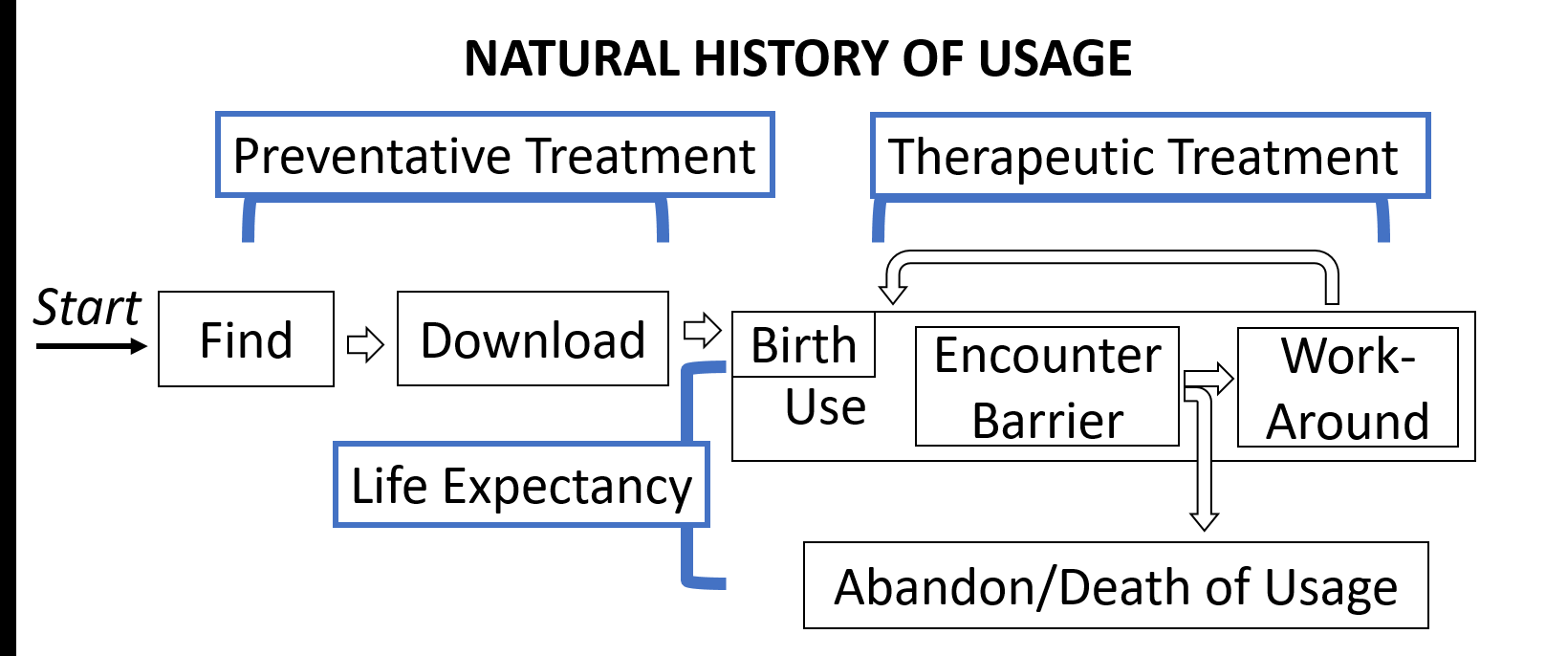

**Figure 3.** The natural history of app usage model represents the process by which an end user finds, downloads, uses, and abandons an app. The usage stage includes first usage, or *birth* of usage. Within usage, someone might cycle through the stages of encountering a barrier and trying to work around it. The progression could ultimately end when a user abandons an app and usage *dies*.

An app’s usage-birth happens when it is first opened on the device. During usage, barriers caused by “diseases” might be encountered and work-arounds might be attempted. Usage-death occurs when the person discontinues use entirely. Therapeutic methods could be introduced within usage or abandonment. An example of an existing treatment is found in Apple’s and Google’s screen readers, an end-user can create custom button labels for fixing poorly labeled elements. A post-death treatment could prompt a user to submit feedback on why an app’s usage has ceased.

**4.4Evaluating Existing and New Treatments** Epidemiology is motivated to collect information to guide the development of intervention methods and modes of health care delivery. A key component to achieving that is being able to evaluate the effectiveness of interventions in order to focus efforts on the most promising strategies.

App accessibility efforts would benefit from expanding evaluation techniques, such as those motivated by our epidemiology-inspired framework. Existing accessibility enhancement techniques include preventative treatments such as developer guidelines [1,4] and automatic interface analysis tools [5,19] as well as therapeutic treatments such as adding custom labels for screen readers and forums where people can search for assistance [6].

Some existing treatments might have been tested on a small scale with user testing or on a small number of apps, but systematic population-based longitudinal multi-factor analyses are lacking. Such analyses could provide more insights into the effectiveness of treatments that address accessibility diseases and highlight opportunities for improvement.

Example metrics from epidemiology include: (1) tracking the *prevalence* or *lethality* of different disease *determinants*, or causes, in the *population* (e.g., how many Android apps have an unlabeled image button, or how many apps in that same population are abandoned because of that “inaccessibility disease”); (2) performing such tracking before and after a treatment is introduced (e.g., adding the empty content description warning in Android Studio), and (3) examining whether a treatment influences factors as expected (e.g., logging whether missing content description warnings are frequently muted in Android Studio). An impactful treatment should be reflected in the metrics of the whole population. By collecting population-level longitudinal multi-factor data, we can better evaluate the strength of different approaches.

8

Session: Interaction Techniques and Frameworks ASSETS'17, Oct. 29–Nov. 1, 2017, Baltimore, MD, USA

**4.6Inform Public Policy and Regulation**  **5.2Results**

Epidemiology’s consideration of multi-factor and population-level influences on health within an ecosystem guides data collection and analysis. In turn, that data can be applied to impact public health. Mirroring Gordis’ [20] final objective for epidemiology, *Informing Public Policy and Regulation*, we consider how a population-based model of app accessibility can change the app environment to enhance the health of apps. Changes could include legislation (e.g., web accessibility [32]), company-enforced vetting of apps, initiatives to inform developers, or initiatives to educate people on available treatments for their apps. Data-driven direction and structure can propel these changes to happen. For example, as in the introduction of this paper, the percentage of people in the world with disabilities is often used as motivation for accessibility work. Similar data around the *prevalence* and *lethality*, or impact, of app accessibility problems could compel policy changes. An epidemiology-inspired framework helps inform what data collection, analysis, and presentation might look like.

**5. EXERCISING THE FRAMEWORK**   
Our chief contribution in this paper is conceptual, providing a new framework that reshapes how we think about and work to improve app accessibility. To demonstrate how this framework guided our own thinking, we present an initial empirical study of the *prevalence* of various “inaccessibility diseases” in Android apps.

**5.1Method**   
We took a stratified sample from the *population* of top free Android apps. Apps were selected from the “top downloaded, free” lists in the Google Play Store in each of ten categories (i.e., our strata): Business, Communication, Education, Entertainment, Health and Fitness, Maps and Navigation, Medical, Productivity, Shopping, and Social. We excluded apps that required a specialized log-in (e.g., a bank account or subscription) or blocked automated scanning (e.g., banking apps often block taking screenshots). Ten apps from each category were analyzed, totaling 100 apps. For each app, 4-8 primary tasks were identified. For example, in the “Indeed Job Search” app, the tasks were as follows: recover forgotten password, log-in, search for jobs, apply for jobs, and access settings. Google’s Accessibility Scanner [19] was the *diagnostic tool* used to scaneach screen required to complete the tasks for *determinants* of various “inaccessibility diseases” (Table 2).

**Table 2.** The accessibility errors, or *disease determinants*, reported by Google’s Accessibility Scanner provide a *health indicator* for apps.

|  |  |
| --- | --- |
| **Error** | **Description** |
| Clickable Items | Overlapping clickable items |
| Editable Image Label | TextView has a content description. This might interfere with a screen reader’s ability to read the content of the text field |
| Image Contrast | Low contrast in image or icon |
| Item Descriptions | Items with identical speakable text |
| Item Label | Missing element label |
| Item Type Label | Item label ends with type, e.g., “Play Button.” TalkBack automatically announces item type, so information is redundant |
| Link | URL in link may be invalid |
| Text Contrast | Low text contrast between foreground and background |
| Touch Target | Item is too small |

9

Session: Interaction Techniques and Frameworks

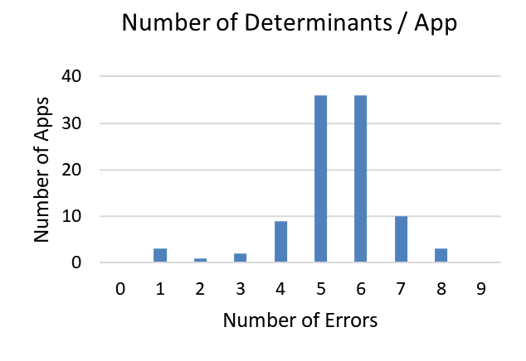

**Figure 6.**  The distribution of the number of errors in each app explores co-occurrences of different disease determinants. Co-occurrence might suggest different underlying influential factors.

Although *prevalence* is one useful metric of app accessibility, it does not alone capture disease causes or impact. The *lethality* of each case of inaccessibility varies due to the determinant and context. For example, the Item Label error is more lethal than the Item Type Label for a screen reader user. A Touch Target error may be more lethal for someone with a motor impairment than an Item Label error. These observations motivate the development of advanced diagnostic tools and techniques that can give deeper insights into the most impactful determinants.

There are many co-occurrences of different determinants of inaccessibility (Figure 6). Cases where different lethalities of similar determinants co-occur are of special interest. For example, Item Description and Item Label are similar errors but Item Label is usually more lethal. An Item Label error will result in a screen reader saying “unlabeled button” versus an Item Description error will cause it to redundantly say “save button button.” The co-occurrence of these determinants raises the question of why some elements get poor labels while others get none. The fact that the co-occurrence was not an isolated incident (at least 11% of apps tested had both errors) suggests that there might be underlying common factors involved. A more detailed analysis of what tools, education, or other factors contributed to some elements being labeled while

ASSETS'17, Oct. 29–Nov. 1, 2017, Baltimore, MD, USA

larger ecosystem of app accessibility. The framework also provided many opportunities for considering future work in understanding and enhancing app accessibility.

The primary purpose and contribution of this paper is to introduce the epidemiology-inspired framework for app accessibility and to put a small piece of it through its paces in a preliminary analysis of disease *prevalence*. But, as the size of the entire framework makes clear, there are many other aspects of accessibility that can be measured in future work. Creating tools that allow for large-scale population-level analyses, tracing “inaccessibility diseases” in apps to identify potential *agents* (e.g., the Android Studio icon button example), and designing novel interventions beyond guidelines and individual developer tools are priorities for future work. Our new conceptual framework provides the motivation and structure to explore these opportunities. We acknowledge the sheer size and complexity of the epidemiology-inspired framework, but find it proportional to the problems and opportunities associated with improving the accessibility of the entire mobile app ecosystem.

**7. CONCLUSION**   
We have shown how epidemiology’s motivation, language, techniques, and models are highly transferrable to the challenge of mobile app accessibility on a population-level, beyond just addressing individual apps. It is our hope that our epidemiology-inspired framework will shape, guide, and inform our current methods and priorities for addressing app accessibility by incorporating multi-factor, longitudinal, and population-level concepts.

**8. ACKNOWLEDGMENTS**   
We thank Anat Caspi of the Taskar Center for Accessible Technology at the University of Washington for her insights and feedback. This work was funded in part by the National Science Foundation under awards IIS-1053868, IIS-1702751, and DGE-1256082; the Wilma Bradley Endowed Fellowship in Computer Science & Engineering; a Google Faculty Award; and The Mani Charitable Foundation.

**9. REFERENCES**   
1. Android Accessibility Developer Guidelines.

https://developer.android.com/guide/topics/ui/accessibility

2. Android Studio.

https://developer.android.com/studio/index.html

|  |  |  |
| --- | --- | --- |
| others were not would give insight into: (1) in what stages of an | 3. | Androzoo. https://androzoo.uni.lu/ |
| app’s natural history of development and usage it might be exposed | 4. | Apple Accessibility Developer Guidelines. |
| to different infectious agents and determinants (e.g., what libraries |
| https://developer.apple.com/accessibility/ios/ |
| are associated with unlabeled versus poorly labeled elements); (2) |
| the effectiveness of current treatments; and (3) where in the chain | 5. | Apple Accessibility Scanner. |
| of infection new treatments might be most effective. | 6. | https://developer.apple.com/library/content/documentation/ |
| Accsssibility/Conceptual/AccessibilityMacOSX/ |
| Our results also highlight the limitations of current accessibility |
| OSXAXTestingApps.html |
| analysis tools. As noted above, the three apps that only have one |
| AppleVis. http://www.applevis.com/ |
| error are due to the whole interface canvas being represented as a |
| single, unlabeled element. This design makes them among the most | 7. | Victoria Bellotti, Maribeth Back, W. Keith Edwards, Rebecca |
| inaccessible apps for screen reader users. Yet our current approach | E. Grinter, Austin Henderson, and Cristina Lopes. (2002). |
| of counting types of errors, based on the granularity of the |
| Making Sense of Sensing Systems: Five Questions for |
| Accessibility Scanner, does not reflect the magnitude of those |
| 8. | Designers and Researchers. *Proc CHI 2002*, 415–422. |
| single error cases. Advancements in diagnostic tools would allow |
| http://doi.org/10.1145/503376.503450 |
| for the collection of better overall *health metrics*. |
| Jeffrey P. Bigham, Anna C. Cavender, Jeremy T. Brudvik, |
| **6. TAKEAWAYS AND FUTURE WORK** | Jacob O. Wobbrock, and Richard E. Lander. (2007). |
| Our epidemiology-inspired framework has influenced how we | WebinSitu: a Comparative Analysis of Blind and Sighted |
| approach app accessibility, driving our initial *prevalence* analysis. | Browsing Behavior. *Proc. Assets 2007*, 51–58. |
| Situating our analysis and findings within the framework guided | http://doi.org/10.1145/1296843.1296854 |

our methods, structured the types of phenomena we investigated,   
and gave us language to discuss the results and how they impact the

10

Session: Interaction Techniques and Frameworks ASSETS'17, Oct. 29–Nov. 1, 2017, Baltimore, MD, USA

9. Matt Bishop. (2003). What is Computer Security? *IEEE*  25. Lauren R. Milne, Cynthia L. Bennett, and Richard E. Ladner.

*Security & Privacy Magazine*, *1*(1), 67–69. http://doi.org/10.1109/MSECP.2003.1176998

10. Matthias Böhmer, Brent Hecht, Johannes Schöning, Antonio Krüger, and Gernot Bauer. (2011). Falling Asleep with Angry Birds, Facebook and Kindle – A Large Scale Study on Mobile Application Usage. *Proc. MobileHCI 2011*, 47–56.

http://doi.org/10.1145/2037373.2037383

11. Urie Bronfenbrenner. (1979). *The Ecology of Human Development: Experiments by Nature and Design*. Harvard University Press.

12. Parmit K. Chilana, Andrew J. Ko, Jacob O. Wobbrock, Tovi Grossman, and George Fitzmaurice. (2011). Post-Deployment Usability: a Survey of Current Practices. *Proc. CHI 2011*, 2243–2246. http://doi.org/10.1145/1978942.1979270

13. Raphael Clegg-Vinell, Christopher Bailey, and Voula Gkatzidou. (2014). Investigating the Appropriateness and Relevance of Mobile Web Accessibility Guidelines. *Proc. W4A 2014*, 1–4. http://doi.org/10.1145/2596695.2596717

14. Association for Professionals in Infection Control. (2017). Break the Chain of Infection. *Infection Protection and You: Healthcare Professionals*.

15. Michael Cooper, Peter Korn, Andi Snow-Weaver, Gregg Vanderheiden, Loïc Martínez Normand, and Mike Pluke.

(2013). *Guidance on Applying WCAG 2.0 to Non-Web Information and Communications Technologies*   
*(WCAG2ICT)*. http://www.w3.org/TR/wcag2ict/

16. Biplab Deka, Zifeng Huang, and Ranjitha Kumar. (2016). ERICA: Interaction Mining Mobile Apps. *Proc. UIST 2016*, 767–776. http://doi.org/10.1145/2984511.2984581

17. Floating Action Button Usage Guidelines.   
https://www.material.io/guidelines/components/ buttons-floating-action-button.html

18. Santiago Gil, Alexander Kott, and Albert-László Barabási. (2014). A Genetic Epidemiology Approach to Cyber-Security. *Scientific Reports*, *4*, 5659. http://doi.org/10.1038/srep05659

19. Google Accessibility Scanner.

https://play.google.com/store/apps/details?

id=com.google.android.apps.accessibility.auditor

20. Leon Gordis. (2004). *Epidemiology*. Saunders, Philadelphia, PA.

21. Vicki L. Hanson and John T. Richards. (2013). Progress on Website Accessibility? *ACM Transactions on the Web*, *7*(1), 1–30. http://doi.org/10.1145/2435215.2435217

22. Dale F. Leipper. (1961). Oceanography—A Definition for Academic Use. *Transactions, American Geophysical Union*, *42*(4), 429. http://doi.org/10.1029/TR042i004p00429

23. Jennifer Mankoff, Holly Fait, and Tu Tran. (2005). Is Your Web Page Accessible?: a Comparative Study of Methods for Assessing Web Page Accessibility for the Blind. *Proc. CHI 2005*, 41–50. http://doi.org/10.1145/1054972.1054979

24. Material Design. https://material.io/guidelines/

11