**Descriptive Epidemiology of Neonatal Mortality in Gowa**

**District 2015**

Amalya Rezky Putri Jumriani Ansar Dian Sidik Arsyad

Faculty of Public Health, Hasanuddin Faculty of Public Health, Hasanuddin Faculty of Public Health, Hasanuddin

University, University, University, Jl. Perintis Kemerdekaan

Jl. Perintis Kemerdekaan Km. 10, Jl. Perintis Kemerdekaan Km. 10, Km. 10, Tamalanrea Indah,

Tamalanrea Indah, Tamalanrea, Tamalanrea Indah, Tamalanrea, Tamalanrea, Tamalanrea Indah,

Tamalanrea Indah, Tamalanrea, Kota Tamalanrea Indah, Tamalanrea, Kota Tamalanrea, Kota Makassar, Sulawesi

Makassar, Sulawesi Selatan 90245, Makassar, Sulawesi Selatan 90245, Selatan 90245, Indonesia

amalyarp@gmail.com   
Indonesia

jumriani.ansar@gmail.com   
 Indonesia dian_sidiq@yahoo.com

**ABSTRACT**   
The aim of this study is to describe epidemiology of neonatal mortality in Gowa district 2015. The study type was an observational descriptive study. The population for this study was all neonatal deaths had recorded in Gowa district health office in 2015. Meanwhile, the sample sizes were 77 neonatal death cases. The point coordinates were determined by using geographic positioning system (GPS) and exported into geographic information system (GIS). The result showed neonatal death cases occurred by maternal characteristics with received antenatal care

visit (ANC) ≥ 4visits (71.2%), 2 times of tetanus toxoid (TT) vaccination (81.9%) and birth attendance by midwife (85.7%). Based on infant characteristics occurred based on parity 1 (51.9%), gestational age < 37 weeks (64.9%), birth weight < 2500 gram (54.2%). The main cause of neonatal mortality was asphyxia neonatorum (45.5%). The neonatal mortality was occurred at health centres (46.8%) and hospital (57. 1%).The average distance from respondent house to the hospital respectively 19. 41 km and 19.94 km. Most of neonatal mortality occurred in September with total of 12.52/1000 live births. The number of midwives should be increasing to reduce neonatal mortality.

**CCS Concepts**  
•**Social and professional topics → User characteristics**

**Keywords**   
Descriptive; epidemiology; neonatal death; GIS

**1.INTRODUCTION**   
Neonatal is period that infant adapted new environment from intrauterine life to extra-uterine life [1,2]. Each year, more than 4 million infants were died within first 4 weeks of their life, while 3 million deaths occurred in early neonatal period [3]. The

Permission to make digital or hard copies of all or part of this work for personal or classroom use is granted without fee provided that copies are not made or distributed for profit or commercial advantage and that copies bear this notice and the full citation on the first page. To copy otherwise, or republish, to post on servers or to redistribute to lists, requires prior specific permission and/or a fee.

*ICHSM 2018,*June 8–10, 2018, Tsukuba, Japan  
© 2018 Copyright is held by the owner/author(s). Publication rights licensed to ACM.

ACM ISBN 978-1-4503-6435-5/18/06...$15.00   
DOI: https://doi.org/10.1145/3242789.3242827

202

included residing in Gowa district in 2015 and willing to be respondent in this district.

**2.4Data Processing and Data Analysis**   
Data analysis was performed by using Microsoft Excel 2010, SPSS program version 16, Quantum GIS 2.14.1. The univariate analysis was done for general description by using frequency distribution table. The geographical distribution was represented by QGIS.

**3.RESULT AND DISCUSSION**   
**3.1Univariate Analysis**   
Based on Table 1, 52 respondents (71.2%) had more than 4 ANC visits and only 21 respondents (28.8%) had less than 4 ANC visits during their pregnancy.

**Table 1. Distribution of respondent based on frequency of ANC visits in Gowa district 2015.**

|  |  |  |
| --- | --- | --- |
| **ANC visit**  **frequency** | **n** | **%** |
| <4 times | 21 | 28.8 |
| ≥4 times | 52 | 71.2 |
| Total | 73 | 100.0 |

Source: Primary data, 2016

The spreading of neonatal mortality cases based on ANC visit frequency in Gowa district 2015 in Figure 1.

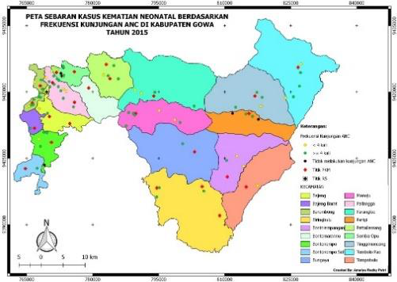

**Figure 1. Coverage map of neonatal mortality cases based on ANC visits in Gowa district 2015.**

Based on Table 2, There were 59 respondents had 2 times of TT vaccination and 13 respondents had only once vaccination

**Table 2. Distribution of respondent based TT vaccination in Gowa district 2015.**

|  |  |  |
| --- | --- | --- |
| **TT vaccination** | **n** | **%** |
| 1 | 13 | 18.1 |
| 2 | 59 | 81.9 |
| Total | 72 | 100.0 |

Source: Primary data, 2016

Figure 2 had described spreading of neonatal mortality based on TT vaccination during their pregnancy period.

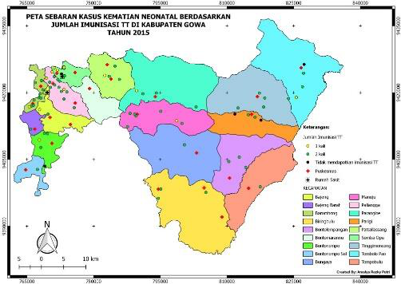

**Figure 2. Coverage map of neonatal mortality cases based on TT vaccination in Gowa district 2015.**

Based on Table 3, most birth attendances were midwives, 66 respondents (85.7%) and 3 respondents (3.9%) had no birth attendants. Meanwhile, Figure 3 showed spreading of neonatal mortality cases based on birth attendances in Gowa district in 2015.

**Table 3. Distribution of respondents based on birth attendance in Gowa district 2015.**

|  |  |  |
| --- | --- | --- |
| **Birth attendant** | **n** | **%** |
| Obstetricians | 4 | 5.2 |
| Midwives | 66 | 85.7 |
| Traditional healer | 2 | 2.6 |
| Friend/family | 2 | 2.6 |
| No birth attendance | 3 | 3.9 |
| Total | 77 | 100.0 |

Source: Primary data, 2016

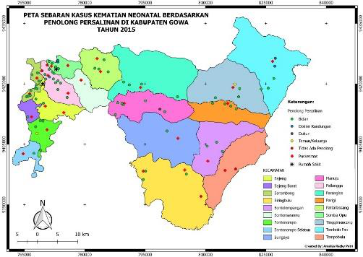

**Figure 3. Coverage map of neonatal mortality cases based on birth attendances in Gowa district 2015.**

Based on Table 4, Most of respondents had parity 2-3, 59 respondents (33.8%) and 11 respondents (14.3%) had parity more than 4.

203

**Table 4. Distribution of respondent based parity in Gowa district 2015.**

|  |  |  |
| --- | --- | --- |
| **Parity** | **n** | **%** |
| 1 | 40 | 51.9 |
| 2-3 | 59 | 33.8 |
| ≥4 | 11 | 14.3 |
| Total | 77 | 100.0 |

Source: Primary data, 2016

Figure 4 was described spreading of neonatal mortality cases based on parity in Gowa district 2015.

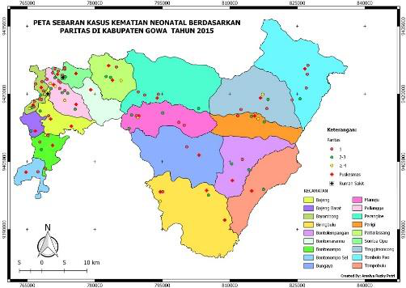

**Figure 4. Coverage map of neonatal mortality cases based on parity in Gowa district 2015.**

Based on Table 5, There were 50 respondents (64.9%) were pregnant less than 37 weeks and 27 respondents (35.1%) were pregnant more than 37 weeks.

**Table 5. Distribution of respondent based gestational age in Gowa district 2015.**

|  |  |  |
| --- | --- | --- |
| **Gestational age** | **n** | **%** |
| < 37 weeks | 50 | 64.9 |
| ≥37 weeks | 27 | 35.1 |
| Total | 77 | 100.0 |

Source: Primary data, 2016

Figure 5 had described the spreading of neonatal mortality cases based on gestational age in Gowa district in 2015.

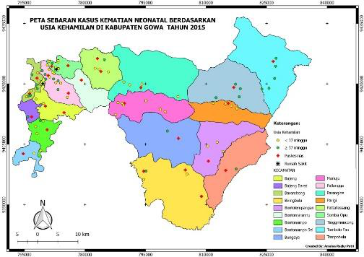

**Figure 5. Coverage map of neonatal mortality cases based on gestational age in Gowa district 2015.**

Based on Table 6, More than half of respondents (54.2%) had birth weight lower than 2500 gram and 33 respondents had birth weight more than 2500 gram.

**Table 6. Distribution of respondent based birth weight in Gowa district 2015.**

|  |  |  |
| --- | --- | --- |
| **Birth weight** | **n** | **%** |
| < 2500 gram | 39 | 64.9 |
| ≥2500 gram | 33 | 45.8 |
| Total | 72 | 100.0 |

Source: Primary data, 2016

Figure 6 showed spreading of neonatal mortality cases based on birth weight in Gowa district.

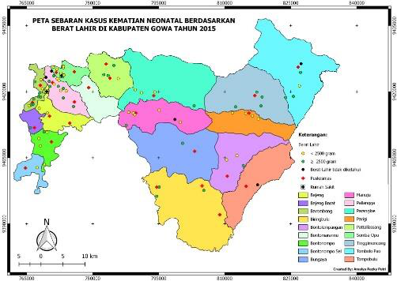

**Figure 6. Coverage map of neonatal mortality cases based on birth weight in Gowa district 2015.**

Based on Table 7, Most of neonatal mortality was asphyxia neonatorum, 35 cases (45.5%) and 2 cases (2.6%) had recorded was due to neonatal tetanus.

**Table 7. Distribution of respondents based on death causes in Gowa district 2015.**

|  |  |  |
| --- | --- | --- |
| **Death causes** | **n** | **%** |
| Low birth weight | 26 | 33.8 |
| Asphyxia  neonatorum | 35 | 45.5 |
| Congenital  abnormalities | 8 | 10.4 |
| Neonatal sepsis | 6 | 7.8 |
| Neonatal tetanus | 2 | 2.6 |
| Total | 77 | 100.0 |

Source: Primary data, 2016

Figure 7 was described spreading of neonatal mortality cases based on death causes in Gowa district.

204

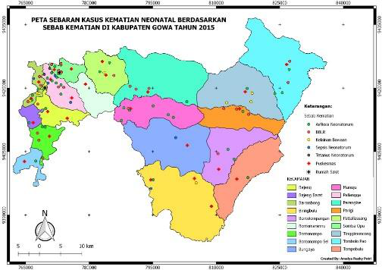

**Figure 7. Coverage map of neonatal mortality cases based on death causes in Gowa district 2015.**

Based on Table 8, Most of respondents had birth delivery in Puskesmas or auxiliary public health center (Pustu) (46.8%) and only 1 respondent (1.3%) had attended at maternity hospital.

Figure 8 had described spreading of neonatal mortality cases based on birth places in Gowa district.

**Table 8. Distribution of respondents based on birth place in Gowa district 2015.**

|  |  |  |
| --- | --- | --- |
| **Birth place** | **n** | **%** |
| House | 19 | 24.7 |
| Hospital | 9 | 11.7 |
| Maternity hospital | 1 | 1.3 |
| Community health center  (Puskesmas)/ auxiliary public health center (Pustu) | 36 | 46.8 |
| Midwives practice | 12 | 15.6 |
| Total | 77 | 100.0 |

Source: Primary data, 2016

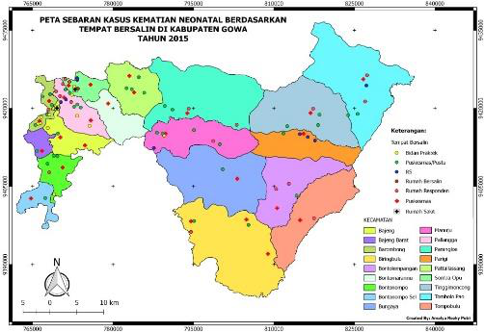

**Figure 8. Coverage map of neonatal mortality cases based on birth places in Gowa district 2015.**

Based on Table 9, Most neonatal mortality occurred in hospital were 44 respondents (57.1%) and lowest neonatal mortality occurred at midwives practice, 4 respondents (5.2%).

**Table 9. Distribution of respondents based on neonatal mortality location in Gowa district 2015.**

|  |  |  |
| --- | --- | --- |
| **Neonatal mortality location** | **n** | **%** |
| House | 13 | 16.9 |
| Hospital | 44 | 57.1 |
| Puskesmas/Pustu | 16 | 20.8 |
| Midwives practice | 4 | 5.2 |
| Total | 77 | 100.0 |

Source: Primary data, 2016

Figure 9 had described spreading of neonatal mortality based on neonatal mortality location in Gowa district.

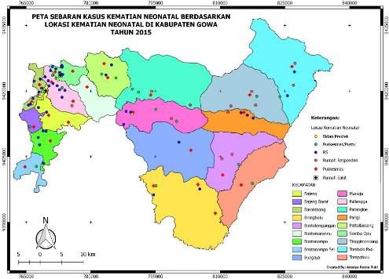

**Figure 9. Coverage map of neonatal mortality cases based on neonatal mortality location in Gowa district 2015**

Based on Table 10, The minimum distance for respondents to reach Syed Yusuf and Thalia Irham hospitals were 0.53 km and 1.15 km. Meanwhile, longest distance from respondent’s house to hospital were 54.45 km and 58.12 km. The average distance for both hospitals were 19.41 km and 19.94 km.

**Table 10. Distribution of respondents based on distance to hospital in Gowa district 2015**

|  |  |  |  |  |  |  |
| --- | --- | --- | --- | --- | --- | --- |
| **Hospital** | **n** | **Distance (km)** | | | | |
| **Min** | **Max** | **Median** | **Mean** | **SD** |
| Syekh Yusuf | 77 | 0.53 | 54.45 | 13.27 | 19.41 | 17.23 |
| Thalia Irham |  | 1.15 | 58.12 | 12.42 | 19.94 | 18.51 |

Source: Primary data, 2016

Figure 10 showed distribution of respondents by time (months) of neonatal mortality in Gowa district. The time is months of neonatal mortality which obtained from Puskesmas or hospital. Highest neonatal mortality rate occurred in September at 12.52 per 1000 live births and lowest neonatal mortality occurred in December at 2.10 per 1000 live births.

205

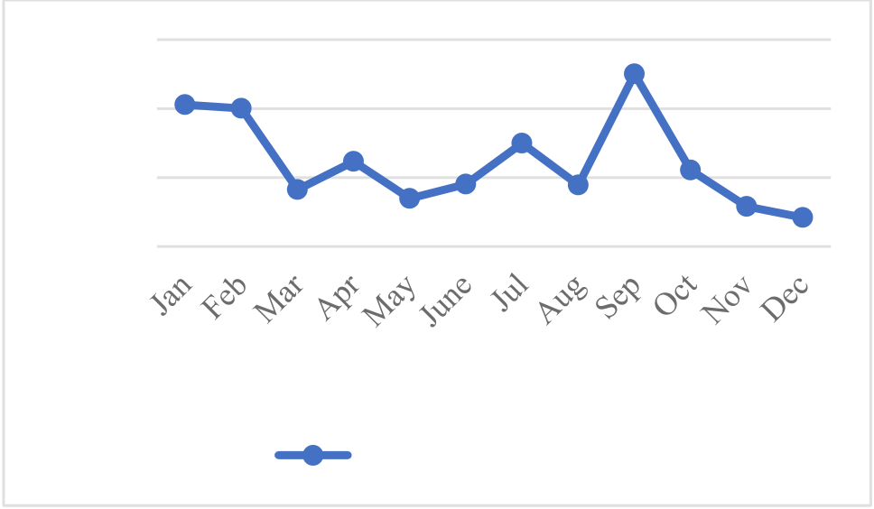

|  |  |  |  |
| --- | --- | --- | --- |
| Neonatal MOrtality | 15 | 10.28 | There were 46.8% of respondents preferred Puskesmas or Pustu as their birth delivery and only 1.3% of respondents preferred birth delivery at maternity hospital. The factors in consideration of birth delivery place included budget, distance to health centers, health facilities, health services and environment. |
| 10 | 12.52 10.02  4.13 6.16 3.48 4.51   7.49  4.45 5.54   2.9 2.1 |
| 5 |
| 0 | The result showed most neonatal mortality cases occurred in the hospital and lowest neonatal mortality cases occurred in midwifery practices. The neonatal mortality occurred was due to late in access to health centers. The short distance from house to Syekh Yusuf Hospital and Thalia Irham Hospital were 0.53 km and 1.15 km and longest distance were 54.45 km and 58.13 km. In Malawi and Zambia, a study found distance to health care facilities with neonatal mortality [23]. |
| Month |
| per 1000 live births |

**Figure 10. Distribution of respondents based on neonatal mortality time in Gowa district 2015.**

**3.2Overall Discussion**   
The result found 71.2% respondents had ANC visits more than 4 times and 28.8% of respondents had ANC visits less than 4 times. A study found pregnant women had ANC visit less than 4 times at risk of 7.3 times greater than pregnant women had ANC visits more than 4 times [13]. The ANC behavior had influenced by various factors. In Kenya, maternal education level, socioeconomic, transportation and distance to health facilities had influenced pregnant women in ANC visits [14]. The lack in health facilities also contributed in neonatal mortality. In additions, inappropriate neonatal care due to lack of maternal knowledge also increase risk in neonatal mortality [15].

In this study, 81.9% of respondents had TT vaccination for 2 times during their pregnancy period. This vaccination has prevented infants from tetanus neonatorum but not for other death causes included asphyxia neonatorum and LBW. The proper medical handling could reduce birth complications [16]. Most of birth attendances were midwives and lowest of birth attendances were traditional healer and friend or family members with 2.6%. In this study, most pregnant women are assisted by health workers in their birth delivery. The neonatal mortality had high risk in birth delivery with health workers than non-health workers [17].

Besides, 33.8% of respondents had parity of 2- 3 and 14.3 % of respondents had parity more than 4. The parity 2 or 3 is safest parity in maternal and perinatal mortality [18]. High parity more than 3 had high risk in maternal mortality rate. High parity could prevent by family planning. Some pregnancies at high parity are unplanned. Besides, repetitive pregnancy and childbirth also caused damage to blood vessels in uterine lining.

The result also showed 64.9% of respondents had gestational age less than 37 weeks and 35.1% of respondents had gestational age more than 37 weeks. In Kenya, premature infants had high risk in neonatal mortality shortly after birth [19]. Based on this study, 54.25% of respondents had LBW less than 2500 gram and 45.8% of respondents had birth weight more than 2500 gram. The LBW had high tendency toward in birth complications such as jaundice, hypoglycemia and hypothermia. In Cameroon, infants had LBW had 1.6 times greater risk in neonatal mortality than infants had normal birth weight [9].

Furthermore, the result found most common cause of neonatal mortality was neonatal asphyxia which was 45.5%. In Bangladesh, highest neonatal mortality cases were due to asphyxia neonatorum [20,21]. In additions, insufficient monitoring by health workers was among factors associated with asphyxia-induced mortality in South Africa [22].

206

[9]Chiabi, A. et al. (2014). Risk factors for neonatal mortality at the Yaounde Gynaeco-Obstetric and Pediatric Hospital,   
Cameroon. *Iranian journal of Pediatrics*, 24, 393-400.

[10]Anggraini, A. et al. (2012). Faktor risiko kematian neonatus dengan penyakit membran hialin. *Sari Pediatri*, 15, 75-80.

[11]Yani, D. F. et al. (2013). Pelayanan kesehatan ibu dan kematian neonatal.*Kesmas: Jurnal Kesehatan Masyarat Nasional,* 7, 373-377.

[12]Masni et al. (2014). Faktor risiko kematian neonatal di Kabupaten Morowali provinsi Sulawesi Tengah.

[13]Abdullah, A. et al. (2015). Faktor risiko kematian neonatal di provinsi Nusa Tenggara Timur: a matched case-control study.

*NTT: Australia Indonesia Partnership for Maternal and Neonatal Health*.

[14]Eijk, A. M. et al. (2006). Use of antenatal services and delivery care among women in rural western Kenya: a community based survey. *Reproductive Health,* 6.

[15]Ayaz, A. et al. (2010). Neonatal mortality and prevalence of practices for newborn care in a squatter settlement of Karachi, Pakistan: a cross-sectional study. *PLoS ONE,* 5, e13783.

[16]Kementerian Kesehatan Republik Indonesia. (2013). *Profil kesehatan Indonesia 2012.* Jakarta: Kementerian Kesehatan Republik Indonesia.

207