**Summarize the Etiology and Epidemiology Characteristics of the New Coronavirus**

Sicheng Shen

Ravenscroft School Student

7909 hardwick drive

+1 9197856563

Seanshen4@gmail.com

**ABSTRACT**   
Until May 16th, there are more than four million people who have been confirmed of the Covid-19 virus in the whole world and 311,739 of total deaths. The virus caused disastrous effects in the economy around the whole world, destroying small businesses and the stock market, ruining international transportation, devastating the morale of the people and prohibiting people from interacting and socializing. Considering these huge impacts that the virus made, on March, 12, 2020, the World Health Organization (WHO) characterized the Covid-19 caused by the Sars-CoV-2 virus as a global pandemic. There is not an effective vaccination or specific medicine to cure the disease. The most effective way to slow down the transmission is early detection, isolation of new carriers and operating proper treatment to patients. Thus, the research on the physical properties and clinical characteristics of the Covid-19 become significantly important. To prepare for the future prevention, this paper summarizes the

overall treatment of the virus, mainly through the virus’s origin, etiology, epidemiology, and clinical symptoms to inform readers more about the Covid-19, eliminate misunderstanding and bias to the virus, invoke the sense of self-protection and finally use scientific and logical methods to overcome this world-wide pandemic.

**CCS Concept**   
**Applied computing**➝**Life and medical sciences**➝**Health informatics**

**Keywords**   
Sars-CoV2; etiology; epidemiology; disease

**1.INTRODUCTION**   
Until May 16th, there are more than four million people who have been confirmed of the Covid-19 virus in the whole world and 311,739 of total deaths. The virus caused disastrous effects in the economy around the whole world, destroying small businesses and the stock market, ruining international transportation, devastating the morale of the people and prohibiting people from interacting and socializing. Considering these huge impacts that

Permission to make digital or hard copies of all or part of this work for personal or classroom use is granted without fee provided that copies are not made or distributed for profit or commercial advantage and that copies bear this notice and the full citation on the first page. Copyrights for components of this work owned by others than ACM must be honored. Abstracting with credit is permitted. To copy otherwise, or republish, to post on servers or to redistribute to lists, requires prior specific permission and/or a fee. Request permissions from Permissions@acm.org.

*ICMHI 202*0, August 14–16, 2020, Kamakura City, Japan © 2020 Association for Computing Machinery.

ACM ISBN 978-1-4503-7776-8/20/08…$15.00   
https://doi.org/10.1145/3418094.3418142

218

severe symptoms, becomes one of the most difficult viruses to   
deal with during the 21th century.

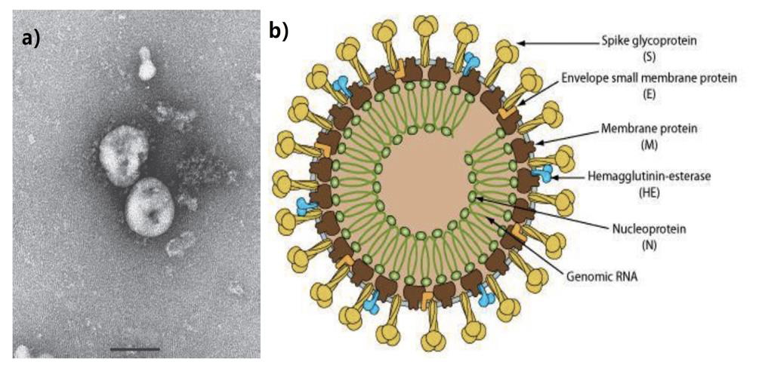

**Figure 1(a).** The structure of the Sars-CoV2 under electron microscope 9]

**Figure1 (b)**  animated inner structure of Sars-CoV2 [10]

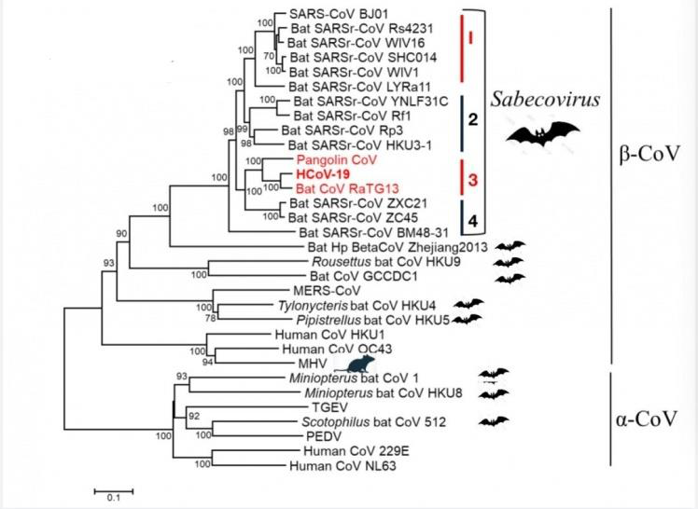

**Figure 2. [13] Lineage of coronavirus graph, which the letters marked as red represent the cluster that the new Coronavirus belongs to**

**2.Etiology**   
Figure 1 (a) shows Covid-19’s structure under the electronic macroscope. Under the scope, the virus is in a relatively circular

shape. Figure 1(b) shows a diagram of the virus’ inner structure. The virus is an enveloped, multi-shaped or round shaped single RNA virus with a radius usually ranging from 150 to 160nm. The virus contains positive-sense single-stranded RNA, unsegmented capsid, matrix, Nucleoproteins, and S proteins [11]. By tracing its ancestry and relatives, scientists discovered that Sars-CoV2 belongs to cluster three of the sabecovirus subgenus as figure 2 describes [12]

219

the subunits of the Sars-CoV in the 2004 pandemic [15]. However, compared to Sars-CoV, Covid-19 contains longer spike proteins made by S1 and S2 which are essential for the virus to confirm the host’s target and transmission ability [16]. Thus the complex spike proteins can help Covid-19 to find the best host that can transmit the virus quickly. Covid-19 viruses are fragile to ultraviolet and high temperatures. It can be destroyed by exposure of 56 Celsius degrees for thirty minutes. Also some solutions such as ether, 75 percent ethanol, disinfectant containing Chlorine, peracetic acid can all kill the virus effectively [17].

**3.Epidemiological Characteristics**   
**3.1Introduce to R0**   
R0, the basic reproduction number, usually recognized by the scientists to measure the transmission ability of a certain disease by measuring a variable using a well-designed equation. If R0 is smaller than 1, which means the disease would disappear slowly. If R0 equals to 1, the disease would become a regional pandemic that does not transmit to other places. If R0 is larger than 1, the disease would transmit exponentially and become a global pandemic [18]. The R0 of the Covid-19 is between 2.2 to 3.8, which exceeds the 1 line of R0 by 1.2 to 2.8 proving its high transmission ability [19]. However, the coronavirus is not very contagious compared to the measles and diphtheria, which have Ro numbers between 12-18, and 6-7 [20], [21]. However, scientists have already developed effective medicine and vaccines to cure such diseases and the government have made several regulations to control the spread of such diseases. The Covid-19, on the other hand, does not have an effective way to control its spread due to its complicated transportation.

**3.2Difficulties to Detect the Virus**   
One of the difficulties to control the spread of the Covid-19 is its trick ability to infect others when the patients cannot completely recognize it. The incubation period of the Covid-19 is usually one to fourteen days, and sometimes three to seven days applying to different people [22]. During the virus’s incubation period, the patients cannot feel any symptoms caused by the virus. Thus the doctors cannot find the patients as fast as possible to limit the spread of the virus. The incubation period of the virus is also relatively long, causing the patients exponentially infecting people surrounded by them when they go to work or join parties. Asymptomatic infection may also become a source of transmission of the virus, which means that some patients, due to their special body traits, do not show obvious clinical symptoms due to their weak immune system stress response or their own physical characteristics, but they carry the virus and can infect others and cause other people having the symptoms that they don’t have [23]. Asymptomatic infection is not easy to find, because they don’t show any traits that can warn them to do a diagnosed test. The patients themselves do not know. Because of this, it is difficult to control and isolate in time, causing large-scale transmission, which also brings up the importance of social-distancing, section prevention and control work [24]. Thus the government has to implement coronavirus testing for everybody to diagnose those asymptomatic patients to erase the risks of further transmission. Also, some studies have suggested that patients in the recovery period carry pathogens, but they have not been widely confirmed and need further study.

**3.3Transmission of the virus**   
Covid-19 entered the body through the ACE2 enzyme located on the lung. ACE2 is a new found Metalloproteinase maintaining located on the alveoli cell, belonging to the I Transmembrane

220

more susceptible and high-risk groups of infectious diseases. The majority of the population that are critically infected in this pandemic usually have high ages such as sixty or older. The novel coronavirus is susceptible to pneumonia in children and pregnant women as well, since they also have relatively weak immunity ability compared to a health adult [32].

**4.Conclusion and Concern**   
The World has already exposed three major pandemics involved in coronavirus: the Sars-CoV in 2002, Mers-CoV in 2012 and the SARs-CoV-2 in 2020. Even though the new Coronavirus has seventy five percent similarity with the SARs-CoV, the new virus actually contains a lot of new traits that scientists still cannot solve, like its epidemiological and etiology traits. Recently, the implementation of herd immunity became popular among some countries. As a high school student, I am very disappointed with the idea of herd immunity following the old trend of social Darwinism, the indifference of the government in the herds and I hope people can find a way altogether solving the pandemic issue. Scientists already experienced the previous two pandemics and accumulated a lot of relative information about the control and cure of the pandemic. Based on the successful clinical trial for the Sars-CoV diseases, scientists have already made significant progress for developing treatments for the new coronavirus. As a result, I hope that the research on the virus can effectively limit the outbreak of the pandemic and we can finally overcome the virus and embrace our success.

**5.REFERENCES**   
[1] Lai, C. C., Shih, T. P., Ko, W. C., Tang, H. J. & Hsueh, P. R.

Severe acute respiratory syndrome coronavirus 2 (SARS-CoV-2) and coronavirus disease-2019 (COVID-19): The epidemic and the challenges. *Int J Antimicrob Agents***55**, 105924, doi:10.1016/j.ijantimicag.2020.105924 (2020).

Ali, I. & Alharbi, O. M. L. COVID-19: Disease, [2]   
management, treatment, and social impact. *Sci Total*   
*Environ***728**, 138861, doi:10.1016/j.scitotenv.2020.138861 (2020).

[3] Shao, S. *et al.* Experiences and practices in the current prevention and control of the novel coronavirus pneumonia in China. *Disaster Med Public Health Prep*, 1-19,   
 doi:10.1017/dmp.2020.173 (2020).

[4] Cheever, F. S., Daniels, J. B. & et al. A murine virus (JHM) causing disseminated encephalomyelitis with extensive destruction of myelin. *J Exp Med***90**, 181-210,   
 doi:10.1084/jem.90.3.181 (1949).

[5] Bailey, O. T., Pappenheimer, A. M., Cheever, F. S. &   
 Daniels, J. B. A Murine Virus (Jhm) Causing Disseminated Encephalomyelitis with Extensive Destruction of Myelin : Ii.

Pathology. *J Exp Med***90**, 195-212, doi:10.1084/jem.90.3.195 (1949).

[6] Hamre, D. & Procknow, J. J. A new virus isolated from the human respiratory tract. *Proc Soc Exp Biol Med***121**, 190- 193, doi:10.3181/00379727-121-30734 (1966).

[7] Goldstein, S. A. & Weiss, S. R. Origins and pathogenesis of Middle East respiratory syndrome-associated coronavirus: recent advances. *F1000Res***6**, 1628,   
 doi:10.12688/f1000research.11827.1 (2017).

[8] Jewell, N. P. *et al.* Non-parametric estimation of the case fatality ratio with competing risks data: an application to Severe Acute Respiratory Syndrome (SARS). *Stat Med***26**, 1982-1998, doi:10.1002/sim.2691 (2007).

221

2019 novel coronavirus pneumonia receiving combined   
Chinese and Western medicine treatment. *Biosci Trends***14**,   
64-68, doi:10.5582/bst.2020.01030 (2020).

[26]Zhang, T. *et al.* Clinical trials for the treatment of   
Coronavirus disease 2019 (COVID-19): A rapid response to   
urgent need. *Sci China Life Sci***63**, 774-776,   
doi:10.1007/s11427-020-1660-2 (2020).

[27]Asadi, S., Bouvier, N., Wexler, A. S. & Ristenpart, W. D.

The coronavirus pandemic and aerosols: Does COVID-19   
transmit via expiratory particles? *Aerosol Sci Technol***0**, 1-4,   
doi:10.1080/02786826.2020.1749229 (2020).

28 Zhao, F. *et al.* The Time Sequences of Oral and Fecal   
Viral Shedding of Coronavirus Disease 2019 (COVID-19)   
Patients. *Gastroenterology*,   
doi:10.1053/j.gastro.2020.05.035 (2020).

[28]Adhikari, S. P. *et al.* Epidemiology, causes, clinical   
manifestation and diagnosis, prevention and control of   
coronavirus disease (COVID-19) during the early outbreak   
period: a scoping review. *Infect Dis Poverty***9**, 29,   
doi:10.1186/s40249-020-00646-x (2020).

[29]Karimi-Zarchi, M. *et al.* Vertical Transmission of   
Coronavirus Disease 19 (COVID-19) from Infected   
Pregnant Mothers to Neonates: A Review. *Fetal Pediatr*   
*Pathol***39**, 246-250, doi:10.1080/15513815.2020.1747120   
(2020).

[30]Chen, N. *et al.* Epidemiological and clinical characteristics   
of 99 cases of 2019 novel coronavirus pneumonia in Wuhan,   
China: a descriptive study. *Lancet***395**, 507-513,   
doi:10.1016/S0140-6736(20)30211-7 (2020).

[31]Zhou, M. *et al.* The proportion of patients with   
thrombocytopenia in three human-susceptible coronavirus   
infections: a systematic review and meta-analysis. *Br J*   
*Haematol***189**, 438-441, doi:10.1111/bjh.16655 (2020).

[32]Liu, H. *et al.* Why are pregnant women susceptible to   
COVID-19? An immunological viewpoint. *J Reprod*   
*Immunol***139**, 103122, doi:10.1016/j.jri.2020.103122 (2020).

222