

NATURE|Vol 455|23 October 2008

FEATURE

The mental wealth of nations   
**Countries must learn how to capitalize on their citizens’ cognitive resources if they are to prosper, both economically and socially. Early interventions will be key.**

|  |  |  |
| --- | --- | --- |
| **John Beddington, Cary L. Cooper, John** | state-of-the-art scientific and other evidence to investigate the challenges and opportunities that lie ahead in the next 20 years. The report provides an independent assessment that is intended to inform policy-makers both in the United Kingdom and around the world.  The project tracks the implications of future challenges to our mental developmentfrom cradle to grave. Taking two years to complete, it has involved more than 450 experts and stakeholders from many disciplines and from 16 countries. Eighty peer-reviewed papers summarize the latest evidence, and inter-national workshops have brought together experts and policy-makers to discuss what could be done to address the challenges.  Although our project focused on the United Kingdom, the challenges of depression, demen-tia, learning difficulties and mental ill-health are evident worldwide. The project therefore has far-reaching implications for the course of an individual’s life, for societies and for nations. Five reports synthesize the evidence base; and a final report sets out the overall findings and options for policy, which are summarized here. All reports are available at http://tinyurl. com/49jonm. Box 1 shows some of the key findings. | during the development of mental capital in childhood and adolescence. Early learning in children can increase their resilience to stress and common mental disorders. Later in life, this resilience helps to engender well-being at work and into old age. And older individu-als who report higher levels of well-being also have better cognitive function, even when adjustment has been made for other possi-ble explanatory factors, such as socio-demo-graphic variables, health and lifestyle1.  Thus, how a nation develops and uses its mental capital not only has a significant effect on its economic competitiveness and prosper-ity, it is also important for mental health and well-being and social cohesion and inclusion. Because they are so closely linked, mental health and well-being should both therefore be considered when developing policies and designing interventions.  The project comprised two key stages: understanding the evidence and identifying ways forward. Three particular areas of focus were: childhood development; mental health and well-being at work; and making the most of cognitive resources in older age. |
| **Field, Usha Goswami, Felicia A. Huppert,** |
| **Rachel Jenkins, Hannah S. Jones, Tom B. L.** |
| **Kirkwood, Barbara J. Sahakian and Sandy** |
| **M. Thomas** |
| To prosper and flourish in a rapidly changing world, we must make the most of all our resources — both mental and material. Globalization and its associated demands for competitiveness are increasing the pres-sures in our working lives. Added to this are the demands from evolving family structures and increased care responsibilities, both for children and for older relatives. And increased life expectancy in most industrialized nations means that ever greater numbers of people will be at risk of degenerative disorders in older age.  The UK Government Office for Science is this week announcing the findings of a peer-reviewed study: the Foresight Project on Mental Capital and Wellbeing. This used |
| **Box 1** | **Key findings**   |  | | --- | |  | | ●**Boosting brain power in young and old** There is huge scope for improving  mental capital through different types of intervention. The genetic contribution to mental capital is well below 50% in childhood, rising to more than 60% in adulthood and old age.  ●**What science could do in the early years** Cognitive neuroscience is already uncovering neural markers, or biomarkers, that can reveal learning difficulties as early as in infancy.  ●**Early detection of mental disorders** The challenge of tackling mental ill-health is considerable. There is great potential in improving diagnosis and treatment, and in addressing social risk factors such as debt.  ●**Learning must continue throughout life** This can have a direct effect on mental health and well-being across all age groups, and has particular promise in older people.  ●**Changing needs for a changing workplace** The workforce is changing both in  demographics and in the demands placed on it. Workers’ mental well-being is an important factor when attempting to improve the  mental capital of economies and societies. | |
| **Progression through life** |
| **Defining mental capital** | Evidence on childhood learning difficulties shows that, left untreated, very small initial differences in the sensory processing systems used by the brain in learning can lead to sig-nificant problems later in life2. Subtle impair-ments in auditory processing, for example, can give rise to developmental dyslexia, which can have significant negative effects on a person’s passage through life. More over, the interac-tive nature of the developing brain means that a problem in one sensory area can affect development in other areas. By late child-hood it can be hard to identify the core prob-lem. The cognitive problems experienced by a child with a learning difficulty can lead to poor self-esteem, or to frustration that results in the child disengaging from learning and lacking the motivation to learn. If a problem is identified later in life, it is often harder for an individual to realize the full potential of their mental capital and well-being.  The brain undergoes significant structural and functional changes during adolescence3: the formation of new synapses peaks at around 9–12 years, followed by some ‘pruning’ of synapses that are surplus or underused. In |
| The project looked at two main aspects of mental development: mental capital and mental well-being. Mental capitalencompasses both cognitive and emotional resources. It includes people’s cognitive ability; their flexibility and efficiency at learning; and their ‘emotional intelligence’, or social skills and resilience in the face of stress. The term therefore captures a key dimension of the elements that establish how well an individual is able to contribute to soci-ety and to experience a high quality of life. Mental well-being, on the other hand, is a dynamic state that refers to individuals’ ability to develop their potential, work productively and creatively, build strong and positive rela-tionships with others and contribute to their community.  However, the two concepts are intimately linked both throughout life and across dif-ferent areas of the project. Positive emotional states or a generally positive approach to life are associated with greater curiosity, more flexible thinking and a greater openness to learning, and these qualities are particularly important |

**1057**



|  |  |  |  |  |  |
| --- | --- | --- | --- | --- | --- |
| FEATURE |  | NATURE|Vol 455|23 October 2008 | NATURE|Vol 455|23 October 2008 |  | FEATURE |
| addition, adolescents go through significant emotional, hormonal and behavioural adjustment, and are particularly prone to risk-taking behaviour, such as drug and alco-hol use. As the brain is still developing, such behaviour is particularly injurious to it at this stage3, with long-term effects. Neuroimaging and neuropsychological studies indicate that substance use during adolescence is associated with neural disadvantages, particularly in the networks involved in learning, attention and executive function.  To help address these issues, the report came up with three main recommendations. First, training should be available for parents and teachers about issues in child development and how to help children who have learning diffi-culties to flourish. In addition, a higher priority needs to be placed on supporting children with these difficulties, as well as their carers. Finally, more emphasis needs to be placed on early identification and treatment of intrinsic learn-ing difficulties such as dyslexia and dyscalculia | — essentially dyslexia for numbers.  Much more can be done to improve mental well-being as children develop into adults. Occupational professionals should be closely integrated with primary-care givers, and work-places can promote mental health through well-being audits and widespread availability of flexible working. In addition, demand should be stimulated for continued learning in both individuals and employers by raising awareness and providing incentives. New technologies are also available and constantly being developed to personalize learning. For adults who have problems with depression and alcohol use, for instance, use of best-practice treatments should become more widespread. Treatments for these and other problems should encompass social support (such as working with financial advis-ers to help reduce debt) and address the under-lying social risk factors.  As people move into older age, learning should continue to be promoted and actively encouraged, as this can protect against | cognitive decline. In particular, information technology has an important role in help-ing people to overcome the memory effects of dementias. Governments should also be encouraged to enable and empower people to work longer if they so wish. Older people should also be involved in making these and other policy decisions. In addition, efforts should be made to tackle the negative social stereotypes associated with old age. | of biomarkers already exists. For instance, altered levels of proteins such as tau protein and Aβ42 (a pathogenic form of amyloid) in cerebrospinal fluid can identify patients in the early stages of Alzheimer’s disease5. Structural magnetic resonance imaging (MRI) can also be used to measure brain atrophy, particularly in regions that are affected in Alzheimer’s, such as the entorhinal cortex and hippocampus6,7. Genes have also been shown to play a part in the development of the disease, particularly the E4 variant of the apo lipo protein E (refs 8, 9). Furthermore, new insights into underlying mechanisms, coupled with the use of more selective cohorts in clinical trials (see below), will be essential in the development of effective drugs, including those to enhance cognition or for neuroprotection. This will also allow patients to be diagnosed earlier, allowing them to seek treatment and support, and plan for their futures.  Mechanistic studies coupled with novel biomarkers could also be important in the | treatment of depression. One effective way is to measure brain activity in the left amygdala and ventromedial prefrontal cortex using functional MRI. By monitoring brain activity in response to being shown happy or sad faces, researchers can differentiate between unipolar and bipolar depression10, disorders that require very different treatments.  Similarly, differences in the subgenual anterior cingulate identified by structural and functional neuroimaging can predict the likely responsiveness to treatment11,12. | to identify susceptibility genes in diseases such as type 2 diabetes. In much the same way, an international collaboration to generate simi-lar cohorts for various mental illnesses could prove very valuable. Large public–privately funded consortia could play an important part here.  The challenge also extends to the research community. Research is needed to identify factors that directly affect our mental capital and well-being, as well as those that are merely associated with them. To deepen our under-standing of causes and effects, multidiscipli-nary longitudinal studies involving genetics, neuroscience, social risk factors and behav-iour will be required. For instance, we need to explore the underlying neuroscientific basis of the strong associations between men-tal disorders and lone parenting13, bullying14 and debt15.  Significant gaps also exist in medications for the treatment of mental disorders, par-ticularly antipsychotics, antidepressants, |
| **Biological basis** |
| As in the case of learning difficulties, mental illnesses should also be a particular target for early identification and prompt action. Neural, genetic and cognitive biomarkers can play an important part in the early identification of many of these diseases.  Alzheimer’s disease, for example, accounts for about 60% of all dementia cases. The plaques and neurofibrillary tangles that characterize the disease begin to form many years before any clinical signs start to appear4. A range |
| **Implications for future research** |
| Future research will be key to improving both mental capital and mental well-being, as well as diagnosis and treatment of disease.  One strategy for identifying complex com-binations of risk factors and for validating potential biomarkers of learning difficulties, dementia and depression is the development of large, publicly available cohorts. Cohorts con-taining tens of thousands of people have helped |

MENTAL CAPITAL OVER THE COURSE OF LIFE 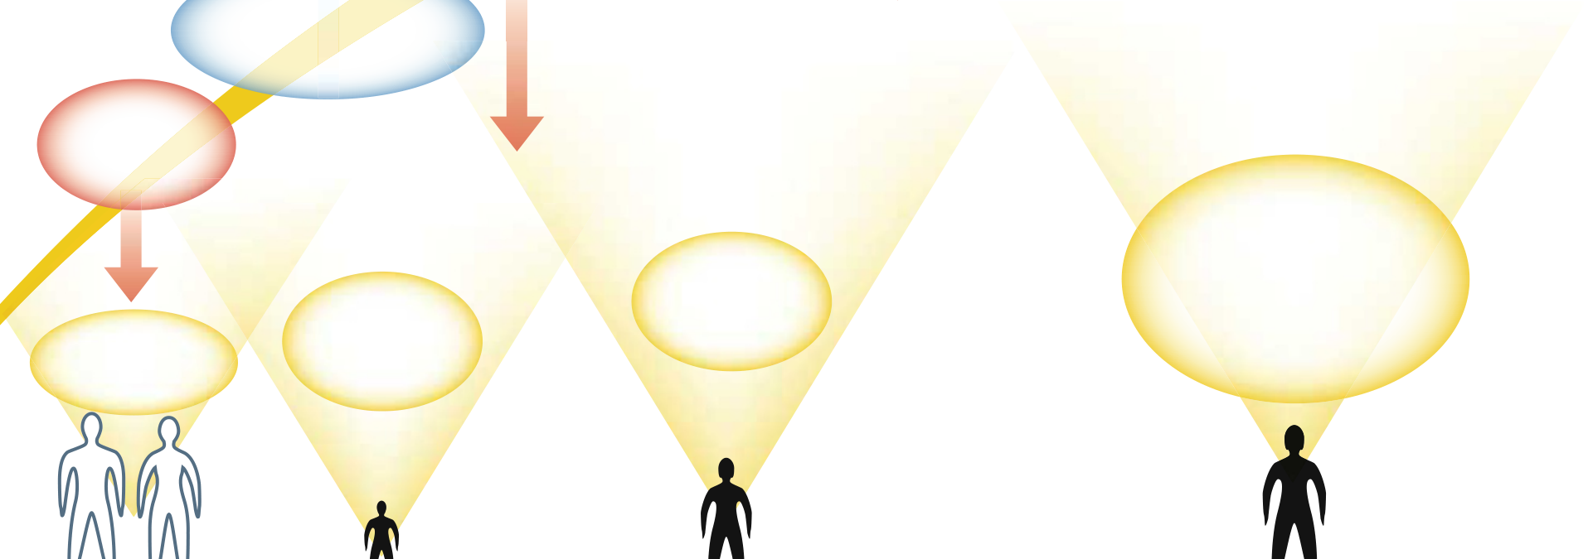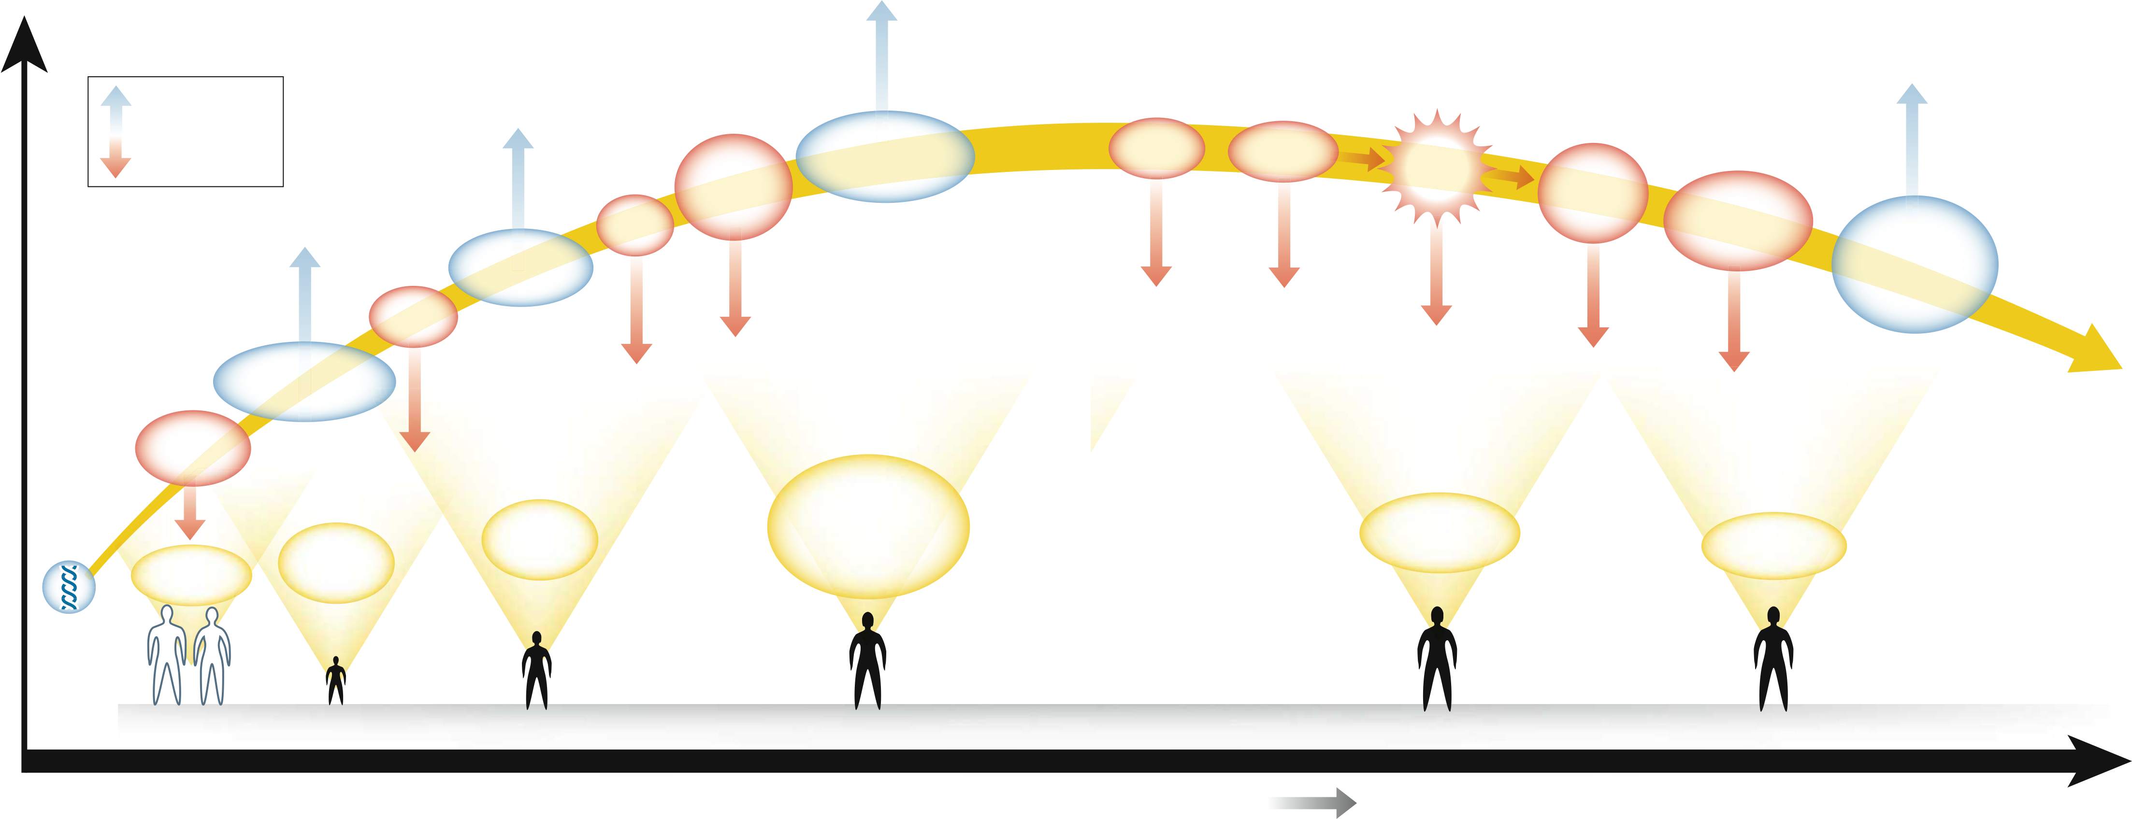

Positive influences

|  |  |  |  |  |  |  |  |  |  |  |  |  |
| --- | --- | --- | --- | --- | --- | --- | --- | --- | --- | --- | --- | --- |
| **Mental capital** | Negative influences | Supportive teaching | Childhood | • Antisocial | • Resisting peer-pressure | Drug and | Social | **Stress** | • Anxiety | Age-related | • Physical activity | **Waste of** |
| alcohol abuse | exclusion |
| • Social engagement |
| behaviour |
| • Depression |
| • Teen pregnancy |
| • Chronic illness |
| Early stress | Smoking | cognitive and |
| trauma | physical challenges |
| • Mental activity |
| • Social stimulation |
| and education | • Medication or |
| dietary interventions |
| exposure |
| • Good parenting skills |
| • Early home experiences |
| • Tobacco | **mental capital** |
| • Poor diet |
| • Drugs/alcohol |

**• Executive function**

|  |  |  |  |  |  |
| --- | --- | --- | --- | --- | --- |
| **Fetal** | **Early** | **Disposition** | **• Social cognition** | **Cognitive resilience**  **and coping skills** | **Cognitive reserve** |
| **• Self-esteem** |
| **to learn** | **• Literacy and numeracy** |
| **development** |
| **programming** |

Genetic

endowment

|  |  |  |  |  |  |
| --- | --- | --- | --- | --- | --- |
| **Pren e atal** | **Early y childhood (0–4)** | **Child (5–12)** | **Adolescent** | **Adult** | **Older adult** |
| **S c h o o l** | **W o r k** | **R e t i r e m e n t** |

**Life course**   
**1058**  **1059**



|  |  |  |
| --- | --- | --- |
| FEATURE |  | NATURE|Vol 455|23 October 2008 |
| mood stabilizers, and neuroprotective agents for Alz heimer’s. Improved techniques and longer-acting medications are needed to tackle addiction, and developing these will require innovative approaches. Furthermore, although many treatments are available for depression, most work by increasing levels of monoamine neurotransmitters. More effective therapies with different mechanisms of action and fewer side effects are urgently needed.  Behavioural and other non-pharmaceutical interventions for improving well-being also need to be developed. This would encompass the treatment of people affected and prevention of the disorders in high-risk groups, as well as the enhancement of mental capital and well-being for all members of the population.  A range of skills and behaviours is crucial in empowering people to develop and main-tain their mental capital and well-being. These include executive function (self-regulation) skills; an eagerness to learn, train and retrain throughout life; the resilience to cope with stress and life events; and behaviours that can promote a healthy lifestyle and protect against decline in old age. Multidisciplinary research, in the natural and social sciences, will be needed to investigate the systematic relations between these skills, to determine how they can best be developed. | Furthermore, depression is the leading global cause of years lived with disability19. The annual costs from mental ill-health in England alone are about £36 billion (US$62 billion) for economic costs, rising to £77 billion when wider impacts are included, such as a reduction in quality of life20. Measures to improve mental health would therefore yield benefits well in excess of costs. Future demographic changes mean that this figure could rise substantially. The age profile of the population will change as life expectancy increases and fecundity levels fall. The UK Office of National Statistics21 estimates that, by 2071, the number of people older than 65 could double to nearly 21.3 million, and those aged 80 and over could more than treble to 9.5 million. This would probably lead to much more cognitive decline and dementia, and an expenditure time bomb: over the next 30 years, the number of people with dementia in the United Kingdom could double to 1.4 million, and costs to the UK economy could treble to more than £50 billion22. In addition, as the number of older people increases, there is a pressing case to take steps to prevent the wast-age of their mental capital that occurs in part through marginalization.  The effects of mental capital and well-being on an individual’s life course are profound, and governments have considerable scope to more fully realize a long-term and strategic perspec-tive that spans the life course. As discussed ear-lier, this Foresight project has delivered some specific policy recommendations. It will now be for the UK government to consider how best to take these forward.  However, a cross-governmental approach is needed to realize the full benefits. Early inter-vention in education could provide benefits for reducing crime, improving productivity in work, and reducing pressure on health and care systems by preserving mental capital in older age. Departments will need to work together more closely. And interventions may have long timescales before they see any returns. Imple-menting these recommendations will require significant changes in the nature of govern-ance, placing mental capital and well-being at the heart of policy-making. n | **education at the University of Cambridge** |
| **Felicia A. Huppert is professor of psychology** |
| **in the Department of Psychiatry and director** |
| **of the Well-being Institute at the University of** |
| **Cambridge** |
| **Rachel Jenkins is professor of epidemiology** |
| **and international mental health policy at the** |
| **Institute of Psychiatry, King’s College London,** |
| **and director of the WHO Collaborating Centre** |
| **on Research and Training** |
| **Hannah S. Jones is a member of the Foresight** |
| **project team in the Government Office for** |
| **Science** |
| **Tom B. L. Kirkwood is director of the Institute** |
| **for Ageing and Health, Newcastle University** |
| **Barbara J. Sahakian is professor of clinical** |
| **neuropsychology, University of Cambridge** |
| **Sandy M. Thomas is head of the Foresight** |
| **programme at the Government Office for** |
| **Science in London** |
| 1. Llewellyn, D. J., Lang, I. A., Langa, K. M., McWilliams, B. C. |
| & Huppert, F. A. *Age Ageing* (in the press). |
| 2. Goswami, U. *Foresight Mental Capital and Wellbeing Project.* |
| *Learning Difficulties: Future Challenges* (Government Office |
| for Science, 2008). |
| 3. Kirkwood, T., Bond, J., May, C., McKeith, I. & Teh, M. |
| *Foresight Mental Capital and Wellbeing Project. Mental* |
| *Capital through Life: Future Challenges* (Government Office |
| for Science, 2008). |
| 4. Albert, M. S. & Blacker, D. *Annu. Rev. Clin. Psychol.***2,** |
| 379–388 (2006). |
| 5. Blennow, K. & Hampel, H. *Lancet Neurol.***2,** 605–613 |
| (2003). |
| **The costs of inaction** |
| 6. Chua, T. C., Wen, W., Slavin, M. J. & Sachdev, P. S. |
| *Curr. Opin. Neurol.***21,** 83–92 (2008). |
| Our project shows that governments and others have tremendous opportunities to cre-ate environments in which mental capital and well-being flourish. However, failure to act could have severe consequences.  Already, we have found that learning difficulties such as dyslexia, which affects up to 10% of children, reduce the probability of achieving good grades at school16. In turn, dis-engagement with the educational system can lead to behavioural problems, social exclusion and crime and reduced employment prospects (which in turn make mental ill-health more likely). This in turn can have adverse conse-quences for cognitive function throughout life. In addition, developmental dyscalculia is currently the poor relation of dyslexia, with a much lower public profile2. But the conse-quences of dyscalculia are at least as severe as those for dyslexia.  Mental ill-health is more widespread than many realize, with 16% of adults in Britain having a common mental disorder such as depression at any one time17. Worldwide, the prevalence of having any mental disorder in the year prior to assessment varies from 4% in Shanghai in China to 26% in the United States18. |
| 7. Schott, J. M. *et al. Neurology***65,** 119–124 (2005). |
| 8. Papassotiropoulos, A. *et al. Science***314,** 475–478 (2006). |
| 9. Reiman, E. M. *et al. Neuron***54,** 713–720 (2007). |
| 10. Phillips, M. L. & Vieta, E. *Schizophr. Bull.***33,** 893–904 |
| (2007). |
| 11. Mayberg, H. S. *et al. NeuroReport***8,** 1057–1061 (1997). |
| 12. Chen, C. H. *et al. Neuropsychopharmacology***33,** 1909–1918 |
| (2008). |
| 13. Cooper, C. *et al. Psychol. Med.* **38,** 335–342 (2008). |
| 14. Bebbington, P. E. *et al. Br. J. Psychiatr.* (in the press). |
| 15. Jenkins, R. *et al. Psychol. Med.* **38,** 1485–1493 (2008). |
| 16. Challen, A., King, D., Knapp, M. & McNally, S. *Foresight* |
| *Mental Capital and Wellbeing Project. The Economic* |
| *Consequences of Specific Learning Difficulties and the Cost-* |
| *Effectiveness of Prevention Strategies* (Government Office |
| for Science, 2008). |
| 17. Jenkins, R. *et al. Foresight Mental Capital and Wellbeing* |
| *Project. Mental Health: Future Challenges* (Government |
| Office for Science, 2008). |
| 18. The WHO World Mental Health Survey Consortium*.* |
| *J. Am. Med. Assoc.* **291,** 2581–2590 (2004). |
| 19. World Health Organization www.who.int/mental_health/ |
| **John Beddington is the UK government chief** | management/depression/definition/en |
| 20. Sainsbury Centre for Mental Health *Economic and Social* |
| **scientific adviser and head of the Government** |
| *Costs of Mental Illness in England* (2003). |
| **Office for Science in London** | 21. Office for National Statistics *National Population Projections* |
| **Cary L. Cooper is pro-vice chancellor and** | *2006-based* (ONS, 2008). |
| **professor of organizational psychology and** | 22. Knapp, M. *et al. Dementia UK (*Alzheimer’s Society, 2007). |
| **health at Lancaster University** | **Author information** |
| **John Field is co-director of the Centre for** | Reprints and permissions information is available |
| **Research in Lifelong Learning, Stirling** | at www.nature.com/reprints. The authors declare |
| competing financial interests: details accompany the |
| **Institute of Education, University of Stirling** |
| full-text HTML version of the paper at www.nature. |
| **Usha Goswami is director of the Centre for** |
| com/nature. Correspondence should be addressed to |
| **Neuroscience in Education, and professor of** | S.M.T. (sandy.thomas@dius.gsi.gov.uk). |

**1060**

