# SCHOOL OF ENGINEERING AND TECHNOLOGY ACADEMIC SESSION AUGUST 2022;

**WEB1201 WEB FUNDAMENTALS**

# DEADLINE: 25TH November 2022 (FRIDAY), 5:00 PM

**STUDENT NAME: Tan Hui Xin NRIC/PASSPORT NO: 030219-12-0742**

# INSTRUCTIONS TO CANDIDATES

* This final assessment will contribute 50% to your final grade.
* This is an individual assignment.

**Academic Honesty Acknowledgement**

“I ......................Tan Hui Xin....................................(Name) verify that this

paper contains entirely our own work. I have not consulted with any outside person or materials other than what was specified (an interviewee, for example) in the assignment or the syllabus requirements. Further, I have not copied or inadvertently copied ideas, sentences, or paragraphs from another student. We realize the penalties *(refer to the student handbook diploma and undergraduate programme)* for any kind of copying or collaboration on any assignment.”

…………………huixin……22/11/2022.................................. (Student’s Signature / Date)

**IMPORTANT**

The University requires students to adhere to submission deadlines for any form of assessment. Penalties are applied in relation to unauthorized late submission of work. Coursework submitted after the deadline will be subjected to the prevailing academic regulations. Please check your respective programme handbook.

1.0 Introduction

My website is called Cofiee. This website's specific purpose is to sell coffee as well as to provide online reservations. Furthermore, my website's purpose is to be eye-catching, colourful, easily identifiable, and simple, as well as to display high-quality products. It will show customers the new exclusive products. The entire operation is conducted online. We save a lot of money by not having a physical store where customers can come in and look at the products, and we pass those savings on to the customers, ensuring very low prices. Also, to provide high-quality products for both genders and to deliver the products purchased on time. The website should also promote the business branches and occasional special offers.

* 1. Overview of the project

This web project allows me to customise my own website. It also helps me to design and manage website elements such as photos, text, tables, and forms. These days I learn HTML and CSS quickly by watching extra videos or using a tutorial site like “w3schools.com.” Doing this project, allows me to express myself on my own website, stand out from the crowd, contribute to projects more effectively, learn and explore new languages, and will explore a different career in the future.

**2.0 Rationale behind the creation of my website**

One of the main functions of my website is to promote and sell services or products. To accomplish this, different levels of user expectations must be considered. A good design has a few key characteristics, including being visually attractive, drawing attention, and fitting into a specific context. Creating a website with a specific topic necessitates the use of an appropriate layout and content. In a specified context of use, a product or service can be used by specified users to achieve specified goals with efficiency, effectiveness, and enjoyment (Hussain & Mkpojiogu, 2015).

**2.1 Main Page**

In figure 1, This main page shows my shop name at the top left along with the navigation bar that includes buttons for pages such as home, login, about, service, cart, menu, reservation, and contact. I also apply a coffee bean wallpaper that suits my topic appropriately. Figure 1.2 shows my footer page which contains my shop’s address, open hours, social media, and newsletter sign-up.

Figure 1

Figure 2

**2.2 About us Page**

In Figure 2, it shows the webpage of about us which contains the information and the vision of my shop. I also inserted an image in the middle of the webpage to improve my brand identity.

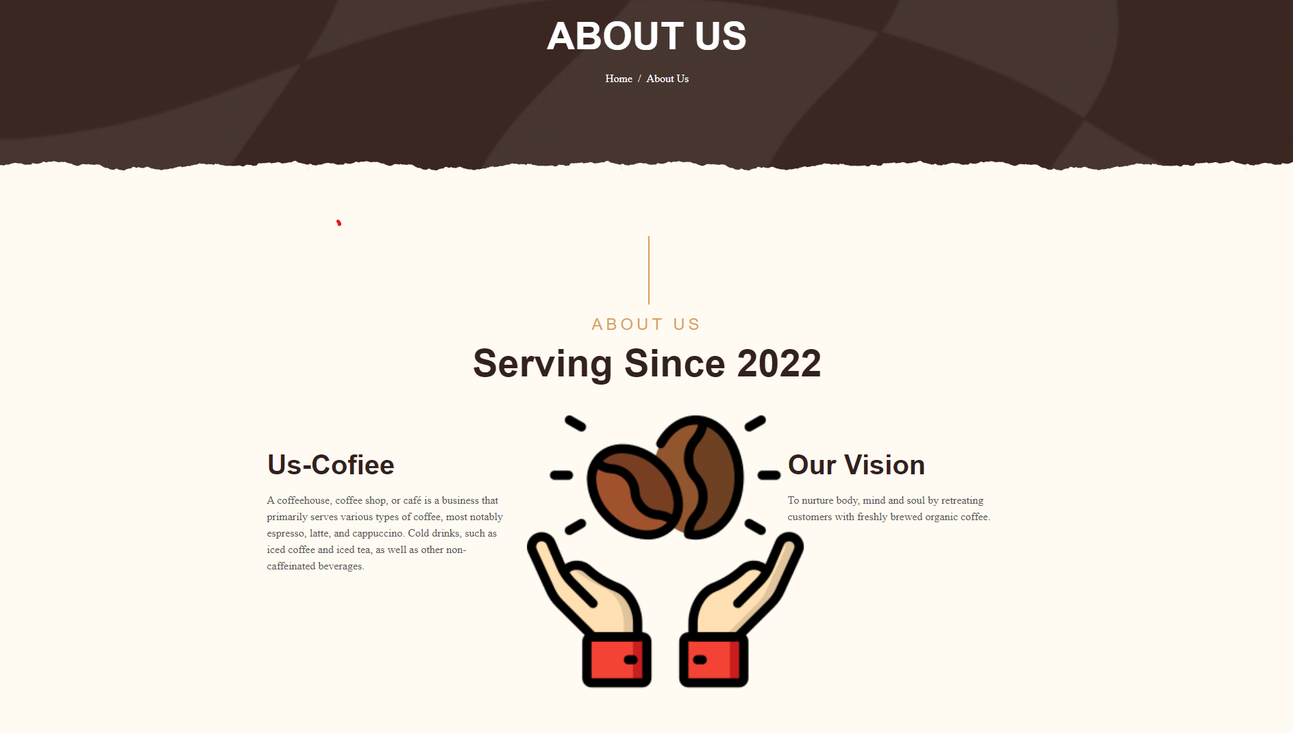

Figure 2

**2.3 Sign-up Page /Login page**

This page indicates new customers and registered customers to continue their sign-up or login action by clicking the buttons as shown in Figure 3. The registered customers can log in to their email directly.

Figure 3

**2.4 Registration Page**

This webpage will lead the new customer to fill in their simple personal information such as first name, last name, and email address. I also designed a “Sign up for newsletter” checkbox. The login information should also be filled in after completing the personal information form as shown in Figure 4.

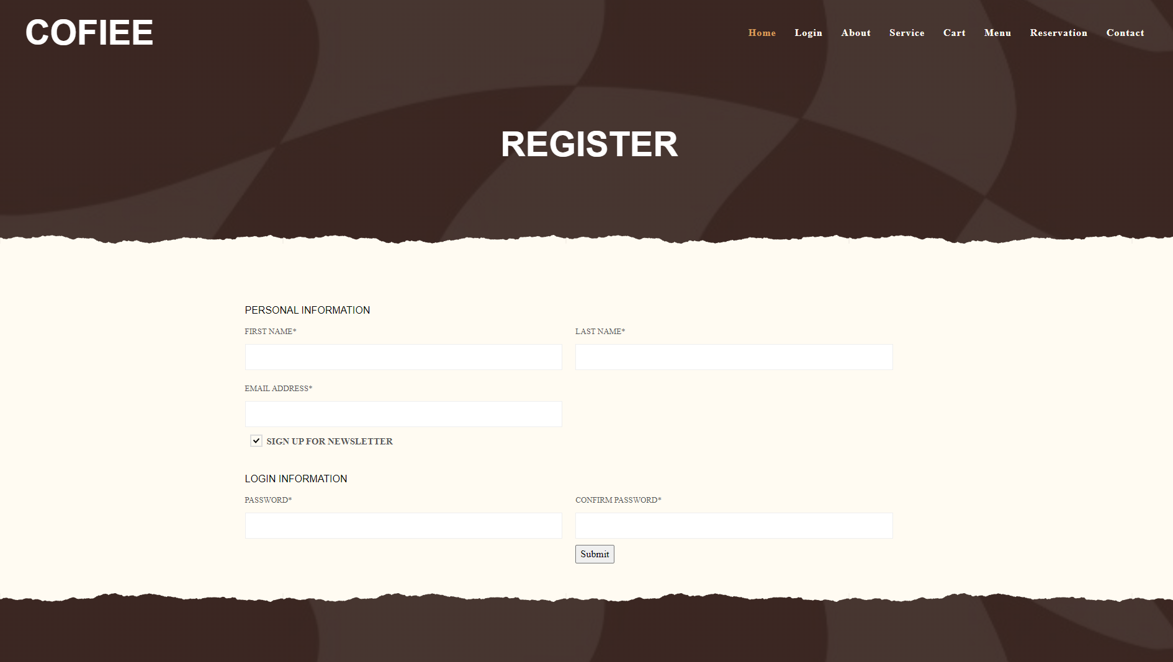

Figure 4

**2.5 Service Page**

In Figure 5, this webpage displays the services that I provide for customers by adding some images to let customers feel more welcome on my page.

Figure 5

**2.6 Menu page**

Next, this webpage shows all the coffees that I sell along with pricing, description, and images as shown in Figure 6 below.

Figure 6

**2.7 Cart page**

In figure 7, I have created a dummy cart page by adding some items inside.

Figure 7

**2.8 Reservation Page**

I made a reservation page for customers to book their tables online by filling in their name, email, date, time, and person which improves convenience as shown in Figure 8. Besides, customers can enjoy 15% off by booking online.

Figure 8

**2.9 Contact Page**

In figure 9, I have created a contact webpage with a form to let customer send their messages and know about my shop’s phone, email, and address.

Figure 9

**3.0 Implementation details of the website and justification of the approaches**

In this section, I will explain in more detail about functional requirements, functional testing, and user interface elements for the project.

**3.1 Validation of register page**

Figure 10 is my register form, which will use JavaScript to allow users to register a new account through the webpage. If the first name, last name, and email are empty and the password is not between 6 to 20 words or the password is not the same as the confirm password, the user will be unable to register. It will show the alert messages to the customer as shown in Table 1. Aside from that, this is merely a fake method that will not really query the database.

Figure 10

|  |  |
| --- | --- |
|  |  |
|  |  |
|  |  |
|  |  |

Table1: Error messages of register page

**3.2 Validation of login page**

Figure 11 shown below, is my login form for registered customers, the function will be slightly the same as the registration page which is just only validating for email and password.

Figure 11

**3.3 Validation of reservation page**

This is the reservation form that I designed for customers to book their tables as shown in Figure 12. In Table 2, this form validation is close to the two validations above also, but I add the validation of the date in the format dd/mm/yyyy and the validation of time in the format hh: mm. The number of persons can be chosen by clicking the up-down arrow too as shown in Figure 13.

Figure 12

|  |  |  |
| --- | --- | --- |
|  |  | |
|  | |

Table 2: Error messages of reservation page

Figure 13

**3.4 Validation of Contact Page**

Figure 14 is the contact page that I designed, I have added the validation of the subject which should not be more than 20 characters, and the message which should not be more than 150 characters.

Figure 14

**3.5 Requirements**

This e-commerce website should be created for usability, or how easy it is to use my website, as well as for user experience and how enjoyable it is to interact with my website.

|  |  |
| --- | --- |
| Functional Requirements | Description |
| a) Register function | This website should have a new customer registration to allow users to register with their email addresses. |
| b) Login function | This website should have a customer login function that allows users to log in with their email addresses. |
| c) Sign-up function | The customer should be able to sign-up for their email to get newsletters and offers. |
| d) Booking function | The customer should be able to book their reservation online. |
| e) Contact function | This website should have a contact function to let the customer deliver their message. |

Table 3: Functional Requirements of e-commerce website

|  |  |
| --- | --- |
| Non -Functional Requirements | Description |
| a) Understandability | This website should be able to allow the customer to understand the information about my products and service. |
| b) Availability | This website should be able to let customer delivers their message and book their reservation. |
| c) Usability | The user should be able easy for a customer to view the website. |

Table 4: Non-Functional Requirements of e-commerce website

**3.6 Test case and test result**

|  |  |
| --- | --- |
| **Test Case ID** | TC-01-001 |
| **Objective** | Test the register page without giving any customer information |
| **Test Steps** | 1. Do not enter the first name 2. Do not enter the last name 3. Do not enter the email address 4. Do not enter the password 5. Do not enter the confirm password 6. Click the “Submit” Button. |
| **Input Data** | First name:  Last name:  Email Address:  Password:  Re-enter Password: |
| **Expected Results** | The system will display the alert messages “First name is required.” “Last name is required.” Email address is required.” “Password is required.” “Confirm password is required.” |
| **Actual Results** | Matches the expected results |
| **Test Results** | Pass |

|  |  |
| --- | --- |
| **Test Case ID** | TC-01-002 |
| **Objective** | Test the register page with the confirm different password. |
| **Test Steps** | 1. Enter the first name and last name 2. Enter the email address 3. Enter the password 4. Enter the confirm password that does not meet the requirement 5. Click the “Submit” Button. |
| **Input Data** | First name: Hui  Last name: Xin  Email Address: huixin030219@gmail.com  Password: 123456  Re-enter Password: 123444 |
| **Expected Results** | The system will display an alert message "Confirm password should be same as the password." |
| **Actual Results** | Matches the expected results |
| **Test Results** | Pass |

|  |  |
| --- | --- |
| **Test Case ID** | TC-01-003 |
| **Objective** | Test the register page with the error re-enter password |
| **Test Steps** | 1. Enter the first name 2. Enter the last name 3. Enter the email address 4. Enter the password 5. Enter the confirmed password that meets the requirement 6. Click the “Submit” Button. |
| **Input Data** | First name: Hui  Last name: Xin  Email Address: huixin030219@gmail.com  Password: 123456  Re-enter Password: 123456 |
| **Expected Results** | The system will display an alert message “Register and login successfully.” |
| **Actual Results** | Matches the expected results |
| **Test Results** | Pass |

|  |  |
| --- | --- |
| **Test Case ID** | TC-02-001 |
| **Objective** | Test the login page with the correct email and password |
| **Test Steps** | 1. Enter the email address. 2. Enter the password. 3. Click the “Login” Button. |
| **Input Data** | Email: huixin030219@gmail.com  Password: 123456 |
| **Expected Results** | The system will display an alert message "Login Successfully" |
| **Actual Results** | Matches the expected results |
| **Test Results** | Pass |

|  |  |
| --- | --- |
| **Test Case ID** | TC-02-002 |
| **Objective** | Test the login page with an incorrect email format |
| **Test Steps** | 1. Enter the incorrect email format 2. Enter the password. 3. Click the “Login” Button. |
| **Input Data** | Email: huixin.com  Password: 123456 |
| **Expected Results** | The system will display an alert message “Email incorrect.” |
| **Actual Results** | Matches the expected results |
| **Test Results** | Pass |

|  |  |
| --- | --- |
| **Test Case ID** | TC-03-001 |
| **Objective** | Test the contact page that meets the requirement |
| **Test Steps** | 1. Enter the name. 2. Enter the email. 3. Enter a subject. 4. Enter a message. 5. Click the “Submit” button. |
| **Input Data** | Name: Hui Xin  Email: huixin030219@gmail.com  Subject: Hello  Comments: Nice to meet you |
| **Expected Results** | The system will display an alert message “Sent successfully.” |
| **Actual Results** | Matches the expected results |
| **Test Results** | Pass |

|  |  |
| --- | --- |
| **Test Case ID** | TC-03-002 |
| **Objective** | Test the contact page that does not meet the requirement |
| **Test Steps** | 1. Enter the name. 2. Enter the email. 3. Enter a subject over 20 words. 4. Enter a message over 150 words 5. Click the “Submit” button. |
| **Input Data** | Name: Hui Xin  Email: huixin030219@gmail.com  Subject: Hellooooooooooooooooooooooooooooooooooooooo  Comments: Nice to meet you Nice to meet you Nice to meet you Nice to meet you Nice to meet you Nice to meet you Nice to meet you Nice to meet you Nice to meet you Nice to meet you Nice to meet you Nice to meet you Nice to meet you |
| **Expected Results** | The system will display an alert message "Subject should not be more than 20 characters" and "Message should not be more than 150 characters." |
| **Actual Results** | Matches the expected results |
| **Test Results** | Pass |

|  |  |
| --- | --- |
| **Test Case ID** | TC-04-001 |
| **Objective** | Test the reservation page that meets the requirement |
| **Test Steps** | 1. Enter the name. 2. Enter the email. 3. Enter the date in dd/mm/yyyy format. 4. Enter the time in hh:mm format. 5. Select the person option. 6. Click the “Book Now” button. |
| **Input Data** | Name: Hui Xin  Email: huixin030219@gmail.com  Date: 12/31/2022  Time: 12:30  Person: Person 2 |
| **Expected Results** | The system will display an alert message “Booking successfully.” |
| **Actual Results** | Matches the expected results |
| **Test Results** | Pass |

**4.0 References**

Hussain, A., & Mkpojiogu, E. O. C. (2015). The effect of responsive web design on the user experience with laptop and smartphone devices. *Jurnal Teknologi*, *77*(4). https://doi.org/10.11113/jt.v77.6041