Class activity 8 – Hover effect animation
Learning outcome: students should be able to
- create simple hover effect to HTML elements using CSS properties.
- make HTML elements to response to at least two different window browser width.
Activity description: create a row with four cards with the following styles and features:
Styling
- Each card should have a box shadow, image, title and subtitle in-front of the image.
- The title and subtitle in-front of the image should have different color and size.
- Each card should be linked to a website.
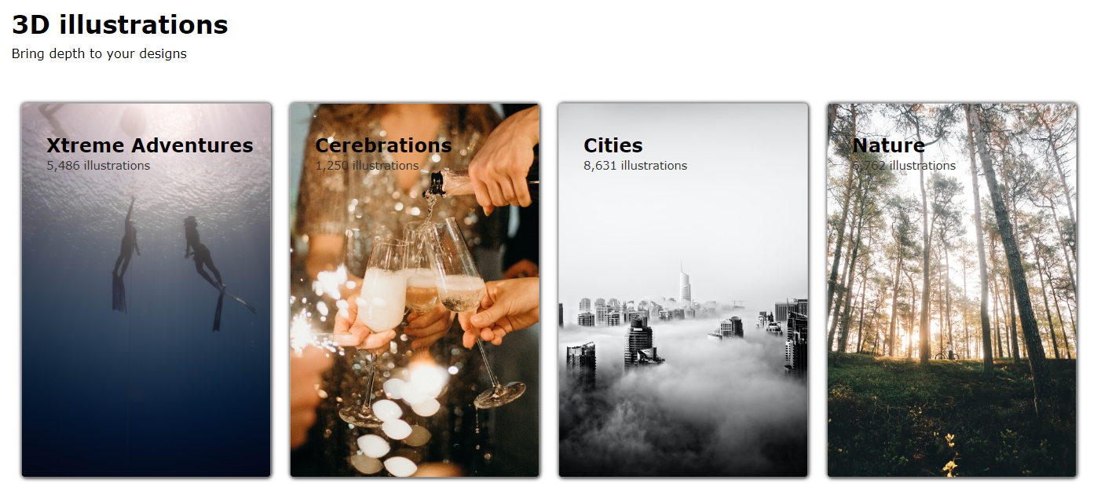
Features
- When a mouse hover on a card, the card should zoom-out a little bit,

