**3. Arrays**

An array is literally an array where you can store as few or as many items as you like and retrieve one of, some of, or all of those items.

There are different ways to create an array. Manly, to create an array using an array initializer, first create an undefined variable, then add the different values to the array using a comma separated list wrapped in square brackets.

let fruits;

fruits = **[**'oranges', 'apples', 'peaches'**]**; //Create an array using square brackets console.log(fruits);

Also, instead of a two lines code, you can write the code in one line of code

let fruits=['oranges','apples','peaches']; //Create an array using square brackets console.log(fruits);

Arrays can also be created by using a constructor **new Array** with an single number parameter

fruits = new Array ('oranges', 'apples', 'peaches'); console.log(fruits);

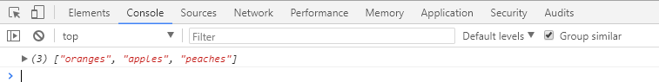

One interesting note about arrays each value in the array can be a separate data type so you can mix strings, Booleans, and numbers all you like.

let mixedArray =['cars', 10, true, 'mixed array']; console.log(mixedArray);

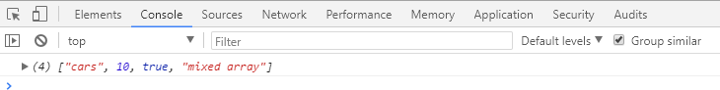

*Accessing array elements*

Each of the values added to an array is placed in a separate slot and given an index number. **Computer indexes start with zero** so the first item has index number zero, the second number is indexed one, and so on. Once the array is created, you can retrieve a specific value from the array based on its index.

fruits = new Array ('oranges', 'apples', 'peaches');

let x = fruits[2]; // Store string “peaches” in variable x

If you need to change a value in the array you simply refer to its index position and assign a new value.

fruits = new Array ('oranges', 'apples', 'peaches');

fruits[0] = “cherries”; // replace the string “oranges” with “cherries”

*Subarrays*

You can also create arrays inside of an array. To do so, we just need to open a square brackets inside of a square brackets:

*Syntax*

*let meals= ['breakfast',['egg','bread','juice'], 'lunch',['fish','salad']];*



let countries = ['America',['Canada', 'USA', 'Mexico', 'Brasil', 'Argentina'], 'Europe',['France', 'England', 'Italy', 'Spain', 'Germany','Switzeland'], 'Asia',['China', 'India', 'Japan', 'Korean', 'Singapore'] ];



To retrieve information from a subarray, we write square brackets of the array position follow by the square bracket of the subarray index.

countries[1][3];



*String as array*

A string can also be treated as an array. We create an string and retrieve the character by using square brackets and the index position of the character.

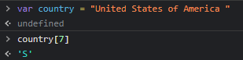

let country = "United States of America "

country[7] 🡺 'S'

Also, we can use string properties such as **length** to retrieve elements out of an array

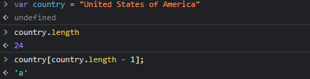

***Properties and methods in arrays***

In JavaScript, objects have properties and methods. Properties are pieces of meta information about the object we can retrieve and use. Methods are functions that belong to that object. For more information about the different arrays and how to use then, go to [**w3schools.com**](https://www.w3schools.com/js/js_array_methods.asp)or[**developer.mozilla.org**](https://developer.mozilla.org/en-US/docs/Web/JavaScript/Reference/Global_Objects/Array)

***Direct methods***

These are the methods that update the array information directly within the array:

let mixedArray =['cars', 10, true, 'apples']; console.log("Before :", mixedArray);

//

// Reverse method mixedArray.reverse();

console.log("After reverse :", mixedArray);

//

// Remove the first value of the mixedArray using method "shift" mixedArray.shift();

console.log("After shift method :", mixedArray);

//

// Add comma-separated list of values to the beginning, starting index 0, of the array using method "unshift"

mixedArray.unshift("NY", 280);

console.log("After unshift method :", mixedArray);

//

//add comma-separated list values at the end of the array using method “push"

mixedArray.push(350, "QCC");

console.log("After push method :", mixedArray);

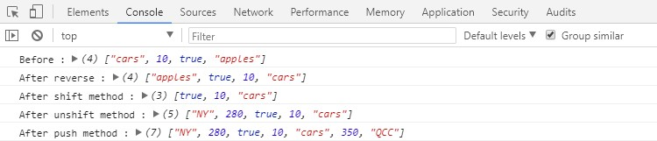

#### Methods that return values

***slice*** creates a copy of the array and then returns it to us, and typically we would place it inside a variable, or use it directly in some sort of function.

let fruits = ["apples", "cherries", "beaches"];

// create a copy of array fruits let fruits1 = fruits.slice();

console.log("Array fruits: ", fruits);

console.log("New fruits array using method slide : ", fruits1);

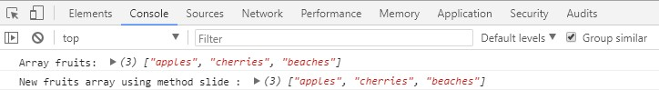

The next method, **indexOf**, gives us the index number for a specific search. If the search is false, it returns a -1.

*Syntax:*

**indexOf** (value we are searching, from which index position);

let fruits = ["apples", "cherries", "beaches"];

// create a copy of array fruits

let fruits1 = fruits.indexOf("cherries", 0); // the syntax of indexOf (value we are searching, from which index position)

console.log("Array fruits: ", fruits);

console.log("Search of location of the cherries in array fruits : ", fruits1); console.log("To display value of searched index is: ", fruits[fruits1]);

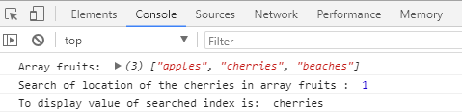

**join** method takes all the elements in an array, and join them together in a single string and separate them with a comma.

let fruits = ["apples", "cherries", "beaches", ];

// create a copy of array fruits let fruits1 = fruits.join();

console.log("Array fruits: ", fruits);

console.log("Display elements in an array separated with a comma : ", fruits1);

let fruits1 = fruits.join**(" % ");**

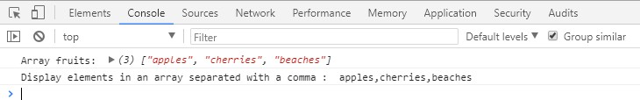



Now, notice that the commas have no space after them, so if you want to use these as actual HTML, you probably want to change that separator. You can do that by changing it in the arguments between the parentheses.

**REFERENCE**

|  |  |
| --- | --- |
| **Array Method** | **Description** |
| [**concat()**](https://www.w3schools.com/jsref/jsref_concat_array.asp) | Joins two or more arrays, and returns a copy of the joined arrays |
| [**copyWithin()**](https://www.w3schools.com/jsref/jsref_copywithin.asp) | Copies array elements within the array, to and from specified positions |
| [**entries()**](https://www.w3schools.com/jsref/jsref_entries.asp) | Returns a key/value pair Array Iteration Object |
| [**every()**](https://www.w3schools.com/jsref/jsref_every.asp) | Checks if every element in an array pass a test |
| [**fill()**](https://www.w3schools.com/jsref/jsref_fill.asp) | Fill the elements in an array with a static value |
| [**filter()**](https://www.w3schools.com/jsref/jsref_filter.asp) | Creates a new array with every element in an array that pass a test |
| [**find()**](https://www.w3schools.com/jsref/jsref_find.asp) | Returns the value of the first element in an array that pass a test |
| [**findIndex()**](https://www.w3schools.com/jsref/jsref_findindex.asp) | Returns the index of the first element in an array that pass a test |
| [**forEach()**](https://www.w3schools.com/jsref/jsref_forEach.asp) | Calls a function for each array element |
| [**from()**](https://www.w3schools.com/jsref/jsref_from.asp) | Creates an array from an object |
| [**includes()**](https://www.w3schools.com/jsref/jsref_includes_array.asp) | Check if an array contains the specified element |
| [**indexOf()**](https://www.w3schools.com/jsref/jsref_indexof_array.asp) | Search the array for an element and returns its position |
| [**isArray()**](https://www.w3schools.com/jsref/jsref_isarray.asp) | Checks whether an object is an array |
| [**join()**](https://www.w3schools.com/jsref/jsref_join.asp) | Joins all elements of an array into a string |
| [**keys()**](https://www.w3schools.com/jsref/jsref_keys.asp) | Returns a Array Iteration Object, containing the keys of the original array |
| [**lastIndexOf()**](https://www.w3schools.com/jsref/jsref_lastindexof_array.asp) | Search the array for an element, starting at the end, and returns its position |
| [**map()**](https://www.w3schools.com/jsref/jsref_map.asp) | Creates a new array with the result of calling a function for each array element |
| [**pop()**](https://www.w3schools.com/jsref/jsref_pop.asp) | Removes the last element of an array, and returns that element |
| [**push()**](https://www.w3schools.com/jsref/jsref_push.asp) | Adds new elements to the end of an array, and returns the new length |
| [**reduce()**](https://www.w3schools.com/jsref/jsref_reduce.asp) | Reduce the values of an array to a single value (going left-to-right) |
| [**reduceRight()**](https://www.w3schools.com/jsref/jsref_reduceright.asp) | Reduce the values of an array to a single value (going right-to-left) |
| [**reverse()**](https://www.w3schools.com/jsref/jsref_reverse.asp) | Reverses the order of the elements in an array |
| [**shift()**](https://www.w3schools.com/jsref/jsref_shift.asp) | Removes the first element of an array, and returns that element |
| [**slice()**](https://www.w3schools.com/jsref/jsref_slice_array.asp) | Selects a part of an array, and returns the new array |
| [**some()**](https://www.w3schools.com/jsref/jsref_some.asp) | Checks if any of the elements in an array pass a test |
| [**sort()**](https://www.w3schools.com/jsref/jsref_sort.asp) | Sorts the elements of an array |
| [**splice()**](https://www.w3schools.com/jsref/jsref_splice.asp) | Adds/Removes elements from an array |
| [**toString()**](https://www.w3schools.com/jsref/jsref_tostring_array.asp) | Converts an array to a string, and returns the result |
| [**unshift()**](https://www.w3schools.com/jsref/jsref_unshift.asp) | Adds new elements to the beginning of an array, and returns the new length |
| [**valueOf()**](https://www.w3schools.com/jsref/jsref_valueof_array.asp) | Returns the primitive value of an array |