**More about functions**

***Anonymous functions***

Anonymous functions do not have names, so they need to be tied to something, a variable, or an event, or something similar to run. Anonymous functions are used mainly when the function is not called often in different part on the script.

var x = function(){

var a =5/7; var b = 8/25;

var result;

a>b? result =["a = ",a] : result = ["b = ",b]; console.log(result);

}

x( );

NOTE: CHANGE CODE

Example) Anonymous function without argument and return value

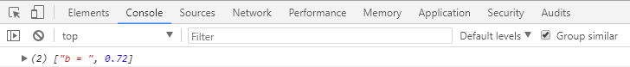

Example) Return the value in an anonymous function

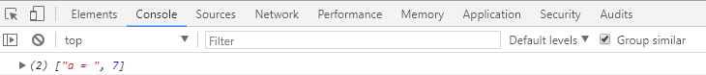

var x = function(){

var a =7;

var b = -18;

var result;

a>b? result =["a = ",a] : result = ["b = ",b]; return result;

}

console.log(x());

*Object constructor using functions*

Object Constructors are templates for creating objects that we define once and then we can use those templates again and again.

To make a constructor for any object we start with function, then we give our function a name and here we capitalize the first letter to signify this is an object.

// Create an object function named course

function **course**(title, instructor, code, session, students){ this.title = title;

this.instructor = instructor; this.code = code; this.session= session; this.students = students;

};

// call for object function

var course1 = new course("Creating Smarthphone Apps", "Prof. Wu", "ET570","M4",20); var course2 = new course("Computer Applications", "Prof. Novak", "ET501", "C3", 26);

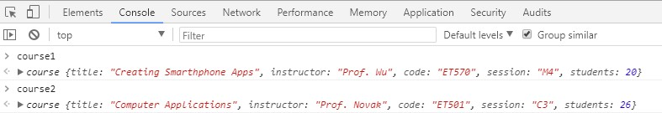

***Closure***

A closure is a function inside a function that relies on variables in the outside function to work

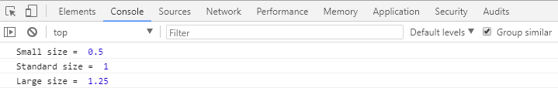

function giveMeEms(pixels){ var baseValue = 16;

// function inside the function giveMeEms function DoMath(){

return pixels/baseValue;

}

return DoMath;

}

var smallSize = giveMeEms(8); var standardSize = giveMeEms(16); var largeSize = giveMeEms(20);

// Display the different sizes console.log("Small size = ", smallSize()); console.log("Standard size = ", standardSize()); console.log("Large size = ", largeSize());