**Conditional and Logic Statement**

***true*** *and* ***false*** *values*

In JavaScript, the Boolean data type represents one of two values: true or false. Those values can also be assigned to a variable as:

let day = true;

let night = false;

The Boolean variables are later used in the program to test or compare if a given condition is true or false.

if (day){

console.log("The statement is: ", day);

}

The display in the console 🡺 

A lot of programming is about testing for conditions, asking if some condition is met, then do this, otherwise do something else. This is done using conditional statements and logic operators.

|  |  |
| --- | --- |
| **Boolean**  **operator** | **Purpose** |
| **>** | Greater than |
| **<** | Less than |
| **>=** | Greater than or equal to |
| **<=** | Less than or equal to |
| **==** | equality |
| **===** | Exact equal to |
| **!=** | Not equal |
| **!==** | Exact not equal to |
| **&&** | And |
| **||** | Or |
| **!** | Not |

Character or string comparison with **greater than > or less than <** with compare the character Unicode value

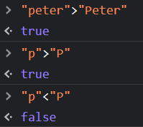

**== double** equals checks for equality of value, but not equality of type. It basically treats both values as the same type and then compares them. This can be very problematic.

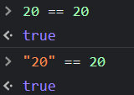

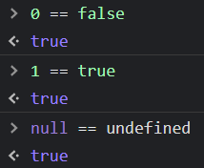

**=== triple equals** sign checks for equality of type and value

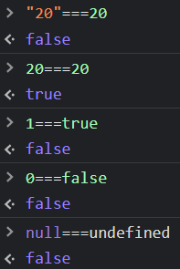

**!= not equal to** compares if the values, and not the type, that are not equal to each other

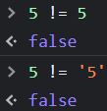

**!== exactly not equal to** compares if the values and the types are not equal to each other

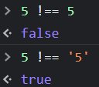

For comparison, it is recommended to use triple equal **===** and exactly not equal to **!==**

***Conditional if statement***

**if** statement testes if a condition is true, then do something. It is also known as an ON/OFF switch condition.

*Syntax*

**if (***testing condition***) {** *do something* **}**

Here, the parenthesis wrap the condition, or conditions, and the curly braces wrap what happens if the condition is met. This is known as the code block. You could technically write this all on one line, but that would be hard to read for the humans who will be looking at your code, so you can write the first curly brace on one line, then the code block inside in the next line.

**if (***testing condition***)**

**{** *do something* **}**

**Example 1)** Use if statement to check a person mood

let goodMood = true;

let gotSleep = false;

if (goodMood **!==** gotSleep){

console.log("Today is a good day!");

}

console.log("I am moody!");



the console displays 🡺

If we change the conditional to triple equal sign, we are basically comparing if the two logic statements are true.

let goodMood = true;

let gotSleep = true;

if (goodMood **===** gotSleep){

console.log("Today is a good day!");

}

console.log("I am moody!");



The console displays 🡺

#### if – else condition

If you want to create an **if/else** statement, where you perform a separate specific action **if** the condition is not met as well, you add **else**, and a new set of curly braces after the **if** statement. If some condition is true, do something, **else**, if the condition it's not true, then check something **else**. If statements require conditions to work, so we need some logic operators.

**Example 2)** Check if two numbers are equal

let a = 5, b = 4, equalNum;

if (a===b)

{equalNum = true; } else

{equalNum = false; }

console.log("The numbers match: " + equalNum);



The console displays 🡺

#### if – else if - else condition

if-else if-else condition test more than two statements.

**Example 3)** use if-else if-else statement to check if two numbers are the same, greater than or less than

let num1 = 5, num2 = 8;

if (num1===num2){

console.log("The numbers are equal");

}

else if (num1>num2) {

console.log("number 1 is greater than number 2");

}

else if (num2>num1) {

console.log("The number 1 is less than number 2");

}

else {

console.log("Invalid Entry");

}



The console displays 🡺

**Example 4)** use an **if, else if** statement to check which color is selected from an array

let colors =['red','blue','green','yellow','orange']

let userPick = parseInt(prompt("Select a color from 1 to 5")) // parseInt () converts input into an integer

let selectColor = colors[userPick - 1]

if(selectColor === 'red'){

console.log('The selected color is red!')

}

else if (selectColor =='blue'){

console.log('The selected color is blue!')

}

else if (selectColor =='green'){

console.log('The selected color is green!')

}

else if (selectColor =='yellow'){

console.log('The selected color is yellow!')

}

else if (selectColor =='orange'){

console.log('The selected color is orange!')

}

else{

console.log('INVALID!')

}

The console displays 🡺 

Remember that JavaScript allows data type collision, meaning that it can modify data to produce the same resulting data type, then it uses a triple equal sign === Boolean operator, to identify exact equal data values. For example, if we want to compare if number 5 and string value 5 are equal values, by using double equal signs, JavaScript will apply data type collision and will treat both value as the same value:

let num = 10;

let otherNum = "10";

if(num>otherNum){

console.log("Number ", num, "is greater than ",otherNum)

}

**else if(num==otherNum){**

console.log("Number ", num, "is equal to ",otherNum)

}

else if(num<otherNum){

console.log("Number ", num, "is less than ",otherNum)

}

else{

console.log("Different data values");

}

The console displays 🡺 

Now, if we replace the double equal signs with the triple equal signs, then JavaScript will check for the exact the same type and value.

let num = 10;

let otherNum = "10";

if(num>otherNum){

console.log("Number ", num, "is greater than ",otherNum)

}

**else if(num===otherNum){**

console.log("Number ", num, "is equal to ",otherNum)

}

else if(num<otherNum){

console.log("Number ", num, "is less than ",otherNum)

}

else{

console.log("Different data values");

The console displays 🡺 

***isNaN()* function**

isNaN(), is Not a Number, is a function that can check if a value is not a number. If the value is not a number, it returns true, else, if the value is a number, it returns false.

**Example 5)** write JS code that opens a dialog box and asks the user to enter a number. If the user enters a string, it will console a message as: *_______ is a string*. Otherwise, if the user enters a number, it will console a message as*: ____ is a number.*

let userInput = prompt("Enter a number: ")

let checkInput = isNaN(parseInt(userInput))

if(checkInput){

console.log(`${userInput} is a string`)

}

else{

console.log(`${userInput} is a number`)

}

***Nesting conditions***

Nesting condition is when we have a condition inside of a condition. It basically check another condition of a true condition.

**Example 6)** Create a JS code, using if-else statement, to check if a password is at least six characters not counting the space. If the password has more than six characters but it also has space, then the program will display an error message.

let password= prompt("Enter a password");

if (password.length>=6){

console.log("Password has 6+ characters!");

if (password.indexOf(' ')===-1){

console.log(`${password} Great! Password has no space!`)}

else{

console.log("Warning! Password can't have space! ")}

}

else{console.log("Password has less than 6 characters! ");}

Running the program, if user types *Peter Pan* and click OK, the console will display:

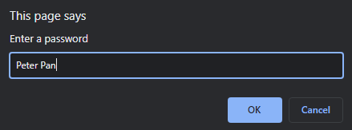



If user types *Peter*  and click OK, the console will display:

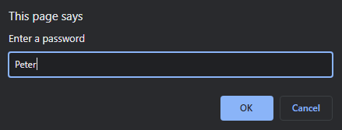



If user types *PeterPan*  and click OK, the console will display:

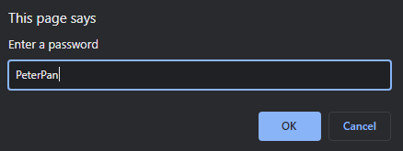



***True and false values***

Some statement or values are assigned to be true or false depending on the condition.

**Example 7)** Write a JS code that asks the user to enter a name. If the user enters a name, it will display a welcome message with the entered name. Otherwise, if the user does not enter a name, it will display that no name was entered.

let name = prompt("Enter a name: ");

if (name){console.log(`Welcome to the program ${name}`)}

else{console.log(`You didn't enter a name!`)}

If user types Peter Pan and click OK, the console will display:

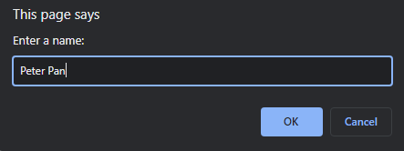



If user doesn’t type anything and click OK, the console will display:

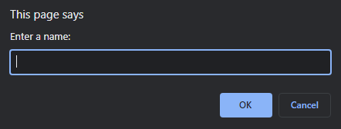



A null, empty, undefined, NaN, and 0 are inherent to be **false**. Otherwise, any string, numbers, or even a space are inherent to be true.

***Logical operators***

***AND operator &&***

In a chain of statements, compares if all statements are **true** for the entire statement to be **true**. In another words, the statement is true if all the conditions are true.



**Example 8)** modify example 6 in the nesting if-else statement using AND operation

let password= prompt("Enter a password");

if (password.length>=6 && password.indexOf(' ')===-1){

console.log(`${password} is valid password`);

else{

console.log(`WARNING! ${password} is incorrect password format`);}

}

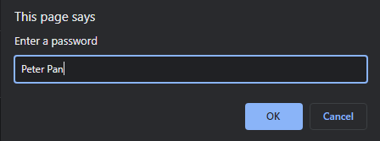

If the user types *Peter Pan* and click OK, the console will display:

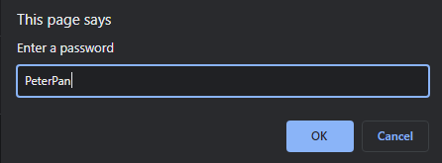

If the user types *PeterPan* and click OK, the console will display:



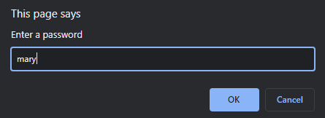

If the user types *mary* and click OK, the console will display:



**Example 9)** type a mystery word that will make the console to display *YOU GOT IT!!!*. User has to guess a word that starts with letter “P”, with length greater than 5, and has a number 7 in the word!

const mystery = prompt(“Enter a word that starts with P, with 5+ characters, and with number 7 in the word!”)

if(mystery[0] === 'P' && mystery.length > 5 && mystery.indexOf('7') !== -1){

console.log("YOU GOT IT!!!");

}

else{console.log("Wrong Guess!");}

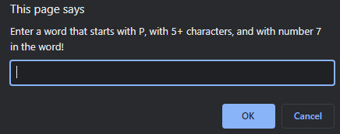

If user type ***Patricia27****,* the console will display 🡺 

***OR operator* ||**

From a chain of statements, if one statement is true, the entire statement is true.

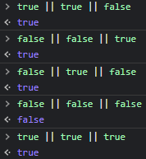

**Example 10)** write a JS code that asks the user to rate a book as:

1. Excellent
2. Good/Average
3. Bored

If the user select “Bored”, the program will prompt another window asking why the book was rated as “Bored”

let rate = prompt('Enter a rate for the book "The book". \n 1) Excellent \n 2) Good\Average \n 3) Bored \nSelect a number from 1 to 3.')

if(rate==='3'){

let comment = prompt('We are sorry that you find "The Book" boring. Please

comment what we can do to improve your experience with "The Book" ?');

console.log(`Thank you for your feedback: ${comment}`)

}

else if (rate ==='1' || rate ==='2'){

console.log('Thank you for choosing "The Book".')

}

else{

console.log('INVALID RATE!')

}

***Combining logical operators***

We can also combine logical operators in one statement. If you combine logical operators, AND operator has precedent over OR operator, meaning that a JS code always checks on the AND operator before the OR operator.

**Example 11)** Tickets to a park charge the following fee:

|  |  |
| --- | --- |
| **Age** | **Price** |
| 0 to 7 | FREE |
| 8 to 17 | $ 5.00 |
| 18 to 64 | $ 8.00 |
| 65 and up | FREE |

Create a JS code that will display the price according to the age or status.

let age = 18;

if (age<=7 || age>=65){console.log("FREE ticket")}

else if(age<=17 ){console.log("$5.00 ticket per person")}

else if(age<65){console.log("$8.00 ticket per person")}

else{console.log("INVALID AGE!")}

If you want to control the negative ages, we can add an AND operators for ages between 0 and 7. Since in JS, an AND operator is checked first, the program will check the ages in between of the && operators first.

let age = -20;

if (age>=0 && age<=7 || age>=65){console.log("FREE ticket")}

else if(age<=17 && age>7 ){console.log("$5.00 ticket per person")}

else if(age<65 && age>17){console.log("$8.00 ticket per person")}

else{console.log("INVALID AGE!")}

***NOT ! operator***

NOT operator returns a true if an expression is false.

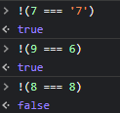

**Example 12)** write a JS code that will ask the user to type a positive number in the prompt dialog. If the user enters a negative number, then the program will prompt again dialog asking to enter another number. This program is good only for one check point.

let msg = parseInt(prompt("Type a positive number "));

if (msg <0){

msg = parseInt(prompt("Wrong number! Type a positive number again! "));

}

console.log(`Entered number: ${msg}`)

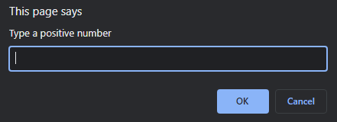

If user types -10 and click OK, another dialog box appears asking to enter another number…

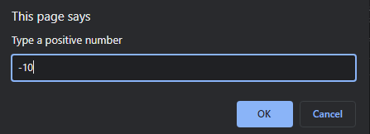

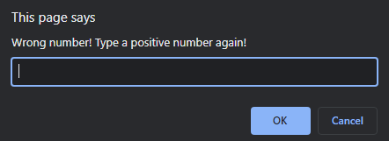

Remember that this program is good for one check point. Therefore, if the user enters a positive or negative number, the program will just end the if statement and display a message in the console.

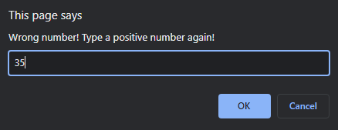



***Switch***

Switch statements works the same as if, else if, else statement, with the difference that we select among different cases.

**Example 13)** use switch statement to check which color is selected from an array

let colors = ['red','blue','green','yellow','orange'];

let selectColor = colors[2];

switch(selectColor){

case "red":

console.log('The selected color is red');

break;

case "blue":

console.log('The selected color is blue');

break;

case "green":

console.log('The selected color is green');

break;

case "yellow":

console.log('The selected color is yellow');

break;

case "orange":

console.log('The selected color is orange');

break;

default:

console.log('Color is not in the list!');

}

Result in console🡺 

You can also check multiple cases with the same output:

let selectColor = 'BLUE';

switch(selectColor){

**case "red": case "RED": case "Red":**

console.log('The selected color is red');

break;

**case "blue": case "BLUE":**

console.log('The selected color is blue');

break;

**Bibliography**

* Duckett, J. (2016). *HTML and CSS Design and build websites.* Indianapolis: John Wiley and Sons Inc.
* Duckett, J. (2016). *JavaScript and JQuery: interactive front-end developer.* Indianapolis: John Wiley and Sons Inc.
* *HTML, CSS, JavaScript, JQuery, and Bootstrap*. (2017, June). Retrieved from w3schools: www.w3schools.com
* Some material compiled from [www.lynda.com](http://www.lynda.com) (May 2018), www.w3schools.com (2020), www.coursera.org (2020)

**IMPORTANT NOTE**

The materials used in this manual have the author's rights and are for educational use only.