3.10.2

n = 50 n = 100 n = 200

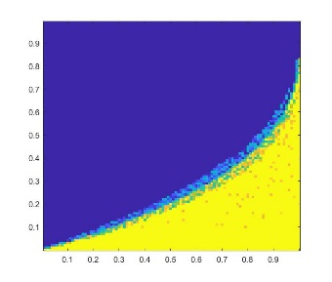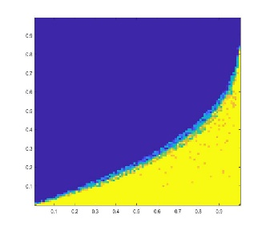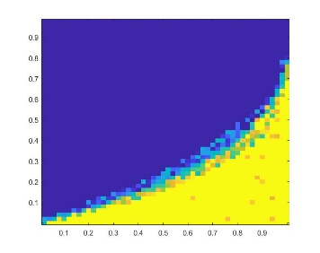

The area which is more yellow represents a high rate of correct recoveries; the area which is more blue represents a low rate of correct recoveries.