**3.11**

The result of multiple linear regression model: y~x1+x2+x3+x4+x5

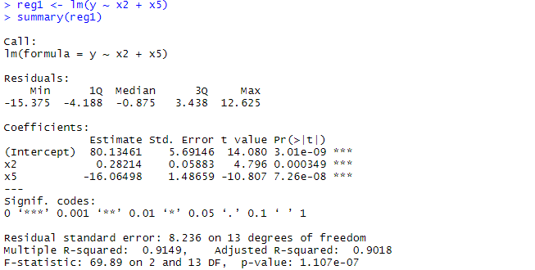

The result of multiple linear regression model: y~x2+x5

