**Q1.（Gauss-Newton Method）**

The following are the results from different initial guesses.

10 is iteration times, and C(205, 0.08), C(342, 0.12), C(28, 0.01) are initial guesses.

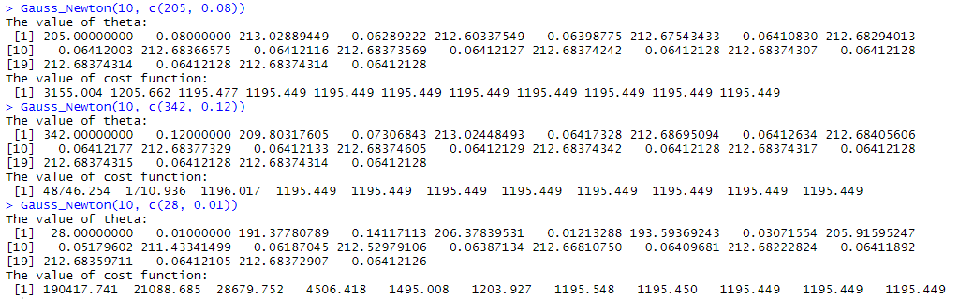Plot of y versus x and the fitted nonlinear model.

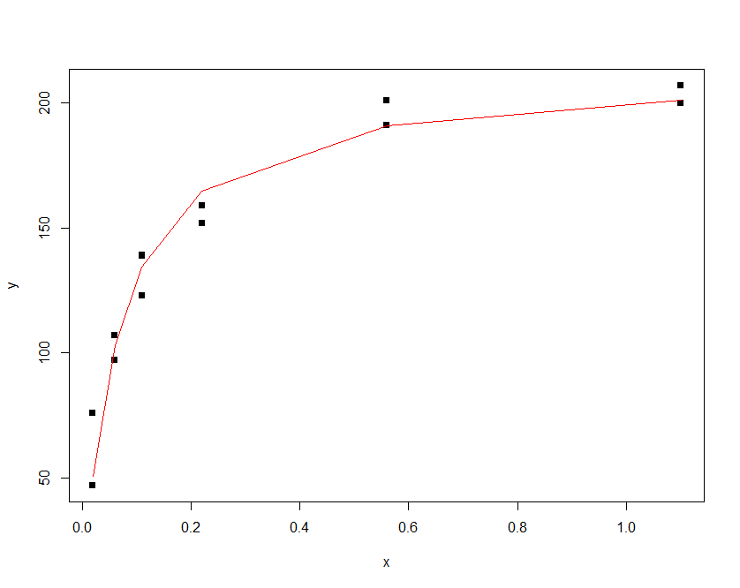

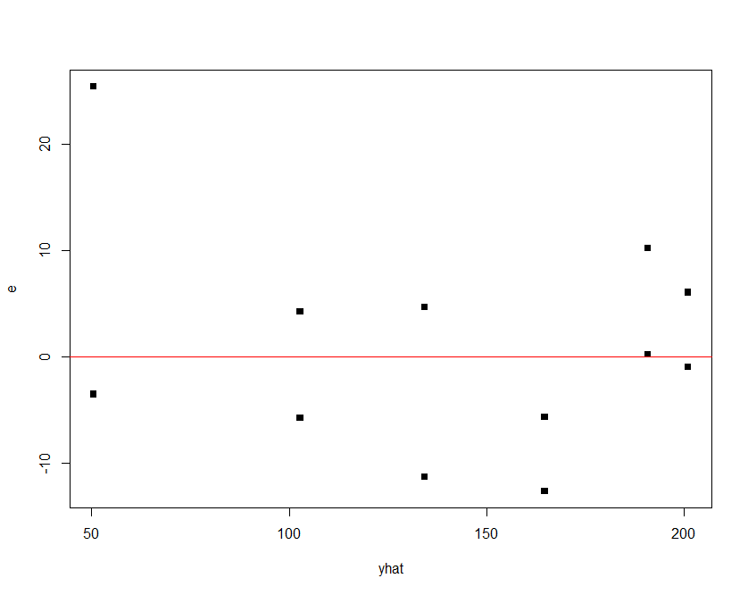Plot of residual versus yhat.

**Q2.（Newton Method）**

The following are the results from different initial guesses.

10 is iteration times, and C(205, 0.08), C(342, 0.12), C(28, 0.01) are initial guesses.

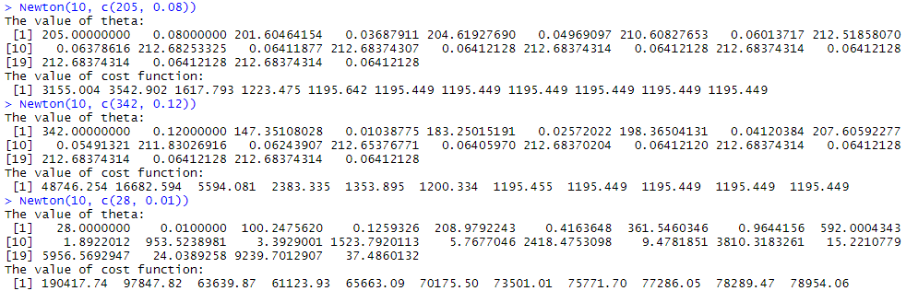

Plot of y versus x and the fitted nonlinear model.

Plot of residual versus yhat.



**Q3.（Linear Model）**

Plot of y versus x and the fitted nonlinear model.

Plot of residual versus yhat.

Plot of residual versus yhat.

**Source Code**



