Flight delays can be caused by events such as hazardous weather, crew availability and security issues. When purchasing flight tickets, many passengers hope to minimize delays to avoid spending too much time at the airport or missing a connecting flight. Route selection is multifaceted and may be based on reducing the number of connections, ticket cost, arrival/departure time, or airline loyalty. However, expected delays are hard to predict for the average consumer outside of historical data on flight tracker websites, which may be unavailable or only show short time periods (not generalizable). Some passengers may try to optimize the time of day of flights (i.e., early morning departure) to minimize expected delay time, for both the flight and security screening. However, few customers use data driven approaches such as examining historical flight data or considering how different airlines may operate in the same airline (outside of known “home” airports such as Southwest Airlines at Dallas Love Field).
It is known that flight delays often have a cascading effect within an airline’s route schedule, associated with aircraft or gate availability, where one flight's delay may influence the next. Additionally, flight delays can be caused by cross-airline, region-specific events such as hazardous weather or security lockdowns. We hypothesize that airline “hubs” - defined here as an airport and airline pair containing a large volume of passenger traffic for that airline - may be more equipped to respond to delay perturbations than non-hubs, and that in turn “hub” airports should be selected by passengers if the goal is delay minimization. We began this investigation by first studying the passenger flow and travel patterns for the four main airlines in the continental United States, which are shown below.
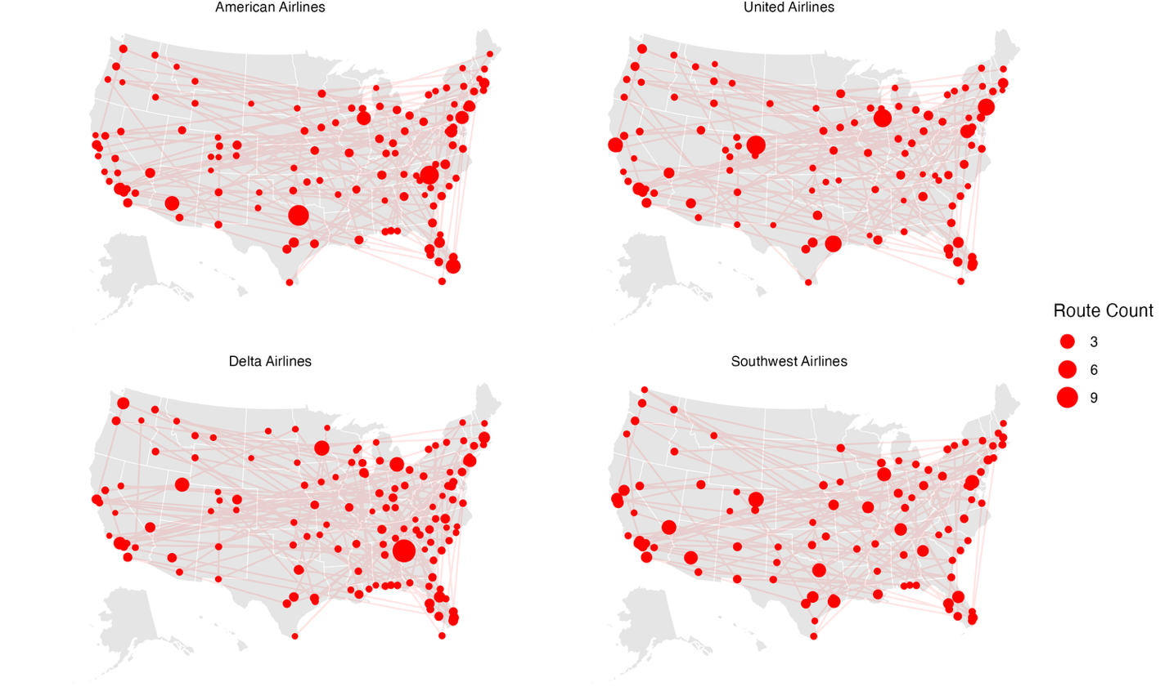
Next, we began interested in how airlines self-classify an airport as a hub, and the tiers of hubs as reported by the FAA (large, medium, small and non, based on the total number of yearly passengers). We then began an exploratory data analysis to determine patterns in hub structures for specific airport/airline pairs. Below is a summary histogram of the arrival and departure times of all the self-declared “hubs”, all large, for American Airlines (AA) in recent years.
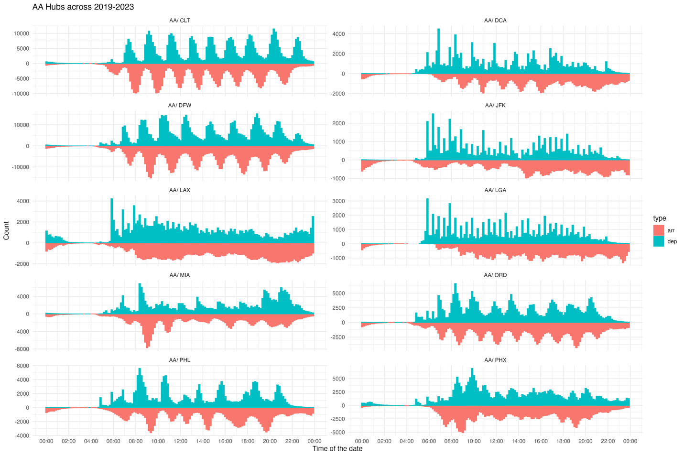
While all these airports do have large passenger fluxes, there are distinctly different patterns between the arrival (arr) and departure (dep) trends. Some appear to be periodic, such as DFW (Dallas Fort Worth) while others such as LAX (Los Angeles International Airport) are more uniform. We then became interested if airports, while controlling for the passenger volume, would be more robust to delay perturbations (e.g., recover more quickly) with certain periodicity patterns compared to others. Thus, we decided to fit a spline curve to the data and apply a Fast Fourier Transform (FFT) to estimate airline/airport periodicity. The relationship between hub status, periodicity, and delays is explored. We also compare differences between traditional "hub and spoke" airlines, where traffic is accumulated centrally (hub) and then diverted to destinations/origins (spokes) such as Delta and American to "point to point" structured airlines such as Southwest, where specific routes, as opposed to airlines, are the main focus.

