

**North American Airports and Complex Networks**

Course: Complex Network

Profs: Dr. Chen, Dr. Hu

Students:

Keyvan Derakhshan Nik 201509962

Huizhong Liu

**Abstract:** Transportation infrastructure of a continent is one of the most important indicators of its economic growth. Lots of facilities are prepared by the government based on the importance of each airport. The links between airports are the main factor to calculate the importance of that airport. Therefore the relationship between countries can affect this importance. In this project, we will see the current structure of commercial airports in North America and calculate some complex network factors for each airports and then we will see what will happen if the commecrcial airport network will be disconnected between US and Canada.

In this project, we discovered the graph model of US and Canada Airport Network by using the available dataset1, then built an individual version of Airport Network of US and Airport Network of Canada separately.

Notice: all of the datasets are allocated to commercial airports (general airport).

**Connected Version of North America Data Set:**

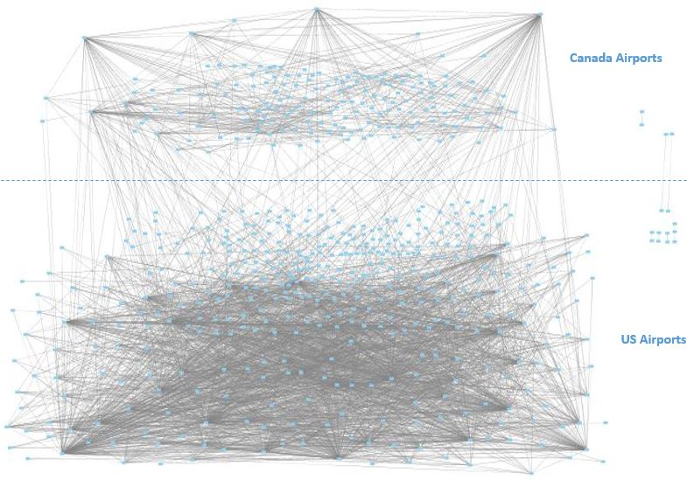

Figure1: North America Airport Graph

After we extracted the dataset. This graph contains 592 vertices and 3052 edges and 8 components which is shown in figure 1. There is one giant component and 7 small components which are so interesting because for 2 of them their availability is strongly dependent on the connection between US and Canada [USDVO, CAZAM] [USLHW, CAYZY]. Moreover there are 5 components which are independent from other country. One independent component is available in Canada and 4 independent components in US. Graph 1 illustrates the degree of each airport in US and Canada.

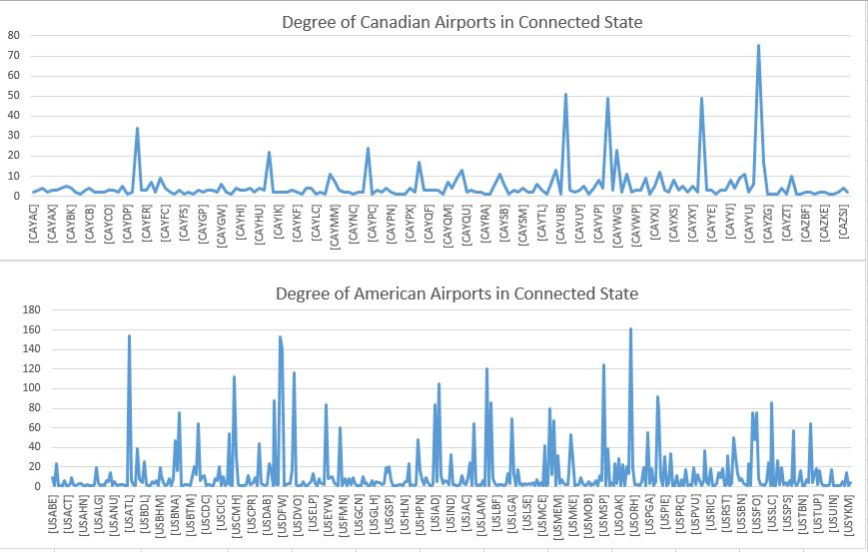

Graph 1: Degree Distribution of American and Canadian Airports in connected state

In the above graph USORD has highest degree with 161 edges in US. After that, there are 16 US airports with higher degree than the first highest Canadian airport CAYYZ with 75 edges. Meanwhile there are three airports in US with equal degree size of CAYYZ. After calculation the components and degree of every node. We find each node’s closeness centrality which is depicted on the next graph.

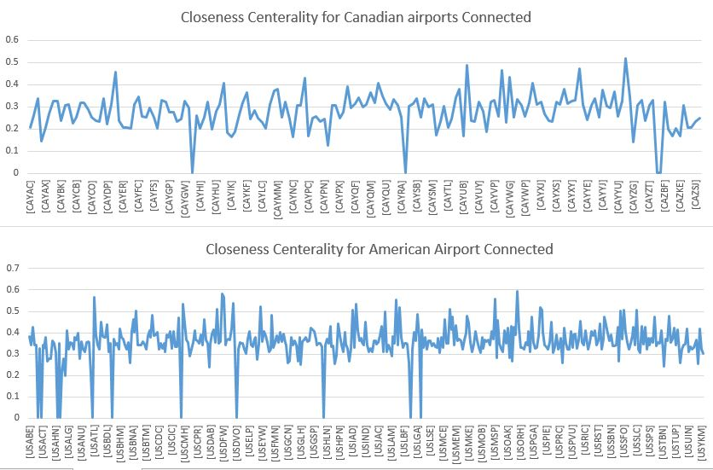

Graph2: Closeness Centrality of American and Canadian Airports in connected state

As far as our output depicted the USORD has the most closeness centrality with about 0.6 which is pretty high at all. Also, the most closeness airport is CAYYT with about 8 percent less than USORD in the 13th place in ranking.

On the next part we calculated the betweenness centrality in this section for connected graph. It was amazing result based on previous two sections which is shown the USORD has the first rank but in this part USDEN passed USORD with over 48177. On the other hand, CAYUL has the highest betweenness among all of Canadian airports with 36660 and it stands on 3rd place. Graph 3 illustrates the Betweenness Centrality in connected graph.

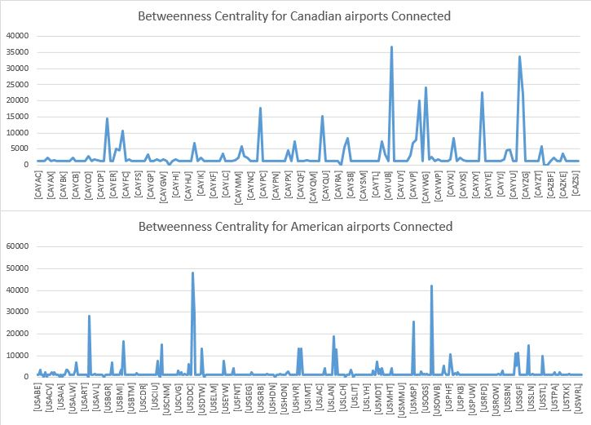

Graph3: Betweenness Centrality of American and Canadian Airports in connected state

Refference:

1. https://openflights.org/data.html