**1. clustering coefficient**

a clustering coefficient is a measure of a degree to which nodes in a graph tend to cluster together.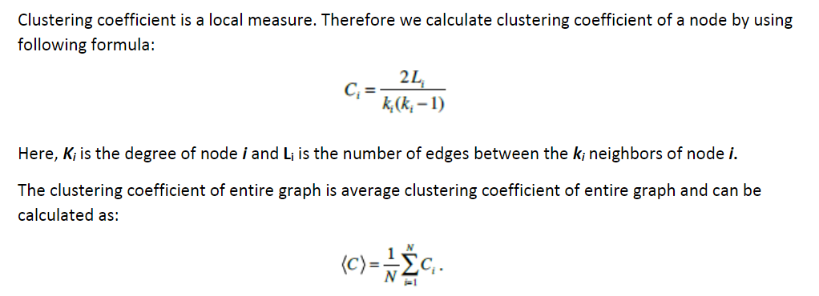

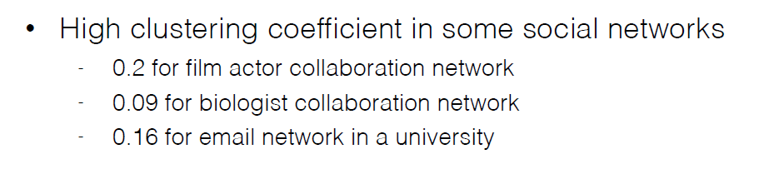

PS: In my opinion, the higher clustering coefficient of airport means if this airport is closed due to the reason of bad weather condition such as blizzard. The whole airline will still be available.

So we can compare the clustering coefficient of the airport which have a high degree or betweenness centrality. That is to say, the big or important city. between CA and US. such as for example, both A(one of the biggest city in CA) and B(one of the biggest city in US) have a relative high degree/ centrality. but their clustering coefficient have a obvious different.

then the average clustering coefficient or density of this graph can represent the robust of this graph more or less. we can compare the average clustering coefficient and density in this topic.

**2. clossness centrality**

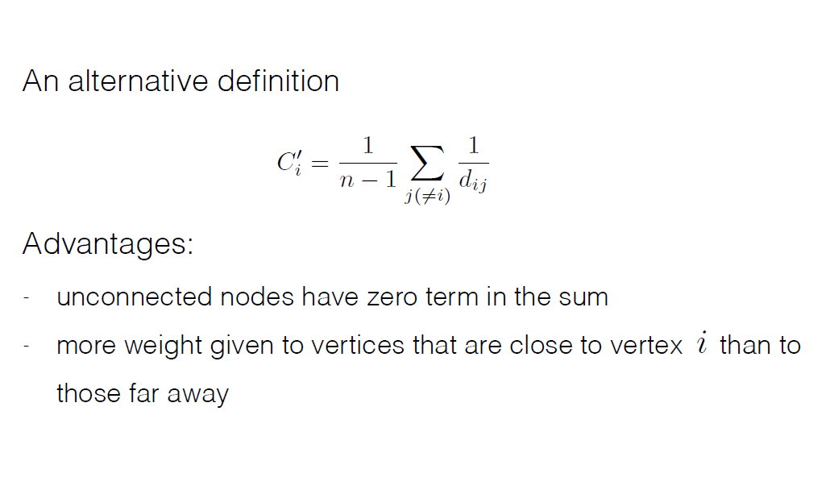

**3. betweenness centrality**

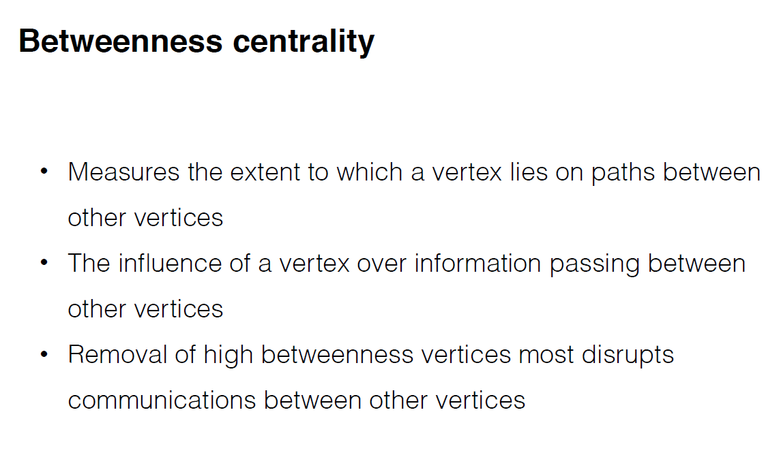

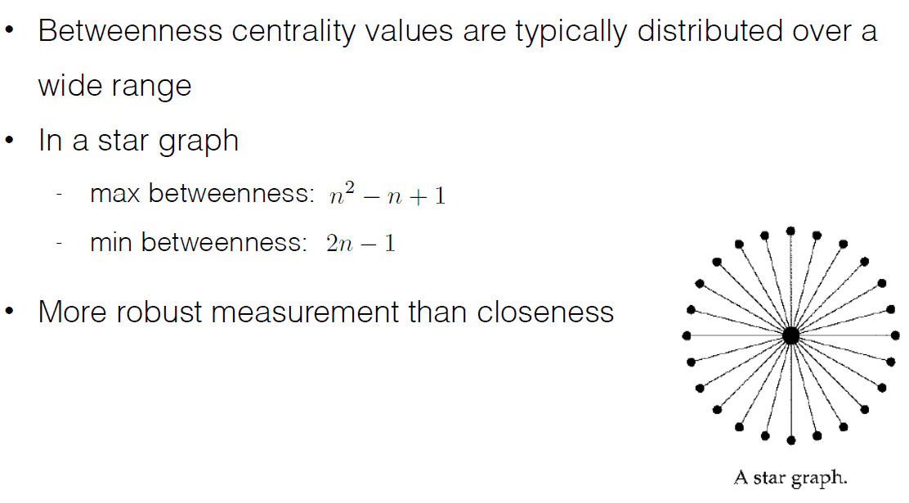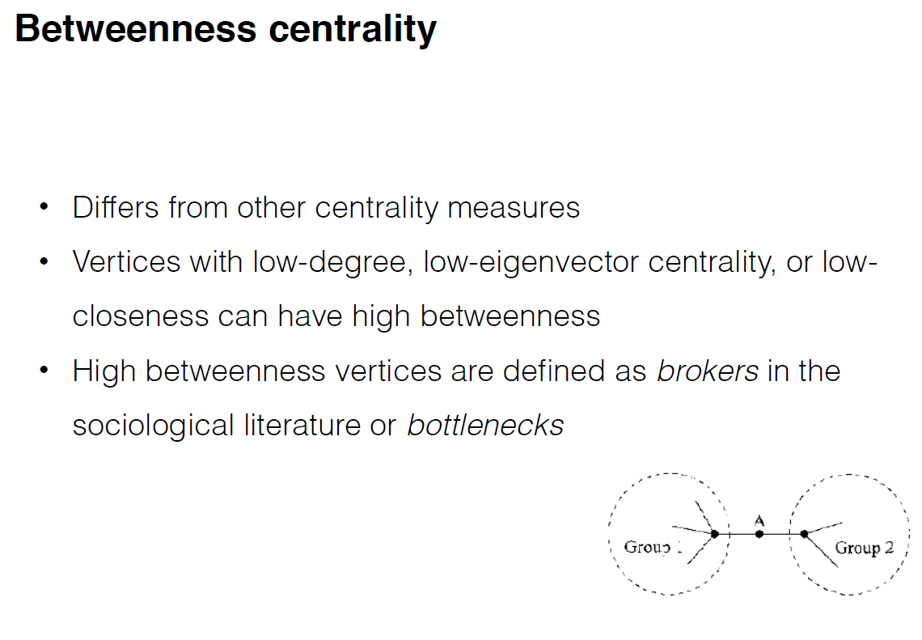

**4. pageRank**

**PS: if a vertex ‘s neighbor is important, then this vertex also becomes important. we can compare the data which have the same value of degree/ centrality, but there are obvious difference between them. We can try to find one example and show.**

**We can also use this method to compare other data. such as if these two city have almost the same high degree. but their betweenness/ clossness /clustering value have a obvious different. then we can find one example to illustrate them.**