CO3_AT_2
ASSIGNMENT — QUESTION 20
CUSTOMER SUPPORT KNOWLEDGE-BASE BOT
A Retrieval-Augmented Generation (RAG) Document QA System
Student Name | ____________________________
Register Number | ____________________________
Course Code | CSA6503
Course Name | Generative AI for Large Scale Models

1. Introduction
This assignment implements a Customer Support Knowledge-Base Bot using a complete Retrieval-Augmented Generation (RAG) pipeline. The system grounds support replies in a local corpus of 16 help-center articles, retrieves the most relevant articles for a user question, and generates an answer from the retrieved context.

2. Assignment Question
20. Customer Support Knowledge-Base Bot — A SaaS company grounds replies in its help-center articles. Build a Document QA system over 15+ help articles. Demonstrate troubleshooting queries and one query where the bot must combine steps from two articles.

3. Objectives
- Build a RAG Document QA system over more than 15 customer-support help articles.
- Create semantic embeddings for the help-center articles.
- Retrieve relevant articles for troubleshooting questions.
- Generate grounded answers from retrieved help-center context.
- Demonstrate ordinary troubleshooting queries.
- Demonstrate a query that requires combining steps from two separate articles.
- Avoid unsupported answers when the knowledge base does not contain the required information.

4. Knowledge-Base Corpus
The system contains 16 curated help-center articles:
- A01 — Reset Your Password
- A02 — Account Locked After Failed Logins
- A03 — Enable Two-Factor Authentication
- A04 — Disable Two-Factor Authentication
- A05 — Change Your Email Address
- A06 — Update Your Profile Name
- A07 — Cancel a Subscription
- A08 — Request a Refund
- A09 — Payment Failed
- A10 — Download an Invoice
- A11 — Track an Order
- A12 — Change a Delivery Address
- A13 — Email Notifications
- A14 — Clear Browser Cache for Login Problems
- A15 — Export Account Data
- A16 — Contact Support
The articles are stored locally in data/help_articles.json.

5. System Architecture
16 Help Articles
↓
JSON Knowledge Base
↓
Sentence-Transformer Embeddings
↓
FAISS Vector Index
↓
User Support Question
↓
Top-K Semantic Retrieval
↓
Retrieved Help Articles
↓
Gemini Grounded Answer Generation
↓
Answer + Retrieved Sources
The system uses semantic retrieval with all-MiniLM-L6-v2 and FAISS. The retrieved article text is passed to Gemini with a strict prompt that prohibits invented policies or steps.

6. RAG Pipeline Implementation

6.1 Document Loading
The application loads the 16 help-center articles from data/help_articles.json.

6.2 Embedding
Each article title and content are converted to vectors using sentence-transformers/all-MiniLM-L6-v2.

6.3 Vector Store
Normalized embeddings are indexed using FAISS IndexFlatIP, providing cosine-similarity-style search.

6.4 Retrieval
For each support question, the system retrieves the top four semantically similar articles.

6.5 Answer Generation
Gemini receives only the retrieved article context and the user question.

6.6 Grounding
The prompt instructs the model to answer only from retrieved articles, cite sources, and refuse when evidence is insufficient.

7. Design Choices and Justification
Component | Selected Design | Justification
Corpus | 16 help articles | Exceeds the required 15+ article corpus.
Embedding | all-MiniLM-L6-v2 | Lightweight semantic model suitable for a student machine.
Vector Store | FAISS | Fast local similarity search.
Top-K | 4 | Provides multiple relevant sources for support questions.
LLM | Gemini | Generates natural support responses from retrieved context.
UI | Streamlit | Simple interactive demonstration interface.

8. Complete Program – Core Retrieval and QA
def retrieve(query, articles, model, index, top_k=4):
q = model.encode(
[query],
normalize_embeddings=True,
convert_to_numpy=True
).astype("float32")
scores, ids = index.search(q, top_k)
results = []
for score, idx in zip(scores[0], ids[0]):
if idx >= 0:
results.append({
"article": articles[idx],
"score": float(score)
})
return results

9. Grounded Answer Prompt
Answer the user's question ONLY from the supplied help-center articles.
Do not invent policies, steps, limits, URLs, or product behavior.
If the question requires information from more than one article,
combine the relevant steps in a logical order and cite both sources.
If the retrieved articles do not contain enough information, say:
"I cannot answer this from the available help-center articles."

10. Demonstration Queries and Expected Behavior

A — Troubleshooting: Account Lock
Question: I cannot log in because my account is locked. What should I do?
Expected behavior: Retrieve Account Locked After Failed Logins and explain the 15-minute lock period and password-reset fallback.

B — Troubleshooting: Payment
Question: My payment failed. What should I check?
Expected behavior: Retrieve Payment Failed and provide the documented card, funds, billing-address, retry, and support steps.

C — Combined Two-Article Query
Question: I forgot my password and after resetting it I need to change my email address. What should I do?
Expected behavior: Combine Reset Your Password and Change Your Email Address. The answer should first explain password reset and then the signed-in email-change process.

D — Out-of-Scope
Question: How do I create a Kubernetes cluster using AWS?
Expected behavior: The help-center corpus contains no Kubernetes/AWS article, so the bot should refuse to answer from unsupported knowledge.

11. Grounding and Hallucination Control
- Only retrieved help-center content is supplied to the generation prompt.
- The prompt explicitly prohibits invented policies, steps, limits, and product behavior.
- The answer is instructed to cite retrieved sources.
- Retrieved articles and similarity scores are visible in the Streamlit interface.
- A similarity threshold prevents weak retrieval from being treated as sufficient evidence.
- The out-of-scope query demonstrates refusal when the corpus lacks relevant evidence.

12. Project Structure
customer-support-kb-bot/
├── data/
│ └── help_articles.json
├── app.py
├── requirements.txt
├── .env.example
├── .gitignore
└── README.md

13. Execution Procedure
1. Create and activate a Python virtual environment.
2. Install dependencies from requirements.txt.
3. Copy .env.example to .env and add GOOGLE_API_KEY.
4. Run streamlit run app.py.
5. Enter the demonstration queries and inspect the generated answer and retrieved sources.

14. Implementation Screenshots
After running the application, insert screenshots showing: (1) the Streamlit home screen, (2) a troubleshooting answer with retrieved sources, (3) the combined two-article query and answer, and (4) the out-of-scope refusal.
Figure 1: ________________________________
Figure 2: ________________________________
Figure 3: ________________________________
Figure 4: ________________________________

15. Results
The system is designed to retrieve relevant help-center articles and ground customer-support answers in those articles. The combined demonstration requires information from both the password-reset and email-change articles, showing that the bot can use multiple retrieved sources for one support question.

16. Conclusion
The Customer Support Knowledge-Base Bot demonstrates a complete RAG Document QA workflow over a 16-article help-center corpus. Semantic retrieval, FAISS indexing, and grounded Gemini generation provide a practical support workflow, while the combined query and out-of-scope test demonstrate multi-article reasoning and hallucination control.

17. GitHub Source Code
GitHub Repository: ________________________________
Upload app.py, data/help_articles.json, requirements.txt, .env.example, .gitignore, README.md, and the final assessment PDF/DOCX to the repository.

18. References
The assessment structure follows the uploaded CO3_AT_2 RAG Document QA example. That reference demonstrates a document corpus, RAG pipeline, embeddings, FAISS retrieval, grounded LLM generation, demonstration queries, screenshots, and conclusion. fileciteturn1file0L16-L25
The uploaded example also uses a multi-document corpus and explicitly demonstrates a combined endpoint/authentication query, which is mirrored here as the two-article support query requirement. fileciteturn1file0L145-L165

Assessment Evidence – Combined Two-Article Query
Figure: Combined query demonstrating retrieval and grounding from two help-center articles (Reset Your Password and Change Your Email Address).
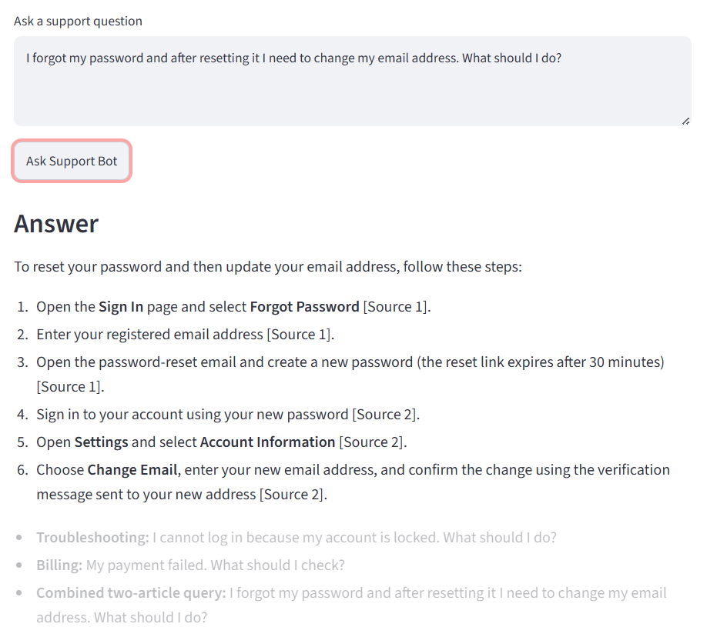
Figure – Combined two-article support query output

