拓扑失败问题

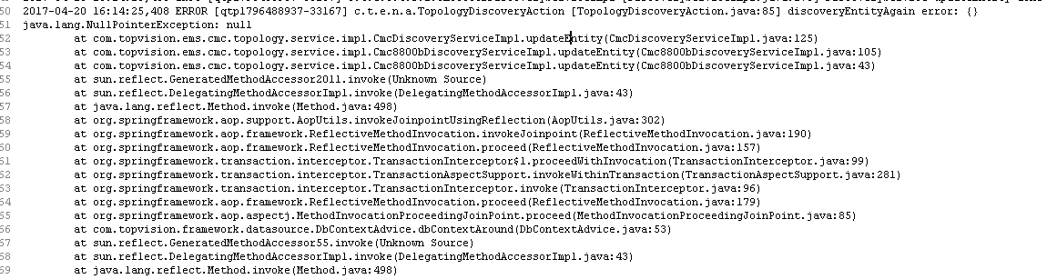

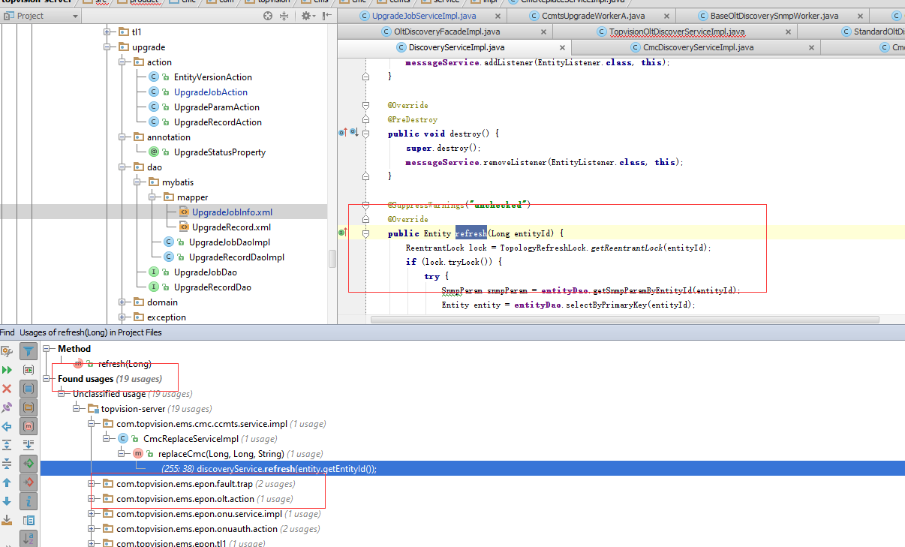

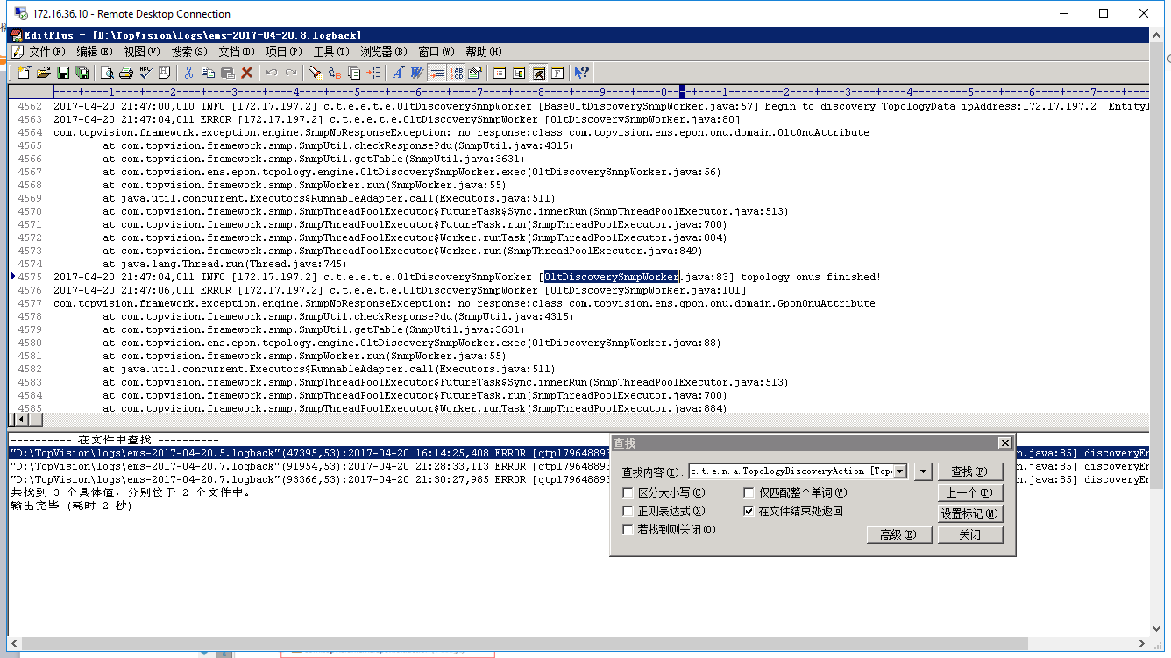

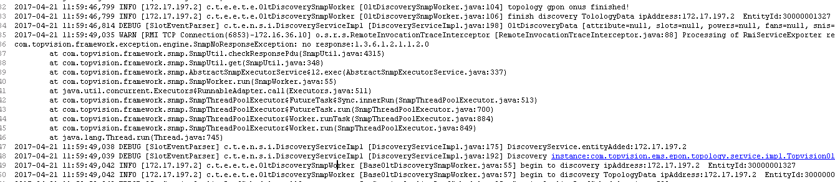

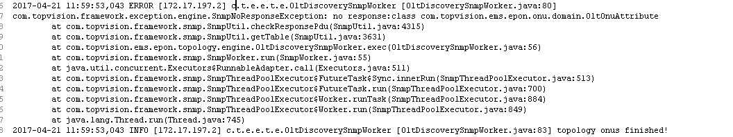

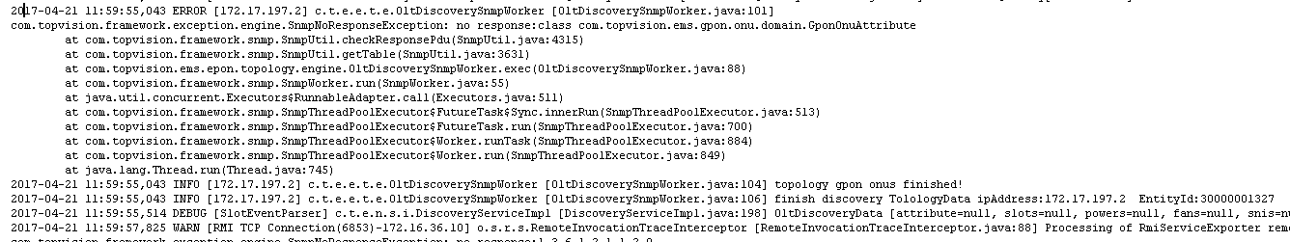

DiscoveryServiceImpl

2017-04-21 11:59:46,814 DEBUG [SlotEventParser] c.t.e.n.s.i.DiscoveryServiceImpl [DiscoveryServiceImpl.java:198]

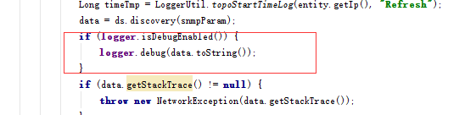

2017-04-21 11:59:49,035 WARN [RMI TCP Connection(6853)-172.16.36.10] o.s.r.s.RemoteInvocationTraceInterceptor [RemoteInvocationTraceInterceptor.java:88] Processing of RmiServiceExporter remote call resulted in fatal exception: com.topvision.ems.facade.network.DiscoveryFacade.discoverySysObjectID

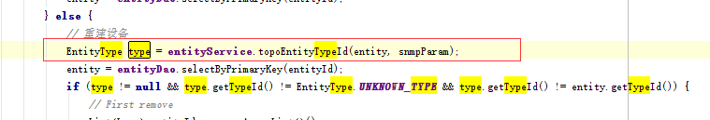

2017-04-21 11:59:49,038 DEBUG [SlotEventParser] c.t.e.n.s.i.DiscoveryServiceImpl [DiscoveryServiceImpl.java:175] DiscoveryService.entityAdded:172.17.197.2

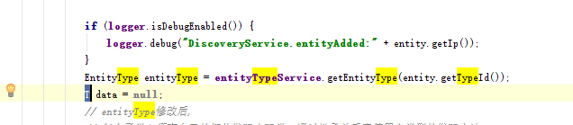

2017-04-21 11:59:49,039 DEBUG [SlotEventParser] c.t.e.n.s.i.DiscoveryServiceImpl [DiscoveryServiceImpl.java:192] Discovery instance:com.topvision.ems.epon.topology.service.impl.TopvisionOltDiscoverServiceImpl@3664966d



2017-04-21 11:59:49,042 INFO [172.17.197.2] c.t.e.e.t.e.OltDiscoverySnmpWorker [BaseOltDiscoverySnmpWorker.java:55] begin to discovery ipAddress:172.17.197.2 EntityId:30000001327

2017-04-21 11:59:49,042 INFO [172.17.197.2] c.t.e.e.t.e.OltDiscoverySnmpWorker [BaseOltDiscoverySnmpWorker.java:57] begin to discovery TopologyData ipAddress:172.17.197.2 EntityId:30000001327

