LLM Initialization
Initializes Gemini 2.5 Flash model (Vertex AI integration) with zero temperature.
Query 1: Total Spent Calculation
This section implements the core logic for calculating total post-discount spending, that is sum of "total paid" across all receipts.
Prompt Design: Pure Numeric Extraction Receipt Processing Logic
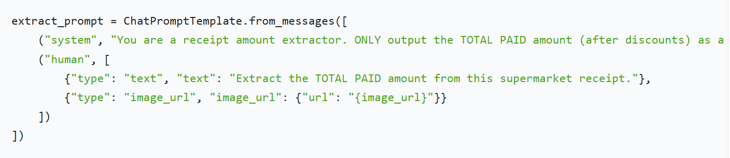
Receipt Processing Logic
Chain Construction: Combine the prompt, LLM, and StrOutputParser into a single executable chain to retrieve the model’s output as a string. Add up all receipts result using total_spent +=amount.
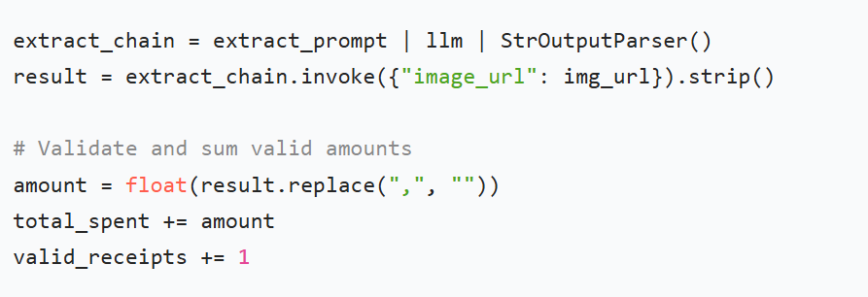
Query 2: Original Price Calculation
The core logic is calculating total pre-discount price: original price = total paid + sum of all discounts. Use structured JSON Extraction for prompt design. Use the equation Original Price = Actual Payment + Discount by extracting actual payment and discount separately.
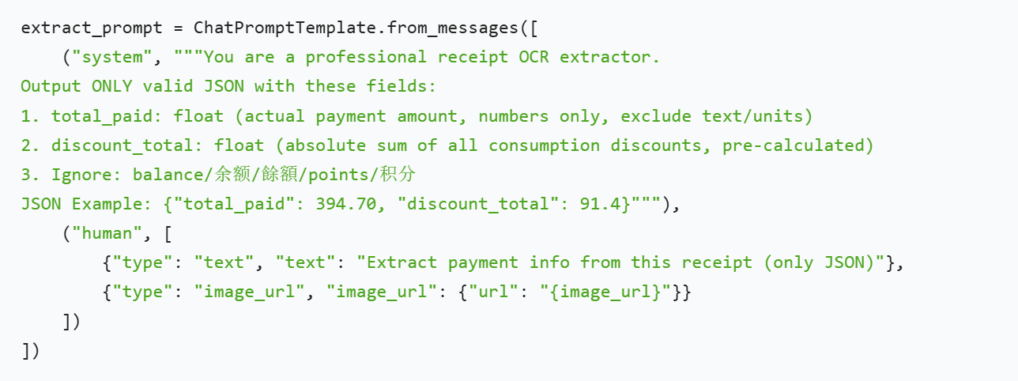
To Instruct the Gemini model to extract two critical numeric fields (actual payment and total discount) from receipt images and return them in a structured JSON format.
Define a request classifier
Route user queries to the correct handler (query1/query2/irrelevant) based on the intent of the supermarket receipt-related request.
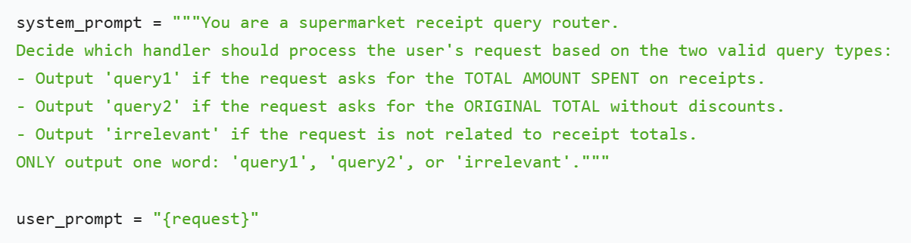
System Prompt: Roles the model as a "receipt query router" with clear classification rules for three outcomes.
User Prompt: A dynamic placeholder ({request}) that injects the raw user query into the prompt for classification.
Create prompt template for query classification, transforms the static prompt rules into a runnable logic for intent recognition.
coordinator_router_prompt = ChatPromptTemplate.from_messages([
("system", system_prompt),
("user", user_prompt)
])

Build classification chain to classify request and then parse output
Uses LangChain’s LCEL (LangChain Expression Language) to chain three components into a single executable pipeline:
coordinator_router_chain = coordinator_router_prompt | llm | StrOutputParser()
Retrieve and standardize the list of receipt image files to ensure consistent processing of receipts in the system.
Remember to run this again when insert new receipt photos.
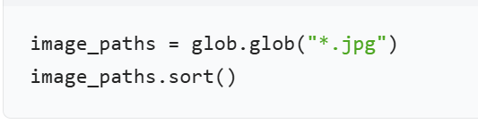
Finally we can run the code to achieve our goals successfully.

