VR Project 2 water

Jessica Hao

This is made by UE4.

IT LOOKS AWESOME!!

Versions:

Windows 64-bit

HTML 5 with Oculus (not sure it works or not, never try)

~~IOS~~ (I have to make license of it and something else, didn’t even think about it.)

Screen shot:

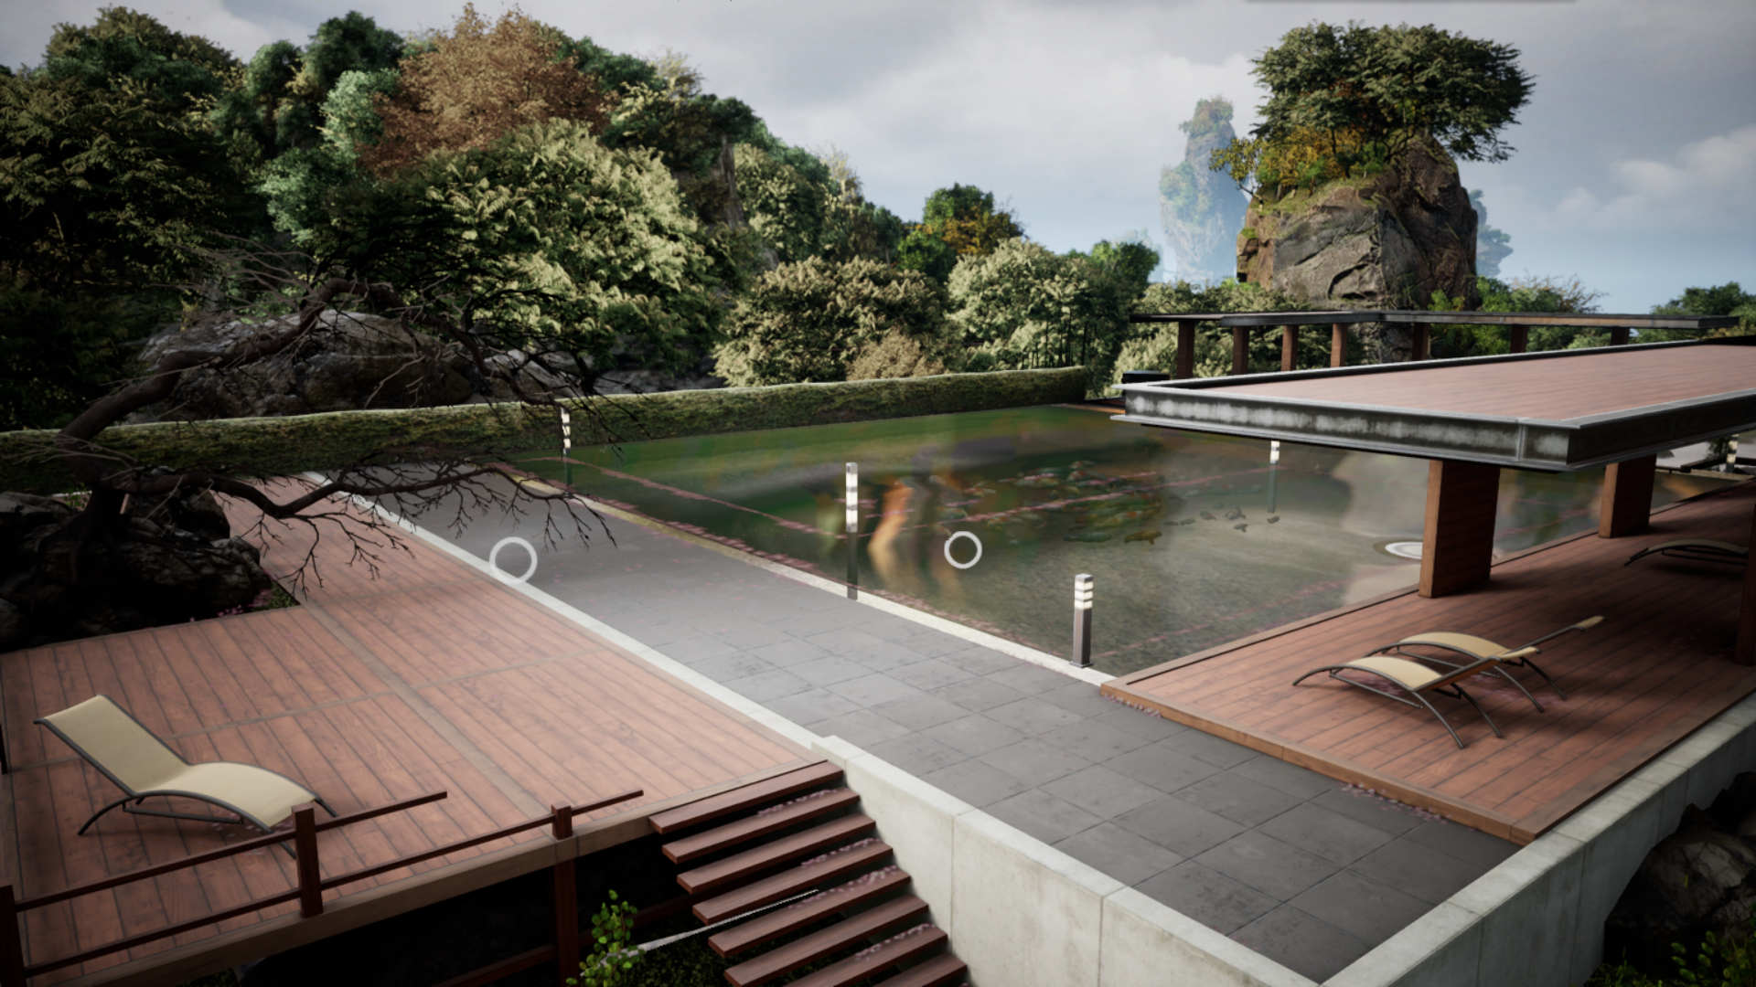

↑ This is why I choose UE4 but not Unity.

Introduction:

This is a project only made by the newest version UE4. I planned to build one map and different models for each season with some cool function materials and models. And you can’t believe how expensive the UE4 tools and models are! BUT there are some Awesome things in marketplace: Zen Garden—the basic of my project.

It includes map, UI, camera, animals, water, and some models. I change it such as removing something I don’t want, adding some models, changing models size. I wonder the map that Zen Garden is empty in the middle. Well I fill it somehow.

Parts:

* Small games:
  + Flower open and waving in the wind(mouse)
  + Play with fishes
  + Draw on the sand
  + Play the water fond and order butterfly
* Audios:
  + Almost have audios for everything
* Cool models:
  + I learned sometimes the models don’t have to be 3D, two pictures can mix to a cool model.

Problems:

* FPS character won’t move in a right way, but it works in another project.
* Low memory RAM gives me a lot of trouble. Too often to stuck.