LiteOS
User’s Guide

Version 0.3.3
Last updated: May 3 2008
This quick guide illustrates how to get started with the LiteOS operating system
Download location: www.liteos.net
Copyright ©2007-2008 LiteOS developers, all rights reserved.

Foreword

Contents
Preface 1
Mailing lists: 1
Additional References 1
Installation of LiteOS 2
Installing LiteOS on Windows machine 2
Installing JDK 2
Installing the Java Packages 4
Installing Cygwin 5
Check that Cygwin and Java have been correctly configured. 6
Installing uisp and rxvt 6
Installing WinAVR (For Programming) 7
Hardware Connection 7
Installing LiteOS on Linux machine 11
Installing JDK 11
Installing the Java Communication API 12
Installing the GNU avr-gcc toolchain 13
Compiling and Installing uisp 14
Setting privileges for serial ports 15
LiteOS Installation 15
Install the base 15
Install the kernel 18
Installer Express Mode 20
Using LiteShell 21
Use LiteShell Commands 22
List current directory information 22
Create and delete files and directories 24
Copy data between the PC and a node 25
Other Command Examples 27
Interacting with the sensors 29
Using the Light Sensor and the Temperature Sensor 29
Using the LED 31
Installation of Sample Applications 32
Appendix 34
Appendix I: A List of LiteShell Commands supported 34
Appendix II: Man Pages 35
Troubleshooting Tips 51
Index 52

Preface
LiteOS provides a UNIX-like environment for sensor network users and developers. It also provides a thread-based run-time execution environment for sensor network applications. The goal of this User’s Guide is to get you familiarized with its environment. For programming in LiteOS, see Programmer’s guide.
For updates, check:
www.liteos.net

Mailing lists:
liteos-users@cs.uiuc.edu
http://lists.cs.uiuc.edu/mailman/listinfo/liteos-users
liteos-developers@cs.uiuc.edu
http://lists.cs.uiuc.edu/mailman/listinfo/liteos-developers

Additional References
The following are additional documentation, available on www.liteos.net
- LiteOS Programmer’s Guide
- LiteOS Application Notes

Installation of LiteOS

This section provides a step-by-step guide on how to install LiteOS on your computer.

Following are the requirements for constructing the working environment of LiteOS:

􀂄 MicaZ nodes with Atmega128 processor (at least two nodes are required, one as base station, the other as the experiment node, three or more suggested)
􀂄 MIB510 Programming Board or MIB520 Programming board (at least one of either of them)
􀂄 PC installed with Microsoft Windows XP or Linux
􀂄 Serial or USB port (at least one port on the PC)

Installing LiteOS on Windows machine

The first step to configure your PC is to install required third-party software. The following software is needed:

􀂄 Java JDK 1.4.2 or later
􀂄 Cygwin (must installed with Perl, Python, Makefile)

You may skip this section if your PC is already installed with JDK and Cygwin.

If you also want to develop your own applications, you also need the following software:

􀂄 WinAVR version 20070122 (GCC 4.1.1)

We next explain how to install various third party software and configure them.

Installing JDK

If you have installed JDK 1.4.2 or later on your computer, you may skip this section.

Otherwise, click
http://java.sun.com/j2se/1.4.2/download.html
to download Java SDK 1.4.2

Click to download Java SDK (the actual download page may be different from shown here)

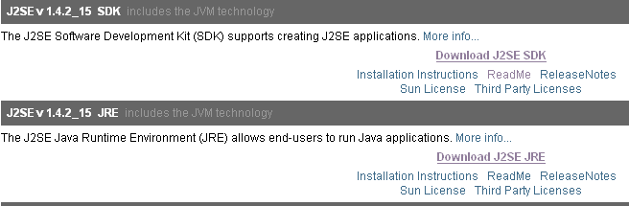

Then install J2SE SDK on your computer, following its instructions.

Take note of the installation path and you will need it below.

Next, set up the environment variables of Java, so that the Java virtual machine can be correctly configured. Follow the steps below to set the environment variables.
- Right click on the My Computer icon on your desktop and select properties
- Click the Advanced Tab
- Click the Environment Variables button
- Under System Variables, click New
- Enter the variable name as JAVA_HOME
- Enter the variable value as the installation path for JDK
- Click OK
- Click Apply Changes
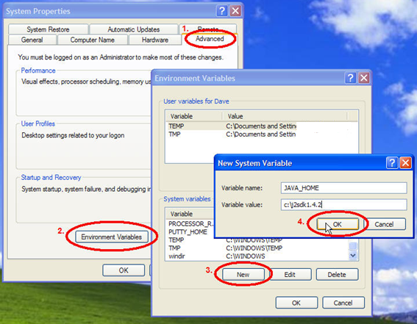

In a typical setting, the following environment variables need to be configured (your particular setting may be different):
JAVA_HOME -> C:\j2sdk1.4.2_15
CLASSPATH -> .;%JAVA_HOME%\lib;% JAVA_HOME%\lib\tools.jar;%JAVA_HOME%\jre\lib\ext
PATH-> %JAVA_HOME%\bin;%JAVA_HOME%\jre\bin

Installing the Java Packages

Next, you need to install the Java Comm package to communicate through the serial port or the USB port, and the jdom.jar package to use messagecenter.
Assuming you have the LiteOS release, you will find a directory called Tools. Find the javacomm20-win32.zip file included in this directory, and the jdom.jar file.
Assuming you have Java installed at C:\j2sdk1.4.2_15
unzip javacomm20-win32.zip
- copy win32com.dll to C:\j2sdk1.4.2_15\jre\bin
- copy comm.jar to C:\j2sdk1.4.2_15\jre\lib\ext
- copy comm.jar to C:\j2sdk1.4.2_15\jre\lib
- copy javax.comm.properties to C:\j2sdk1.4.2_15\jre\lib
- copy jdom.jar to C:\j2sdk1.4.2_15\jre\bin and C:\j2sdk1.4.2_15\jre\lib

Installing Cygwin

Download Cygwin setup from
http://www.cygwin.com/
Install Cygwin following its instructions. Note that it may take a while to download all Cygwin packages from the Internet, so choose an Internet mirror for Cygwin that is near your location.
When installing Cygwin, you must select Python, Perl, and Make during its installation. More specifically, select such packages in the following screenshot during the installation of Cygwin:
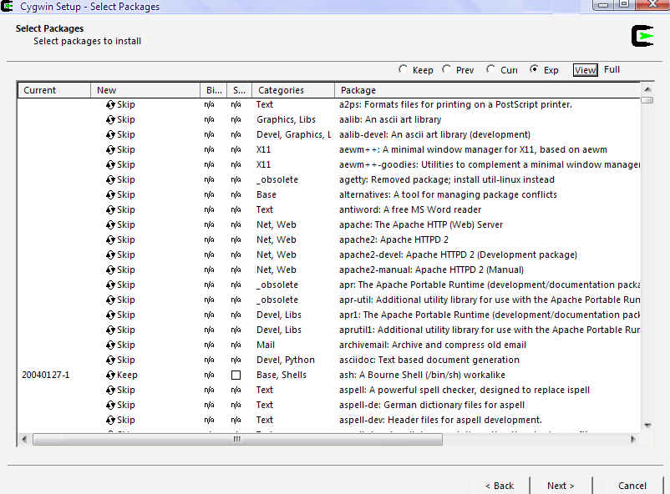
Select cygwin packages here

Check that Cygwin and Java have been correctly configured.

Open the Cygwin window, and type the following:
$ java –version
java version "1.4.2_15"
Java(TM) 2 Runtime Environment, Standard Edition (build 1.4.2_15-b02)
Java HotSpot(TM) Client VM (build 1.4.2_15-b02, mixed mode)
If you do not see a Java version that matches your configuration, then you probably have not installed JDK on your machine correctly, or have not set up the environment variables correctly.

Installing uisp and rxvt

Assuming you have downloaded the LiteOS current release, you will find a subdirectory called Tools. This directory contains two tools that need to be copied to the Cygwin directory.
Enter the Cygwin environment. Navigate to the directory Tools/uisp and please type in the following:

./configure

./make

./make install
Those scripts will compile and install uisp utility into your system at /usr/local/bin.
Then change to directory Tools and type in the following:

cp rxvt.exe /usr/bin/rxvt.exe

These two commands place uisp and rxvt at locations that the cygwin can find.

Installing WinAVR (For Programming)

To develop your own applications, you need to install WinAVR on your computer.
To install WinAVR, go to:
http://winavr.sourceforge.net/download.html
We recommend that you download and install the version 20070122 of WinAVR. This is the version we used and tested. Other versions (including newer versions) may lead to unexpected problems.

Hardware Connection

To set up the hardware for evaluating the LiteOS, follow the steps below.
For PCs with SERIAL PORT
Connect the MIB510 programming board to the PC serial port using the cable provided with the MIB510 hardware. An image of MIB510 is as follows.
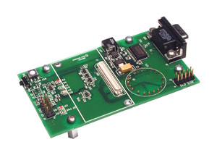
MIB510 with a MicaZ plugged:

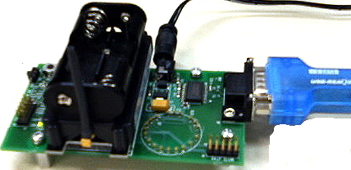

You may also use MIB520, which connects directly to the USB port of the PC. An image of MIB520 is displayed as follows.
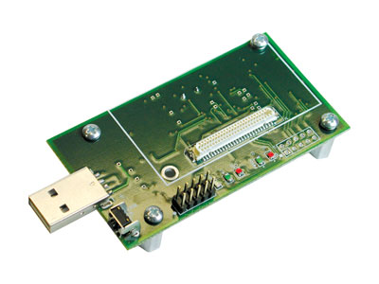
In most cases, you will be using COM1 of your PC to communicate with MIB510. MIB520, on the other hand, uses a pair of COM parts. Finding out exactly which port you are using to communicate to the programming board is very important. You have to later use such port information in various commands. To find such information, open the device manager and find out which ports are being displayed and used.
For PCs with a USB PORT and using MIB510
Some modern PCs, and especially laptops, do not have a serial port. Instead, they supply more than one USB ports. In case you have a MIB510 programming board, it is a little trickier to connect hardware. This section illustrates how to connect MIB510 with USB ports.
To get started, you need to obtain a USB-to-Serial adaptor. The model we tested and found working is Prolific CP-US-03 (a driver is available at http://www.cornerproducts.com/support.html). You may also try out similar models for this purpose.
Once you obtain the USB-to-Serial adaptor, install its driver, and you should see the following in your device manager:
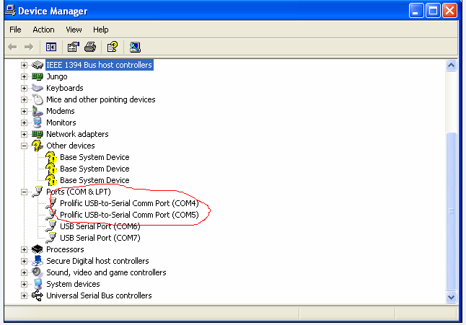

In our settings, we are using two adaptors for two programming boards. Hence, we see two USB-to-Serial ports in our device manager as illustrated above. Note that your COM number will probably be different. Remember the particular port number of your PC. Later, you are going to use this port to communicate with MIB510.
Caution:
When you connect the programming board and hardware, you may be confused by the on/off buttons on the board and the node. The short answer to the on/off button setup is: turn them all on, but usually this does not matter. That is, even if you forget to turn on the mote or the programming board, this usually does not have any effect on some boards. So don’t be confused if you make similar observations.
We also observe that, however, some programming boards do tend to be affected by the on/off buttons. If you meet problems later such as the LiteOS shell fails to communicate, one debugging technique is to switch the buttons on the programming board. The mote, of course, must be turned on later.

Installing LiteOS on Linux machine

The installation of LiteOS on Linux is somewhat more complicated than on Windows machine since the WinAVR package is not officially incorporated into GNU gcc toolchain. However, the patches provided by WinAVR still work well on Linux some environments. LiteOS has been successfully tested and run on Fedora Core 7. The following software is needed to run LiteOS on Linux machine:

􀂄 Linux with latest version of Perl and Python installed
􀂄 Java JDK 1.4.2 or later
􀂄 Java Communication API package
􀂄 GNU avr-gcc toolchain
􀂄 uisp utility

We next explain how to install those software and configure them.

Installing JDK

We recommend that you use Sun Java JDK instead of GNU JDK provided with Fedora Core. If you have installed JDK 1.4.2 or later on your computer, you may skip this section.

Otherwise, click
http://java.sun.com/javase/downloads/index.jsp

to download Java JDK. We recommend that you download the latest version of Java JDK.

Select the latest version of JDK and click Download. Then choose Linux Platform and the Linux RPM in self-extracting file to download, for example jdk-6u4-linux-i586-rpm.bin

Next, change to the directory where you have downloaded the file and execute the following command:
- To become root :
  - su
- Make JDK installer file executable :
  - chmod a+x jdk-6u4-linux-i586-rpm.bin
- Finally, execute JDK install
  - ./ jdk-6u4-linux-i586-rpm.bin

After installation you can delete installer and the temporary files it created on your directory.

Now, there can be multiple copies of JDK in your machine, you have to select the Sun JDK as the default Java Engine. In the terminal window type in the following command:
- Become root
  - su
- Add newly installed Sun JDK to the list of Java alternatives
  - /usr/sbin/alternatives --install /usr/bin/java java /usr/java/latest/bin/java 2
- Finally, select the Sun JDK as your default Java Engine
  - /usr/sbin/alternatives --config java

To check which Java Engine is currently in use, issue the command
  - java --version
  - javac --version

If the display looks similar to Java (TM) SE Runtime Environment then congratulations, you have successfully installed Sun Java JDK.

Installing the Java Communication API

Java Communication API is a Java extension providing access to RS-232 serial ports and IEEE-1284 parallel ports developed by Sun. Go to the following webpage to download Java Communication API
http://www.sun.com/download/products.xml?id=43208d3d
Follow the instruction on the webpage to download the compressed package. After downloading the package, unzip it, you should find the doc subdirectory inside the package which contains the html documents on how to install the API to your system. We recommend that you unzip the file into /usr/local/ directory. Follow the instruction in the Linux section and make sure that you set all the environment variables properly so that the system could be able to find all the files.

Installing the GNU avr-gcc toolchain

Currently the GNU gcc does not support compiling ATMEL AVR microprocessors which is currently used in MicaZ motes. But WinAVR did supply patches which allows gcc generate code for AVR. You will have to download GNU binutils, GNU gcc and avr-libc and also their patches at WinAVR website. Make sure that you have administrative privileges for the following commands.
First, install the prerequisite compilation tools:
- yum install flex bison byacc gcc gcc-c++
Second, go to the following webpage to download binutils 2.18 to your computer
ftp://sources.redhat.com/pub/binutils/snapshots/
You have to choose exactly the tarball package of version 2.18 to download because patches for binutils is now released for version 2.18. Untar the file and go to the following webpage to download the patches for binutils
http://winavr.cvs.sourceforge.net/winavr/patches/binutils/
put all the patches into the same directory as the GNU and apply the command for each patch file (e.g. patchfile.patch) :
- patch –p0 < patchfile.patch
Now you are ready to compile binutils:
- ./configure --target=avr --program-prefix=”avr-“
- make
- make install
Third, you have to download and compile gcc wich is similar to the second step. Go to the following webpage to download GNU gcc
http://gcc.gnu.org/mirrors.html
Select working mirror and download GNU GCC version 4.22 then download patch for AVR chips at
http://winavr.cvs.sourceforge.net/winavr/patches/gcc/
Apply all patches as you did in the second step and execute the following command to compile and install avr-gcc into your system:
- mkdir avr-gcc
- cd avr-gcc
- ../configure --target=avr --program_prefix=”avr-“ --enable_languages=c
- make
- make install
Finally, download the latest version of avr-libc at
http://savannah.nongnu.org/projects/avr-libc/
We suggest that you unzip this file into your /local/usr/ directory and compile this using
- ./configure
- make
- make install

Compiling and Installing uisp

Assuming you have downloaded the LiteOS current release, you will find a subdirectory called Tools. Navigate to the directory Tools/uisp and please type in the following:

./configure

./make

./make install
Those scripts will compile and install uisp utility into your system at /usr/local/bin.
The following sections on installing LiteOS to the motes and using Tools distributed with LiteOS are the same in Linux and Cygwin environment.

Setting privileges for serial ports

In Linux, the I/O devices are treated as a file stored in /dev directory. The serial ports files are usually /dev/ttySn where in is the number of the serial port, for example serial port 0 is /dev/ttyS0. Normally, only root has the privileges to access to those serial ports. You have to set the privilege for the user using chmod command. For example, the following command set the privilege for the owner to read and write on serial port 1
- chmod o+rw /dev/ttyS1
You can also set which user have the right to access to the serial ports by editing the file /etc/group file and add the username to both tty and uucp lines. Note that only root has the right to change the content of this file.

LiteOS Installation

This installation consists of two parts. First, install the base station. Second, install the kernel. The base station allows the user to interact with the sensor network, while the kernel runs on individual nodes to respond to user commands.
To facilitate user installation, we have developed an interactive installer, located at Tools/JavaTools/classes/installer directory. We now describe how to install the base and the kernel using the installer.

Install the base

Assuming your directory for LiteOS is C:\LiteOS_[VERSION], there are four subdirectories:
􀂄 SourceCode: The LiteOS source code.
􀂄 Apps: LiteOS applications including source code for the libraries.
􀂄 Tools: Supporting tools, including the Java tools and the shell.
􀂄 Documentation: Documentation
Before getting started, find out which port you are using on your PC. Open the device manager, under port (COMs and LPT) tab, and find out which port your PC is using. Note that this setup is machine-specific. Normally, you will find that MIB510 connects to COM1 of your PC for the serial port. In case you use a serial-to-USB adaptor, you may find that another port is being used. In case you use MIB520, you will find a pair of ports, say, COM5 and COM6, are used. In our illustration below, we shall assume that the serial port used is COM5 and COM6, given that we are using a MIB520 to do the installation.
Note: Optional setup
Both the interactive installer and the LiteOS shell later supports colorized output. We use terminal characters for colorized output. This is turned on and off by using a –color switch when invoking the installer and the shell. Unfortunately, native Cygwin environment does not support colorized output. Therefore, we suggest you turn it off when using Cygwin. On the other hand, you can use other terminal emulators, such as rxvt, that supports terminal characters. In such cases, you may turn on the colorized output as follows.
We give the following example using rxvt. You may start the rxvt by invoking:
$ rxvt -sr -fn "Lucida Console-12" -g 80x40 -bg black -fg cyan -e /bin/bash --login –i
There is no difference between using rxvt and cygwin other than that rxvt supports colorized output. In rxvt, we typically use red color to display warning messages, and use green color to display correct messages. Other than the –color switch, all the other commands are identical when you use rxvt and when you use cygwin.
Now cd into the Tools/JavaTools/classes directory, and type the following to invoke the installer:

java tools.installer.installer (-color)

Then you can use the –color option to turn on the colorized output.
Note:
You may meet the ClassNotFound error when you use java. In this case, the reason is that you have not invoked the class file in the correct directory. Make sure that you have cd into the /classes directory and use the java command to start the installer.
Then, follow the interactive installer to install the base. The installer asks the following questions:
The port you are using: usually, you are using COM1 if you are using MIB510. Otherwise, input your COM number in case you use USB port or MIB520. You may view your port configurations in the device manager.
Are your using MIB510 or MIB520: input your programming board model
The node ID: input a number between 1 and 255. It is suggested that you reserve node ID 0 for the base station. Very important: if you install multiple nodes with the kernel image, make sure that each node has a unique ID. Otherwise, the shell will not work correctly.
The channel you use: input 15, the default radio channel used
The binary image name: input the binary image name, either it is LiteOS.hex for installing the LiteOS kernel, or Base.hex for installing the LiteOS base station.
Then the installer will install the image into the mote. If successful, it will ask whether you want to proceed with the kernel configuration. You start configuring the kernel only if you are installing LiteOS.hex. Otherwise, select n.
If you are installing the kernel image instead of the base image, proceed to the next section.

Install the kernel

After following the similar previous procedure to install the kernel, you need to answer y when asked whether you want to configure the kernel. The installer will ask the following questions:
The network name of this node: In LiteOS, each node is assumed to be part of a sub-network, where each such network must have a name. From the shell’s perspective, such sub-network appears as a directory. Therefore, choose a name that you think is easy to manage, for instance, net1.
The node name: Similarly, LiteOS assigns a name to each node, which is also used as a directory name. Choose a name that you think is appropriate, for instance, node1.
Another approach for naming the network and the node is that you may use IP addresses. For instance, you may name a node as 192.168.0.1. The important thing to keep in mind is that you should not use more than 16 letter/digits in the naming selection, otherwise the node will not be correctly named.
At the end of the installation, the mote will reboot. The next time you start the node, its file system is formatted. During reboot, you will find that all three LED on the mote (or on the programming board, if the mote is still plugged into the programming board) will be turned on during the file system formatting procedure. If the three LED fail to turn on, then the image must have not been successfully burnt into the program flash of the mote. In this case, please repeat the procedure above to re-install the image.
Note:
If your sensor node is faulty, or the programming board is faulty, you will encounter error messages. Checking your connections and power or changing the hardware, if needed, may solve this problem.
Some errors in serial communication can be solved by remove and re-connect the programming board cable. Such errors may have different warning messages printed.
A typical installation (successful) and a failed installation (because the node is not plugged in) look like the following:

/* A typical installing procedure for the kernel image. */

$ java tools.installer.installer

Starting the LiteOS installer...

Please set up the following configuration parameters:

Please input the port number you intend to use: (e.g. COM1)

COM7

Are you using the MIB510 or MIB520 programmer? (1 (or MIB510) and 2 (or MIB520)

2

Please input the node ID (0 for the base station and 1-255 for other nodes).

1
Please input the channel for communication. (11-26, only used by the kernel installation)
15 (you may also choose other channels)

Please input the binary image name (ending with hex). Leave blank or CTRL-C to exit

LiteOS.hex

Now installing the image into the mote...

First step Installation complete.

Do you want to proceed with kernel configuration? (y/n, this step is not needed

if you are installing the base station or generic hex applications.)

y

Please input the network name that this node belongs to. (no more than 16 letters/digits.)

sensornet1

Input the name of this node: (1-16 letters/digits. You may use IP addresses, such as 192.168.0.1., or more intuitive names, such as MyNodeA, etc.)

192.168.0.1

Now reboot. The mote should turn on all three LEDs during reboot, and turn them

off when reboot finishes. If the mote fails to turn on all three LEDs, reboot it manually, or reinstall the mote.

Installation complete. Bye.

/*A failed installing procedure for the kernel image. In this scenario, the mote is not connected to the programming board. */

$ java tools.installer.installer

Starting the LiteOS installer...

Please set up the following configuration parameters:

Please input the port number you intend to use: (e.g. COM1)

COM5

Are you using the MIB510 or MIB520 programmer? (1 (or MIB510) and 2 (or MIB520))

2

Please input the node ID (0 for the base station and 1-255 for other nodes).

1
Please input the channel for communication. (11-26, only used by the kernel installation)
15

Please input the binary image name (ending with hex). Leave blank or CTRL-C to exit

LiteOS.hex

Now installing the image into the mote...

Installation fails. Here is the diagnosis information:

<Diagnosis info starts>

Firmware Version: 1.8

Probably the AVR MCU is not in the RESET state.

Check it out and run me again.

<Diagnosis info ends>

Installer Express Mode
Currently, the installer also supports an express mode, in addition to the interactive mode as described earlier. The way to use the express mode is simply adding parameters to the command line. For example, a simple example can be written as follows:

java tools.installer.installer COM7 MIB520 1 15 LiteOS.hex sensornet1 node1
where the node is assumed to be node1 in a network called sensornet1
For the base station installation, simply use:

java tools.installer.installer COM7 MIB520 1 15 Base.hex

Using LiteShell

Similar to the installer, you may invoke LiteShell under Cygwin or rxvt. Again, type the following to start rxvt.
$ rxvt -sr -fn "Lucida Console-12" -g 80x40 -bg black -fg cyan -e /bin/bash --login –i
Now navigate to the JavaTools/classes subdirectory. Start the shell as follows.

$java tools.sf.SerialForwarder -comm serial@COM9:57600
This will start serial forwarder. In this case we assume we are using COM9. Note that, when you use MIB520, which shows up as a pair of communication ports, like COM5 and COM6, you must use the higher number of port in this command.
Then you input:

$java tools.terminal.terminal –color
Note that, in this case, the terminal program will connect to the serial forwarder to communicate. If the serial forwarder is not started, you will encounter an error like following:
$Error on sf@localhost:9001: java.net.ConnectException: Connection refused: connnect

Note:
You may encouter a Java exception that says it cannot find the main class. If so, make sure that your current working directory is under the classes directory. You do not need to set any extra environment variables to invoke the terminal.

Use LiteShell Commands

Now that you have installed the LiteOS kernel and the base station on a bunch of nodes, you may wonder how to operate a sensor network using LiteShell. The command details of LiteShell are explained in this section. You will also see how you can upload sensor network applications to nodes and execute them.
Suppose we here installed LiteOS on several nodes, we can then use LiteShell commands to operate them.

List current directory information

LiteOS offers a logical view of the sensor network in which they appear to be “mounted” to the root of the PC’s directory tree. Hence, the user should expect to see a set of directories, one for each sensor sub-network. Within each, the user should expect to see a set of subdirectories, one for each node of the given sensor network. Finally, within a node, the user should expect to see the local file system. Currently, the file system contains a subdirectory /dev, which contains the sensor device drivers.
The example below illustrates the use of common Unix commands to list directory information on the nodes. In most cases, we use the ls command. This command has the option of –l, which lists detailed information. Ls always displays the current up-to-date information.
Caution:
Every time a mote is turned on, it takes about 1-2 minutes to finish the boot-up process when it formats the file system, among other tasks. Please be patient during this phase. Typing ls during this time will get no results, but this is normal.

$ java tools.terminal.terminal

LiteOS [Version]

$ls -l

The returned has 3 packets.

Name Type Size Protection

sensornet1 network -- rwxrwxrwx

Time elapes 547

$cd sensornet1

cd command successful

Time elapes 0

$ls -l

The returned has 3 packets.

Name Type Size Protection

nodeC noderoot -- rwxrwxrwx

nodeB noderoot -- rwxrwxrwx

nodeA noderoot -- rwxrwxrwx

Time elapes 500

$cd nodeA

cd command successful

Time elapes 0

$ls -l

The returned has 1 packets.

Name Type Size Protection

dev directory -- rwxrwxrwx

Time elapes 516

$cd de

No such subdirectory exists. Probably you have not used the ls command to list

uch directory. Currently cd only works for directories that are listed using ls

Time elapes 0

$cd dev

cd command successful

Time elapes 0

$ls

The returned has 6 packets.

led

light

temp

magnet

accel

radio

Create and delete files and directories
The next example illustrates creating and deleting files and directories. The commands involved are ls, cd, mkdir, touch, and rm.

$ls

The returned has 3 packets.

nodeC

nodeB

nodeA

Time elapes 500

$cd nodeA

cd command successful

Time elapes 0

$ls

The returned has 1 packets.

dev

Time elapes 500

$mkdir test1

Make dir complete

Time elapes 265

$touch test2

creating file complete

Time elapes 266

$ls -l

The returned has 3 packets.

Name Type Size Protection

dev directory -- rwxrwxrwx

test1 directory -- rwxrwxrwx

test2 file 0 rwxrwxrwx

Time elapes 532

$rm test1

Time elapes 32

$ls -l

The returned has 2 packets.

Name Type Size Protection

dev directory -- rwxrwxrwx

test2 file 0 rwxrwxrwx

Time elapes 500

Copy data between the PC and a node
By using the cp command, you may also copy data from and to the PC. The current copy status is displayed in real time to help locate network problems.
Remember that a wireless sensor network is assumed to be organized into one or more sub-networks, each of which has a unique network name. Each sub-network, in turn, has multiple nodes, each again with a different name. The local file system on each node is organized hierarchically. To address a file in a sensor network, therefore, the user simply provides a complete location, or a relative location to the current working directory.
To address a file on your PC, you are required to start the file location with /. For example, if a file is located at c:/Data/mydata.txt, then it can be written as /c/Data/mydata.txt in LiteShell.
Caution:
LiteShell currently does not support navigating in your PC directories. Nor does it support copy file between nodes. To do the former, use Windows Explorer. To do the later, please use the PC as the relay.

In the following example, we copy a file called testcp.zip from the location c:/Temp/testcp.zip to the current working directory of /sn01/nodeC (the root directory of nodeC). To achieve this, do the following:

cp /c/Temp/testcp.zip testcp.zip
You can again copy it back to your PC location c:/Temp/testcpback.zip by:

cp testcp.zip /c/Temp/testcpback.zip
The copy operation in LiteShell is reliable. Hence, you can be certain that when you copy large files, not one byte of it will be corrupted by the underlying unreliable radio communication.

$ls -l

The returned has 2 packets.

Name Type Size Protection

dev directory -- rwxrwxrwx

test2 file 0 rwxrwxrwx

Time elapes 515

$cp /c/temp/test.zip test.zip

The reply has 1 packets.

Now trying to send 0 30

Now trying to send sync

Now reply is good on sync

Now trying to send 30 60

Now trying to send sync

Now reply is good on sync

Now trying to send 60 90

Now trying to send sync

Now reply is good on sync

Now trying to send 90 106

Now trying to send sync

Now reply is good on sync

cp succeed

Copy finished

Time elapes 10375

$ls -l

The returned has 3 packets.

Name Type Size Protection

dev directory -- rwxrwxrwx

test.zip file 5254 rwxrwxrwx

test2 file 0 rwxrwxrwx

Time elapes 500

$rm test.zip

Time elapes 47

$ls -l

The returned has 2 packets.

Name Type Size Protection

dev directory -- rwxrwxrwx

test2 file 0 rwxrwxrwx

Time elapes 500

$cp /c/Temp/test.zip .

The reply has 1 packets.

Now trying to send 0 30

Now trying to send sync

Sync reply shows has got 29

Now trying to send 29 59

Now trying to send sync

No sync reply

Now trying to send 29 59

Now trying to send sync

Now reply is good on sync

Now trying to send 59 89

Now trying to send sync

Now reply is good on sync

Now trying to send 89 106

Now trying to send sync

Now reply is good on sync

cp succeed

Copy finished

Time elapes 13625

$ls -l

The returned has 3 packets.

Name Type Size Protection

dev directory -- rwxrwxrwx

test.zip file 5254 rwxrwxrwx

test2 file 0 rwxrwxrwx

Time elapes 516

Other Command Examples
This part illustrates several other command examples for controlling a sensor network. Commands cd, ls, search, ps, pwd, and du are illustrated. Please refer to Appendix I for a list of commands that are supported.

$ls

The returned has 4 packets.

dev

test.zip

test2

test3

Time elapes 500

$search test

/sensornet1/nodeA/test.zip

/sensornet1/nodeA/test2

/sensornet1/nodeA/test3

/sensornet1/nodeA/test3/test4

/sensornet1/nodeA/test3/test4/testfile

Time elapes 516

$cd test3

cd command successful

Time elapes 0

$ls

The returned has 1 packets.

test4

Time elapes 500

$cd test4

cd command successful

Time elapes 16

$ls

The returned has 1 packets.

testfile

Time elapes 500

$pwd

/sensornet1/nodeA/test3/test4

Time elapes 0

$du

The reply has 1 packets.

Node nodeA remains 87% of EEPROM and 98% of Flash

Time elapes 47

$ps

The reply has 1 packets.

sysshell Active

Time elapes 15

Interacting with the sensors
LiteShell also allows the user to directly get sampling readings from sensors. To do this. LiteOS maps sensors that are installed on the nodes into special files. Once one node is formatted, it contains an initial directory called dev, which contains such mapped devices. In the current version, four devices, light sensor, temperature sensor, radio, and led, are mapped. We now illustrate how to use them in the following examples.

Using the Light Sensor and the Temperature Sensor
The general syntax for handling the light sensor is as follows:
./light $Number_of_Samplings$ $Sampling_cycle$
For example, the following command reads the light sensor 60 times at a frequency of 500 milliseconds.
./light 60 500
The screenshot for this command is in the next page.
The temperature sensor is similarly used, by replacing ./light with ./temperature.

$ls

The returned has 6 packets.

led

light

temp

magnet

accel

radio

Time elapes 515

$pwd

/sensornet1/nodeB/dev

Time elapes 0

$./light 50 100

Get reading of 942

Get reading of 942

Get reading of 942

Get reading of 942

Get reading of 942

Get reading of 942

Get reading of 942

Get reading of 942

Get reading of 942

Get reading of 942

Get reading of 939

Get reading of 859

Get reading of 812

Get reading of 706

Get reading of 556

Get reading of 532

Get reading of 523

Get reading of 527

Get reading of 529

Get reading of 662

Get reading of 905

Get reading of 941

Get reading of 943

Get reading of 943

Get reading of 943

Get reading of 943

Get reading of 943

Get reading of 943

Get reading of 943

Get reading of 943

Get reading of 943

Get reading of 942

Get reading of 943

Get reading of 942

Get reading of 943

Get reading of 942

Get reading of 943

Get reading of 942

Get reading of 943

Get reading of 942

Get reading of 943

Get reading of 942

Get reading of 942

Get reading of 942

Get reading of 942

Get reading of 943

Get reading of 942

Get reading of 943

Get reading of 942

Time elapes 5953

We can even display the sensor readings easily in graphs. In this example, we manually put a shadow on the sensor twice. Hence, there are clearly fluctuations in the readings over the sixty samplings.
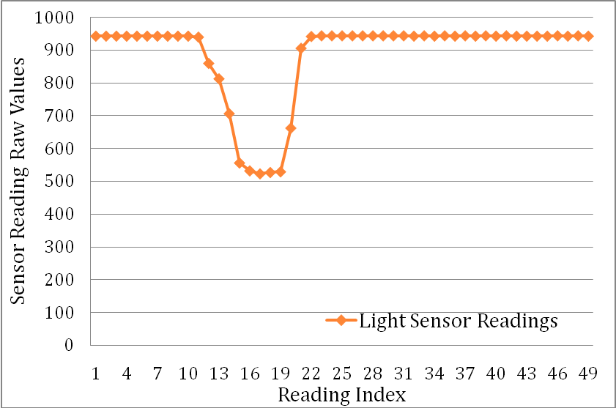

Using the LED
For the Led, use the following command:
./led REDLEDCONTROL, GREENLEDCONTROL, YELLOWLEDCONTROL
Here, LEDCONTROL must be 0, 1, or 2, where:
0 means OFF
1 means ON
2 means TOGGLE
For example, if you invoke
./led 2 2 2
This will toggle all three LED on the node.

Installation of Sample Applications
The following example explains the installation procedure of sample applications, like Blink. For simplicity of illustration, we first copy Blink.lhex and all the other binaries located under the Apps directory to a temporary directory, such as C:/Temp. Then, use the exec (or install) command to run an application. You may use the ps command to verify that the process is indeed running. Finally, you may use the kill (or uninstall) command to kill this process.

$cp /c/Temp/helloworld.lhex helloworld

The reply has 1 packets.

Now trying to send 0 23

Now trying to send sync

Now reply is good on sync

cp succeed

Copy finished

Time elapes 2547

$ls -l

The returned has 2 packets.

Name Type Size Protection

dev directory -- rwxrwxrwx

helloworld file 1120 rwxrwxrwx

Time elapes 500

$exec helloworld

Process execution succeeds.

Time elapes 828

$ps

The reply has 2 packets.

sysshell Active

helloworld Sleep

Time elapes 313

Appendix

Appendix I: A List of LiteShell Commands supported
*The commands with stars are related to debugging and are described in the programmer’s guide.

Command Name | Command Semantics
ls | List directory content
Cd | Enter a directory
cp | Copy files
Rm | Delete files or directories
mkdir | Create a new directory
touch | Create a new file
pwd | Display current directory location
du | Display remaining file system space
ps | Display running threads
exec | Execute an application as one or more threads
kill | Kill a thread
man | Show the help of commands
search | Search particular files using names
format | Format the file system
debug* | Set up debugging environment
breakpoint* | Inserts a breakpoint
continue* | Continue with the previous breakpoint
snapshot* | Snapshots a thread state information
restore* | Restore a thread to a previous snapshot state
print* | Print variable values in a running thread
set* | Set variable values in a running thread
setbasemode | Set the base mode to be promiscuous mode or not
rbb | Reset the base station
rbn | Reset the entire sensor network within one hop
history | Print the list of previous commands
setchannel | Change the channel used by the base station
memory | Display memory allocation information of current threads

Appendix II: Man Pages
LS User Commands
NAME
ls - list directory contents
SYNOPSIS
ls [OPTION]...
DESCRIPTION
List information about the files (the current directory by default).
-l
List detailed information about files.

CD User Commands
NAME
cd - enter a file directory
SYNOPSIS
cd [FILE DIRECTORY]
DESCRIPTION
Enter a file directory.

CP User Commands
NAME
cp - copy files and directories
SYNOPSIS
cp SOURCE DEST
DESCRIPTION
Copy file between directories. The directories may be
located on PC or mounted sensor nodes. To access dire-
ctories on PC, start the address with PC drive name, such
as /c/data.
EXAMPLE
cp /c/Temp/code.lhex /sn01/nodeA/apps/code.lhex
cp /sn01/nodeA/usr/data /c/Temp/data

RM User Commands
NAME
rm - remove a file or a directory
SYNOPSIS
rm FILE/DIRECTORY NAME
DESCRIPTION
Deletes a file or a directory in the file system.

MKDIR User Commands
NAME
mkdir - create a directory
SYNOPSIS
mkdir DIRECTORY NAME
DESCRIPTION
Create a new directory in the current position.

TOUCH User Commands
NAME
touch - creates a new file
SYNOPSIS
touch FILENAME
DESCRIPTION
This command will create a file at the current position
and the newly created file is assumed to be empty.

DU User Commands
NAME
du - estimate file system usage
SYNOPSIS
du
DESCRIPTION
Return the current remaining space in EEPROM and Flash

PS User Commands
NAME
ps - view current running processes
SYNOPSIS
ps
DESCRIPTION
Display the current processes and their status.

SEARCH User Commands
NAME
search - finds and locates a file or a directory
according to a particular regular expression name
SYNOPSIS
search FILE/DIRECTORY NAME
DESCRIPTION
This command will search across the network by file
name and returns a list of files/directories whose names
contains the particular file names

MAN User Commands
NAME
Manual, displays the manual pages for particular commands
SYNOPSIS
man COMMAND NAME
DESCRIPTION
This command displays the manual pages of particular commands.
If the manual pages are not available, it will be added in future versions.

EXIT User Commands
NAME
Exit the shell system
SYNOPSIS
exit
DESCRIPTION
This command exits the shell system

PWD User Commands
NAME
Pwd, displays the current working directory
SYNOPSIS
pwd
DESCRIPTION
This command displays the current working directory.

EXEC User Commands
NAME
Exec, executes a user application
SYNOPSIS
exec BINARYNAME.LHEX
DESCRIPTION
This command executes a user application by invoking its binary name.

KILL User Commands
NAME
Kill, terminates a running application
SYNOPSIS
kill BINARYNAME.LHEX
DESCRIPTION
This command terminates a user application by invoking its binary name.

HISTORY User Commands
NAME
History, displays previous commands
SYNOPSIS
history
DESCRIPTION
After you type history, you can use the beginning numbers of each line to re-invoke a
previous command. Such shortcut can be used only once in the current version.

SETCHANNEL User Commands
NAME
setchannel
SYNOPSIS
setchannel Channel Number
DESCRIPTION
Set the channel used by the base station.

Troubleshooting Tips

- Check FAQ on the website for updated answers to common problems.

- If things went wrong, reboot the node.

- The communication between base and node could be severely degraded by all kinds of interference. If one command does not get a reply, try it again.

- Because of unreliable radio, multiple ls –l commands may return different results.

- Connect all cables and battery securely.

- Report bugs in mailing lists so that they can be solved in future releases.

- It takes 1-2 minutes to boot up a node and format itself. Please be patient during this procedure.

- Some environments have strange problems with file permissions when extracting from the tar.gz tar ball. Change file permission to 777 if you meet such problems, i.e., type the following command: chmod 777 *.

Index

CD 37
Commands 35
CP 38
Cygwin 5
DU 42
EXEC 48
EXIT 46
HISTORY 50
Installation 2
Installer Express Mode 20
JDK 2, 11
KILL 49
Linux Installation 11
LiteOS Installation 15
LiteShell Commands 23
LS 36
MAN 45
MIB510 8
MIB520 8
MKDIR 40
PS 43
PWD 47
RM 39
SEARCH 44
SETCHANNEL 51
TOUCH 41
Troubleshooting Tips 52
uisp 14
USB-to-Serial adaptor 9
WinAVR 7
Windows Installation 2

