Manpass 1.0 User Guide
Contents
Overview 2
How to Use 2
Create a new user 2
Login 3
Specify the configuration directory 4
Add a new credential 5
Retrieve the saved password 6
Retrieve the saved password – for Mobile Device 6
Auto Lock 7
Changing Password 8
Manage History Passwords 10
Other common operations 10
Manually/Import Backup Database 10
Changing MasterPassword 10

Overview
Manpass is a secure password manager, it has following features:
- Support Windows/Linux/OSX
- Only need to remember one password (masterpassword)
- Use proven highly secure crypto algorithm/implementation
- Double-click to copy password to clip-board, and automatically clear it from clipboard after 20 seconds.
- Show password as QRCode image for mobile device use.
- Instant search among saved credentials
- Password history save the past passwords
- Passwords are stored in encrypted form within database, so that the database could reside in cloud storage (e.g. Dropbox) for redundancy and multi-clients synchronization.
- Support multiple Users

How to Use

Create a new user
After application start, click “Create New User…” button on the login window:
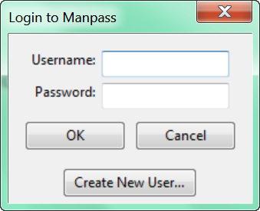
Input the username and the password, the password here is the masterpassword, which is the key used to encrypted all stored passwords.
Note: masterpassword must meet following requirements:
- The total length must>=8
- Masterpassword can’t contain username
- Masterpassword must contain characters from at least 3 of following 4 different kinds:
  - Lower case letters
  - Upper case letters
  - Digits
  - Punctuations
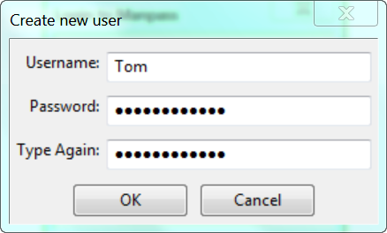

Login
Input the username and the masterpassword in the login window, and then lick “OK” button to login:
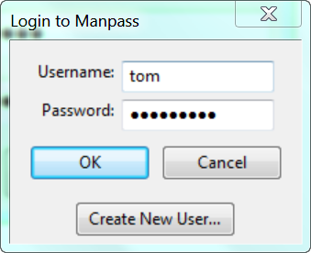
Then the main window will appear:
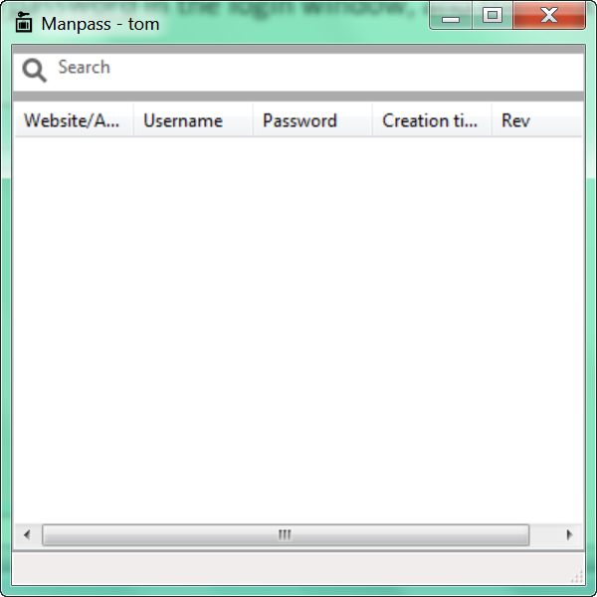

Specify the configuration directory
The first thing to do after creating a new user is to specify the configuration directory for the user, database and configuration are saved in the configuration directory. To make backup and sharing database between devices easier, it is highly recommend to use a cloud storage like Dropbox folder as the configuration directory.
Right click within the window and select “Advanced”->”Option” in the popup menu:
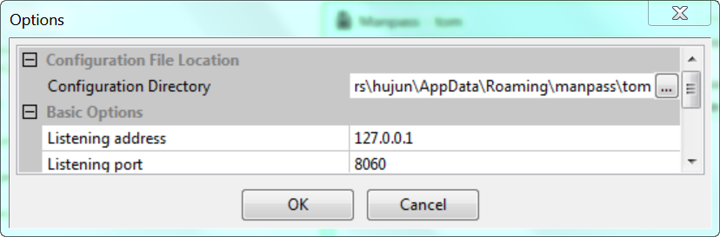
Click the value side of “Configuration Directory”, then click the “…” button, select a directory in the popup window, then click “OK”.

Add a new credential
To save a username/password in Manpass, right click in the main windows, and select “Add…” from the popup menu, a new dialog will show:
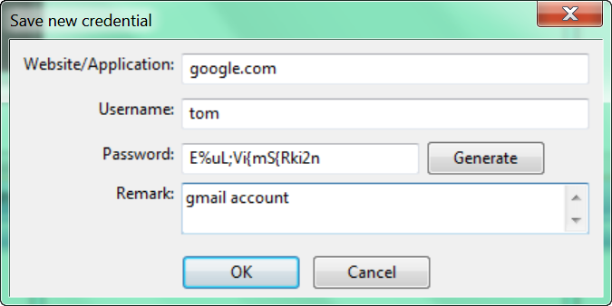
- Website/Application: this could be a Website name, a URL, an application name or any text.
- Username: the username
- Password: the password, Manpass could generate secure password for you, just click “Generate” button.
- Remark: optional remarks
Click “OK” button to save the credential. The saved credential now will appear in the list of the main window:
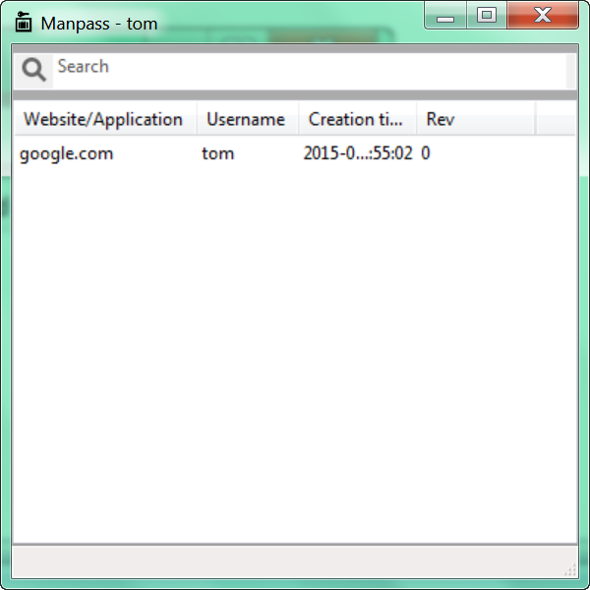

Retrieve the saved password
To retrieve saved password, just double click the credential in the list, the password will be automatically copied to the clipboard.
Another way is to select the credential first, then press “Enter” key.
For security reason, the copied password will be automatically cleared from Clipboard after 20 seconds.

Retrieve the saved password – for Mobile Device
To retrieve password for mobile phone or tablet, right click the selected credential and select “Show Password as QR code” from the popup menu.
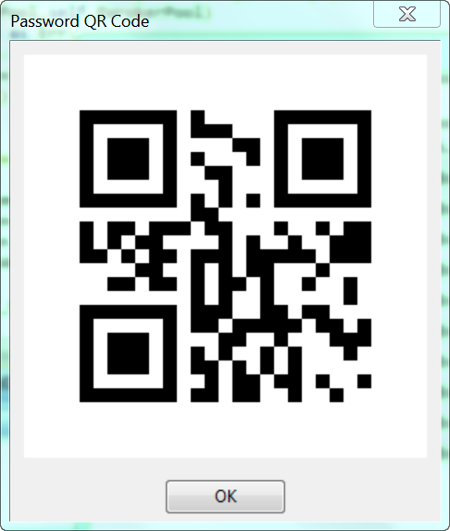
Scan the image use your mobile device’s camera, some App provides function to scan QR code directly to clipboard, so this function avoid the trouble of typing password.

Auto Lock
Manpass will automatically lock itself while in idle for too long. The default timeout is 60 seconds, which could be changed in options.
To unlock, click “Unlock Me” link, and enter the masterpassword.
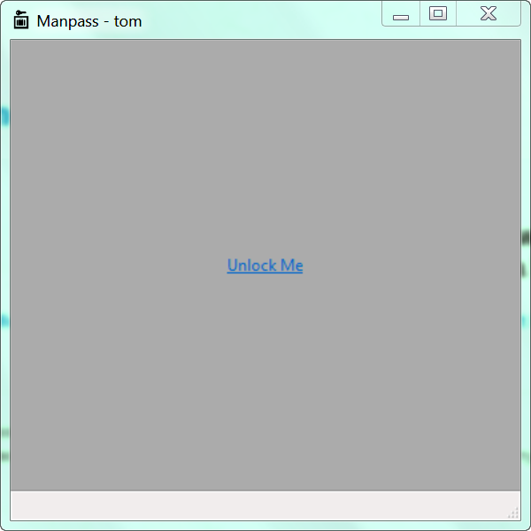

Changing Password
Many applications or website require regularly changing the password, to change a stored password, first right-click the credential and select “Change…” of the popup menu. Enter a new password (or generate a new one by clicking “Generate” button):
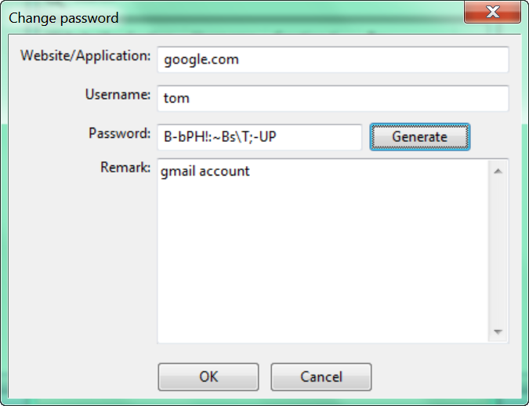
Note: you could also change other fields in this window.
Click “OK”, the new credential will be save into database, “Rev” has been increased to 1 from 0:
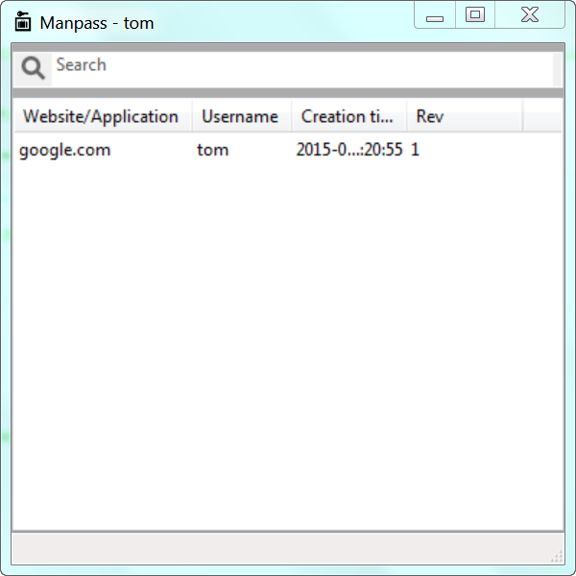

Manage History Passwords
By changing a stored password, the old password is not removed, it is still saved in database, user could access history password by click “List history passwords…” in the popup menu.
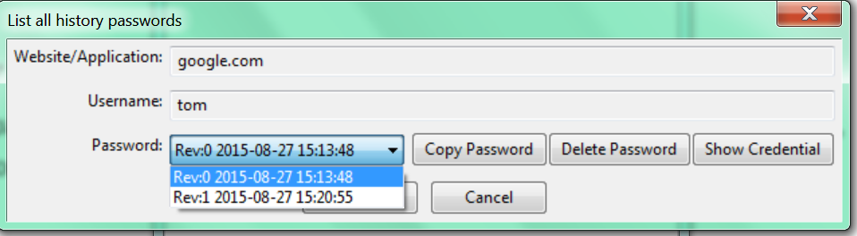
In this window, all saved password are listed with its creation time, you could:
- Copy selected password to clipboard by clicking “Copy Password” button
- Delete selected password to clipboard by clicking “Delete Password” button
- Show the select credential by clicking “Show Credential” button

Other common operations
- “Show…” in popup menu will display selected credential
- “Delete” will delete selected credential
- “Reload” will reload all credentials from database

Manually/Import Backup Database
To manually backup the database, select “Adavanced”->”Backup DB…” in the popup menu, Manpass will dump the database into a text file, the default name is <username>.manpassdb. since content of database is already encrypted, so this file could only be imported with correct masterpassword.
To import a .manpassdb file, select “Adavanced”->”Import DB…” in the popup menu.

Changing MasterPassword
To change masterpassword, select “Advanced”-> “Change master password…”:
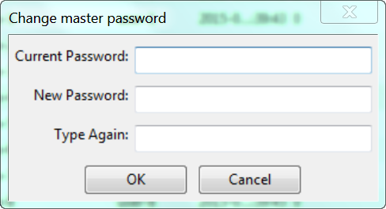
Enter current masterpassword and the new one, click “OK”, Manpass will re-encrypt the database. This process might take a while if number of credentials is big.

