# A MINI UNMANNED AERIAL VEHICLE (UAV): SYSTEM OVERVIEW AND IMAGE ACQUISITION

# 一种迷你无人机：系统概述和图像采集

Henri Eisenbeiss

Henri Eisenbeiss

Institute for Geodesy and Photogrammetry, ETH-Hoenggerberg, CH-8093, Zurich, Switzerland,

ehenri@geod.beug.ethz.ch

大地测量和摄影测量学会，ETH- Hoenggerberg， CH- 8093，苏黎世，瑞士

ehenri@geod.beug.ethz.ch

International Workshop on

国际研讨会

"PROCESSING AND VISUALIZATION USING HIGH-RESOLUTION IMAGERY"

“利用高清晰度图像处理和可视化”

18-20 November 2004, Pitsanulok, Thailand

2004年11月18日至20日Pitsanuloke，泰国

KEYWORDS: UAV, AUTONOMOUS, FLIGHT PLANNING, GPS/INS, CULTURAL HERITAGE

关键词：无人机，自动化，飞行计划，GPS/INS，文化遗产

ABSTRACT:

摘要：

In the last years UAV (Unmanned Aerial Vehicle)-systems became relevant for applications in precision farming and in infrastructure maintenance, like road maintenance and dam surveillance. This paper gives an overview about UAV (Unmanned Aerial Vehicle) systems and their application for photogrammetric recording and documentation of cultural heritage.

在过去的几年无人机系统开始应用在精准农业和相关基础设施的维护方面，如道路维修和大坝监测。本文给出了有关无人机的概述系统及其在摄影记录和文化遗产的文档的应用。

First the historical development of UAV systems and the definition of UAV-helicopters will be given. The advantages of a photogrammetric system on-board a model helicopter will be briefly discussed and compared to standard aerial and terrestrial photogrammetry. UAVs are mostly low cost systems and flexible and therefore a suitable alternative solution compared to other mobile mapping systems.

首先将给出无人机系统发展的历史和无人直升机的定义。简要讨论一个模型直升机自载摄影测量系统的优点和比较标准的空中摄影和地面摄影。无人机大部分是低成本系统和非常灵活，因此相比其它移动地图系统是一个适合的替代方案。

A mini UAV-system was used for photogrammetric image data acquisition near Palpa in Peru. A settlement from the 13 th century AD, which was presumably used as a mine, was flown with a model helicopter. Based on the image data, an accurate 3D-model will be generated in the future. With an orthophoto and a DEM derived from aerial images in a scale of 1:7 000, a flight planning was build up. The determined flying positions were implemented in the flight control system. Thus, the helicopter is able to fly to predefined pathpoints automatically. Tests in Switzerland and the flights in Pinchango Alto showed that using the built-in GPS/INS- and stabilization units of the flight control system, predefined positions could be reached exactly to acquire the images. The predicted strip crossings and flying height were kept accurately in the autonomous flying mode.

迷你无人机系统被用于在秘鲁附近帕尔帕摄影图像数据采集。用模型直升机飞行航拍这个大概从公元前13世纪开始就用作矿山的村庄。基于该图像数据，将在未来生成一个准确的3D模型。随着正射影像和数字高程模型能将图像放大到1：7 000，就可以建立飞行计划了。飞行位置的确定是在飞行控制系统来实现。因此，直升机能飞自动预设的路径点。在瑞士的测试中和在Pinchango Alto飞行中表明使用内置于GPS / INS和飞行控制系统的稳定单元，可以精确地达到预定位置以获取图像。预测长条航线和飞行高度均在自主飞行模式准确地保存。

1. INTRODUCTION

1.介绍

1.1 Aims

1.1目标

In the past Unmanned Aerial Vehicles (UAVs) used in the photogrammetric community were not defined precisely. Therefore, the historical background for the development of UAVs and their different definitions in the literature will be explained. The ancient settlement of Pinchango Alto and the accomplished field work there will be described briefly.

在过去无人机应用于（无人机）摄影界都没有精确的定义。因此，无人机发展的历史背景和不同的定义在本文献中会解释。将简要描述古Pinchango Alto村庄野外航拍工作的完成。

UAVs are mostly used in military applications for recognition,environmental observation, maritime surveillance and mine removal activities. Non-military applications are enviromental surveillance, rice paddy remote sensing and spraying as well as infrastructure maintenance.

无人机在军事应用中主要用于环境观测、海上监视和矿山清除活动。非军事用途是环境监控、水稻遥感和喷涂以及基础设施的维护。

The photogrammetric applications of UAVs will be discussed in more detail.

Here first the helicopter system and specification will be described. Furthermore, the camera system, which is mounted on the RC (Remote Controlled)-helicopter, is displayed.

将讨论无人机摄影测量应用在这些领域的更多细节。这里首先将描述直​​升机制度和规范。另外，被安装在遥控直升机的照相机系统将被展示。

Flight planning and preliminary results of the measurements in Pinchango Alto will be described and an easy flight planning technique will be demonstrated. Finally, the occurred problems and results of the flights will be discussed.

将描述在Pinchango Alto飞行计划及测量的初步结果，并且将提供简单的飞行计划技术。最后，将讨论出现的问题及飞行的结果。

Conclusions and future work show our future plans with the dataset Pinchango Alto. Furthermore some future plans and development of the helicopter system will be discussed.

用Pinchango Alto飞行的数据，得出结论和展示今后的工作中我们的未来计划。此外将讨论直升机系统的发展和一些未来的计划。

* 1. Definition and Historical Development of UAVs in Photogrammetry

1.2 无人机摄影的定义和历史发展

The name UAV covers all vehicles, which are flying in the air with no person onboard with capability controlling the aircraft This term is used commonly in the computer science and artificial intelligence community, but terms like Remotely Piloted Vehicle (RPV), Remotely Operated Aircraft (ROA), Remote Controlled Helicopter (RC-Helicopter), Unmanned Vehicle Systems (UVS) and model helicopter are often used, too. The RC- and model helicopters are clearly defined by the Unmanned Vehicle Systems International Association as mini, close short and medium range UAVs depending on their size, endurance, range and flying altitude. UAVs like Pegasus (Everaerts, 2004) are better described as a long endurance UAV. Because of the focus on UAV helicopters in this paper, the different types of long endurance UAVs and aircrafts are not treated in detail in this paper (more information in UVS, 2004).

这个名字无人机涵盖了所有车辆，它们在空中飞行没有人与机载控制能力飞机。该术语在计算机科学常用人工智能界，但像来讲远程飞行器（RPV），远程操作飞机（ROA）遥控直升机（RC-直升机），无人车辆系统（UVS）和模型直升机经常使用，太。该RC-和型号直升机被明确定义无人机系统国际协会为小，关闭短程和中程无人机取决于它们的大小，耐力，范围和飞行高度。无人机像飞马（Everaerts，2004）更好地描述为长航无人机。由于本文重点无人机直升机，不同类型的长航时无人机和飞机都在本文详细（更多信息，UVS不及时治疗，2004年）。

The definition of the UVS community, in which the helicopters fit, are listed in Table 1-1. All other kinds of aircrafts are generalised in the “High Altitude Long Endurance” group.

所述UVS社区的定义，其中，所述直升机配合，列于表1-1。其它各种飞机的是广义的“高空长航时”组中。

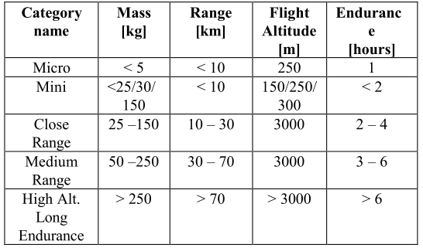

**Table 1-1: Extract of UAV categories defined by UVS- international. In the Mini UAV category the numbers depend on the scope of different countries.**

表1-1：无人机类提取物中的UVS-定义国际化。在Mini UAV类的数字取决于不同的国家的范围。

|  |  |  |  |  |
| --- | --- | --- | --- | --- |
| 类别  名称 | 重量  [kg] | 范围  [km] | 飞行高度  [m] | 续航时间  [h] |
| Micro | <5 | <10 | 250 | 1 |
| Mini | <25/30/150 | <10 | 150/250/300 | <2 |
| Close Range | 25-150 | 10-30 | 3000 | 2-4 |
| Medium Range | 50-250 | 30-70 | 3000 | 3-6 |
| Hight Alt. Long Endurance | >250 | >70 | >3000 | >6 |

The development of UAVs has been strongly motivated by military applications. After World War II, some nations were looking for aerial vehicles, which have the capability for surveillance, reconnaissance and penetration of hostile terrain without the deployment of human beings in areas of high risk. The technical requirements can be defined by autonomous tack-off, flying and landing (Eck, 2001).

无人机的发展得到了强烈的动机军事应用。二战结束后，有些国家是寻找高空作业车，它有能力监视，侦察和敌对的地形渗透没有人在高风险地区部署。技术要求可以自主定义粘性客，飞行和着陆（埃克，2001）。

Przybilla and Wester-Ebbinghaus 1979 did the first experiments with UAVs in photogrammetric applications. For image flights in a scale of 1:1000 or more, with a shutter speed of 1/1000 s, the velocity of the aeroplane was to high to get acceptable image motion. At that time, results were not sufficient because of the vibrations caused by the rotor which resulted in image motion. First tests accomplished using a model aeroplane by the company Hegi were flown (Figure 1-1). The aeroplane was 3 m long and had a wing span of 2.6 m. The plane could carry a payload of max 3 kg. Navigation equipment by Lindhof Technika was used to navigate the aeroplane. The system could determine the flying height from the size of the plane in the image viewer. The flights were done in a height of 150 m above the ground and with a velocity of 40 km/h. With this system, it was possible to acquire images of an archaeological area, architecture and building sites. Furthermore, the combination of terrestrial and aerial measurements was carried out. The application of this model aeroplane was limited by a small runway nearby the object, which was necessary. From this reason, the authors proposed to use less vibration-sensitive model helicopter.

普尔兹比拉和韦斯特 - 艾宾浩斯1979年做的第一件实验与摄影测量应用无人机。对于在比例为1的图像航班：1000以上，快门速度的1/1000秒，飞机的速度是高的，以获得可接受的图像运动。在那个时候，结果是不足够的，因为造成的转子振动的哪导致图像运动。第一次测试使用的是完成该公司Hegi模型飞机飞行了（图1-1）。飞机为3米长，具有2.6微米的翼展。该飞机可以携带最多3公斤的有效载荷。导航设备通过Lindhof的Technika用于导航的飞机。该系统可以从该大小确定飞行高度平面在图像查看器。该航班在高空完成150米高于地面并用40公里/小时的速度。同该系统中，有可能获得的图像考古区，建筑和建筑工地。此外，陆地和空中的结合测量进行。这种模式的应用飞机是由一个小的跑道附近有限的对象，这是必要的。从这一原因，作者提出对少用振动敏感的直升机模型。

In 1980, Wester-Ebbinghaus used firstly a model helicopter for photogrammetric purposes. The helicopter was a Schlueter model Bell 222 with a maximum payload of 3 kg. Polystyrene walls for effective clamping suppresses were installed on the helicopter to compensate the vibrations. Medium format cameras like a Rolleiflex SLX or Hasselblad MK 20 could be mounted on the helicopter system. For flight operation, a pilot and a navigator were needed. The pilot controlled the take off, landing and flying. The navigator had to control the altitude and to activate the camera shutter via radio link. The helicopter had a height range from 10 m to 100 m and the predicted height could be kept within 90 %, using the same navigation equipment like the aeroplane model. The Schwebebahn (monorail) Wuppertal, a steel construction dating from 1890, was documented using the helicopter system (Wester- Ebbinghaus, 1980).

1980年，韦斯特 - 艾宾浩斯首先使用的模型直升机摄影的目的。这架直升机是的Schlüeter为3公斤的最大有效载荷建模贝尔222。聚苯乙烯城墙的有效夹紧强忍分别安装在直升机振动补偿。中画幅相机像禄来福来SLX或哈苏MK20可能是安装在直升机系统。对于航班运行，试点并需要一个导航仪。飞行员控制的起飞，着陆和飞行。领航员不得不控制高度并激活经由无线电链路相机快门。直升机有10至100μm和预测的高度范围高度可保持90％的范围内，使用相同的导航设备类的飞机模型。该的Schwebebahn（单轨）伍珀塔尔，一个钢结构建筑的历史可以追溯到1890年，使用直升机系统（Wester-曾记载，艾宾浩斯，1980年）。

The development of UAVs and the integration of GPS/INS data onboard of UAVs are more and more discussed in the UVS international community (UVS-international, 2004). The background and development of mini UAV helicopter systems are shown in Eck (2001), WITAS (2004) and Conway (1995).

无人机的发展，GPS / INS数据的集成车载无人机在UVS被越来越多的讨论国际社会（UVS-国际，2004年）。该背景和小型无人直升机系统的开发示于埃克（2001），WITAS（2004）和Conway的（1995）。

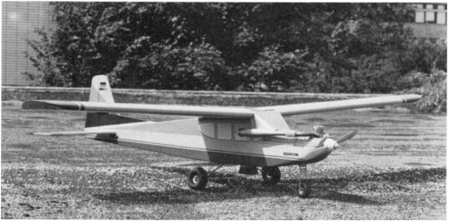

**Figure 1-1: Model airplane Firma Hegi, Przybilla 1979.**

The UAV-systems until there had mostly problems with holding the predicted altitude and in the navigation of the UAV. Through the small payload, these systems could only use few camera-systems, thereofor mini UAV-systems did not atablished at that time.

该无人机系统，直到有过大多与问题保持预测的高度，并在的导航无人机。通过小载荷，这些系统只能使用几个摄像头的系统，thereofor小型无人机系统没有当时atablished。

* 1. Project Pinchango Alto

1.3 Pinchango Alto项目

The field measurements in Palpa (Peru) were done in cooperation with the German Institute of Archaeology, Commission for General and Comparative Archaeology (KAVA) in Bonn (Germany) as a part of the project network NTG which applies new technologies from the natural sciences inside the humanities.

在帕尔帕实地测量（秘鲁）在完成与考古学的中德学院的合作，委员会秘书长和比较考古学（KAVA）在波恩（德国）作为项目网络的一部分NTG从自然科学的应用新技术的人文底蕴。

Pinchango Alto is an old settlement area (200 m x 300 m), see Figure 1-2, from the 10 th to the 14 th century, which was presumably used as mine and processing facility by the ancient population. Rubbing stones and mica were found in the settlement area. Reindel (2002) proposed the function of Pichango Alto as gold mining settlement, but this hypothesis should be verified in future work.

Pinchango奥拓是一个古老的结算面积（200米×300米），见图1-2，从10日至14世纪，这是大概是由古代用作矿山和加工设施人口。擦石和云母中被发现结算面积。 Reindel（2002）提出的功能Pichango奥拓作为黄金开采结算，但这种假说应在今后的工作中得到验证。

In 2004, a field campaign of combined laser scanner measurements and a helicopter flight was done. The project planning, data processing and the results will be published later. The focus of this paper is on the planning of the UAV flights and the UAV system, which were done within this project network.

2004年，结合激光扫描仪的现场活动测量和一个直升机飞行已完成。 该项目规划，数据处理，结果将公布后来。本文的重点是无人机的规划航班和无人机系统，这是在这个工作项目网络。

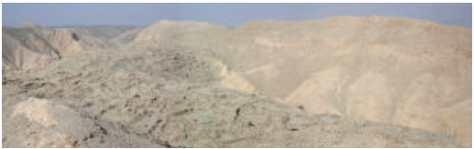

**Figure 1-2: Pinachngo Alto - overview of the settlement area.**

2. APPLICATIONS OF UAVS IN PHOTOGRAMMETRY

2．摄影测量在无人机中的应用

The main application of UAVs could be defined with observation, maintenance, surveillance, monitoring, remote sensing and security tasks.

无人机的主要应用可以与被定义观察，维修，监控，监控，远程传感和安全任务。

In the ISPRS commission V (2004-2008) Working Group 6, the autonomous vehicle navigation will be investigated. Nobody knows which systems already exist for photogrammetric applications, therefor a overview about recent projects will be displayed.

在ISPRS佣金V（2004- 2008年）工作组6，汽车自主导航将进行调查。 没有人知道哪些系统已经存在摄影应用程序，其的介绍关于最近的项目将是显示。

In the last years, more and more applications of UAV-systems in photogrammetry became common. This development can be explained by the spreading of low cost combined GPS/INS- systems, which are necessary to navigate the helicopter with high precision to the predicted acquisition points. Some systems are used without GPS/INS-systems, especially for the capture of roofs for the combination with terrestrial measurements. For the applications using UAVs only and for the reduction of the number of control points, the GPS positioning should reach decimeter accuracy.

在过去几年中，UAV系统的越来越多的应用在摄影变得普遍。这种发展可能通过合并低成本传播的GPS / INS-解释系统，这是必要的导航直升机高精度的预测采集点。 一些系统被用于没有GPS/ INS系统，特别是对屋顶的采集与地面相结合测量。对于应用程序中使用无人机只和的控制点的数目的减少，将GPS定位应达到分米级精度。

Zischinsky et al. (2000) used images taken from a model helicopter partly for the generation of a 3D-model of an historical mill. For the documentation of the building, 82 pictures were taken from the ground and additional 38 images from the helicopter to close the gaps in the model. The small format amateur camera mounted on the helicopter took mainly images of roofs and the courtyard. For the outer orientation of the model 120 control points were determined.

Zischinsky等。从模型拍摄（2000年）中使用的图像直升机部分为的一个3D模型的生成历史厂。对于建筑物的文档，82照片是从地面和附加38拍摄的图像从直升机将在模型中的差距。小格式业余相机安装在直升机了主要屋顶和庭院的图像。对的外方向确定了型号120的控制点。

The Yamaha model helicopter is primarily developed and used for agriculture application, like insect pest control of rice paddies, soybeans and wheat. The first system, RCASS, was built in 1980. Later on, in 1990, the helicopter R50 had a payload of 20 kg and a laser-system for height determination. In the year 1997, the type RMAX came out and 3 years later it was equipped with an azimuth and differential GPS sensor system (Yamaha, 2004).

雅马哈模型直升机主要是开发和利用农业应用，如水稻病虫草害防治水稻，大豆和小麦。第一系统，RCASS，是建于1980年。后来，1990年，直升机R50有一个20公斤的有效载荷和高度确定的激光系统。1997年全年，该类型RMAX出来了，3年后，它装有带方位和差分GPS传感器系统（雅马哈，2004）。

The RMAX UAV system from Yamaha was used as a ground truth measurement system (Hongoh, 2001). Ground truth measurement is used to determine the vegetation coverage. Therefore, the sensor takes images from different viewing angles, which is the most important aspect of bi-directional reflectance measurements.

来自雅马哈的RMAX无人机系统被用作地面真相测量系统（Hongoh，2001）。地面实况测量被用来确定植被覆盖。因此，该传感器从不同观看需要的图像角，这是双向的最重要的方面反射测量。

In the same year a helicopter was used for Chinese fortress measurements. The Japan Miyatsuka Institute of Archaeology wanted to make high-resolution images of this huge fortress side (3 km x 4 km). Normally, foreigners are not allowed to use aeroplanes or helicopters to take aerial images in other countries. The remote controlled helicopter covers none of the both categories and for that reason the UAV-system was used with metric and non-metric cameras.

同年被用于中国山寨直升机测量。考古日本Miyatsuka研究所想使这个庞大的堡垒高分辨率图像侧（3公里×4公里）。通常情况下，外国人不准使用飞机或直升机采取其他航空影像国家。该遥控直升机没有覆盖的这两类，由于这个原因，使用了UAV系统公制和非公制摄像机。

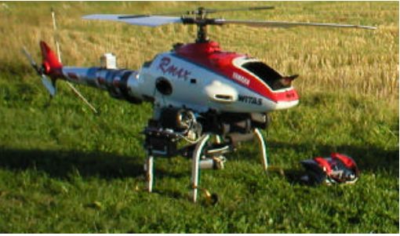

Figure 2-1: WITAS Unmanned Area Vehicle –Yamaha RMAX Aero Robot.

In 2002, the Yamaha RMAX helicopter was used in photogrammetric flights over two tests sites in Sweden, to analyse the accuracy of the GPS/INS for the photogrammetric purposes with manual and autonomous flying modus. The results show that the stability of the camera mounting, the vibrations are caused by the main rotors and the GPS accuracy are the important parts of a UAV-helicopter (Eisenbeiss, 2002 & 2003). These flights were done in co-operation with WITAS –Wallenberg Laboratory for research on Information Technology and Autonomous Systems (Linköping University, Sweden) and the Institute of Photogrammetry and Remote Sensing (TU-Dresden).

2002年，雅马哈RMAX直升机使用在瑞典的两个测试地点摄影航班，以分析GPS / INS的精度为摄影目的有手动和自主飞行作案。该结果表明，该相机的稳定安装，在振动由主转子和GPS的精确度引起是无人机直升机的重要组成部分（艾森比斯，2002年＆2003）。这些航班在WITAS合作完成-Wallenberg实验室信息研究技术和自治系统（林雪平大学，瑞典）和摄影测量与遥感学会传感（TU-德累斯顿）。

At the ISPRS congress 2004 in Istanbul two papers about UAV-helicopters and three about UAV-aircraft were published. The first is a system, which integrates laser scanner and CCD-cameras with GPS/INS data for constructing digital surface model. This system use a Subaru helicopter with a payload of 100 kg and diameter of the main rotor of 4.8 m. Similar helicopter systems before were classified by mini UAV system. This bigger helicopter is not covered by the micro to medium size UAVs because of the mass of 330 kg. But looking at the range and altitude, the helicopter can be defined as a mini or close range UAV. (Nagai, 2004)

在ISPRS大会2004年在伊斯坦布尔两篇论文约无人机直升机和三架无人机左右，飞机被出版。首先是一个系统，它集成了激光扫描仪和CCD摄像头与GPS / INS数据构建数字表面模型。该系统使用斯巴鲁直升机一100公斤载荷和4.8米主转子的直径。类似直升机系统前就小型无人机分类系统。这个更大的直升机是不包括在微观到中等大小的无人机，因为330公斤质量。但看在范围和高度，直升机可以被定义为一个Mini或近距离无人机。 （永井，2004年）

The second presented system is a mini UAV-helicopter, which was used as a photographic system for the acquisition of ancient towers and temple sites. The helicopter should replace high camera tripods and ladder trucks, which are uneconomical in cost and time. The helicopter Hirobo & Eagle 90 has a main rotor diameter of 1.8 m of the main rotor and a payload capability of 8.5 kg. The helicopter took images from the upper part of the temple from all sides. The images of the lower part were taken from the ground. The helicopter could carry different camera systems like miniature (35 mm), medium (6 cm x 4.5 cm) and panorama (6 cm x 12 cm) format cameras and video cameras. A gimbal was designed as a buffer that can absorb noises as well as vibrations. Onboard the system, a small video camera is installed too, which is connected to the ground station to transmit the images to a monitor in real time (Sik, 2004)

第二个提出的系统是一个小型无人机，直升机，这作为一个摄影系统用于收购古老的塔楼和寺庙遗址。直升机应该取代高相机三脚架和云梯车，这是不经济在成本和时间。直升机Hirobo＆鹰90具有一个主1.8米的主转子和一个有效载荷的转子直径的8.5公斤能力。这架直升机把图像从上来自各方面的寺庙的一部分。下部的图像从地面被采取。直升机可以携带不同的相机系统，如微型英寸（35 mm），中（6厘米×4.5厘米）和全景（6厘米×12厘米）画幅相机和摄像机。万向节的目的是作为一个缓冲区，可以吸收噪音和振动。板载系统，小视频安装摄像机太，其被连接到地面站将图像发送到在实时监视器（植，2004年）

The Chinese Academy of Surveying and Mapping develops a mini UAV-aircraft which is used to extract from one image and a 2D GIS database 3D models of buildings. Because of the wind it was difficult to control the vehicle-photographing pose and to take images on the predicted acquisition points. The developers had some problems to obtain stereo images (Wang, 2004).

中国的测绘科学研究院的一个发展它用于小型无人机的飞机从一个图像提取和一个二维GIS数据库的建筑物的3D模型。因为风，很难控制车辆拍摄姿势并采取预测的采集点的图像。该开发商遇到了一些问题，以获得立体图像（王，2004年）。

On the ISPRS congress 2004, also two papers were published about the Pegasus, which is a long endurance UAV system for remote sensing. These kind of systems have the capability to fly long time because solar energy is used as power supply. The system can carry a payload of about 300 kg (Everaerts, 2004).

2004年的ISPRS大会，也两篇论文发表关于天马，这是一个很长航时无人机系统遥感。这些类型的系统有能力飞很长一段时间，因为太阳能作为电源。该系统可以携带约300千克的有效载荷（Everaerts，2004年）。

Some companies already use helicopters (Figure 2-2) with/ without GPS navigation for the production of aerial imagery of single buildings and cities or for documentation of industrial constructions (Helicam 2004, Pollak 2004).

一些公司已经使用带/直升机（图2-2）没有用于生产航空影像的GPS导航仪单体建筑和城市或工业文档结构（Helicam2004年，2004年波拉克）。

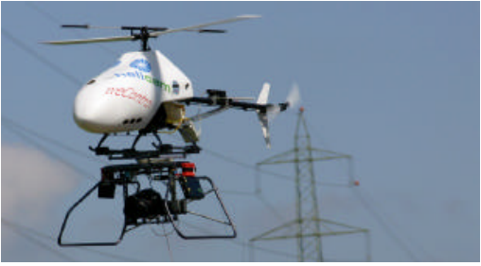

Figure 2-2: UAV-helicopter by Helicam and weControl, Switzerland.

The studies have shown that UAV-systems in photogrammetric applications are at the beginning, even though that the first applications have been accomplished at the end of the seventies of the last century. The potential of these systems, due to their capability to fly nearby the object from different positions and to combine aerial and terrestrial acquisitions, were already pointed out by Wester-Ebbinghaus in 1980. But the problems caused by vibrations of the UAV and the influence of wind and manual controlling of these systems limited their acceptance as photogrammetric measurement platform in the past. Nowadays, even with low cost GPS/INS– systems, UAVs can be navigated with decimetre accuracy and the orientation parameters can be used for navigation, post processing by reducing the number of control points.

该研究显示在摄影该UAV系统应用程序是在开始时，即使在第一应用已经在该年底已经完成上个世纪七十年代。这些系统的潜力，由于他们的能力飞附近的不同对象立场，空中和地面相结合的收购，由韦斯特 - 艾宾浩斯在1980年就已经指出，但引起的UAV和振动的问题这些系统的风和手动控制的影响限制其接受为摄影测量平台中来。现在，即使以低成本的GPS / INS-系统，无人机可以分米精度和导航的取向参数可用于导航，交通过减少的控制点的数目的处理。

In comparison with other mobile mapping systems, the RC- helicopters are not developed to cover large areas and for the use of photogrammetric film based cameras (23 cm x 23 cm). The unmanned helicopter can cover small areas and in particular, it could acquire images easily from all sides of complex buildings (Table 2-1). Also the project costs by the use of RC-helicopters are lower than by the use of aircraft or terrestrial equipment. More information about the state of the art of mobile mapping systems were published in Schwarz, et al. (2004).

在与其他移动绘图系统相比，RC-直升机没有发展到大面积覆盖，为使用基于摄影胶片相机（23厘米×23厘米）。该无人直升机可以覆盖小的区域，并在特别是，它可以从四面八方轻松获取图像复杂的建筑物（表2-1）。也是由工程费用利用RC-直升机是比使用飞机或更低地面设备。有关的国家的更多信息移动测绘系统的艺术发表在施瓦茨等人。 （2004）。

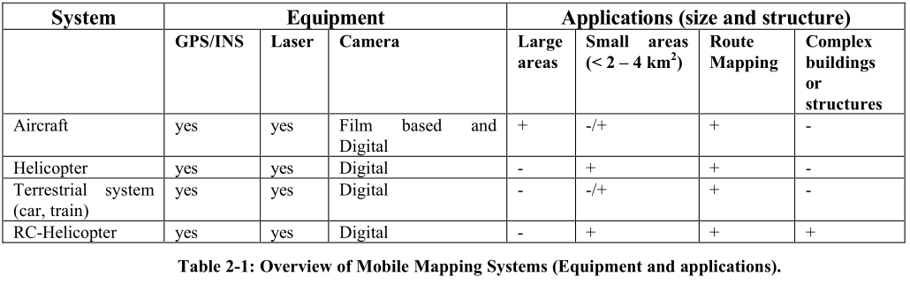

表2-1：移动绘图系统（设备和应用程序）的概述。

|  |  |  |  |  |  |  |  |
| --- | --- | --- | --- | --- | --- | --- | --- |
| 系统 | 设备 | | | 应用程序（大小和结构） | | | |
|  | GPS/INS | Laser | Camera | 大面积 | 小面积（<2-4平方米） | 路由映射 | 复杂房屋或结构 |
| 飞行器 | Yes | yes | 基于电影的数码相机 | + | -/+ | + | - |
| 直升机 | Yes | yes | 数码相机 | - | + | + | - |
| 地面系统  （汽车，火车） | Yes | yes | 数码相机 | - | -/+ | + | - |
| RC-直升机 | Yes | yes | 数码相机 | - | + | + | + |

3. DESCRIPTION OF THE HELICOPTER SYSTEM

3.直升机系统说明

3.1 UAV Mini Helicopter System

3.1无人机迷你直升机系统

For the photogrammetric recording of Pinchango Alto, we decided to use an UAV-helicopter Copter 1B from Survey- Copter equipped with a GPS/INS stabilised system (Figure 3-1) and a ground control station by weControl.

对于Pinchango奥拓的摄影记录，我们 决定利用从调查 -无人机直升机直升机1B 直升机配备有GPS / INS稳定系统（图 3-1）和weControl一个地面控制站。

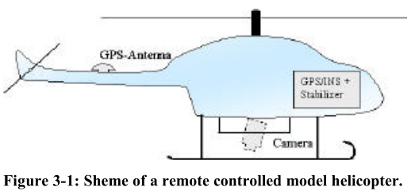

Furthermore, for the flights it was necessary to have monitoring software, communication links, flight determination system, ground support and maintenance equipment, power generation, handling, storage and transport equipment and a video link for monitoring the image overlapping as a manual control. The last point was important, because it was not clear how accurate the predicted points (in and across flight direction) could be flown.

此外，对于飞行有必要具有监控软件，通讯联系，确定航班 系统，地面支持和维护设备，电力 生成，处理，储存和运输设备和 视频链接监控图像重叠作为手动控制。最后一点很重要，因为它是不明确 如何准确预测点（在和整个飞行 方向），可以飞行。

A flight planning system was developed such that the predefined points could be loaded into the controlling system and illustrated on a digital map in the control software viewer. The helicopter position and orientation is displayed in the map, too. Therefore, the operator is able to control its position and orientation (Figure 3-2).

的飞行计划系统的开发使得 预定点可以装入控制系统并且在控制软件观看者的数字地图上示出。 直升机的位置和方向显示在地图 太。因此，操作者能够控制它的位置，并 取向（图3-2）。

With the controlling software, it is possible to load a flight mission. The stop points for the image acquisitions and the route can be defined and after that, the flying path will be automatically flown.

与控制软件，它可以装入一个飞行 任务。对于图像采集和止损点 路径可以被定义并在此之后，飞行路径将是 自动飞行。

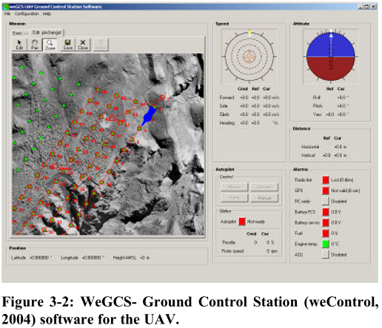

A pilot is only needed for starting and landing in dangerous areas like Pinchango Alto and for the support of the UAV. After take off, the operator controls the functionality of the UAV-system through the check buttons (position, heading, radio link, GPS, RC radio, battery). If the predicted point is not correctly reached, the operator can correct the position, the altitude and the yaw angle of the helicopter through commands on the laptop.

只需要飞行员在危险的出发和降落领域，如Pinchango奥拓的支持无人机。起飞后，操作者控制的功能通过检查按钮无人机系统（位置，航向，无线链路，GPS，无线电遥控，电池）。如果预测的点不正确地达到，操作人员可以正确的位置，高度，并通过命令直升机的偏航角在笔记本电脑。

With the predefined points, the actual position and a special stabiliser the orientation of the UAV is automatically corrected, even though a light wind force influences the position. The rest vibration of the helicopter can almost eliminated by a special mounting of the camera. Until now, the GPS/INS-system is used for navigation only and not for direct georeferencing. The system’s parameters are listed in the following:

与预定点，实际的位置和一个特殊的稳定剂方向的无人机自动为纠正，即使光风力影响位置。直升机其余振动几乎可以由照相机的一个特殊的安装消除。到现在为止，该GPS / INS-系统用于导航，而不是为了直接地理坐标定位。该系统的参数中列出以下：

Relative positioning accuracy GPS:

- Horizontal: ± 0.5 m

- Vertical: ± 0.3 m

Velocity:

- Forward direction: 20 m/s

- Sideward direction: ±5 m/s

- Backward direction: 5 m/s

- Vertical Direction: ± 2 m/s

- Vertical turning rate: 30 deg/s

Accelerations:

- Horizontal: 1 m/s 2

- Vertical: 0.5 m/ s 2

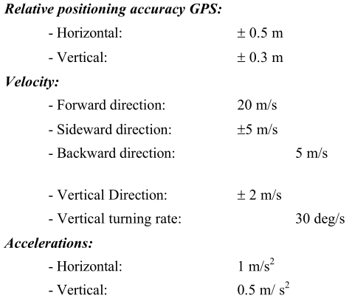

The maximum possible distance between the ground control station and the helicopter is 1000m in horizontal direction and the maximum flying altitude is 300 m. For safety reasons, the pilot and the operator must see the helicopter The payload capability of the UAV-helicopter is 8 kg at this time.

地面控制之间的最大可能距离 站和直升机在水平方向和1000米 最大飞行高度为300微米。为安全起见，该 飞行员和操作员必须看到直升机的有效载荷 无人机直升机的能力是8公斤这个时候。

3.2 Camera System

3.2摄像系统

We decided to use a Canon D60, D10 and a Rollei 6006 for the image acquisition. The Canon D10/D60 has a CMOS-Sensor with 6.3 Mpixel (3072 x 2048). The camera has also a possibility to save the image with a radiometric resolution of 48 Bit (16 Bit per channel) in RAW-format. Because of their high radiometric resolution and the short time for image saving due to the CMOS-sensor technique, the Canon cameras were available. To reduce the height of the helicopter a lens with a focal length of 14.26 mm was selected to get the required image scale.

我们决定使用佳能D60，D10，为的是禄莱6006 图像采集。佳能D10/ D60拥有CMOS传感器 6.3兆像素（3072×2048）。摄像头也一 可能性保存图像的辐射分辨率 48位（每通道16位）的RAW格式。由于它们的 高辐射分辨率和短时间进行图像保存 由于CMOS传感器技术，佳能相机是 可用。以降低直升机与透镜的高度 被选为14.26毫米焦距，以获得所需的 图像比例。

The camera system could also be replaced with other digital cameras or medium size analog cameras like Rollei 6006 (Image format 6 cm x 6 cm). For the controlling of sufficient image overlapping, a video camera was installed, which covers the same area like the digital cameras. This video signal was transmitted to the ground control station and displayed on monitor or video glasses.

照相机系统也可以与其他的数字替换 相机或中等大小的模拟摄像机一样禄6006 （图像格式6厘米×6厘米）。为了充分控制 图像重叠，安装摄像机，其覆盖 在同一地区，如数码相机等。该视频信号是 传送到地面控制站并显示在 显示器或视频眼镜。

Due to problems with the forwarding agency we had only two days left for image acquisition in Peru. Therefore, we decided to take images with digital cameras only.

由于与货运代理，我们只有两个问题 离开天在秘鲁图像采集。因此，我们决定 采取只用数码相机拍摄的影像。

4. FLIGHT PLANNING AND FIRST RESULTS FROM THE FLIGHTS

4飞行计划和第一名的成绩从航班

Before the flights in Peru, some tests were necessary in order to check the system. The UAV-system from Helicam was already used for photo flights in Switzerland, but has never been applied before for photogrammetric flights with a predefined flight path.

秘鲁的航班之前，一些测试，以是必要的 检查系统。从Helicam无人机系统是 已经用于在瑞士的照片飞行，但从来没有 被之前施加用于与摄影的航班 预定的飞行路线。

The tests in Switzerland showed that the used camera platform was not sufficient for our purposes, because vibrations were not absorbed and the camera could not be aligned straight to the ground. Furthermore, some problems with engine and gas occured. For Peru, a new platform was built in the way that the camera is directed straight down and the vibrations are reduced to a minimum. The engine and the petrol were changed too.

瑞士的试验表明，使用摄像机平台 不足以对我们来说，因为震动是 不被吸收和相机无法对准直 地面。此外，一些问题发动机和气体 发生。对于秘鲁，一个新的平台建于该方式 照相机直下定向和振动被减小 到最低限度。在发动机和汽油进行过修改。

The test flights showed also, that in the manual mode it is not possible to keep the predefined waypoints. Therefore, all flights were done autonomous, barred from take off and landing. The pilot controlled these manoeuvres.

试飞也显示，在手动模式下是不 能够保持预定的航点。因此，所有 航班被做自主，禁止从起飞 降落。飞行员控制这些演习。

For the area of Pinchango Alto, an image scale of 1:4000 for the digital images was selected. With the fixed image scale and focal length, the flying height was defined to 56 m above ground. The area of interest was located using an orthophoto (Figure 4-1), which was produced from aerial images with a scale 1:7000 (Gruen et al., 2000). We defined as two areas of interest, due to the lack of time it was impossible to aquire “everything”. The area with the best-preserved walls got the priority one (Figure 4-1, blue frame) and the whole settlement (Figure 4-1, red frame) priority two for the image acquisition.

对于Pinchango奥拓，1图像的规模面积：4000 数字图像被选中。与固定图像规模和 焦距，飞行高度被定义至56米以上 地面。感兴趣的区域是用一种正射影像位于 （图4-1），将其从与航拍照片制作 比例1：（格鲁恩等，2000）7000。我们定义为两个区域 息，由于缺少时间是不可能的AQUIRE “一切”。最好的保存完好的墙壁的面积得到了 最高优先级的（图4-1，蓝框）整个结算 （图4-1，红框）的优先级两个用于图像采集。

Due to the slop terrain in the area, the absolute flying heights were defined using the orthoimage and an elevation model (DTM generated from the aerial imagery). With the image format of 15 by 22 m on the ground and the image overlapping along and across track of 75 percent, the acquisition points were calculated. All formulas can be found in Warner et al. (1995). All points were set up as stop points. The maximum speed between the points was set to 2 m/s.

由于在该区域的污水地形，绝对浮动高度 使用的垂直图像和高程模型被定义 （DTM从航拍图像生成）。与图像 通过在地面上22米15格式和图像重叠 沿着和越过轨道的75％，收购点 进行了计算。所有的公式可以在华纳等人发现。 （1995年）。所有的点都设置为止损点。 最大值 点之间的速度被设定为2米/秒。

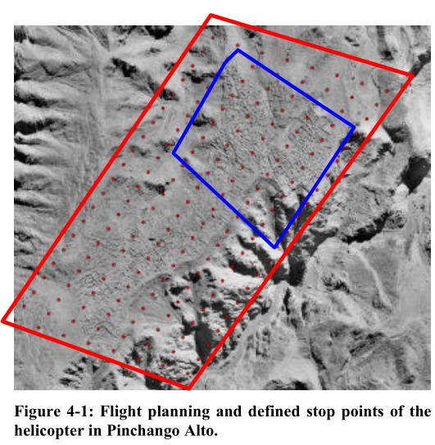

With the used UAV-helicopter system, we could cover 90 percent of the whole area with only 5 image strips and around 100 images. The 3D position of the projection centres could be achieved with an accuracy of 2 to 5 percent of the predicted position. In Figure 4-2 the UAV-helicopter over the settlement in Pinchango Alto is shown.

随着使用无人机，直升机系统，我们可以覆盖90 整个区域的百分比只有5图像带条和周围 100张图像。投影中心的三维位置可能是 为2的精确度达到所预测的5％的 位置。图4-2中的无人机，直升机在解决 在Pinchango奥拓所示。

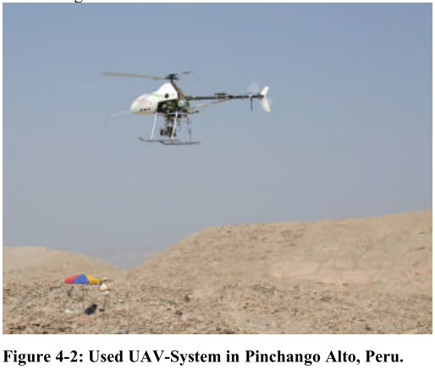

Using the acquired images, we will produce a DTM, an orthoimage from the whole settlement and derivates (Figure 4-3).

使用所获取的图像，我们将产生一个DTM，一个 从整体结算和衍生工具（正射影像图 4-3）。

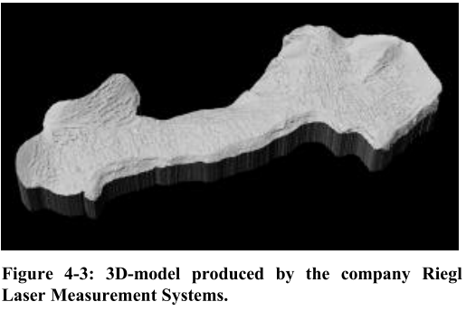

5. CONCLUSIONS AND FUTURE WORK

5.结论和未来的工作

Within the project Pinchango Alto we did the first photogrammetric flight over an ancient settlement in Peru using an UAV-mini-helicopter system, which is equipped with a GPS/INS-sensor and a stabiliser. The flight planning and measurements have shown that this UAV-system offers great advantages in cultural heritage recording compared to traditional methods. The RC-helicopter is easy to handle and can fly the predicted flight path even when a light wind is influencing the helicopter. The results also show, that we have to handle the engine problems. The helicopter should have the capability to fly longer than 15 minutes, which requires a bigger tank. The engine power should also be increased, so that the helicopter has the capability to carry a higher payload.

在项目Pinchango奥拓我们做的第一 在一个古老的定居在秘鲁摄影飞行 使用无人机小型直升机系统，其配备 一个GPS/ INS传感器和稳定剂。该飞行计划和 测量表明，该无人机系统提供了巨大的 在文化遗产的优势录音相比， 传统的方法。该RC-直升机易于操作， 即使在微风是能飞的预测飞行轨迹 影响直升机。结果还表明，我们有 处理引擎问题。直升机应具有 能力飞时间超过15分钟，这需要一个 更大的坦克。发动机的动力也应增加，从而使 直升机具有携带一个更高的有效载荷的能力。

In comparison with other described UAV photogrammetric projects, this helicopter can be used without terrestrial imagery. Because of the stability of the helicopter in air, no problems with image overlapping occurred. Until now, the post processing takes still the same time as the ordinary photogrammetric flights, because of the low accuracy of the GPS/INS-system. In the future we will increase the accuracy and reduce the processing time.

与其他无人机描述比较摄影 项目中，该直升机可以在没有地面使用 图像。因为空气中的直升机的稳定性，无 与图像重叠的问题发生。到现在为止，后 处理花费仍然是相同的时间作为普通 摄影航班由于低精度的， GPS / INS系统。今后，我们将提高准确率 和减少处理时间。

With the data in Pinchango Alto, we plan to produce a 3D- model, which we will compare with the results of laser scanning. We will generate maps of the settlement and produce a virtual 3D-model from both data sets.

随着Pinchango奥拓的数据，我们计划生产3D- 模型，我们将用激光的比较结果 扫描。我们将生成结算的地图和生产 虚拟3D模型，从两个数据集。

Recently, UAV-helicopters in photogrammetry have shown the capability for mobile mapping in close range applications. The main problem of a mini model helicopter is still the vibration of the system, the payload capability and the integration of all sensors.

近日，在摄影无人机，直升机所示 能力在近距离应用的移动映射。该 迷你模型直升机的主要问题仍是震动 该系统中，有效载荷能力和所有的融合 传感器。

6. ACKNOWLEDGEMENTS

6.致谢

The author thanks Prof. A. Gruen who gave us the opportunity to realise the laser scanner and model helicopter project in Pinchango Alto, Peru. The author also wants to thank Karsten Lambers and Martin Sauerbier (IGP- ETH Zurich), who supported the planning and realisation of the laser and helicopter measurements in Pinchango Alto. Furthermore, the author is very grateful for the project funding by the NTG project network.

作者感谢A.格鲁恩教授是谁给了我们机会实现了激光扫描仪和模型直升机项目Pinchango奥拓，秘鲁。笔者也想感谢卡斯滕Lambers和马丁Sauerbier（IGP-苏黎世联邦理工学院），谁支持激光的规划与实现直升机在测量奥拓Pinchango。此外，该笔者是由NTG项目资金非常感谢项目网络。