**A MINI UNMANNED AERIAL VEHICLE (UAV): SYSTEM OVERVIEW AND IMAGE ACQUISITION**

**一种迷你无人机：系统概述和图像采集**

Henri Eisenbeiss

Henri Eisenbeiss

Institute for Geodesy and Photogrammetry, ETH-Hoenggerberg, CH-8093, Zurich, Switzerland,

ehenri@geod.beug.ethz.ch

大地测量和摄影测量学会，ETH- Hoenggerberg，CH- 8093，苏黎世，瑞士

ehenri@geod.beug.ethz.ch

International Workshop on

国际研讨会

"PROCESSING AND VISUALIZATION USING HIGH-RESOLUTION IMAGERY"

“利用高清晰度图像处理和可视化”

18-20 November 2004, Pitsanulok, Thailand

2004年11月18日至20日Pitsanulok，泰国

KEYWORDS: UAV, AUTONOMOUS, FLIGHT PLANNING,GPS/INS, CULTURAL HERITAGE

关键词：无人机，自动化，飞行计划，GPS/INS，文化遗产

### ABSTRACT:

### 摘要：

In the last years UAV (Unmanned Aerial Vehicle)-systems became relevant for applications in precision farming and in infrastructure maintenance, like road maintenance and dam surveillance. This paper gives an overview about UAV (Unmanned Aerial Vehicle) systems and their application for photogrammetric recording and documentation of cultural heritage.

在过去的几年无人机系统开始应用在精准农业和相关基础设施的维护方面，如道路维修和大坝监测。本文给出了有关无人机的概述系统及其在摄影记录和文化遗产的文档的应用。

First the historical development of UAV systems and the definition of UAV-helicopters will be given. The advantages of a photogrammetric system on-board a model helicopter will be briefly discussed and compared to standard aerial and terrestrial photogrammetry. UAVs are mostly low cost systems and flexible and therefore a suitable alternative solution compared to other mobile mapping systems.

首先将给出无人机系统发展的历史和无人直升机的定义。简要讨论一个模型直升机自载摄影测量系统的优点和比较标准的空中摄影和地面摄影。无人机大部分是低成本系统和非常灵活，因此相比其它移动地图系统是一个适合的替代方案。

A mini UAV-system was used for photogrammetric image data acquisition near Palpa in Peru. A settlement from the 13 th century AD, which was presumably used as a mine, was flown with a model helicopter. Based on the image data, an accurate 3D-model will be generated in the future. With an orthophoto and a DEM derived from aerial images in a scale of 1:7 000, a flight planning was build up. The determined flying positions were implemented in the flight control system. Thus, the helicopter is able to fly to predefined pathpoints automatically. Tests in Switzerland and the flights in Pinchango Alto showed that using the built-in GPS/INS- and stabilization units of the flight control system, predefined positions could be reached exactly to acquire the images. The predicted strip crossings and flying height were kept accurately in the autonomous flying mode.

迷你无人机系统被用于在秘鲁附近帕尔帕摄影图像数据采集。用模型直升机飞行航拍这个大概从公元前13世纪开始就用作矿山的村庄。基于该图像数据，将在未来生成一个准确的3D模型。随着正射影像和数字高程模型能将图像放大到1：7 000，就可以建立飞行计划了。飞行位置的确定是在飞行控制系统来实现。因此，直升机能飞自动预设的路径点。在瑞士的测试中和在Pinchango Alto飞行中表明使用内置于GPS / INS和飞行控制系统的稳定单元，可以精确地达到预定位置以获取图像。预测长条航线和飞行高度均在自主飞行模式准确地保存。

目录

ABSTRACT: 2

摘要： 2

1. INTRODUCTION 4

1.介绍 4

1.1 Aims 4

1.1目标 4

1.2 Definition and Historical Development of UAVs in Photogrammetry 5

1.2 无人机摄影的定义和历史发展 5

1.3 Project Pinchango Alto 8

1.3 Pinchango Alto项目 8

2. APPLICATIONS OF UAVS IN PHOTOGRAMMETRY 9

2．摄影测量在无人机中的应用 9

3. DESCRIPTION OF THE HELICOPTER SYSTEM 14

3.直升机系统说明 14

3.1 UAV Mini Helicopter System 14

3.1无人机迷你直升机系统 14

3.2 Camera System 17

3.2相机系统 17

4. FLIGHT PLANNING AND FIRST RESULTS FROM THE FLIGHTS 17

4飞行计划和飞行的第一成果 17

5. CONCLUSIONS AND FUTURE WORK 21

5.结论和未来的工作 21

6. ACKNOWLEDGEMENTS 22

6.致谢 22

# 1. INTRODUCTION

# 1.介绍

## 1.1 Aims

## 1.1目标

In the past Unmanned Aerial Vehicles (UAVs) used in the photogrammetric community were not defined precisely. Therefore, the historical background for the development of UAVs and their different definitions in the literature will be explained. The ancient settlement of Pinchango Alto and the accomplished field work there will be described briefly.

在过去无人机应用于（无人机）摄影界都没有精确的定义。因此，无人机发展的历史背景和不同的定义在本文献中会解释。将简要描述古Pinchango Alto村庄野外航拍工作的完成。

UAVs are mostly used in military applications for recognition, environmental observation, maritime surveillance and mine removal activities. Non-military applications are enviromental surveillance, rice paddy remote sensing and spraying as well as infrastructure maintenance.

无人机在军事应用中主要用于环境观测、海上监视和矿山清除活动。非军事用途是环境监控、水稻遥感和喷涂以及基础设施的维护。

The photogrammetric applications of UAVs will be discussed in more detail. Here first the helicopter system and specification will be described. Furthermore, the camera system, which is mounted on the RC (Remote Controlled)-helicopter, is displayed.

将讨论无人机摄影测量应用在这些领域的更多细节。这里首先将描述直​​升机的制度和规范。另外，被安装在遥控直升机的照相机系统将被展示。

Flight planning and preliminary results of the measurements in Pinchango Alto will be described and an easy flight planning technique will be demonstrated. Finally, the occurred problems and results of the flights will be discussed.

将描述在Pinchango Alto飞行计划及测量的初步结果，并且将提供简单的飞行计划技术。最后，将讨论出现的问题及飞行的结果。

Conclusions and future work show our future plans with the dataset Pinchango Alto. Furthermore some future plans and development of the helicopter system will be discussed.

用Pinchango Alto飞行的数据，得出结论和展示今后的工作中我们的未来计划。此外将讨论直升机系统的发展和一些未来的计划。

## 1.2 Definition and Historical Development of UAVs in Photogrammetry

## 1.2 无人机摄影的定义和历史发展

The name UAV covers all vehicles, which are flying in the air with no person onboard with capability controlling the aircraft. This term is used commonly in the computer science and artificial intelligence community, but terms like Remotely Piloted Vehicle (RPV), Remotely Operated Aircraft (ROA), Remote Controlled Helicopter (RC-Helicopter), Unmanned Vehicle Systems (UVS) and model helicopter are often used, too. The RC- and model helicopters are clearly defined by the Unmanned Vehicle Systems International Association as mini, close short and medium range UAVs depending on their size, endurance, range and flying altitude. UAVs like Pegasus (Everaerts, 2004) are better described as a long endurance UAV. Because of the focus on UAV helicopters in this paper, the different types of long endurance UAVs and aircrafts are not treated in detail in this paper (more information in UVS, 2004).

无人机这个名字涵盖了所有在空中飞行的没有人在上面控制飞机交通工具。该术语常用在计算机科学和人工智能领域，但像远程飞行器（RPV），远程操作飞机（ROA）遥控直升机（RC-直升机），无人车辆系统（UVS）和模型直升机来讲是经常使用。该RC型号直升机取决于它们的大小，续航能力，飞行范围和高度接近短程和中程无人机，被无人机系统国际协会明确定义为小的（型号）。无人机像Pegasus（Everaerts，2004）更好地描述为无人机。由于本文重点在无人机直升机，不同类型的长时间续航无人机和飞机不会在本文详细讨论（更多信息在UVS，2004年）。

The definition of the UVS community, in which the helicopters fit, are listed in Table 1-1. All other kinds of aircrafts are generalised in the “High Altitude Long Endurance” group.

所述直升机的UVS社区的定义列于表1-1。其它各种在“高空长航时”组中的飞机是广义的飞机。

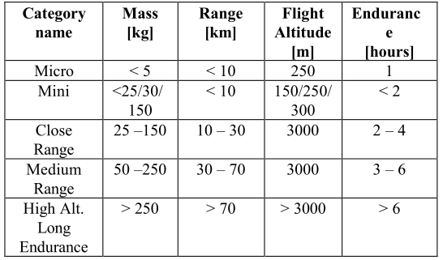

**Table 1-1: Extract of UAV categories defined by UVS- international. In the Mini UAV category the numbers depend on the scope of different countries.**

表1-1：提取无人机类中UVS国际化的定义。在Mini UAV类中的数字取决于不同国家的范围。

|  |  |  |  |  |
| --- | --- | --- | --- | --- |
| 类别  名称 | 重量  [kg] | 范围  [km] | 飞行高度  [m] | 续航时间  [h] |
| Micro | <5 | <10 | 250 | 1 |
| Mini | <25/30/150 | <10 | 150/250/300 | <2 |
| Close Range | 25-150 | 10-30 | 3000 | 2-4 |
| Medium Range | 50-250 | 30-70 | 3000 | 3-6 |
| Hight Alt. Long Endurance | >250 | >70 | >3000 | >6 |

The development of UAVs has been strongly motivated by military applications. After World War II, some nations were looking for aerial vehicles, which have the capability for surveillance, reconnaissance and penetration of hostile terrain without the deployment of human beings in areas of high risk. The technical requirements can be defined by autonomous tack-off, flying and landing (Eck, 2001).

在军事应用的推动下，无人机得到了迅猛的发展。二战结束后，有些国家寻找高空作业车，部署在没有人的高风险地区，它有能力监视、侦察和敌对地形渗透。技术要求方面，可以自动起飞、飞行和着陆（埃克，2001）。

Przybilla and Wester-Ebbinghaus 1979 did the first experiments with UAVs in photogrammetric applications. For image flights in a scale of 1:1000 or more, with a shutter speed of 1/1000 s, the velocity of the aeroplane was too high to get acceptable image motion. At that time, results were not sufficient because of the vibrations caused by the rotor which resulted in image motion. First tests accomplished using a model aeroplane by the company Hegi were flown (Figure 1-1). The aeroplane was 3 m long and had a wing span of 2.6 m. The plane could carry a payload of max 3 kg. Navigation equipment by Lindhof Technika was used to navigate the aeroplane. The system could determine the flying height from the size of the plane in the image viewer. The flights were done in a height of 150 m above the ground and with a velocity of 40 km/h. With this system, it was possible to acquire images of an archaeological area, architecture and building sites. Furthermore, the combination of terrestrial and aerial measurements was carried out. The application of this model aeroplane was limited by a small runway nearby the object, which was necessary. From this reason, the authors proposed to use less vibration-sensitive model helicopter.

Przybilla和Wester-Ebbinghaus 在1979年用无人机做的第一件实验是摄影测量应用。对于在比例为1：1000以上的成图飞行，快门速度在1/1000秒时，为了获得可接受的运动图像，飞机的速度必须很快的。在那个时候，结果是不足够的，因为振动导致运动图像产生转子。第一次测试是使用Hegi模型飞机完成该公司飞行的（图1-1）。飞机为3米长，具有2.6米的翼展。该飞机可以携带最多3公斤的有效载荷。导航设备通过用于导航飞机的Lindhof Technika。该系统可以从飞行高度在图像查看器上确定该平面大小。该飞行在高空完成高于地面150米并用40公里/小时的速度飞行。该系统中，有可能获得考古区、建筑和建筑工地的图像。此外，进行陆地和空中结合测量。从这一原因，作者提出对振动敏感少的直升机模型。

In 1980, Wester-Ebbinghaus used firstly a model helicopter for photogrammetric purposes. The helicopter was a Schlueter model Bell 222 with a maximum payload of 3 kg. Polystyrene walls for effective clamping suppresses were installed on the helicopter to compensate the vibrations. Medium format cameras like a Rolleiflex SLX or Hasselblad MK 20 could be mounted on the helicopter system. For flight operation, a pilot and a navigator were needed. The pilot controlled the take off, landing and flying. The navigator had to control the altitude and to activate the camera shutter via radio link. The helicopter had a height range from 10 m to 100 m and the predicted height could be kept within 90 %, using the same navigation equipment like the aeroplane model. The Schwebebahn (monorail) Wuppertal, a steel construction dating from 1890, was documented using the helicopter system (Wester- Ebbinghaus, 1980).

1980年，Wester-Ebbinghaus首先以摄影为目的使用模型直升机。这架直升机是最大有效载荷为3公斤的Schlueter model Bell 222。能有效夹紧机体并提供振动补偿的Polystyrene walls被安装在直升机上。像Rolleiflex SLX或Hasselblad MK 20可能在直升机系统中安装中等画质的相机。对于飞行操控，需要一个飞控手和一个导航员。飞控手控制直升机的起飞、着陆和飞行。领航员必须控制高度并经由无线电链路激活相机快门。直升机有10至100米的高度范围并且使用相同的导航设备类的飞机模型预测高度可保持在90％范围内。历史可以追溯到1890年的一个钢结构建筑Schwebebahn (monorail) Wuppertal，曾记载使用在直升机系统上（Wester- Ebbinghaus，1980年）。

The development of UAVs and the integration of GPS/INS data onboard of UAVs are more and more discussed in the UVS international community (UVS-international, 2004). The background and development of mini UAV helicopter systems are shown in Eck (2001), WITAS (2004) and Conway (1995).

无人机的发展，集成GPS / INS数据的车载无人机在UVS国际社会被越来越多的讨论（UVS-international，2004年）。该小型无人直升机系统背景和发展可在Eck（2001），WITAS（2004）和Conway（1995）上看到。

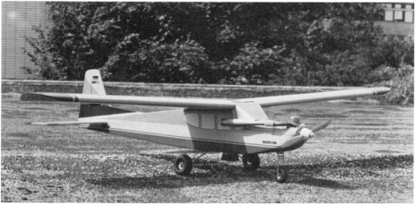

**Figure 1-1: Model airplane Firma Hegi, Przybilla 1979.**

图1-1：模型飞机Firma Hegi, Przybilla 1979.

## 1.3 Project Pinchango Alto

## 1.3 Pinchango Alto项目

The field measurements in Palpa (Peru) were done in cooperation with the German Institute of Archaeology, Commission for General and Comparative Archaeology (KAVA) in Bonn (Germany) as a part of the project network NTG which applies new technologies from the natural sciences inside the humanities.

在与德国考古研究所的合作下完成了帕尔帕实地测量（秘鲁），在德国波恩委员会秘书长和KAVA作为从自然科学到人文底蕴新技术的应用项目网络NTG的一部分。

Pinchango Alto is an old settlement area (200 m x 300 m), see Figure 1-2, from the 10 th to the 14 th century, which was presumably used as mine and processing facility by the ancient population. Rubbing stones and mica were found in the settlement area. Reindel (2002) proposed the function of Pichango Alto as gold mining settlement, but this hypothesis should be verified in future work.

Pinchango奥拓是一个古老的村落地区（200米×300米），见图1-2，从10世纪至14世纪，根据古代人口。这里大概是用作矿山和设施加工的地方。在这个村落地区发现了擦石和云母石。 Reindel（2002）作为黄金开采结算提出Pichango Alto方法，但这种假说应在今后的工作中得到验证。

In 2004, a field campaign of combined laser scanner measurements and a helicopter flight was done. The project planning, data processing and the results will be published later. The focus of this paper is on the planning of the UAV flights and the UAV system, which were done within this project network.

2004年，结合激光扫描仪和一个飞行直升机现场活动测量已完成。该项目的规划、数据处理和结果将在后面公布。本文的重点是在这个已完成的工作项目网络中的无人机规划飞行和无人机系统。

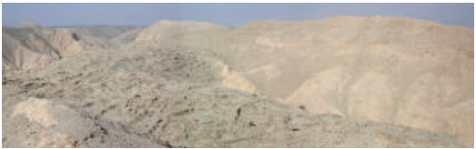

**Figure 1-2: Pinachngo Alto - overview of the settlement area.**

图1-2：Pinachngo Alto--村落地区概览

# 2. APPLICATIONS OF UAVS IN PHOTOGRAMMETRY

# 2．摄影测量在无人机中的应用

The main application of UAVs could be defined with observation, maintenance, surveillance, monitoring, remote sensing and security tasks.

无人机的主要应用可以被定义为观察、维修、监控、监测、远程传感和安全任务。

In the ISPRS commission V (2004-2008) Working Group 6, the autonomous vehicle navigation will be investigated. Nobody knows which systems already exist for photogrammetric applications, therefor a overview about recent projects will be displayed.

在ISPRS commission V（2004- 2008年）第6工作组中，将进行汽车自主导航调查。没有人知道哪些系统已经存在摄影应用程序，其关于最近项目的介绍将被展示。

In the last years, more and more applications of UAV-systems in photogrammetry became common. This development can be explained by the spreading of low cost combined GPS/INS- systems, which are necessary to navigate the helicopter with high precision to the predicted acquisition points. Some systems are used without GPS/INS-systems, especially for the capture of roofs for the combination with terrestrial measurements. For the applications using UAVs only and for the reduction of the number of control points, the GPS positioning should reach decimeter accuracy.

在过去几年中，UAV系统越来越多的应用在摄影上。这种发展可通过合并低成本传播的GPS / INS-系统解释，必须要高精度的预测采集点的直升机导航。一些系统被用于没有GPS/ INS系统，特别是对屋顶的采集与地面相结合测量。对于应用中只使用无人机和减少控制点的数目，GPS定位应达到分米级精度。

Zischinsky et al. (2000) used images taken from a model helicopter partly for the generation of a 3D-model of an historical mill. For the documentation of the building, 82 pictures were taken from the ground and additional 38 images from the helicopter to close the gaps in the model. The small format amateur camera mounted on the helicopter took mainly images of roofs and the courtyard. For the outer orientation of the model 120 control points were determined.

Zischinsky等在图像拍摄（2000年）中使用的模型直升机部分是一个具有历史的厂生产的3D模型。对于建筑物的文档，在模型中82张从地面拍摄的照片是和附加38的从直升机拍摄的图像的差距。安装在直升机的小格式业余相机主要对屋顶和庭院进行图像摄影。对于其他外方向，模型确定了120个控制点。

The Yamaha model helicopter is primarily developed and used for agriculture application, like insect pest control of rice paddies, soybeans and wheat. The first system, RCASS, was built in 1980. Later on, in 1990, the helicopter R50 had a payload of 20 kg and a laser-system for height determination. In the year 1997, the type RMAX came out and 3 years later it was equipped with an azimuth and differential GPS sensor system (Yamaha, 2004).

雅马哈模型直升机主要是开发和利用农业应用，如防治水稻、大豆和小麦病虫草害。第一系统RCASS建于1980年。后来，1990年，直升机R50有20公斤的有效载荷和一个确定高度的激光系统。1997年全年，该类型RMAX出来了，3年后，它装有方位传感器和带差分的GPS系统（雅马哈，2004）。

The RMAX UAV system from Yamaha was used as a ground truth measurement system (Hongoh, 2001). Ground truth measurement is used to determine the vegetation coverage. Therefore, the sensor takes images from different viewing angles, which is the most important aspect of bi-directional reflectance measurements.

来自雅马哈的RMAX无人机系统被用作地面真实测量系统（Hongoh，2001）。地面实况测量被用来确定植被覆盖。因此，该传感器需要从不同的图像角观看，这是双向反射测量最重要的方面。

In the same year a helicopter was used for Chinese fortress measurements. The Japan Miyatsuka Institute of Archaeology wanted to make high-resolution images of this huge fortress side (3 km x 4 km). Normally, foreigners are not allowed to use aeroplanes or helicopters to take aerial images in other countries. The remote controlled helicopter covers none of the both categories and for that reason the UAV-system was used with metric and non-metric cameras.

同年直升机被用于中国村寨测量。考古日本Miyatsuka研究所想在这个庞大的村寨（3公里×4公里）上拍摄高分辨率图像。通常情况下，外国人不准使用飞机或直升机采取其他国家航空影像。该遥控直升机没有覆盖的这两类，由于这个原因，使用了UAV系统公制和非公制摄像机。

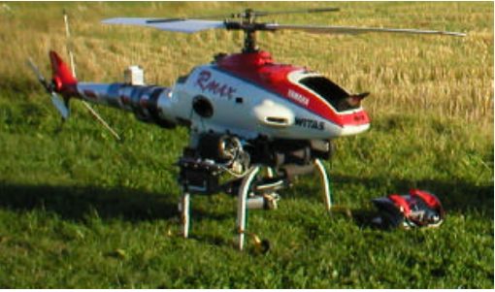

**Figure 2-1: WITAS Unmanned Area Vehicle –Yamaha RMAX Aero Robot.**

图2-1：WITAS无人机—Yamaha RMAX 航空机器人

In 2002, the Yamaha RMAX helicopter was used in photogrammetric flights over two tests sites in Sweden, to analyse the accuracy of the GPS/INS for the photogrammetric purposes with manual and autonomous flying modus. The results show that the stability of the camera mounting, the vibrations are caused by the main rotors and the GPS accuracy are the important parts of a UAV-helicopter (Eisenbeiss, 2002 & 2003). These flights were done in co-operation with WITAS –Wallenberg Laboratory for research on Information Technology and Autonomous Systems (Linköping University, Sweden) and the Institute of Photogrammetry and Remote Sensing (TU-Dresden).

2002年，雅马哈RMAX直升机在瑞典使用两个测试地点摄影飞行，有手动和自主飞行作案，以分析GPS / INS的摄影精度为目的。该结果表明，该相机的稳定安装、由主转子振动影响和GPS的精确度是无人机直升机的重要组成部分（艾森比斯，2002年＆2003）。这些飞行在WITAS-Wallenberg实验室信息研究技术和自治系统（林雪平大学，瑞典）和摄影测量与遥感传感学会（TU-德累斯顿）合作完成。

At the ISPRS congress 2004 in Istanbul two papers about UAV-helicopters and three about UAV-aircraft were published. The first is a system, which integrates laser scanner and CCD-cameras with GPS/INS data for constructing digital surface model. This system use a Subaru helicopter with a payload of 100 kg and diameter of the main rotor of 4.8 m. Similar helicopter systems before were classified by mini UAV system. This bigger helicopter is not covered by the micro to medium size UAVs because of the mass of 330 kg. But looking at the range and altitude, the helicopter can be defined as a mini or close range UAV. (Nagai, 2004)

在2004年ISPRS大会在伊斯坦布尔发表约两篇关于无人直升机的论文和三篇关于无人机的论文被出版。首先是一个集成了激光扫描仪和CCD摄像头与GPS / INS数据构建数字表面模型的系统。该系统使用具有100公斤载荷和4.8米直径的主转子的Subaru直升机。类似小型无人机分类系统中的直升机系统。因为330公斤的质量，这个更大的直升机是不包括微观到中等大小无人机的。但看在范围和高度，该直升机可以被定义为一个Mini或近距离无人机。（Nagai，2004年）

The second presented system is a mini UAV-helicopter, which was used as a photographic system for the acquisition of ancient towers and temple sites. The helicopter should replace high camera tripods and ladder trucks, which are uneconomical in cost and time. The helicopter Hirobo & Eagle 90 has a main rotor diameter of 1.8 m of the main rotor and a payload capability of 8.5 kg. The helicopter took images from the upper part of the temple from all sides. The images of the lower part were taken from the ground. The helicopter could carry different camera systems like miniature (35 mm), medium (6 cm x 4.5 cm) and panorama (6 cm x 12 cm) format cameras and video cameras. A gimbal was designed as a buffer that can absorb noises as well as vibrations. Onboard the system, a small video camera is installed too, which is connected to the ground station to transmit the images to a monitor in real time (Sik, 2004)

第二个提出的系统是一个小型无人直升机，这作为一个摄影系统用于拍摄古老的塔楼和寺庙遗址。直升机应该取代高相机三脚架和云梯车，在成本和时间这是不经济。直升机Hirobo & Eagle 90具有一个直径1.8米的主转子和一个有效载荷为8.5公斤的转子。这架直升机从上部分拍摄来自寺庙的各方面的图像。下部的图像从地面被采取。直升机可以携带不同的相机系统，如微型英寸（35 mm），中（6厘米×4.5厘米）和全景（6厘米×12厘米）画幅相机和摄像机。万向节作为一个缓冲区的目的是可以吸收噪音和振动。其板载系统、安装小视频摄像机，被连接到地面站将图像发送到实时监视器上（Sik，2004年）

The Chinese Academy of Surveying and Mapping develops a mini UAV-aircraft which is used to extract from one image and a 2D GIS database 3D models of buildings. Because of the wind it was difficult to control the vehicle-photographing pose and to take images on the predicted acquisition points. The developers had some problems to obtain stereo images (Wang, 2004).

中国的测绘科学研究院开发了一架可以从一个图像和一个二维GIS数据库提取建筑物3D模型的小型无人机。因为风，很难控制车辆拍摄姿势并采取预测的采集点的图像。该开发商在获得立体图像上遇到了一些问题（王，2004年）。

On the ISPRS congress 2004, also two papers were published about the Pegasus, which is a long endurance UAV system for remote sensing. These kind of systems have the capability to fly long time because solar energy is used as power supply. The system can carry a payload of about 300 kg (Everaerts, 2004).

2004年的ISPRS大会，也发表两篇关于Pegasus的论文，这是一个长时间续航的无人机遥感系统。以太阳能作为电源，这些类型的系统有能力飞很长一段时间。该系统可以携带约300千克的载荷（Everaerts，2004年）。

Some companies already use helicopters (Figure 2-2) with/ without GPS navigation for the production of aerial imagery of single buildings and cities or for documentation of industrial constructions (Helicam 2004, Pollak 2004).

一些公司已经使用带/没带GPS导航仪的直升机（图2-2）用于拍摄单体建筑和城市或工业结构的航空影像（Helicam 2004, Pollak 2004）。

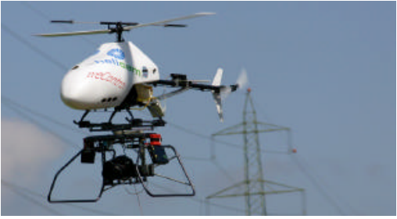

**Figure 2-2: UAV-helicopter by Helicam and weControl, Switzerland.**

图2-2：使用Helicam和weControl地面站的无人直升机，瑞士

The studies have shown that UAV-systems in photogrammetric applications are at the beginning, even though that the first applications have been accomplished at the end of the seventies of the last century. The potential of these systems, due to their capability to fly nearby the object from different positions and to combine aerial and terrestrial acquisitions, were already pointed out by Wester-Ebbinghaus in 1980. But the problems caused by vibrations of the UAV and the influence of wind and manual controlling of these systems limited their acceptance as photogrammetric measurement platform in the past. Nowadays, even with low cost GPS/INS– systems, UAVs can be navigated with decimetre accuracy and the orientation parameters can be used for navigation, post processing by reducing the number of control points.

该研究显示该UAV系统在摄影应用程序是刚开始的，即使在第一应用已经在上个世纪七十年代完成。由于他们飞附近的物体不同位置，空中和地面相结合的能力，这些系统的潜力由Wester-Ebbinghaus在1980年就已经指出。但在过去，UAV振动引起的问题、风的影响和手动控制这些系统限制其成为摄影测量平台。现在，即使以低成本的GPS / INS系统，无人机仍可以以分米级精度导航、取向参数可用于导航、减少控制点的数目来处理飞行轨迹。

In comparison with other mobile mapping systems, the RC- helicopters are not developed to cover large areas and for the use of photogrammetric film based cameras (23 cm x 23 cm). The unmanned helicopter can cover small areas and in particular, it could acquire images easily from all sides of complex buildings (Table 2-1). Also the project costs by the use of RC-helicopters are lower than by the use of aircraft or terrestrial equipment. More information about the state of the art of mobile mapping systems were published in Schwarz, et al. (2004).

与其他移动绘图系统相比，RC-直升机没有发展到覆盖大面积，使用基于摄影胶片相机（23厘米×23厘米）的程度。该无人直升机可以覆盖小的区域，特别是，它可以从四面八方轻松获取复杂建筑物的图像（表2-1）。这也是利用RC-直升机比使用飞机或更低地面设备花费少的原因。更多有关国家信息的移动测绘系统发表在Schwarz等人的论文里（2004）。

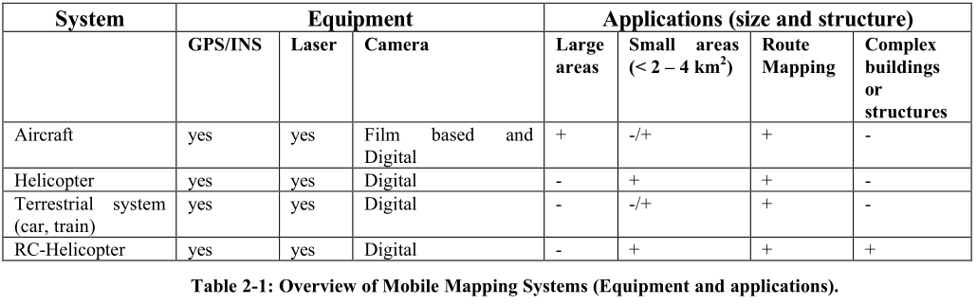

表2-1：移动绘图系统（设备和应用程序）的概述。

|  |  |  |  |  |  |  |  |
| --- | --- | --- | --- | --- | --- | --- | --- |
| 系统 | 设备 | | | 应用程序（大小和结构） | | | |
|  | GPS/INS | Laser | Camera | 大面积 | 小面积（<2-4平方米） | 路由映射 | 复杂房屋或结构 |
| 飞行器 | Yes | yes | 基于胶卷的数码相机 | + | -/+ | + | - |
| 直升机 | Yes | yes | 数码相机 | - | + | + | - |
| 地面系统（汽车，火车） | Yes | yes | 数码相机 | - | -/+ | + | - |
| RC-直升机 | Yes | yes | 数码相机 | - | + | + | + |

# 3. DESCRIPTION OF THE HELICOPTER SYSTEM

# 3.直升机系统说明

## 3.1 UAV Mini Helicopter System

## 3.1无人机迷你直升机系统

For the photogrammetric recording of Pinchango Alto, we decided to use an UAV-helicopter Copter 1B from Survey- Copter equipped with a GPS/INS stabilised system (Figure 3-1) and a ground control station by weControl.

对于Pinchango Alto的摄影记录，我们决定利用从Survey- Copter中配备有GPS / INS稳定系统无人直升机Copter 1B（图 3-1）和一个weControl地面控制站。

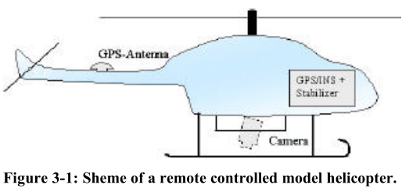

图 3-1：远程控制模型直升机的方案

Furthermore, for the flights it was necessary to have monitoring software, communication links, flight determination system, ground support and maintenance equipment, power generation, handling, storage and transport equipment and a video link for monitoring the image overlapping as a manual control. The last point was important, because it was not clear how accurate the predicted points (in and across flight direction) could be flown.

此外，对于飞行必须具有监控软件、通讯联系、飞行确定系统、地面支持和维护设备，电力生成、处理、储存和运输设备和作为手动控制的视频链接监控图像重叠。最后一点很重要，因为它不明确如何准确在预测点（在和通过整个飞行方向）飞行。

A flight planning system was developed such that the predefined points could be loaded into the controlling system and illustrated on a digital map in the control software viewer. The helicopter position and orientation is displayed in the map, too. Therefore, the operator is able to control its position and orientation (Figure 3-2).

飞行计划系统的开发使得预定点可以装入控制系统并且在控制软件的数字地图上示出。直升机的位置和方向显示在地图上。因此，操作者能够控制它的位置和方向（图3-2）。

With the controlling software, it is possible to load a flight mission. The stop points for the image acquisitions and the route can be defined and after that, the flying path will be automatically flown.

在控制软件下，可以装入一个飞行任务到飞机。停止点和图像采集路径可以被定义，飞行路径将自动飞行。

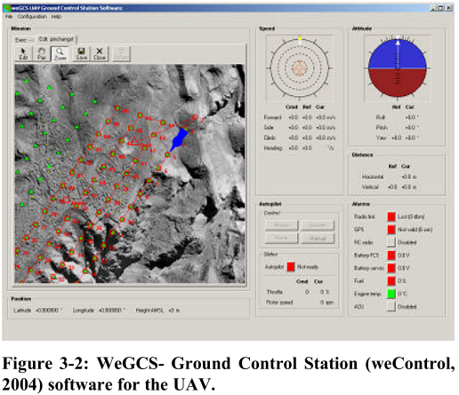

图3-2：用于无人机的WeGCS地面站（weControl，2014）软件

A pilot is only needed for starting and landing in dangerous areas like Pinchango Alto and for the support of the UAV. After take off, the operator controls the functionality of the UAV-system through the check buttons (position, heading, radio link, GPS, RC radio, battery). If the predicted point is not correctly reached, the operator can correct the position, the altitude and the yaw angle of the helicopter through commands on the laptop.

像Pinchango Alto支持的无人机，只需要飞控手在危险的领域起飞和降落。起飞后，操作者通过检查按钮控制无人机系统的功能（位置，航向，无线链路，GPS，无线电遥控，电池）。如果预测的点不能够正确地达到，操作人员在笔记本电脑可以通过命令记录正确的位置、高度和直升机的偏航角。

The maximum possible distance between the ground control station and the helicopter is 1000m in horizontal direction and the maximum flying altitude is 300 m. For safety reasons, the pilot and the operator must see the helicopter The payload capability of the UAV-helicopter is 8 kg at this time.

在水平方向，地面控制站和直升机之间的最大距离为1000米，最大飞行高度为300米。为安全起见，该飞控手和操作员必须看到直升机。在这个时候，无人直升机的有效载荷能力是8公斤。

## 3.2 Camera System

## 3.2相机系统

We decided to use a Canon D60, D10 and a Rollei 6006 for the image acquisition. The Canon D10/D60 has a CMOS-Sensor with 6.3 Mpixel (3072 x 2048). The camera has also a possibility to save the image with a radiometric resolution of 48 Bit (16 Bit per channel) in RAW-format. Because of their high radiometric resolution and the short time for image saving due to the CMOS-sensor technique, the Canon cameras were available. To reduce the height of the helicopter a lens with a focal length of 14.26 mm was selected to get the required image scale.

我们决定使用佳能D60、D10、Rollei 6006进行图像采集。佳能D10/ D60拥有6.3兆像素（3072×2048）CMOS传感器。摄像头能一次性保存分辨率为48位（每通道16位）的RAW格式图像。由于佳能相机的CMOS传感器技术图像可以以高辐射分辨率和短时间进行保存。为了降低直升机的高度 选择焦距为14.26毫米的镜头，以获得所需的图像比例。

The camera system could also be replaced with other digital cameras or medium size analog cameras like Rollei 6006 (Image format 6 cm x 6 cm). For the controlling of sufficient image overlapping, a video camera was installed, which covers the same area like the digital cameras. This video signal was transmitted to the ground control station and displayed on monitor or video glasses.

照相机系统也可以替换为与其他的数字相机或中等大小一样的模拟摄像机Rollei 6006（图像格式6厘米×6厘米）。为了充分控制图像重叠覆盖，在同一地区安装摄像机，如数码相机等。该视频信号传送到地面控制站并显示在显示器或视频眼镜上。

Due to problems with the forwarding agency we had only two days left for image acquisition in Peru. Therefore, we decided to take images with digital cameras only.

由于与货运代理的问题，我们只有两天在秘鲁进行图像采集。因此，我们决定只用数码相机拍摄影像。

# 4. FLIGHT PLANNING AND FIRST RESULTS FROM THE FLIGHTS

# 4飞行计划和飞行的第一成果

Before the flights in Peru, some tests were necessary in order to check the system. The UAV-system from Helicam was already used for photo flights in Switzerland, but has never been applied before for photogrammetric flights with a predefined flight path.

在秘鲁飞行之前，用一些测试来检查系统是必要的。在瑞士的Helicam无人机系统已经用于航拍飞行，但预定的飞行路线之前从来没有被用于摄影飞行。

The tests in Switzerland showed that the used camera platform was not sufficient for our purposes, because vibrations were not absorbed and the camera could not be aligned straight to the ground. Furthermore, some problems with engine and gas occured. For Peru, a new platform was built in the way that the camera is directed straight down and the vibrations are reduced to a minimum. The engine and the petrol were changed too.

瑞士的试验表明，对我们来说使用摄像机平台不足以完成任务的，因为不被吸收的震动和相机无法准直对准地面。此外，发动机和气体发生一些问题。对于秘鲁，该照相机直下定向和振动被减小到最低限度的方式建成一个新的平台。发动机和汽油也进行过修改。

The test flights showed also, that in the manual mode it is not possible to keep the predefined waypoints. Therefore, all flights were done autonomous, barred from take off and landing. The pilot controlled these manoeuvres.

试飞也显示，在手动模式下是不能够保持预定的航点。因此，从起飞到降落所有飞行都是自动化的。飞控手控制这些演习。

For the area of Pinchango Alto, an image scale of 1:4000 for the digital images was selected. With the fixed image scale and focal length, the flying height was defined to 56 m above ground. The area of interest was located using an orthophoto (Figure 4-1), which was produced from aerial images with a scale 1:7000 (Gruen et al., 2000). We defined as two areas of interest, due to the lack of time it was impossible to aquire “everything”. The area with the best-preserved walls got the priority one (Figure 4-1, blue frame) and the whole settlement (Figure 4-1, red frame) priority two for the image acquisition.

对于Pinchango Alto的面积，图像的规模被定为为1：4000 数字图像。根据固定的图像规模和焦距，飞行高度规定在距地面56米以上。用一种正射影像位于信息区域（图4-1），将其按1：7000比例从航拍照片中制作（格鲁恩等，2000）。由于缺少时间是不可能得到 “一切”的，我们定义为两个信息区域。得到了最好的保存完好的墙壁的面积，这是最高优先级的（图4-1，蓝框）和优先两个用于图像采集整个村落 （图4-1，红框）。

Due to the slop terrain in the area, the absolute flying heights were defined using the orthoimage and an elevation model (DTM generated from the aerial imagery). With the image format of 15 by 22 m on the ground and the image overlapping along and across track of 75 percent, the acquisition points were calculated. All formulas can be found in Warner et al. (1995). All points were set up as stop points. The maximum speed between the points was set to 2 m/s.

由于在该区域的污水地形，绝对浮动高度使用垂直图像和高程模型定义（DTM从航拍图像生成）。通过距地面22米高的15张图像和沿着越过轨道的75%与图像重叠，并按控制点进行了计算。所有的公式可以在Warner等人中找到（1995年）。所有的点都设置为停止点。点之间的最大速度被设定为2米/秒。

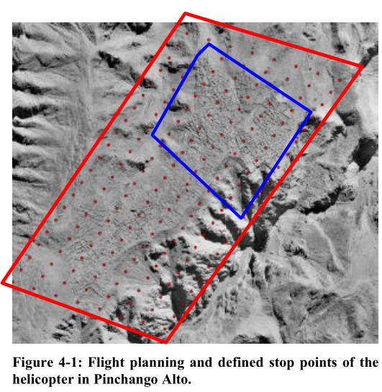

图 4-1：飞行计划和在Pinchango Alto设置的停止点

With the used UAV-helicopter system, we could cover 90 percent of the whole area with only 5 image strips and around 100 images. The 3D position of the projection centres could be achieved with an accuracy of 2 to 5 percent of the predicted position. In Figure 4-2 the UAV-helicopter over the settlement in Pinchango Alto is shown.

随着无人直升机系统的使用，我们只用5拍摄航线和100张周围图像就可以覆盖整个区域的90%。投影中心的三维位置可能是精确度达到所预测的为2%到5%的位置。如图4-2中所示，在Pinchango Alto，无人直升机飞过这个村落。

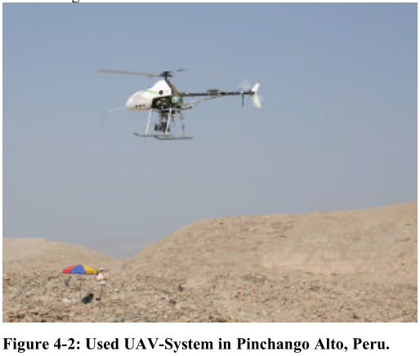

图 4-2：在秘鲁Pinchngo Alto中使用的无人机系统

Using the acquired images, we will produce a DTM, an orthoimage from the whole settlement and derivates (Figure 4-3).

使用所获取的图像，我们将产生一个包含整体村落和衍生物的正射影像图（图 4-3）。

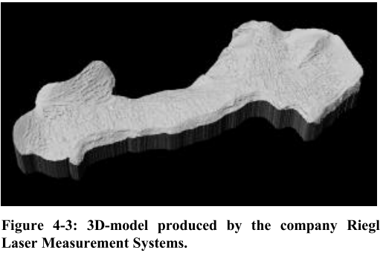

图 4-3：Riegl 公司激光测量系统产生的3D模型

# 5. CONCLUSIONS AND FUTURE WORK

# 5.结论和未来的工作

Within the project Pinchango Alto we did the first photogrammetric flight over an ancient settlement in Peru using an UAV-mini-helicopter system, which is equipped with a GPS/INS-sensor and a stabiliser. The flight planning and measurements have shown that this UAV-system offers great advantages in cultural heritage recording compared to traditional methods. The RC-helicopter is easy to handle and can fly the predicted flight path even when a light wind is influencing the helicopter. The results also show, that we have to handle the engine problems. The helicopter should have the capability to fly longer than 15 minutes, which requires a bigger tank. The engine power should also be increased, so that the helicopter has the capability to carry a higher payload.

在Pinchango Alto项目中我们是第一个在秘鲁的一个古老的村落使用无人机小型直升机系统摄影飞行，其配备一个GPS/ INS传感器和稳定装置。该飞行计划和测量表明，该无人机系统在文化遗产中相比传统的录制方法提供了巨大的的优势。该RC-直升机易于操作，即使在微风影响直升机飞行轨迹的情况下也能预测飞行。结果还表明，我们必须要处理引擎问题。直升机需要一个更大的油箱来使飞行时间超过15分钟。发动机的动力也应增加，从而使直升机具有一个更高的携带有效载荷的能力。

In comparison with other described UAV photogrammetric projects, this helicopter can be used without terrestrial imagery. Because of the stability of the helicopter in air, no problems with image overlapping occurred. Until now, the post processing takes still the same time as the ordinary photogrammetric flights, because of the low accuracy of the GPS/INS-system. In the future we will increase the accuracy and reduce the processing time.

与其他描述无人机摄影项目比较，该直升机可以在没有地面影像中使用。因为空气中的直升机的稳定性，图像重叠的问题不会发生。到现在为止，由于低精度的GPS / INS系统，处理花费的时间仍然和普通摄影飞行的时间一样。今后，我们将提高准确率和减少处理时间。

With the data in Pinchango Alto, we plan to produce a 3D- model, which we will compare with the results of laser scanning. We will generate maps of the settlement and produce a virtual 3D-model from both data sets.

使用Pinchango Alto的数据，我们计划生产3D模型，将用激光扫描比较结果。我们将从两个数据集中生成村落的地图和构建虚拟3D模型。

Recently, UAV-helicopters in photogrammetry have shown the capability for mobile mapping in close range applications. The main problem of a mini model helicopter is still the vibration of the system, the payload capability and the integration of all sensors.

近日，摄影无人直升机展示出在近距离应用中的移动映射能力。该迷你模型直升机在系统中的主要问题仍是震动、有效载荷能力和所有传感器的集成。

# 6. ACKNOWLEDGEMENTS

# 6.致谢

The author thanks Prof. A. Gruen who gave us the opportunity to realise the laser scanner and model helicopter project in Pinchango Alto, Peru. The author also wants to thank Karsten Lambers and Martin Sauerbier (IGP- ETH Zurich), who supported the planning and realisation of the laser and helicopter measurements in Pinchango Alto. Furthermore, the author is very grateful for the project funding by the NTG project network.

在秘鲁的Pinchango Alto项目中，作者感谢A. Gruen教授给了我们机会实现了激光扫描仪和模型直升机项目。作者也想感谢Karsten Lambers和Martin Sauerbier（IGP-苏黎世联邦理工学院），在Pinchango Alto项目中他们支持激光的规划与实现和直升机测量。此外，作者非常感谢由NTG项目网络提供的项目资金。