Learning Generalizable REST API Test Oracles via Supervised Fine-Tuning of Small Language Models



Haris Umar
09-241251-005
A thesis submitted in fulfillment of the
Requirements for the award of the degree of
Master of Science (Software Engineering)
Department of Software Engineering
BAHRIA UNIVERSITY ISLAMABAD
August 2026

APPROVAL FOR EXAMINATION

Scholar's Name: Haris Umar, Registration No: 09-241251-005
Program of Study: MS (Software Engineering)
Thesis Title: Learning Generalizable REST API Test Oracles via Supervised Fine-Tuning of Small Language Models
This is to certify that the above scholar's thesis has been completed to my satisfaction and, to my belief, its standard is appropriate for submission for examination. I have also conducted a plagiarism test of this thesis using HEC-prescribed software and found a similarity index within the permissible limit set by the HEC for the MS degree thesis. I have also found the thesis in a format recognized by the BU for the MS thesis.
Principal Supervisor's Signature: ______________________________
Date: ______________________
Name: Dr. Tamim Ahmed Khan

AUTHOR'S DECLARATION
I, Haris Umar hereby state that my MS thesis titled "Learning Generalizable REST API Test Oracles via Supervised Fine-Tuning of Small Language Models" is my own work and has not been submitted previously by me for taking any degree from this university Bahria University Islamabad or anywhere else in the country/world.
At any time if my statement is found to be incorrect even after my graduation, the University has the right to withdraw/cancel my MS degree.
Name of scholar: Haris Umar (09-241251-005)
Date: ______________________

PLAGIARISM UNDERTAKING
I, Haris Umar, solemnly declare that the research work presented in the thesis titled "Learning Generalizable REST API Test Oracles via Supervised Fine-Tuning of Small Language Models" is solely my research work with no significant contribution from any other person. Small contribution/help wherever taken has been duly acknowledged and that the complete thesis has been written by me.
I understand the zero-tolerance policy of the HEC and Bahria University towards plagiarism. Therefore, as an Author of the above-titled thesis, I declare that no portion of my thesis has been plagiarized and any material used as reference is properly referred to/cited.
I undertake that if I am found guilty of any formal plagiarism in the above-titled thesis even after the award of my MS degree, the university reserves the right to withdraw/revoke my MS degree and that HEC and the University have the right to publish my name on the HEC/University website on which names of scholars are placed who submitted a plagiarized thesis.
Scholar / Author's Signature: ______________________________
Name of the Scholar: Haris Umar (09-241251-005)

DEDICATION
To my brother and supervisor, whose patience and support made this work possible.

ACKNOWLEDGEMENT
With my deepest gratitude to Allah Almighty, I would like to begin this acknowledgement. I extend my sincere appreciation to my thesis supervisor, Dr. Tamim Ahmed Khan, for his valuable guidance, patience, and mentorship throughout the course of this research. His feedback shaped not only the direction of this work but also the way I approach research problems.
I would also like to thank my family for their continued support and encouragement, which remained a constant source of motivation throughout this journey.

ABSTRACT
REST APIs are widely used to connect software systems, and testing whether an API's response is actually correct remains a labor-intensive task, typically requiring either hand-written assertions or access to the API's formal specification (an OpenAPI document) at the moment of judgment. This thesis investigates whether a small, low-cost language model can be fine-tuned to act as a test oracle for REST API responses — judging correctness and identifying the type of violation present — without requiring access to the specification at inference time, and whether such a model can generalize this judgment to APIs unseen during training. To answer this, a complete, reusable dataset-construction pipeline was designed and implemented, covering collection of real API responses, controlled mutation of those responses into six categories of labeled violations, quality review, and export into a supervised fine-tuning format. The pipeline was applied to eight training APIs and three held-out APIs kept out of training entirely, yielding a balanced dataset of 2,072 labeled records. A Llama-3-8B-Instruct model was fine-tuned using QLoRA on a single consumer-grade GPU and evaluated against both its own untrained baseline and a large general-purpose reference model (Claude), using the held-out APIs exclusively for final evaluation.
Two evaluation conditions were tested. Without the specification shown at inference time, fine-tuning produced a modest overall improvement (F1 0.410 → 0.442), with measurable gains concentrated in two of seven violation categories — enum and constraint violations. When the model was instead shown only the relevant field's specification snippet at inference time, fine-tuning produced a substantially larger improvement (F1 0.442 → 0.724 relative to the no-spec fine-tuned result), with gains observed across six of seven categories. This second experiment demonstrates that the model's limited generalization without a specification is attributable, in large part, to the genuine difficulty of inferring API-specific business rules from response patterns alone — a limitation that is not unique to small models, as the same evaluation shows the large reference model also performs poorly at recognizing genuinely correct responses.
This thesis contributes: (1) a validated, reusable dataset-construction pipeline for REST API test oracle training data; (2) a balanced, quality-audited dataset spanning eleven real-world APIs; (3) an empirical characterization of which categories of API response violations a small fine-tuned model can and cannot learn to detect without spec access; and (4) evidence that fine-tuning improves not only raw judgment but also the model's ability to make effective use of a specification when one is available.

TABLE OF CONTENTS
APPROVAL FOR EXAMINATION 2
AUTHOR'S DECLARATION 3
PLAGIARISM UNDERTAKING 4
DEDICATION 5
ACKNOWLEDGEMENT 6
ABSTRACT 7
TABLE OF CONTENTS 9
LIST OF TABLES 11
LIST OF FIGURES 12
CHAPTER 1 INTRODUCTION 13
1.1 Motivation 14
1.2 Research Gap 15
1.3 Problem Statement 16
1.4 Research Questions 17
1.5 Research Objectives 17
1.6 Thesis Outline 18
CHAPTER 2 LITERATURE REVIEW 19
2.1 Introduction 19
2.2 The Test Oracle Problem 19
2.3 REST API Testing Tools and Techniques 19
2.4 Mutation-Based Construction of Labeled Test Data 21
2.5 Parameter-Efficient Fine-Tuning: LoRA and QLoRA 22
2.6 Open-Source Base Models for Fine-Tuning 23
2.7 Fine-Tuning Small Models for Classification and Software Engineering Tasks 24
2.7.1 Sentiment and General Text Classification 24
2.7.2 Software Engineering Task Automation 24
2.7.3 Vulnerability Detection 25
2.7.4 Hyperparameter Sensitivity 26
2.7.5 Summary Comparison 27
2.8 Language Models Applied to REST API Testing 29
2.9 Prompt Design and Evaluation Methodology 32
2.9.1 Prompt Design 32
2.9.2 Evaluation Metrics 33
CHAPTER 3 RESEARCH METHODOLOGY 35
3.1 Overview 35
3.2 Proposed Approach 35
3.3 Dataset Construction Pipeline 37
3.3.1 Step 1 — Source API Selection 38
3.3.2 Step 2 — Specification Authoring 39
3.3.3 Step 3 — Response Collection 40
3.3.4 Step 4 — Controlled Mutation 40
3.3.5 Step 5 — Review and Quality Audit 43
3.3.6 Data Quality Issues Identified and Resolved 43
3.3.7 Step 6 — Export 43
3.4 Final Dataset Composition 44
3.5 Fine-Tuning Methodology 46
3.5.1 Configuration Selection Process 47
3.5.2 Base Model Selection 48
3.5.3 LoRA Rank, Alpha, and Dropout 49
3.5.4 Training Duration, Learning Rate, and Batch Size 49
3.5.5 Response-Only Loss Masking 51
3.5.6 The QLoRA Training Procedure 53
3.6 Evaluation Methodology 54
3.7 Second Evaluation Condition: Specification-Augmented Inference 55
CHAPTER 4 RESULTS AND DISCUSSION 58
4.1 Results Without Specification Access 58
4.2 Per-Category Results Without Specification (RQ4) 59
4.3 Error Analysis 61
4.4 Results With Specification Shown (Relevant Field Only) 63
4.5 Comparing the Two Conditions 66
4.6 Why the Reference Model's Advantage Is Not Uniform 67
4.7 Threats to Validity 68
4.7.1 Internal Validity 68
4.7.2 Construct Validity 69
4.7.3 External Validity 69
4.7.4 Conclusion Validity 70
CHAPTER 5 CONCLUSION AND FUTURE WORK 71
5.1 Conclusion 71
5.2 Future Work 72
REFERENCES 73
APPENDIX A: SAMPLE TRAINING RECORD 74
APPENDIX B: SAMPLE WITH-SPECIFICATION RECORD 75
APPENDIX C: COMPLETE TRAINING API LIST 76

LIST OF TABLES
TABLE NO. | TITLE | PAGE
2.1 | Summary of machine learning and NLP approaches in software engineering | 23
2.2 | Comparison of language-model approaches to REST API testing | 24
3.1 | Training APIs | 28
3.2 | Test APIs (not used in training) | 28
3.3 | The six mutation operators | 29
3.4 | Data quality issues identified and resolved during construction | 30
3.5 | Dataset split summary | 30
3.6 | Per-category record counts across all splits | 31
3.7 | Final QLoRA fine-tuning configuration | 31
4.1 | Main results, no specification shown (test set, unseen APIs) | 35
4.2 | Per-category F1, no specification shown | 36
4.3 | Main results, relevant-field specification shown (test set, unseen APIs) | 38
4.4 | Per-category F1, relevant-field specification shown | 38
C.1 | Complete list of training APIs and record counts | 44

LIST OF FIGURES
FIGURE NO. | TITLE | PAGE
2.1 | Conceptual overview of the test oracle problem in REST API testing | 20
3.1 | The six-step dataset construction pipeline | 27
3.2 | Training-pool category distribution (n = 1,846) | 31
3.3 | Training loss and validation loss curves across one epoch | 32
3.4 | Token masking scheme applied during response-only loss masking | 33
4.1 | Confusion matrices, no specification shown | 35
4.2 | Per-category F1 comparison, no specification shown | 36
4.3 | Confusion matrices, relevant-field specification shown | 38
4.4 | Per-category F1 comparison, relevant-field specification shown | 39
4.5 | Effect of showing the relevant specification field, fine-tuned model | 39

INTRODUCTION
Software systems today are increasingly built as collections of services that communicate through REST APIs over HTTP. A REST API defines a contract between a service provider and its consumers: given a specific request, the response must conform to an agreed structure, data types, and value constraints. When a REST API response violates this contract — returning a field of the wrong type, omitting a required field, or including a value outside the declared range — downstream systems that consume that response may fail in ways that are difficult to diagnose and expensive to fix after deployment [1].
Verifying that an API response conforms to its contract is therefore an important part of software quality assurance, but it remains a largely manual or specification-dependent activity. Existing automated approaches rely on the API's OpenAPI specification being available, accurate, and provided at the moment of testing. This dependency is a real limitation in practice: API specifications are frequently outdated, incomplete, or entirely absent [2], particularly in rapidly evolving systems where the code and its documentation drift apart over time.
Recent advances in large language models have raised the possibility of a different approach: training a model to recognize whether an API response looks correct or broken, based on patterns learned from labeled examples, without requiring the specification to be present at the moment of judgment. If a small, locally-runnable model could learn this judgment reliably and generalize it to APIs it has never seen during training, it would provide a practical, lightweight complement to existing contract testing tools [3] — one that operates even when a maintained specification is unavailable.
This thesis investigates that possibility. We design and implement a systematic pipeline for constructing labeled training data through controlled, specification-derived mutation of real API responses, fine-tune a small open-weight language model using parameter-efficient methods, and evaluate the resulting model's ability to judge REST API responses correctly on APIs held out entirely from training — under both a without-specification and a with-specification inference condition.

Motivation
Modern software systems are built as networks of REST APIs that exchange structured data over HTTP. Verifying that an API's response is actually correct — not merely that a request succeeded — is a persistent, labor-intensive part of software testing [1]. A response can return a successful HTTP status code and still violate the API's contract in subtle ways: a field may hold the wrong data type, a required field may be silently missing, a value may fall outside an allowed range, or an undeclared field may leak internal implementation details.
The conventional way to detect such violations is contract testing against the API's OpenAPI specification [4] — a machine-readable document describing every endpoint's expected request and response shape. This works well when a specification is available, accurate, and provided at the moment of testing. However, requiring the specification at test time is itself a limitation: it means an automated checker is inapplicable to an API whose specification is unavailable, outdated, or undocumented, which is common in real industrial settings [2].
Large general-purpose language models have shown an ability to reason about structured data without explicit rules [5]. This raises a natural question: could a language model learn to recognize a broken API response the way an experienced engineer does — by pattern, not by rule lookup — and could a small, inexpensive model learn to do this well enough to be useful, without needing the specification at the moment of judgment?
The significance of this problem extends beyond academic interest. REST APIs serve as the integration backbone of modern enterprise software, mobile applications, and cloud services; a response-body violation that goes undetected in a testing pipeline can propagate silently into production, causing data corruption, security exposures, or service failures that are considerably more expensive to diagnose after deployment than before it. Automated response-level checking, if it can be made to work without requiring a maintained specification, therefore has direct practical value in continuous integration pipelines where maintaining accurate API specifications alongside rapidly evolving code is itself a challenge many teams struggle to sustain.

Research Gap
Existing work on REST API response verification has largely followed two separate directions. The first is specification-driven contract testing: tools such as RESTler [3] and EvoMaster [6] generate and execute test requests guided by the OpenAPI specification, but require that specification to be accurate and available at test time, and cannot judge responses from an API lacking one. The second direction is the use of large, general-purpose language models as ad hoc judges of response correctness; such models have shown a general capacity for structured judgment [5]. But this capacity has yet to be systematically evaluated for how well it distinguishes genuinely correct responses from genuine violations, rather than defaulting toward one verdict -- a bias documented in recent audits of LLM-based judging systems in software engineering contexts [7].
Several more specific lines of work sit closer to this thesis's aim but each stops short of it. RESTler's own oracle checking is explicitly limited to detecting server crashes and specification-declared error codes [3], leaving response-body-level contract violations largely unchecked. Zhang and Arcuri [8] find that no single existing fuzzing tool dominates across tested services, underscoring that tool-level progress has yet to translate into a general-purpose response oracle. Golmohammadi, Zhang and Arcuri [1] similarly note that oracle strategies remain among the least mature aspects of REST API test automation. Kim, Sinha and Orso [9] demonstrate that a small, fine-tuned language model can perform competitively against much larger models on a REST-API-testing-related task, but their model is fine-tuned to generate realistic test input values, not to judge whether an already-received response is correct. Barradas, Paes and Neves [10] and Moradi, Yan, Colwell and Asgari [11] similarly apply language models to test specification and test case generation respectively, rather than to response-level judgment. Han and Zhu [12] present a multi-agent system spanning the full REST API testing workflow, including response analysis, but rely on large, general-purpose models (GPT-4o, DeepSeek V3.1) at every stage rather than a small, locally fine-tuned model. Chu, Feng, Liu, Guo, Zhang, Shi, Nan and Xu [13] explicitly identify test oracle generation as an open sub-problem within LLM-based testing research more broadly, without resolving the specific question of spec-free judgment addressed here. Degiovanni and Papadakis [14] use a pre-trained language model to generate more realistic mutants for evaluating existing test suites -- a related but distinct use of language models within the mutation testing process, rather than to generate labeled data for training a response-judgment model.
It is pertinent to note that Barr, Harman, McMinn, Shahbaz and Yoo [15] categorize established oracle automation strategies as specified, derived, or implicit; a model trained to judge without specification access at inference time does not map cleanly onto any of these three categories, since its judgment is neither a direct specification lookup nor a naive crash detector, but a learned approximation of specification-consistent behavior. Whether such a learned approximation holds equally well across different categories of violation -- a wrong data type, a missing field, an out-of-range value, an unexpected extra field -- or whether it holds only for some categories and not others, remains uncharacterized, and studies of LoRA-based fine-tuning for related tasks report that downstream performance is highly sensitive to hyperparameter choices, task framing, and training data diversity, rather than following a single uniform pattern across all target categories.
Therefore, there is a need to investigate whether a small, fine-tuned language model can be trained specifically for REST API response judgment without specification access at inference time, using systematically generated, spec-derived labeled examples rather than ad hoc prompting of a general-purpose model, and to characterize empirically which categories of violation such training generalizes to and which it does not.

Problem Statement
Most approaches to automated REST API testing rely on the API's OpenAPI specification being available, accurate, and provided at the moment of testing, and existing uses of large language models as ad hoc response judges rely on a general-purpose model accessed at inference time rather than a model trained specifically for this task. Constructing labeled training data for such a task-specific model requires deliberately generating both correct and incorrect API responses across multiple categories of violation, a process for which no established, validated methodology currently exists. It remains unknown whether a small, fine-tuned language model can learn to judge REST API response correctness without specification access at inference time, whether such judgment generalizes to APIs unseen during training, and whether this capability holds uniformly across different categories of violation or only for some. We need to investigate how such a dataset can be systematically constructed and validated, and how a small fine-tuned model's judgment performance compares, category by category, against both an untrained baseline and a large general-purpose reference model.
We provide a six-step dataset construction pipeline that collects real API responses and generates labeled violations through controlled, specification-derived mutation, fine-tune a small language model using QLoRA on the resulting dataset, and use a three-way comparison against an untrained baseline and a large reference model, evaluated on held-out unseen APIs, to discuss results.

Research Questions
- RQ1: How can a labeled dataset of REST API response violations be constructed systematically and validated for quality, across multiple real-world APIs?
- RQ2: Can a small language model, fine-tuned on such a dataset, judge REST API response correctness without access to the specification at inference time?
- RQ3: Does this judgment generalize to APIs that were held out from the training data?
- RQ4: Which categories of response violation generalize well to unseen APIs, and which do not, and why?

Research Objectives
- To design and implement a reusable pipeline for collecting real API responses and generating labeled violation data through controlled, spec-driven mutation.
- To construct a balanced, quality-audited training dataset spanning multiple real-world APIs, with a held-out set of APIs reserved from training for genuine generalization testing.
- To fine-tune a small language model (Llama-3-8B-Instruct) using parameter-efficient fine-tuning (QLoRA) on this dataset.
- To evaluate the fine-tuned model against its own untrained baseline and a large general-purpose reference model, on held-out, unseen APIs.
- To determine empirically which categories of violation benefit from fine-tuning and which do not, and to characterize the effect of specification availability on model performance.

Thesis Outline
The structure of this thesis is given as follows:
- Chapter 2 discusses the background and related literature on REST API testing, test oracle automation, mutation-based fault injection, and parameter-efficient fine-tuning of small language models.
- In Chapter 3, the dataset construction pipeline is explained. The six-step process of source selection, specification authoring, response collection, controlled mutation, quality review, and export is described in full, along with the QLoRA fine-tuning configuration and the evaluation design.
- Chapter 4 of this study presents the evaluation results. Results of both the without-specification and with-specification evaluation conditions are reported, and a three-way comparison of the fine-tuned model against the untrained baseline and the large reference model is discussed category by category.
- Chapter 5 discusses the conclusion and future work.

LITERATURE REVIEW

Introduction
This chapter reviews prior work across the areas this thesis draws on: the test oracle problem, REST API testing tools and techniques, mutation-based approaches to generating labeled test data, parameter-efficient fine-tuning of language models, the open-source base models available for such fine-tuning, prior applications of language models to REST API testing specifically, and the use of language models as evaluators (“LLM-as-a-judge”). Each section identifies what has been established and how it relates to the specific gap this thesis addresses.

The Test Oracle Problem
Barr, Harman, McMinn, Shahbaz and Yoo [15] define and survey the “test oracle problem”: given an input and an observed output, the challenge of automatically determining whether that output is correct. Their survey identifies several established oracle automation strategies — specified oracles derived from formal models, derived oracles inferred from related artifacts, and implicit oracles that detect obviously anomalous behavior such as crashes — and notes that, absent one of these, the burden falls back on a human judge. This framing is directly relevant here: a REST API response oracle that must operate without the API's specification at inference time sits outside the “specified oracle” category the survey describes, since the very information a specified oracle relies on is deliberately withheld.
Khan, Runge and Heckel [16] address a related but distinct problem: using visual contracts — graph-transformation-based behavioral specifications — as a test oracle for validating the behavior of a system under test. Their approach demonstrates that a formal contract can serve as an automatically checkable oracle without requiring a full reference implementation. The present work adopts a similar underlying principle — a specification-derived contract determines correctness — but differs in that the contract (the OpenAPI specification, in this case) is used only to generate labeled training data, not consulted at the moment of judgment.

REST API Testing Tools and Techniques
A substantial body of work automates the generation of test inputs for REST APIs using the OpenAPI specification as a guide. Atlidakis, Godefroid and Polishchuk [3] present RESTler, a stateful fuzzing tool that infers producer-consumer dependencies between API operations from the specification and uses them to generate longer, more effective test sequences; oracle checking in RESTler is limited to detecting server crashes and specification-declared error codes. Arcuri [6] presents EvoMaster, a white-box, search-based test generation tool that uses an evolutionary algorithm guided by code coverage to generate REST API test cases, reporting 80 real faults found across five open-source services. Golmohammadi, Zhang and Arcuri [1] provide a comprehensive survey of REST API testing research, cataloging the input generation strategies, oracle strategies, and evaluation practices used across the field, and Zhang and Arcuri [8] specifically compare the practical effectiveness of several fuzzing tools (including RESTler and EvoMaster) against one another, finding no single tool dominates across all tested services.
Baniaș, Florea, Gyalai and Curiac [4] similarly survey specification-based REST API testing, emphasizing that the completeness and accuracy of the OpenAPI document is a precondition for these tools' effectiveness — a limitation this thesis's approach is specifically designed to avoid depending on at inference time. More recent work has begun exploring alternatives to pure specification-driven generation: Ribeiro, Mamede and Ferreira [2] combine model checking with executable contracts to strengthen REST API testing beyond what specification parsing alone provides, and Corradini, Zampieri, Pasqua and Ceccato [17] present DeepREST, which uses deep reinforcement learning to discover API constraints not explicitly stated in the specification. Both lines of work implicitly acknowledge the same limitation motivating this thesis: that a specification, even when present, is often an incomplete description of an API's true behavior.

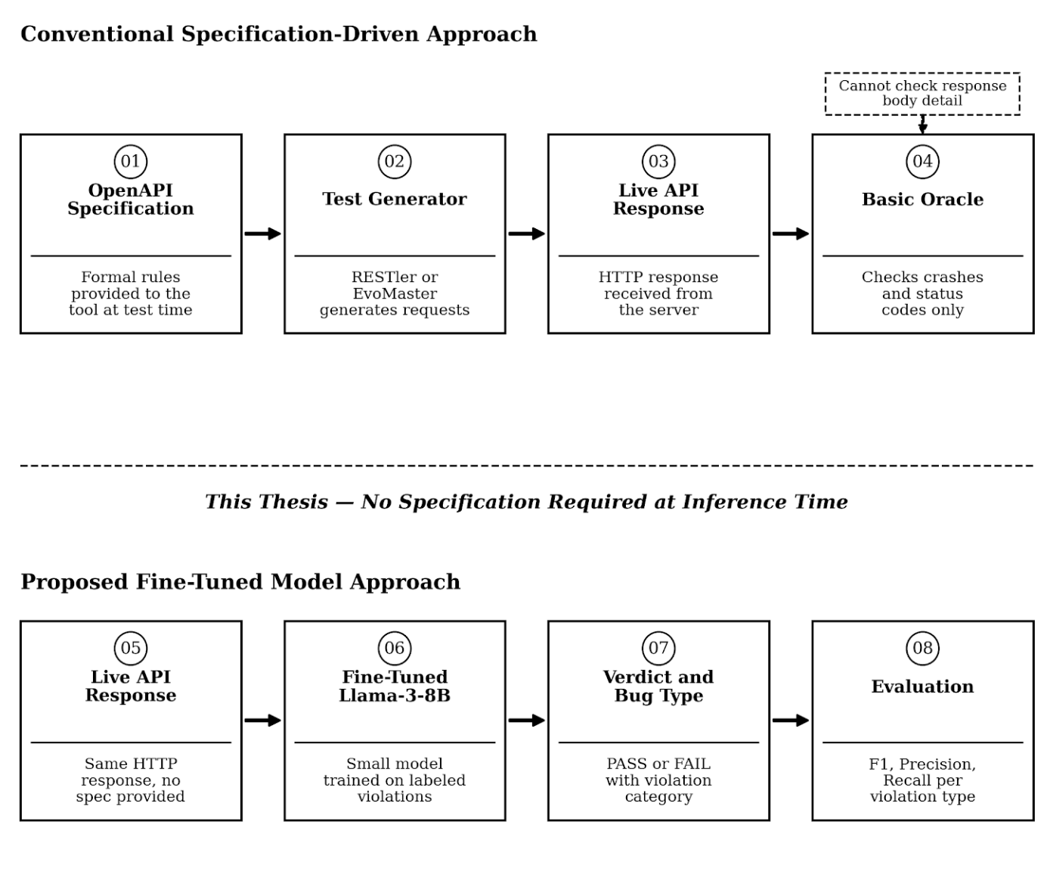
Figure 2.1: Conceptual overview of the test oracle problem in REST API testing

Mutation-Based Construction of Labeled Test Data
Mutation testing traditionally evaluates the strength of an existing test suite by introducing small, deliberate faults (mutants) into a program and measuring whether the test suite detects them. Jia and Harman [18] provide the canonical survey of the field's development, tracing mutation testing from its origins in fault-based testing theory through decades of tooling and empirical study. Ma, Offutt and Kwon [19] present MuJava, an influential mutation testing tool for Java that defines a taxonomy of class-level mutation operators targeting object-oriented language features such as inheritance and polymorphism; their operator-taxonomy approach — defining a small, well-motivated set of mutation types, each targeting one class of fault — directly informed the design of the six mutation operators used in this thesis's dataset construction pipeline (Chapter 3), applied at the level of an HTTP response body rather than source code.
More recent work has begun combining mutation testing with language models. Degiovanni and Papadakis [14] present μBERT, which uses a pre-trained language model to generate more natural, contextually plausible mutants than traditional syntactic mutation operators, reporting that BERT-generated mutants are harder for existing test suites to detect than mutants from conventional tools. This thesis's use of mutation is oriented differently — mutations are generated to produce labeled training data for a model to learn from, rather than to challenge an existing test suite — but the underlying premise that language models can meaningfully participate in mutant generation is consistent with this line of work.
[20] provide an empirical evaluation of mutation testing for object-oriented programs, finding that the effectiveness of mutation operators varies considerably depending on the diversity of fault types targeted — a finding that directly motivates this thesis's use of six distinct mutation operators rather than a single general-purpose mutant generator.

Parameter-Efficient Fine-Tuning: LoRA and QLoRA
Fine-tuning the full parameter set of a modern language model is computationally expensive and, for models in the billions of parameters, often infeasible on a single consumer GPU. Hu, Shen, Wallis, Allen-Zhu, Li, Wang, Wang and Chen [21] introduce Low-Rank Adaptation (LoRA), which freezes the pretrained model's weights and instead trains a small pair of low-rank matrices injected into each targeted layer, reducing the number of trainable parameters by several orders of magnitude while matching or approaching full fine-tuning performance on downstream tasks. Dettmers, Pagnoni, Holtzman and Zettlemoyer [22] extend this with QLoRA, which additionally quantizes the frozen base model to 4-bit precision (using their proposed NormalFloat4 data type) before applying LoRA adapters, making it possible to fine-tune models as large as 65 billion parameters on a single GPU with 48GB of memory — and, at smaller model scales such as the 8-billion-parameter model used in this thesis, on considerably more modest hardware. This thesis's fine-tuning methodology (Section 3.5) applies QLoRA directly, following the configuration principles established in this work.

Open-Source Base Models for Fine-Tuning
Several open-weight language model families are available as a base for fine-tuning of the kind performed in this thesis. Meta AI [23] introduces Llama 3, the model family used in this thesis (specifically the 8-billion-parameter instruction-tuned variant), and Rozière et al. [24] present Code Llama, a code-specialized variant of the Llama family, illustrating the broader ecosystem's suitability for downstream fine-tuning on structured, code-adjacent tasks such as the one addressed here. Comparable open-weight alternatives include Qwen2 [25], Mistral 7B [26], and Gemma [27] — each broadly similar in parameter count and instruction-tuning approach to Llama-3-8B-Instruct. Llama-3-8B-Instruct was selected for this thesis primarily due to its widespread adoption within the fine-tuning ecosystem (including direct support in the Unsloth framework used for training) and its competitive benchmark performance among models of comparable size at the time this study was conducted; a systematic comparison of fine-tuning outcomes across these alternative base models was outside this thesis's scope and is proposed as future work (Section 5.2).
The broader motivation for fine-tuning a small model rather than relying solely on a large proprietary one is addressed by the knowledge distillation literature. Xu, Sun, Wei, Yang, He, Su, Xie and Zhang [25] survey knowledge distillation for large language models, characterizing the general finding that a smaller “student” model can be trained to approximate specific capabilities of a larger “teacher” model at a fraction of the computational cost, though typically with some measurable capability gap remaining — a pattern consistent with, and a useful frame for interpreting, the gap this thesis observes between its fine-tuned 8-billion-parameter model and the large reference model used for comparison (Chapter 4).
[28] provide a comparative evaluation of open-source language models against proprietary alternatives across a range of benchmarks, finding that the gap between open-source and proprietary models had narrowed substantially by late 2023 — supporting the choice of an open-weight model as a viable base for task-specific fine-tuning in this thesis.

Fine-Tuning Small Models for Classification and Software Engineering Tasks
A growing body of work applies parameter-efficient fine-tuning of Llama-class models to classification and software engineering tasks, each demonstrating a different facet of what small fine-tuned models can and cannot do compared to their untrained counterparts. This section reviews that work across four specific areas: sentiment and general text classification, software engineering task automation, vulnerability detection, and hyperparameter sensitivity — each directly relevant to one or more design decisions made in this thesis.

Sentiment and General Text Classification
Fine-tuning Llama-3 for text classification has been examined across several domains, with consistent findings that parameter-efficient methods achieve performance comparable to full fine-tuning at a fraction of the computational cost. A study analyzing Llama-3 performance on sentiment classification using both LoRA and QLoRA [29] reports measurable improvement over the untrained base model — accuracy rising from 0.333 to 0.923 after fine-tuning — and specifically examines the effect of hyperparameter choices such as LoRA rank and alpha on downstream performance, findings directly relevant to the hyperparameter search process undertaken in this thesis (Section 3.5.1). [30] challenge, finding that data fusion across related tasks improves downstream classification accuracy — a finding consistent with this thesis's use of diverse API sources to broaden the training distribution.

Software Engineering Task Automation
The application of parameter-efficient fine-tuning to software engineering tasks beyond code generation has expanded substantially. Lu, Yu, Li, Yang and Zuo [31] present LLaMA-Reviewer, a framework that applies parameter-efficient fine-tuning of LLaMA to automated code review, using less than 1% of trainable parameters while achieving performance improvements over pre-trained baselines on review comment generation — demonstrating that LoRA-based fine-tuning can transfer a general-purpose language model's capabilities to a highly specific software engineering judgment task with minimal compute. Haider, Mostofa, Hossain, Iqbal and Ahmed [32] extend this line of work by comparing prompting against QLoRA fine-tuning of Code Llama and Llama-3.1 for code review comment generation, finding competitive performance improvements of 25–83% over untrained baselines, and conducting human evaluations that validate the practical utility of fine-tuned outputs. Both studies frame their contribution in terms directly analogous to this thesis's baseline-versus-fine-tuned comparison, providing prior evidence that parameter-efficient fine-tuning of Llama-class models generalizes to judgment tasks in software engineering contexts beyond the domains those models were originally trained on.

Vulnerability Detection
Security vulnerability detection in source code represents a classification task structurally similar to this thesis's REST API response judgment task: in both cases, a model must examine a piece of structured content and produce a binary judgment — vulnerable or safe in the security domain, FAIL or PASS in the oracle domain. Prior work applying fine-tuned language models to this task provides directly relevant evidence about what small fine-tuned models can and cannot do on binary classification problems of this kind.
Ouchebara and Dupont [33] compare prompt engineering against QLoRA fine-tuning of Llama-3.1-8B for source code vulnerability classification, reporting a significant improvement from 0.780 to 0.900 average F1-score through fine-tuning — and a further improvement to 0.950 F1 when a classification head is added on top of the fine-tuned model. This study is particularly relevant to the present thesis in two respects. First, it demonstrates that QLoRA fine-tuning of a small Llama model can substantially improve a binary classification task, providing prior evidence that the same approach used in this thesis is capable of meaningful performance gains on judgment-type tasks. Second, it shows that the generative fine-tuning approach — training the model to produce text output — is less effective than the classifier approach for binary decisions. This finding motivated this thesis's use of structured text output (VERDICT: PASS/FAIL with a required REASONING field) as a middle ground: more constrained than free-form generation, which forces the model toward a binary decision, but more interpretable than a hard classifier head, which provides no explanation for its judgment. The inclusion of the REASONING field in particular serves a diagnostic purpose — making it possible to examine why the model reached a given verdict, not just what verdict it reached.
Degiovanni and Papadakis [14] approach fault detection from a different angle, using a pre-trained BERT model to generate more natural, contextually plausible mutants for evaluating existing test suites. While their task differs from vulnerability classification, their work reinforces the broader finding that pre-trained language models carry transferable knowledge about what plausible and implausible content looks like — a property that both vulnerability detection and REST API response judgment exploit, albeit in different ways.

Hyperparameter Sensitivity
Parameter-efficient fine-tuning methods such as LoRA and QLoRA introduce a set of configuration choices — LoRA rank, alpha scaling, dropout, learning rate, and training duration — each of which can substantially affect downstream task performance. Unlike full fine-tuning, where the primary hyperparameter is the learning rate, LoRA-based approaches require practitioners to additionally choose the rank of the adapter matrices, which controls how many parameters are trained and therefore how much the model can deviate from its pretrained behavior. Smith [34], [35] establishes that learning rate choice is among the most consequential hyperparameter decisions in neural network training, with values that are too high causing unstable convergence and values that are too low causing insufficient learning within a fixed training budget. Goodfellow, Bengio and Courville [35] similarly identify training duration as a critical variable: training for too many epochs on a limited dataset leads to overfitting, in which the model memorizes training examples rather than learning generalizable patterns — a failure mode directly relevant to this thesis's experimental observations.
An empirical study of hyperparameter impact on LLM tuning across real-world tasks [36] conducts a large-scale grid search across Llama-3-8B and Mistral-7B under both full fine-tuning and LoRA, providing empirical evidence that downstream performance is highly sensitive to choices of learning rate, rank, and training duration across diverse tasks. Critically, their results show that no single configuration generalizes well across all tasks — optimal hyperparameters vary substantially depending on dataset size, task type, and base model architecture. This finding directly motivated this thesis's iterative configuration search (Section 3.5.1) and supports the decision to report that search process transparently rather than presenting only the final configuration, since the path to the final configuration is itself informative about the nature of the learning problem.
Huang et al. [28] empirically study the effect of low-bit quantization on Llama-3 performance across a range of bit-widths, finding that 4-bit quantization introduces a measurable but task-dependent capability tradeoff compared to higher-precision alternatives. This is directly relevant to this thesis's use of 4-bit NF4 quantization during QLoRA training: the results suggest that quantization may reduce the model's effective capacity on tasks requiring fine-grained numerical reasoning — which could partly explain the limited generalization observed in the without-specification evaluation condition, where detecting constraint violations (which require reasoning about numeric bounds) showed the smallest improvement over the untrained baseline.

Summary Comparison
Table 2.2 summarizes the studies reviewed in this section, comparing their base model, fine-tuning method, task type, and key finding, with this thesis shown in the final row for direct comparison.

Study | Base Model | Fine-tuning Method | Task | Key Finding
Patil [29] | Llama-3-8B | LoRA + QLoRA | Sentiment classification | Accuracy improved from 0.333 to 0.923; hyperparameter choices significantly affect results
Cao et al. [30] | Llama-3-8B and Mistral-7B | LoRA | Financial text classification | Data fusion across related tasks improves downstream classification accuracy
Lu et al. [31] | LLaMA | LoRA (PEFT) | Code review automation | Under 1% trainable parameters; outperforms pre-trained baselines on review tasks
Haider et al. [32] | Code Llama and Llama-3.1 | QLoRA | Code review comment generation | 25 to 83% improvement over untrained baselines; validated by human evaluation
Ouchebara and Dupont [33] | Llama-3.1-8B | QLoRA | Vulnerability detection | F1 improved from 0.780 to 0.900; classifier head further improves to 0.950
Stay Tuned [36] | Llama-3-8B and Mistral-7B | LoRA and Full Fine-Tuning | Hyperparameter study | Learning rate, rank, and duration are highly sensitive; motivates iterative search
Huang et al. [28] | Llama-3 variants | QLoRA 4-bit | Quantization evaluation | 4-bit quantization introduces capability tradeoff; varies by task type
This thesis | Llama-3-8B-Instruct | QLoRA 4-bit | REST API response judgment | Improves on 6 of 7 violation types with spec; 2 of 7 without spec

Table 2.1: Summary of machine learning and NLP approaches in software engineering

Several observations emerge from this comparison. First, all studies in the table use Llama-class or comparable open-weight models at the 7–8 billion parameter scale, confirming that this parameter range is well-established as a practical target for parameter-efficient fine-tuning on specific tasks — supporting the base model choice made in this thesis (Section 3.5.2). Second, QLoRA consistently appears as the fine-tuning method of choice when GPU memory is a constraint, with multiple studies reporting competitive results against full fine-tuning at a fraction of the computational cost. Third, all prior studies in this table apply their fine-tuned model to tasks where the input at inference time is complete and well-defined — a code snippet, a sentiment text, a financial document — whereas this thesis introduces an additional constraint: the model must judge correctness without access to the specification that defines what "correct" means. This constraint distinguishes this thesis's task as genuinely harder than any of the precedent tasks, and provides context for interpreting the more modest performance gains observed in the without-specification evaluation condition (Chapter 4). Finally, the only prior study targeting a judgment task analogous to PASS/FAIL verdict prediction — Ouchebara and Dupont [33] on vulnerability detection — reports F1 improvements of 0.120 through fine-tuning, which is comparable to the F1 improvement of 0.168 this thesis achieves in the with-specification condition, suggesting that the fine-tuning approach is performing within a reasonable range for this class of task.

Language Models Applied to REST API Testing
A recent and directly relevant line of work applies language models to REST API testing tasks. Kim, Sinha and Orso [9] present LlamaRestTest, which uses small, fine-tuned language models — rather than large proprietary models accessed via API — to generate realistic parameter values for REST API test requests, reporting that fine-tuned small models can match or exceed the effectiveness of much larger models on this task while being substantially cheaper to run. This is the closest direct precedent for this thesis's central premise: that a small, fine-tuned model can perform a REST-API-testing-related task competitively without relying on a large hosted model at inference time. Han and Zhu [12] present MASTEST, a multi-agent system in which multiple LLM-based and conventionally-programmed agents collaborate across the full REST API testing workflow, from test scenario generation through response analysis; unlike this thesis, MASTEST relies on large, general-purpose models (GPT-4o and DeepSeek V3.1) rather than a small fine-tuned model. Kang et al. [37] demonstrate that large language models can act as general bug detectors across multiple program types with minimal task-specific prompting, establishing that language models possess transferable bug-detection capability beyond code generation — a finding this thesis extends to the specific domain of REST API response validation through deliberate fine-tuning rather than few-shot prompting. Barradas, Paes and Neves [10] combine Test Specification Languages with LLMs to automate REST API test generation, and Moradi, Yan, Colwell and Asgari [11] specifically study LoRA-based fine-tuning of LLMs for automated test case generation more broadly, reinforcing that parameter-efficient fine-tuning is an actively studied approach for adapting language models to testing-related tasks.
Chu, Feng, Liu, Guo, Zhang, Shi, Nan and Xu [13] survey the broader application of large language models to unit test generation, explicitly identifying test oracle generation as an open sub-problem within this space — the same problem this thesis addresses, though at the level of REST API response bodies rather than unit-level assertions. Liu, Xia, Wang and Zhang [38] provide a methodologically relevant finding: their rigorous evaluation of LLM-generated code shows that existing benchmarks substantially overestimate LLM correctness due to insufficiently rigorous test construction, underscoring the importance — directly relevant to this thesis's own evaluation design — of evaluating against a quality-audited, held-out test set rather than a convenience sample.
A closely related and particularly relevant contribution is RBCTest, proposed by Huynh, Le, Nguyen, Nguyen, Nguyen and Nguyen [39], which uses large language models to mine and verify oracles specifically for API response body constraints. RBCTest applies an Observation-Confirmation prompting scheme to extract constraints from API specifications and generate test cases that check response body correctness — achieving precision rates of 85.1% to 93.6% in constraint mining across real-world APIs. This work is the closest published study to this thesis's oracle judgment task in terms of what it checks: response body correctness, not merely status codes or schema validity. The key distinction is methodological: RBCTest uses a large LLM (GPT-4-turbo) at inference time with the specification always present, while this thesis trains a small model to perform judgment without requiring the specification at inference time — making the two approaches complementary rather than competing, and highlighting the specific novelty of this thesis's contribution.
Table 2.2 summarizes the closest related work in this area, comparing each study's model choice, specification access at inference time, task type, and whether fine-tuning was applied, with this thesis's own approach shown in the final row for direct comparison.

Reference | LLM Used | Model Size | Spec at Inference | Task | Fine-tuned | Evaluation Metric | Limitation
[3] | None | N/A | Yes | Test input generation | No | Real bugs found | Oracle limited to crash detection only
[6] | None | N/A | Yes | Test input generation | No | Fault detection rate | Requires accurate full specification
[9] | Llama-3 | Small | Yes | Test input generation | Yes | Endpoint coverage | Does not judge whether received response is correct
[12] | GPT-4o / DeepSeek | Large | Yes | Full testing pipeline | No | Pass/Fail rate | Depends on large proprietary model at every stage
[10] | LLM (unspecified) | Large | Yes | Test specification generation | No | Coverage | Not response-level judgment
[11] | Llama-3.1-8B | Small | Yes | Test case generation | Yes | F1 score | Not specific to REST API response judgment
[13] | Multiple LLMs | Large | Yes | Unit test generation | No | Pass rate | Oracle generation identified as open problem, not resolved
[14] | BERT | Small | Yes | Mutant generation for test suite evaluation | Yes | Mutation score | Different use of LLM -- not training a response oracle
This thesis | Llama-3-8B-Instruct | Small (8B) | No | REST API response judgment | Yes | F1, Precision, Recall, Accuracy | Narrow generalization without specification access

Table 2.2: Comparison of language-model approaches to REST API testing

This thesis's use of a large reference model (Claude) as a comparison point for judgment quality is conceptually related to the “LLM-as-a-judge” paradigm. Zheng et al. [5] introduce this paradigm formally, proposing MT-Bench and Chatbot Arena to evaluate whether a strong LLM's judgments of another model's output agree with human preference, finding that GPT-4-class judges achieve over 80% agreement with human evaluators — comparable to the level of agreement between two human evaluators. Their work also documents systematic biases in LLM judges, including a tendency toward verbosity and self-preference, which is a useful frame for interpreting this thesis's own finding (Chapter 4) that the reference model's high recall is achieved partly through a strong bias toward predicting “violation” rather than balanced, case-by-case judgment. A recent extension of this paradigm specifically to software engineering contexts [7] audits LLM-as-a-judge systems for systematic bias in software engineering evaluation tasks, directly relevant to interpreting the reference model's asymmetric precision/recall profile observed in this thesis's results.

Prompt Design and Evaluation Methodology

Prompt Design
The design of the prompt used throughout this thesis's dataset follows established principles from the prompt engineering literature. White et al. [40] catalog a set of reusable prompt patterns for structuring interactions with large language models, identifying the importance of a stable, explicit task-framing instruction — what they call a persona or context pattern — that tells the model what role it is playing and what kind of output is expected before any task-specific content is provided. The system message used in this thesis follows this principle directly: every training and evaluation record begins with the same fixed instruction — "You are a REST API test oracle. Given an API name, an HTTP request, and an HTTP response, determine whether the response is correct. Return VERDICT (PASS or FAIL), BUG_TYPE, and REASONING." — which establishes the model's role, defines the input it will receive, and specifies the output format it must produce.
The inclusion of a REASONING field in the required output format was motivated by the chain-of-thought prompting literature. Kojima et al. [41] demonstrate that prompting a language model to produce a reasoning step before its final answer consistently improves answer quality, even when the reasoning is generated rather than provided. By requiring the model to produce a one-sentence justification for its verdict as part of its structured output, the prompt design encourages the model to make its judgment process explicit — a property that also makes errors easier to diagnose during evaluation, since an incorrect VERDICT is often accompanied by a REASONING field that reveals why the model was confused.

Evaluation Metrics
For statistical comparison of the three models evaluated in this thesis (Chapter 4), overall accuracy is reported but treated as a secondary metric. The primary metric is F1 score, computed treating FAIL as the positive class. This choice is motivated by the class distribution of the test set: 190 of 226 records (84.1%) are genuine violations, meaning a trivial classifier that always predicts FAIL would achieve 84.1% accuracy without performing any genuine discrimination. Sokolova and Lapalme [42] demonstrate that accuracy is an unreliable performance measure for imbalanced datasets precisely because of this property, and recommend F1 as a more informative alternative that balances precision and recall without being dominated by the majority class.
Precision and recall are reported separately in addition to F1, since they capture different aspects of model behavior that are independently meaningful for this task. Powers [43] defines precision as the fraction of FAIL predictions that are genuine violations, and recall as the fraction of genuine violations that the model correctly identifies. A model with high precision but low recall (such as the fine-tuned model in this thesis) is conservative — it speaks up infrequently but is usually right when it does. A model with high recall but lower precision (such as the reference model) catches more violations but also raises more false alarms. Both profiles are informative, and reporting both metrics prevents either from being obscured by an aggregate score. Per-category F1 is additionally reported for each of the seven violation categories, directly addressing RQ4 by showing which categories of violation generalize to unseen APIs and which do not. This work follows the guidance of Dietterich [44], whose analysis of approximate statistical tests for comparing supervised classification algorithms cautions against overstating claims of superiority based on a single evaluation run — a consideration that motivates this thesis's conservative framing of its results as empirical observations rather than definitive performance rankings.
The same set of metrics — overall accuracy, precision, recall, F1, and per-category F1 breakdown — is applied identically under both evaluation conditions described in Section 3.7: the without-specification condition, in which no API specification is shown to any model at inference time, and the with-specification condition, in which only the relevant field's specification snippet is added to the prompt. Reporting identical metrics across both conditions makes the comparison between them directly interpretable: any difference in scores reflects the effect of specification availability alone, since all other factors — the test records, the prompt structure, the models, and the metrics — remain constant between the two runs.

RESEARCH METHODOLOGY

Overview
We adopt supervised machine learning as the research methodology and the goal of this study is achieved in three phases. Figure 3.3 represents the overall methodology of our research.
In the first phase, we construct a labeled dataset for REST API response judgment. We collect real HTTP responses from eight training APIs and apply six controlled mutation operators derived from their OpenAPI specifications to generate labeled violation examples across seven categories: correct, wrong_data_type, missing_required_field, enum_violation, constraint_violation, undeclared_field, and wrong_status_code. The resulting dataset of 1,846 training records is validated through a systematic quality audit that identified and corrected four data quality issues — specification leakage, fixed sentinel values, field-selection bias, and truncation masking — before export.
In the second phase, we fine-tune a Llama-3-8B-Instruct model using QLoRA [22] a parameter-efficient method that trains low-rank adapter matrices while keeping the base model frozen and quantized to 4-bit precision. We apply response-only loss masking so the model is trained exclusively on its own verdict output, not on predicting the input request and response it was given.
In the third phase, we evaluate the fine-tuned model against two baselines: the untrained Llama-3-8B-Instruct model and a large general-purpose reference model (Claude), using 226 held-out test records drawn from three APIs unseen during training. We report precision, recall, F1, and accuracy for each model, with a per-category F1 breakdown addressing RQ4. We additionally evaluate a second condition in which the relevant field's specification snippet is shown at inference time, to isolate the effect of specification availability on model performance.

Proposed Approach
Recent surveys confirm that REST API testing remains heavily reliant on the availability of an accurate OpenAPI specification at test time [1]. Specifications are frequently absent, incomplete, or inconsistent with actual API behavior in practice [2]. Existing automated approaches either require the specification at the moment of judgment [3] or rely on large, general-purpose models that are expensive to run and have not been specifically trained for response-level judgment [12] [5]. There is therefore a need for a small, locally-runnable model trained specifically to judge REST API response correctness without requiring the specification at inference time.
We propose a three-phase approach, illustrated in Figure 3.1, consisting of: (1) a systematic dataset construction pipeline that generates labeled correct and incorrect API responses through controlled, specification-derived mutation across six violation categories; (2) supervised fine-tuning of a small open-weight language model (Llama-3-8B-Instruct) using QLoRA on the resulting dataset of 1,846 training records; and (3) a three-way comparative evaluation on a set of APIs held out from training, under both a without-specification and a with-specification condition, to characterize the model's generalization behavior by violation category.
The key design constraint of this approach is that the specification is used only during dataset construction — to define what constitutes a correct response and to generate labeled violations — and is withheld from the model at inference time in the primary evaluation condition. This constraint is deliberate: it defines the harder, more practically useful version of the problem, in which the model must have internalized a general sense of what a well-formed API response looks like from examples alone, rather than checking responses against a rule it is handed at the moment of judgment.
What distinguishes this approach from prior work is the combination of three elements that have not previously appeared together: a systematically constructed, quality-audited labeled dataset built through specification-derived mutation rather than manual annotation or ad hoc collection; a small, locally-runnable fine-tuned model rather than a large proprietary model accessed via API; and an evaluation design that tests generalization to entire APIs held out from all training activity, rather than held-out records from the same APIs used in training. Each of these elements individually appears in prior work in related contexts, but their combination — and the empirical characterization of which violation categories benefit from this approach and which do not — is the specific contribution of this thesis.

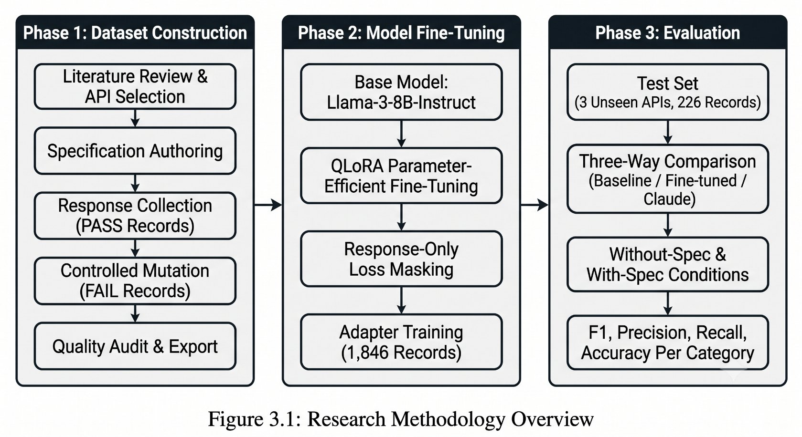

Dataset Construction Pipeline
The central methodological contribution of this thesis is a six-step, reusable pipeline for constructing labeled REST API response data suitable for supervised fine-tuning. The pipeline is illustrated in Figure 3.1 and summarized below.

Figure 3.1: The six-step dataset construction pipeline

Step 1 — Source API Selection
Eleven real-world REST APIs were selected: eight for training and three held out exclusively for final evaluation. The training set combines one custom-built API (to mitigate the possibility that a public API's behavior was already familiar to the base model from its pretraining data) with seven established public APIs chosen to maximize structural diversity — nested objects, enum-typed fields, array-valued responses, and varying endpoint counts. Table 3.1 lists the training APIs; Table 3.2 lists the three held-out test APIs, which were reserved from querying, collection, and mutation until final evaluation.
API | Type | Endpoints | Notes
Task Manager | Custom-built | 6 | Built specifically to rule out base-model pretraining familiarity
JSONPlaceholder | Public | 8 | Fake-success behavior motivates response-body-level judgment
Open-Meteo | Public | 1 | Single endpoint; enum coverage via is_day field
PetStore | Public (Swagger demo) | 8 | Two independent enum fields (Pet.status, Order.status)
ReqRes | Public | 2 | Requires API-key header
GitHub | Public | 6 | Deep nesting; enum coverage via type, visibility
Rick and Morty | Public | 6 | Added specifically for enum coverage
Open Trivia DB | Public | 1 | High enum density per response
Table 3.1: Training APIs
API | Notes
TVMaze | Substituted for a planned API (api.spacexdata.com) which returned persistent SSL handshake failures (HTTP 525) during the collection window, consistent with its source repository being archived and unmaintained
Frankfurter | Currency exchange rate API
Open Library | Book and author metadata API
Table 3.2: Test APIs (not used in training)

Step 2 — Specification Authoring
For each API, an OpenAPI 3.0 specification was authored describing every endpoint's required fields, data types, enum constraints, and numeric/length constraints, with additionalProperties set to false so that undeclared-field violations are well-defined. This specification serves exclusively as the ground-truth rule set used to generate labeled violations in Step 4; it is withheld from the model at training and inference time in the primary evaluation condition (Section 3.5).

Step 3 — Response Collection
Real, correct responses (“PASS records”) were collected by issuing live requests to each API and saving genuinely correct responses. Input values (query parameters, path parameters, and request bodies) were deliberately varied across collection runs — rather than repeating a single input — to avoid teaching the model a narrow, unrepresentative pattern rather than a general one.

Step 4 — Controlled Mutation
Each collected PASS record was passed through six mutation operators, each targeting one specific category of specification violation. The mutation process is deterministic in structure but randomized in field selection: for any given PASS record, each operator first identifies all fields in the response body that are eligible for its specific violation type, then selects one field uniformly at random from that eligible set. This randomization was a deliberate design decision, made after an initial implementation that always selected the first eligible field was found to concentrate violations on a small number of frequently-occurring field names (most commonly id and status), severely limiting the diversity of patterns the model could learn from. The corrected, randomized approach is described formally in Algorithm 3.1.
Algorithm 3.1: Controlled Mutation Pipeline
Input: PASS record P = (api, endpoint, request, response_body) and OpenAPI specification S for the given endpoint
Output: Set of FAIL records F (one per applicable operator)
BEGIN
- Parse S to extract the field schemas for this endpoint, including field names, types, enum values, constraints, required fields, and the additionalProperties setting.
- Initialize F as an empty set.
- FOR EACH operator M in {M1, M2, M3, M4, M5, M6}:
3a. Identify the set E of all eligible fields in response_body for operator M:
M1 (wrong_data_type): fields with a declared type
M2 (missing_required_field): fields listed in required[ ]
M3 (enum_violation): fields with an enum constraint
M4 (constraint_violation): fields with min, max, minLength, or maxLength constraints
M5 (undeclared_field): no target field needed — injects a new field
M6 (wrong_status_code): no target field needed — replaces response body
3b. IF E is empty AND M requires a target field: SKIP this operator for this record.
3c. ELSE: SELECT one field f uniformly at random from E (for M5 and M6, no field selection is required).
3d. APPLY M to produce a mutated response body:
M1: replace the value of f with a value of a different type
M2: remove field f from the response body entirely
M3: replace the value of f with a value outside its declared enum list
M4: set the value of f just outside its declared numeric or length bound
M5: inject one undeclared field into the response body
M6: replace the entire response body with an error-shaped body while keeping the success status code
3e. CONSTRUCT a new FAIL record:
Preserve api, endpoint, and request from P
Set response_body to the mutated version
Set verdict = FAIL
Set bug_type = violation category of M
Set source = mutated
3f. ADD the new FAIL record to F.
- RETURN F.
END
Table 3.5 summarizes the six operators, their target violation categories, and the mechanism each applies.
Operator | Violation category | Mechanism
M1 | wrong_data_type | Replaces a typed field's value with a value of a different type
M2 | missing_required_field | Removes one field listed as required in the specification
M3 | enum_violation | Replaces an enum-typed field's value with a value outside the declared enum
M4 | constraint_violation | Pushes a numeric or length-constrained field just outside its declared bound
M5 | undeclared_field | Injects a field not declared in the specification
M6 | wrong_status_code | Pairs a success status code with an error-shaped response body
Table 3.3: The six mutation operators
Two design principles were enforced across all operators, following issues identified during construction (Section 3.3.6). First, the specific field targeted by each operator is selected at random from the full set of eligible fields in a given record, rather than deterministically selecting the first eligible field — this was necessary to prevent the model from learning a shortcut tied to a specific, frequently-occurring field name such as id or status, rather than the general violation pattern. Second, injected or substituted values are drawn from randomized pools rather than fixed placeholder values. For example, M3 does not always inject the same invalid string — it selects randomly from a pool of plausible-looking but invalid values, so the model is unable to recognize a specific sentinel value as a shortcut to predicting the violation type. Both principles were introduced after the initial implementation was found to produce training data with insufficient diversity, as documented in Section 3.3.6.
Each PASS record produces up to six FAIL records — one per applicable operator. Operators that find no eligible field for a given record (for example, M3 applied to a response from an endpoint with no enum-typed fields) produce no output for that record and that operator. The final count of FAIL records therefore varies by API and endpoint, depending on how many operators find eligible targets in each response body.

Step 5 — Review and Quality Audit
Before export, the dataset was audited for internal consistency: verdict/bug-type label agreement, category balance across the seven possible labels (six violation types plus “correct”), and the absence of any information that would allow the model to infer a label without genuine reasoning (Section 3.3.6 details specific issues found and resolved at this stage).

Data Quality Issues Identified and Resolved
Four issues were identified during construction, each corrected before the dataset was considered final. Reporting these transparently is itself part of the methodology, since each represents a genuine threat to the validity of the resulting model if left uncorrected.
Issue | Risk if uncorrected | Resolution
Specification leakage | Training input included full specification content alongside the request/response, allowing the model to read the answer rather than judge it | All specification content removed from the model-facing input; verified by automated search across the full dataset
Fixed sentinel values | Certain mutations always inserted an identical placeholder value or field name, allowing the model to learn to recognize the placeholder rather than the violation pattern | Replaced with randomized pools of plausible values and field names
Field-selection bias | Mutation operators deterministically selected the first eligible field in a schema (commonly id or status), concentrating violations on a small number of field names | Field selection changed to uniform random sampling across all eligible fields
Truncation masking | A small number of long responses caused the mutated field to fall outside the length-limited text shown to the model, making the mutation indistinguishable from a correct response | Scope quantified (4 of 1,609 affected records); automatically and safely removed by content-level deduplication
Table 3.4: Data quality issues identified and resolved during construction

Step 6 — Export
Final records were exported in a chat-style JSONL format compatible with instruction fine-tuning: a fixed system message defining the task, a user message containing only the API name, HTTP request, and HTTP response, and an assistant message containing the target output — a verdict (PASS/FAIL), a bug-type label, and a brief templated justification. A parallel metadata block (API name, endpoint, source split) accompanies each record for traceability but is withheld from the model. Appendix A shows a complete example record.

Final Dataset Composition
The resulting dataset comprises 2,072 labeled records: 1,476 for training, 370 for validation, and 226 held out for final testing. Figure 3.2 shows the category balance of the training pool (train + validation, n = 1,846); no category exceeds 16.0% or falls below 10.4% of the total, satisfying the balance criterion adopted for this study.
Table 3.8 summarizes the split distribution across the three files.
Split | File | Records | APIs
Training | train.jsonl | 1,476 | 8 training APIs
Validation | val.jsonl | 370 | 8 training APIs
Test | test.jsonl | 226 | 3 unseen APIs
Total |  | 2,072 | 11 APIs
Table 3.5: Dataset split summary
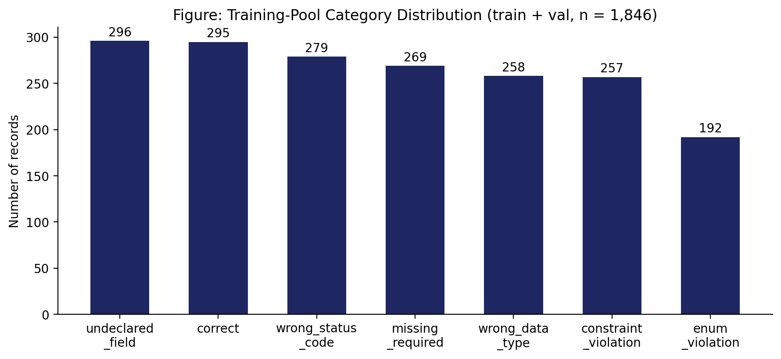
Figure 3.2: Training-pool category distribution (n = 1,846)
The training and validation splits share the same eight source APIs, with an 80/20 random split applied after export and deduplication. The test split is drawn exclusively from three APIs — TVMaze, Frankfurter, and Open Library — that were held out from all training and mutation activity until the final evaluation phase. This API-level split, rather than a record-level split, is a deliberate design choice: splitting individual records from the same API across training and test would allow the model to partially recognize API-specific response patterns from training, weakening the generalization claim. Holding out entire APIs ensures the model has no prior exposure to the structure, field names, or value patterns of any API in the test set.
Figure 3.4 shows the category balance of the training pool (train and validation combined, n = 1,846). No category exceeds 16.0% or falls below 10.4% of the total, satisfying the balance criterion adopted for this study. The slight under-representation of enum_violation (10.4%) relative to other categories reflects the structural constraint that enum-typed fields are less prevalent across the selected APIs than integer or string fields — a schema-intrinsic property rather than a sampling artifact, confirmed by the fact that targeted addition of enum-rich APIs (Rick and Morty, Open Trivia DB) in the second stage of dataset construction was required to bring this category to its current level.
Table 3.9 shows the per-category record counts across all three splits, confirming that the balance observed in the training pool is broadly maintained across validation and test sets.
Category | Train | Val | Test | Total
correct | 236 | 59 | 36 | 331
wrong_data_type | 206 | 52 | 28 | 286
missing_required_field | 215 | 54 | 33 | 302
enum_violation | 154 | 38 | 26 | 218
constraint_violation | 206 | 51 | 31 | 288
undeclared_field | 237 | 59 | 36 | 332
wrong_status_code | 222 | 57 | 36 | 315
Total | 1,476 | 370 | 226 | 2,072
Table 3.6: Per-category record counts across all splits
The test set's category distribution (36 correct, 28 wrong_data_type, 33 missing_required_field, 26 enum_violation, 36 undeclared_field, 31 constraint_violation, 36 wrong_status_code) broadly mirrors the training pool's proportions, with enum_violation remaining the smallest category in both. This consistency across splits supports the validity of per-category performance comparisons in Chapter 4, since the model is evaluated on a category distribution it was trained to handle rather than one that is artificially skewed toward harder or easier categories.

Fine-Tuning Methodology
A Llama-3-8B-Instruct model, loaded in 4-bit (NF4) quantized form, was fine-tuned using QLoRA — a parameter-efficient method that trains a small set of low-rank adapter matrices while keeping the base model's weights frozen and quantized. QLoRA combines two ideas: LoRA, which adds small trainable adapter matrices to a frozen model instead of updating all its weights [21]), and 4-bit quantization, which compresses the frozen base model's weights to reduce GPU memory usage [22] Together they make it possible to fine-tune an 8-billion-parameter model on a single consumer-grade GPU — in this case, a free-tier NVIDIA Tesla T4 with 16GB of memory — at a fraction of the cost of full fine-tuning. The adapter matrices are attached to the query, key, value, and output projection layers of each attention block (q_proj, v_proj, k_proj, o_proj), which are the layers most responsible for how the model routes and combines information across the input sequence. All other weights remain frozen throughout training. Table 3.7 summarizes the final configuration used, arrived at after an iterative process described in Section 3.5.1.
Setting | Value
Base model | Llama-3-8B-Instruct (4-bit NF4)
LoRA rank (r) | 8
LoRA alpha | 16
LoRA dropout | 0.1
Target modules | q_proj, v_proj, k_proj, o_proj
Training epochs | 1
Learning rate | 5e-5
Effective batch size | 8 (batch 2 × gradient accumulation 4)
Loss scope | Assistant response tokens only (response-only masking)
Hardware | Single NVIDIA Tesla T4 GPU
Table 3.7: Final QLoRA fine-tuning configuration

Configuration Selection Process
The final configuration in Table 3.7 was not the first attempted. An initial configuration (3 epochs, learning rate 2e-4, LoRA rank 16) produced severe overfitting: training loss fell to near zero within the first 10% of training steps, while validation loss remained flat across all three epochs, indicating the model was memorizing training examples rather than learning a general pattern. Five successive, independently-motivated interventions were tested to isolate the cause:
- Reducing training to 1 epoch and lowering the learning rate to 5e-5, to reduce the model's opportunity to overfit;
- Reducing LoRA capacity (rank 16 → 8) and increasing dropout (0.05 → 0.1), to reduce the model's capacity to memorize;
- Restricting the training loss to the assistant's response tokens only, rather than the full input sequence, after identifying that the default configuration graded the model on predicting the (largely unpredictable) input request/response verbatim, not only its own answer;
- Correcting a field-selection bias in the mutation pipeline (Section 3.3.6) that concentrated violations on a small number of field names, providing a shortcut around genuine pattern learning.
Each intervention was evaluated on its own before the next was introduced. The combination of response-only loss masking and corrected field-selection diversity, applied together with the reduced-capacity, single-epoch configuration in Table 3.7, produced the training behavior and downstream results reported in Chapter 4. This iterative process is reported in full because a consistent negative result across multiple independent interventions is itself evidence about where the true limiting factor lay — namely, the dataset's residual repetitiveness, not the choice of training hyperparameters alone.

Base Model Selection
Llama-3-8B-Instruct is a large language model developed by Meta AI [23] based on the transformer decoder architecture introduced by Vaswani et al. [45]. It contains approximately 8 billion parameters organized across 32 attention layers, each equipped with multi-head self-attention and feed-forward sub-layers. The model was pretrained on a large multilingual corpus and subsequently fine-tuned using instruction tuning and reinforcement learning from human feedback (RLHF) to align its outputs with structured human instructions — a process building on the instruction-following paradigm established by Brown et al. [46] and refined in Llama 2 [47].
The instruction-tuned variant (Llama-3-8B-Instruct) was chosen over the base pretrained variant (Llama-3-8B) for a specific, task-relevant reason: the instruction-tuned model has already been aligned to follow structured prompt formats and produce outputs in a predictable shape. This property is directly useful for the oracle judgment task in this thesis, which requires the model to produce output in a fixed three-part format — VERDICT, BUG_TYPE, and REASONING — rather than generating free-form continuation text. Using the base pretrained variant would have required substantially more fine-tuning data and training steps to establish this output discipline from scratch.
Among comparable open-weight alternatives at the 7–8 billion parameter scale — including Qwen2 [25], Mistral 7B [26], and Gemma [27] — Llama-3-8B-Instruct was selected for three reasons. First, it has mature, well-documented integration with the Unsloth fine-tuning framework used in this study, which provides memory-optimized QLoRA training kernels specifically tested against Llama-3 architecture variants. Second, it has an established track record in prior fine-tuning studies on classification and software engineering tasks at this parameter scale [29] [31] providing confidence that the model's architecture is amenable to task-specific adaptation through parameter-efficient fine-tuning. Third, at the time this study was conducted, Llama-3-8B-Instruct offered the most favorable balance of performance, ecosystem support, and compatibility with the free-tier T4 GPU hardware available for this research.
A systematic empirical comparison across base models — evaluating Qwen2, Mistral 7B, and Gemma under identical fine-tuning conditions on the same dataset — was outside this thesis's scope and is proposed as a concrete direction for future work in Section 5.2.

LoRA Rank, Alpha, and Dropout
The LoRA rank controls how many parameters the adapter is allowed to learn: a higher rank gives more capacity but also more opportunity to memorize rather than generalize. An initial rank of 16 contributed to the overfitting behavior documented in Section 3.5.1, and reducing it to 8 — approximately halving the adapter's capacity — was one of the interventions that helped address this. The alpha value of 16 (equal to twice the rank, a standard starting point recommended by Hu et al. [21]) controls the scaling of the adapter's contribution relative to the frozen base model weights. The dropout value of 0.1 was increased from the initial 0.05 specifically to add regularization pressure during training, making it harder for the adapter to memorize specific training examples by randomly deactivating a proportion of adapter weights at each training step. These three parameters interact: reducing rank limits capacity, while increasing dropout limits the model's ability to fully exploit even that reduced capacity, together pushing the model toward learning more general patterns rather than specific surface forms.

Training Duration, Learning Rate, and Batch Size
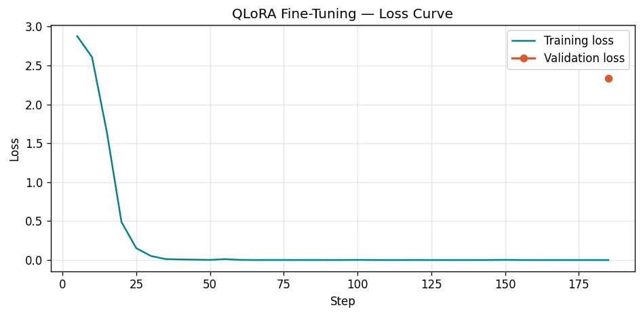
A single training epoch was used after the three-epoch initial configuration produced no measurable validation improvement across any epoch beyond the first. The training loss curve (Figure 3.5) confirmed that the model had largely exhausted its learning within the first quarter of the first epoch — training loss fell to near zero within approximately 50 of 567 total training steps, while validation loss remained flat throughout. This pattern is consistent with the overfitting behavior described by Goodfellow, Bengio and Courville [35], in which a model with sufficient capacity memorizes the training distribution rather than learning a generalizable pattern. Additional epochs beyond the first contributed only further entrenchment of this memorization, producing no benefit to validation performance while increasing training time threefold.
Figure 3.3: Training loss and validation loss curves across one epoch
A learning rate of 5e-5 was selected after the initial value of 2e-4 contributed to an excessively rapid training loss collapse. The learning rate controls the step size taken by the optimizer at each gradient update: a value that is too high causes the adapter weights to move quickly toward the nearest loss minimum, which in the presence of repetitive training data tends to be a memorization solution rather than a generalizable one. Reducing the learning rate to 5e-5 — a value consistent with the low-learning-rate regime recommended by Smith [34] for fine-tuning pretrained models on small datasets — slows this convergence and gives the model more gradient steps to adjust gradually. In practice this intervention reduced the speed of training loss collapse but did not eliminate overfitting entirely, confirming that the learning rate was a contributing factor but not the sole cause.
An effective batch size of 8 was achieved through a per-device batch size of 2 with gradient accumulation over 4 steps. Gradient accumulation simulates a larger batch by accumulating gradients across multiple forward passes before performing a single optimizer update, which produces the same gradient estimate as a true batch size of 8 while requiring only the memory footprint of a batch size of 2 at any given moment. This approach was necessary to fit training within the 16GB memory budget of the free-tier NVIDIA T4 GPU used for this study, since a true batch size of 8 at the model's sequence length would have exceeded available GPU memory. Smith (2018) notes that larger effective batch sizes tend to produce smoother gradient estimates and more stable training curves — a consideration that motivated using gradient accumulation to achieve a reasonable effective batch size rather than reducing it further to fit within memory constraints directly.
Together, these three configuration decisions — one epoch, learning rate 5e-5, and effective batch size 8 — represent the outcome of the iterative process documented in Section 3.5.1. Each was arrived at through empirical observation of training and validation loss behavior rather than theoretical derivation, and each is reported here with its specific justification so that the configuration can be reproduced and critically evaluated independently.

Response-Only Loss Masking
In standard supervised fine-tuning, the training loss is computed over all tokens in the input sequence — including the system prompt and the user message, in addition to the model's own response. This default behavior is appropriate when the goal is to train a model to generate all parts of a conversation, but it is counterproductive for instruction-following tasks where the input is fixed and only the output should be learned. The instruction fine-tuning literature has consistently applied response-only loss masking — computing loss only over the assistant's response tokens — to address this issue, a practice established in early instruction-tuning work including Alpaca [48] and InstructGPT [49]
For the specific task in this thesis, response-only loss masking is particularly important for a reason beyond the general instruction-tuning argument. The user message contains real HTTP response data — field names, field values, HTTP status codes, and nested JSON structures — drawn from live API calls. This content varies unpredictably from training example to training example: the same endpoint may return different field values, different nested structures, or different amounts of data on each call. Asking the model to predict these tokens accurately during training contributes a large, irreducible loss component — the model cannot reliably learn to predict specific API response content because that content is not systematically predictable from any pattern in the training data. This unpredictable loss component competes with and obscures the loss signal coming from the model's actual judgment output, making it harder for the optimizer to improve the model's verdict-prediction ability.
Response-only loss masking was applied using Unsloth's train_on_responses_only utility, which identifies the boundary between the user message and the assistant response using the model's chat template special tokens, and sets the loss weight to zero for all tokens before that boundary. The result is that only the VERDICT, BUG_TYPE, and REASONING tokens contribute to the gradient updates during training, ensuring the model is optimized exclusively for the judgment task it is expected to perform at inference time.
Figure 3.4: Token masking scheme applied during response-only loss masking
Figure 3.6 illustrates the token masking scheme applied during training. Tokens shown in grey (system message and user message) are excluded from the loss computation; tokens shown in dark (assistant response) contribute to the gradient update.
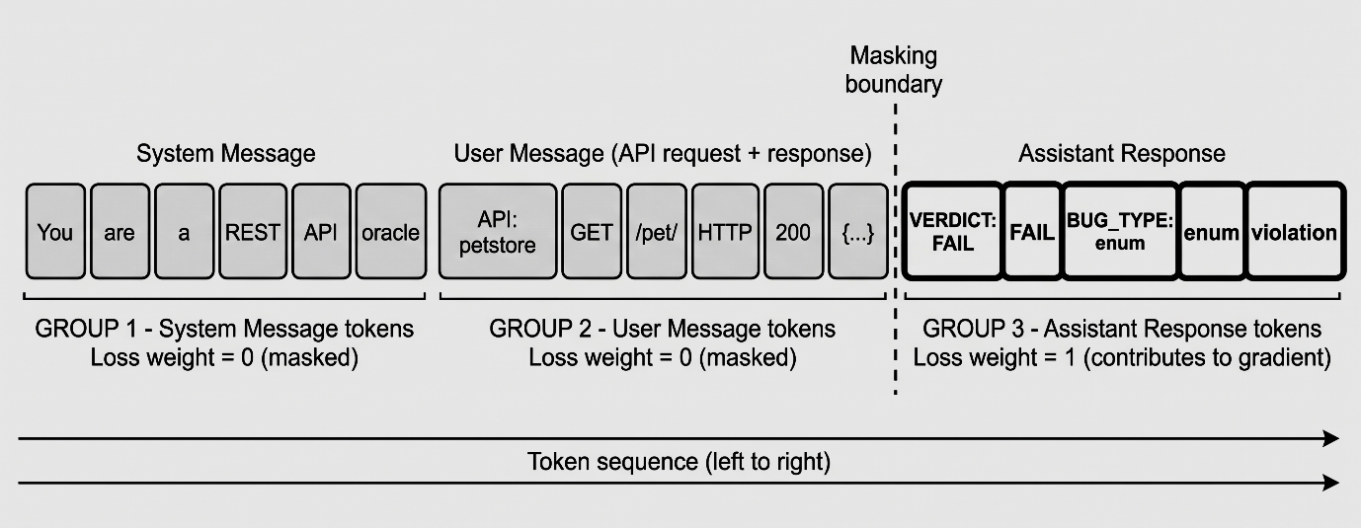

This was the single most impactful intervention identified during the configuration search documented in Section 3.5.1. Prior to applying response-only masking, training loss was dominated by the model's failure to predict unpredictable API response content, which produced a misleadingly high loss value that had no connection to actual judgment quality. After applying masking, the loss signal became a genuine measure of the model's verdict-prediction ability, and the training behavior became interpretable — a rapidly falling loss now meant the model was genuinely learning the judgment task, not memorizing surface patterns in the input.

The QLoRA Training Procedure
The fine-tuning procedure follows the QLoRA training loop established by Dettmers et al. [22], summarized in Algorithm 3.2. The key distinction from standard supervised fine-tuning is that gradients flow only through the adapter matrices, never through the frozen quantized base model weights, and the loss is computed only over the assistant response tokens rather than the full input sequence.
Algorithm 3.2: QLoRA Fine-Tuning Procedure (applied in this thesis)
Input: Training dataset D = {(system, user, assistant)} records
Pre-trained base model M (Llama-3-8B-Instruct)
LoRA configuration: rank r=8, alpha=16, dropout=0.1
Training configuration: epochs=1, lr=5e-5, batch=8
Output: Trained LoRA adapter weights A

BEGIN
1. Quantize M to 4-bit NF4 precision.
Freeze all base model weights — they will not be updated.
2. Attach low-rank adapter matrices A to target layers:
q_proj, v_proj, k_proj, o_proj in each attention block.
Initialize A with random near-zero values.
3. FOR each training epoch (1 epoch total):
FOR each mini-batch B of size 8 from D:
3a. FORMAT each record as a chat prompt:
[system message] + [user message] + [assistant message]
3b. FORWARD PASS through quantized M + adapters A:
Compute token predictions for the full sequence.
3c. COMPUTE LOSS:
Apply response-only masking — compute cross-entropy
loss ONLY over assistant response tokens
(VERDICT, BUG_TYPE, REASONING).
Ignore loss on system and user message tokens.
3d. BACKWARD PASS:
Compute gradients with respect to adapter weights A only.
Base model weights receive no gradient updates.
3e. UPDATE adapter weights A using AdamW optimizer
with learning rate 5e-5.
4. SAVE adapter weights A as the fine-tuned model artifact.
The base model M is unchanged and reusable.
RETURN A.
END
This procedure results in approximately 21 million trainable parameters — roughly 0.26% of the base model's 8 billion total parameters — being updated during training. The remaining 99.74% of parameters remain frozen at their pretrained values throughout.

Evaluation Methodology
Evaluation was conducted exclusively on the 226 held-out test records, spanning three APIs held out from training and mutation. Three models were evaluated under identical conditions — the same 226 examples, the same prompt structure, no specification shown to any model in the primary condition:
- Model A (Baseline): the untrained Llama-3-8B-Instruct model, unmodified.
- Model B (Fine-tuned): the model resulting from the procedure in Section 3.5.
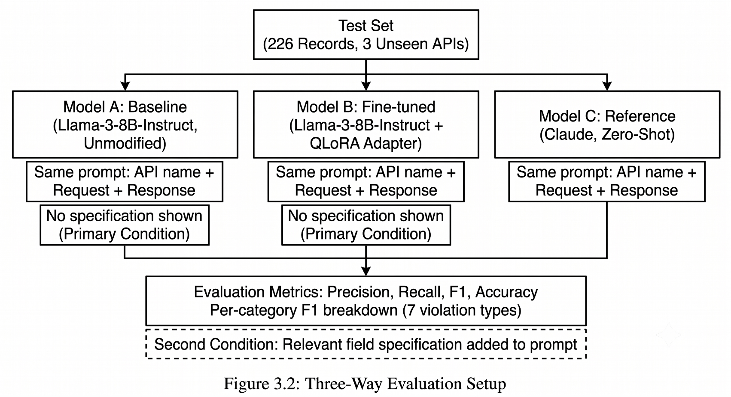
- Model C (Reference): Claude, queried zero-shot via API, included as a large-model reference point rather than a target to be matched.

Standard classification metrics were computed treating FAIL as the positive class: precision, recall, F1, and overall accuracy, together with a per-category F1 breakdown across all seven labels (Chapter 4, Section 4.2). A second evaluation condition, described in Section 3.7, repeats this procedure with one addition.

Second Evaluation Condition: Specification-Augmented Inference
The primary evaluation condition in this thesis — described in Section 3.6 — withholds the API specification from all three models at inference time. This condition tests the harder, more practically useful version of the oracle judgment task. However, it leaves open an important interpretive question: if the fine-tuned model shows limited generalization in this condition, is that limitation attributable to the absence of the specification, or does it reflect a more fundamental weakness in the approach that would persist even with specification access? To answer this question, a second, parallel evaluation condition was designed in which the relevant field specification is provided to the model at inference time, following the principle of controlled experimentation established by Wohlin et al. [50] — changing one variable at a time while holding all others constant.
A second dataset export was performed in which the user message additionally includes a short JSON snippet describing only the specification of the single field relevant to that record. For a PASS record from the PetStore API, for example, the with-specification user message includes the line: Spec (relevant field only): {"status": {"type": "string", "enum": ["available", "pending", "sold"]}} immediately before the request and response content. For a FAIL record involving a constraint violation on a numeric field, the snippet includes only that field's type and minimum or maximum constraint. This design choice was deliberate on two counts. First, including the full endpoint specification would reintroduce the exact problem identified and corrected in Section 3.3.6 — specification leakage — in which the model can trivially look up the answer rather than learn to judge it. Second, a full multi-field specification is often far larger than any single response body, making the comparison between conditions unfair in terms of information volume. Restricting the shown specification to the one relevant field isolates the variable of interest — whether the rule governing that field is available at all — without introducing an unrelated confound about how much total information the model receives.
A second fine-tuning run was performed on the with-specification training data using the identical configuration documented in Table 3.7 — the same base model, LoRA rank, learning rate, training duration, and response-only loss masking. The only difference between the two fine-tuned models is the content of the user message: the with-specification model was trained on records that include the relevant field snippet, and evaluated on a test set constructed using the same format. All five mutation operators that target specific fields (M1 through M5) include the targeted field's specification in the snippet; M6 (wrong_status_code) includes the declared response schema for the success status code. This ensures every record in the with-specification dataset contains a directly relevant, non-trivial specification snippet rather than a generic or empty one.
Results for both conditions are presented side by side in Chapter 4, with the comparison between them directly addressing the interpretive question this condition was designed to answer: does the limited generalization observed without specification access reflect a fundamental ceiling of the approach, or does it reflect the genuine difficulty of the task when the relevant rule is withheld?

RESULTS AND DISCUSSION

Results Without Specification Access
Table 4.1 reports the primary evaluation results on the 226 held-out test records drawn from three APIs — TVMaze, Frankfurter, and Open Library — that were withheld from all training and mutation activity. No specification was shown to any model at inference time. Figure 4.1 shows the corresponding confusion matrices for all three models.
Model | F1 | Precision | Recall | Accuracy
Baseline (Llama-3-8B) | 0.410 | 0.926 | 0.263 | 36.3%
Fine-tuned (this work) | 0.442 | 0.932 | 0.289 | 38.5%
Reference (Claude) | 0.916 | 0.844 | 1.000 | 84.5%
Table 4.1: Main results, no specification shown (test set, unseen APIs)
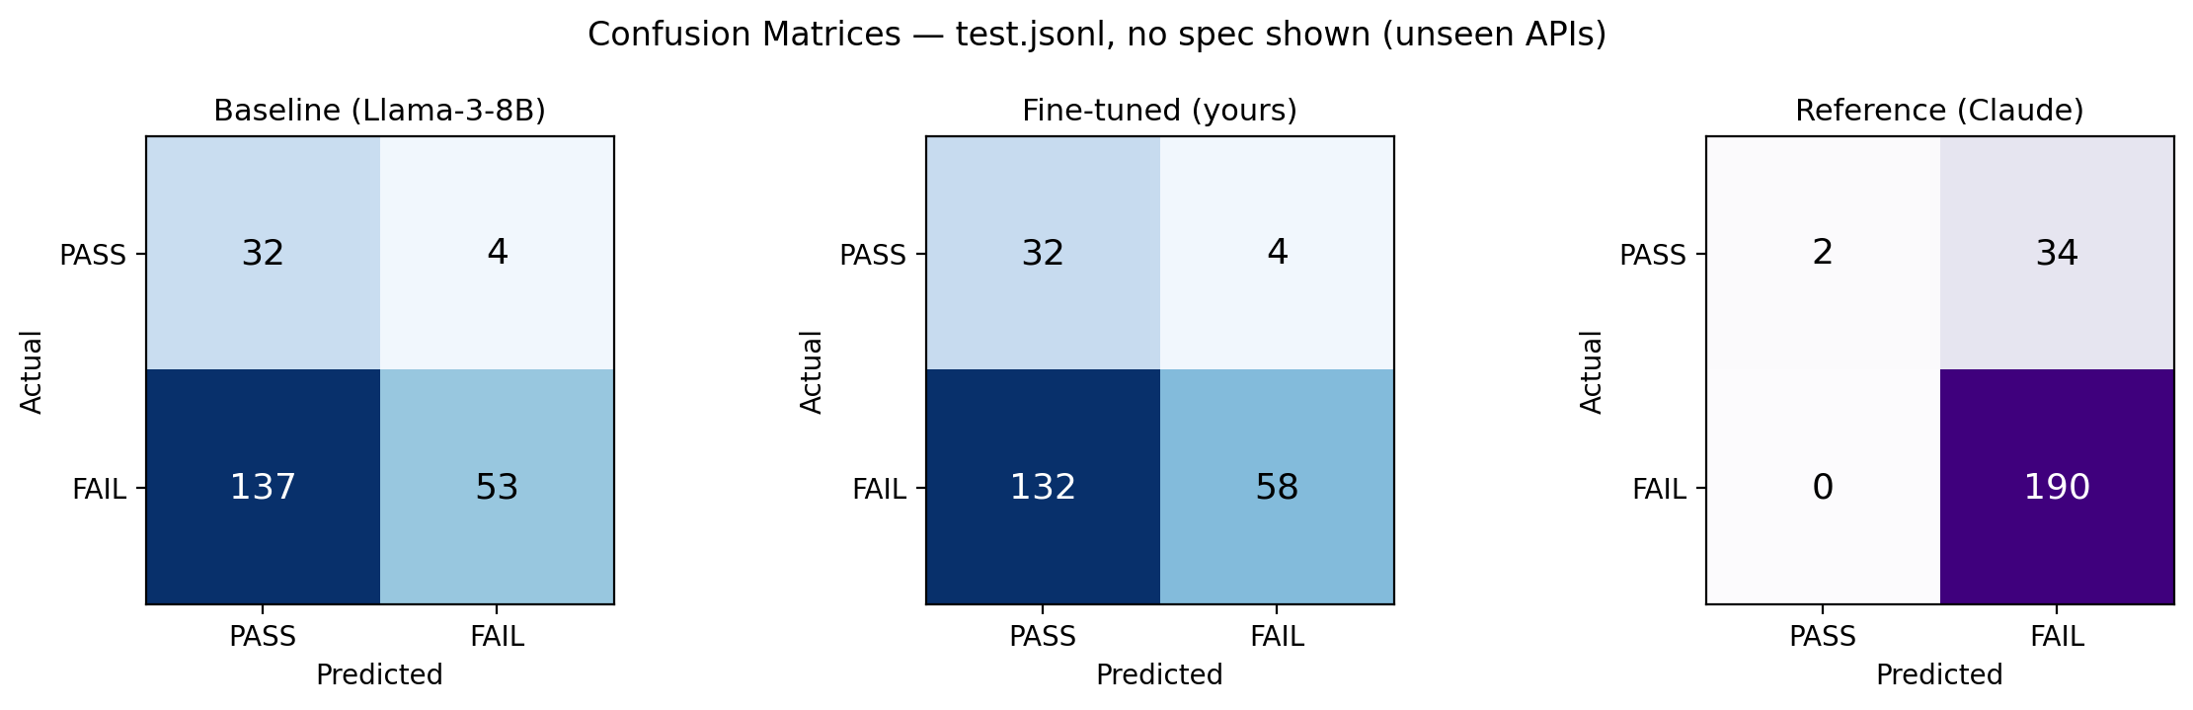
Figure 4.1: Confusion matrices, no specification shown
Fine-tuning produced a modest but genuine improvement over the untrained baseline: an F1 gain of 0.032 and an accuracy gain of 2.2 percentage points. These gains are small in absolute terms, and it is important to interpret them carefully. The test set contains 190 genuine violations out of 226 total records — an 84.1% violation rate — which means a trivial classifier that always predicts FAIL would achieve 84.1% accuracy without performing any genuine discrimination. Both the baseline (36.3%) and the fine-tuned model (38.5%) score well below this trivial ceiling on accuracy, confirming that neither model is simply defaulting to the majority class. The F1 metric, which balances precision and recall treating FAIL as the positive class, is therefore the more informative measure here, and the fine-tuned model's improvement from 0.410 to 0.442 on this metric represents a real, if narrow, generalization gain.
The reference model achieves substantially higher overall F1 (0.916) and accuracy (84.5%), but its behavioral profile is qualitatively different from both Llama-based models. Its recall of 1.000 — catching every genuine violation in the test set — is paired with a precision of 0.844, lower than the fine-tuned model's 0.932. This pattern indicates that the reference model's high aggregate scores are partly a consequence of a systematic tendency to predict FAIL regardless of input content, rather than case-by-case discrimination. This behavioral asymmetry is examined in detail in Section 4.4, where the per-category breakdown reveals that the reference model achieves a correct-category F1 of only 0.054 — recognizing just 2 of the 36 genuinely correct responses in the test set.

Per-Category Results Without Specification (RQ4)
Table 4.2 and Figure 4.2 break the aggregate result down by violation category, directly addressing RQ4: which categories of violation generalize to unseen APIs without specification access, and which do not.
Category | Baseline | Fine-tuned | Reference | n
wrong_data_type | 0.194 | 0.194 | 1.000 | 28
missing_required_field | 0.167 | 0.167 | 1.000 | 33
wrong_status_code | 1.000 | 1.000 | 1.000 | 36
enum_violation | 0.074 | 0.267 ↑ | 1.000 | 26
undeclared_field | 0.200 | 0.200 | 1.000 | 36
constraint_violation | 0.176 | 0.278 ↑ | 1.000 | 31
correct | 0.941 | 0.941 | 0.054 | 36
Table 4.2: Per-category F1, no specification shown (↑ = fine-tuning improves over baseline)
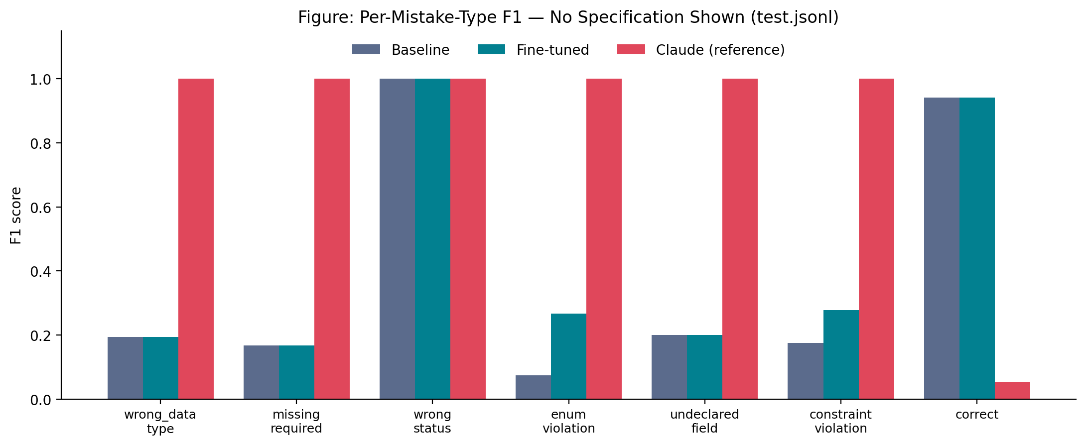
Figure 4.2: Per-category F1 comparison, no specification shown
Fine-tuning produced a measurable improvement in exactly two of the seven categories — enum_violation (0.074 → 0.267) and constraint_violation (0.176 → 0.278) — and no measurable change in the remaining five. This pattern is not random. Both categories where improvement was observed share a common property: the violations they represent are detectable from general knowledge rather than API-specific rules. A value of "BANANA" in a field that typically holds "available", "pending", or "sold" carries a signal of implausibility that does not require knowing the specific enum list for that particular API — a model with sufficient exposure to structured data can recognize that something looks wrong, even without being told the exact rule. Similarly, a numeric value of −5 in a field representing a count, or 99999 in a field representing a percentage, carries a signal of implausibility that generalizes across APIs without requiring knowledge of the specific declared bound.
The five categories where fine-tuning produced no improvement share the opposite property: their violations are detectable only by knowing an API-specific rule that is not visible in the response body alone. A missing required field produces a response body that looks entirely well-formed to a model without the field list — there is nothing visibly wrong about a JSON object that simply has fewer keys than expected. A wrong data type violation where a string "12.4" replaces a number 12.4 may be syntactically plausible in many contexts. An undeclared field is indistinguishable from a legitimate field unless the model knows exactly which fields are and are not declared. Barr, Harman, McMinn, Shahbaz and Yoo [15] categorize oracle automation strategies as specified, derived, or implicit — the violations the fine-tuned model fails to detect without a specification are precisely those that require a specified oracle, where the rule must be explicitly provided rather than inferred from general patterns.
The wrong_status_code category scores a perfect 1.000 for all three models, including the untrained baseline. This is not a generalization success attributable to training: the HTTP status code and the response body are both directly visible in every input, making the mismatch between a success status code and an error-shaped response body detectable by any model capable of basic pattern matching. This category is therefore excluded from generalization claims throughout this thesis.
The correct category shows a striking reversal: both the baseline and fine-tuned model score 0.941, while the reference model scores only 0.054. This reflects the reference model's near-constant prediction of FAIL across the test set — it recognized only 2 of the 36 genuinely correct responses, as shown in the confusion matrices in Figure 4.1. The fine-tuned model's high correct-category score is therefore not attributable to training either — it was already at 0.941 before fine-tuning — but rather reflects the base model's natural tendency toward balanced prediction behavior, which was preserved through fine-tuning.

Error Analysis
To understand the fine-tuned model's behavior beyond aggregate metrics, this section examines specific categories of error observed in the without-specification evaluation condition and discusses the likely reasons behind them. This analysis directly informs the interpretation of the with-specification results in Section 4.3 and the future work directions in Section 5.2.
Wrong data type and missing required field errors. The fine-tuned model showed no improvement over the untrained baseline in either of these two categories (both remained at 0.194 and 0.167 respectively). Examining misclassified examples reveals a consistent pattern: when a field is present but holds the wrong type — for example, a string "12.4" where a number 12.4 is expected — the response body remains syntactically plausible, and the violation is subtle enough that distinguishing it from a correct response requires knowing the field's declared type, information the model was not given at inference time. Similarly, a missing required field produces a response body that looks entirely well-formed to a model without access to the field list; there is nothing visibly wrong about a JSON object that simply has fewer keys than expected. These two categories correspond to what Barr, Harman, McMinn, Shahbaz and Yoo [15] classify as specification-dependent oracle checks — violations that are definitionally undetectable without access to the contract that defines what the correct response should contain.
Undeclared field errors. The undeclared_field category similarly showed no improvement (remaining at 0.200 for both baseline and fine-tuned model). This is consistent with the same underlying reason: an extra field in a response body is indistinguishable from a legitimate field unless the model knows exactly which fields are declared in the specification. A response containing an additional field called cache_version looks syntactically correct and semantically plausible — the violation is only visible when compared against a declared field list that the model was not provided. This category is therefore fundamentally similar to missing_required_field in its dependency on explicit specification knowledge, despite being a structurally different type of violation.
Enum violation and constraint violation improvements. The model's genuine improvement in these two categories (enum_violation: 0.074 → 0.267, constraint_violation: 0.176 → 0.278) is consistent with these violations being detectable from general knowledge rather than API-specific rules. A field holding the value "UNKNOWN" where typical status fields hold "active", "inactive", or "pending" carries a recognizable signal from general language patterns. A numeric field holding a value of −5 or 9999 carries a signal of implausibility that does not require knowing the specific declared range. The model appears to have internalized these patterns from training examples — learning a general sense of what plausible and implausible values look like — even without being told the specific rules governing each API.
The correct category. The fine-tuned model's high score on recognizing genuinely correct responses (F1 0.941, matching the untrained baseline exactly) reflects the base model's natural tendency toward balanced prediction behavior rather than any specific learned skill. This score was already near its ceiling before training and training did not further improve it — confirming that the base model already handles this category well without any task-specific adaptation.
Implications for dataset design and future work. These error patterns suggest a clear direction for future improvement. Categories where fine-tuning helped (enum and constraint violations) are those where the training data provided learnable, generalizable patterns — the signal was strong enough for the model to extract it without explicit rules. Categories where fine-tuning did not help (wrong data type, missing required field, undeclared field) are those where the training data alone cannot provide sufficient signal, because the violations are only identifiable with reference to information not present in the response body itself. The second evaluation condition (Section 4.3), in which the relevant field specification is shown at inference time, directly tests this hypothesis: if the error analysis above is correct, providing the specification should produce substantially larger improvements in precisely these three categories — which is confirmed by the with-specification results, where missing_required_field improves from 0.167 to 0.429, wrong_data_type from 0.194 to 0.303, and undeclared_field from 0.200 to 0.400.

Results With Specification Shown (Relevant Field Only)
Table 4.3 and Figure 4.3 report results under the second evaluation condition described in Section 3.7, in which the model is shown only the specification snippet for the single field relevant to each record, in addition to the request and response content. This condition was designed to isolate the effect of specification availability — holding all other factors constant while providing the one piece of information the error analysis in Section 4.3 identified as the likely limiting factor for the three categories that showed no improvement without a specification.
Model | F1 | Precision | Recall | Accuracy
Baseline (Llama-3-8B) | 0.556 | 0.938 | 0.395 | 46.9%
Fine-tuned (this work) | 0.724 | 0.965 | 0.579 | 62.8%
Reference (Claude) | 0.927 | 0.864 | 1.000 | 86.7%
Table 4.3: Main results, relevant-field specification shown (test set, unseen APIs)
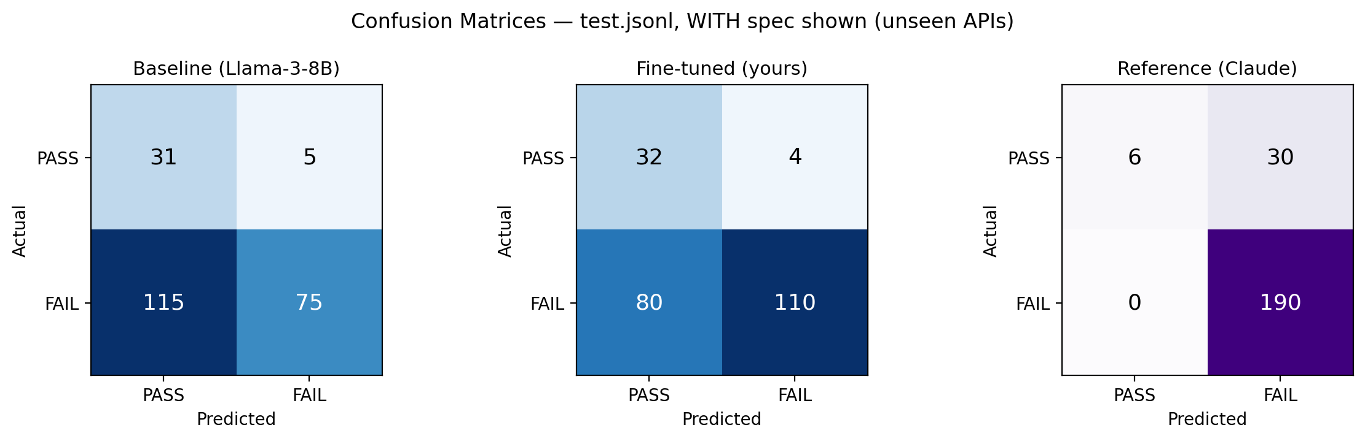
Figure 4.3: Confusion matrices, relevant-field specification shown
Table 4.4 and Figure 4.4 give the corresponding per-category breakdown for this condition.
Category | Baseline | Fine-tuned | Reference | n
wrong_data_type | 0.250 | 0.303 ↑ | 1.000 | 28
missing_required_field | 0.263 | 0.429 ↑ | 1.000 | 33
wrong_status_code | 1.000 | 1.000 | 1.000 | 36
enum_violation | 0.632 | 0.939 ↑ | 1.000 | 26
undeclared_field | 0.200 | 0.400 ↑ | 1.000 | 36
constraint_violation | 0.622 | 0.949 ↑ | 1.000 | 31
correct | 0.925 | 0.941 ↑ | 0.286 | 36
Table 4.4: Per-category F1, relevant-field specification shown
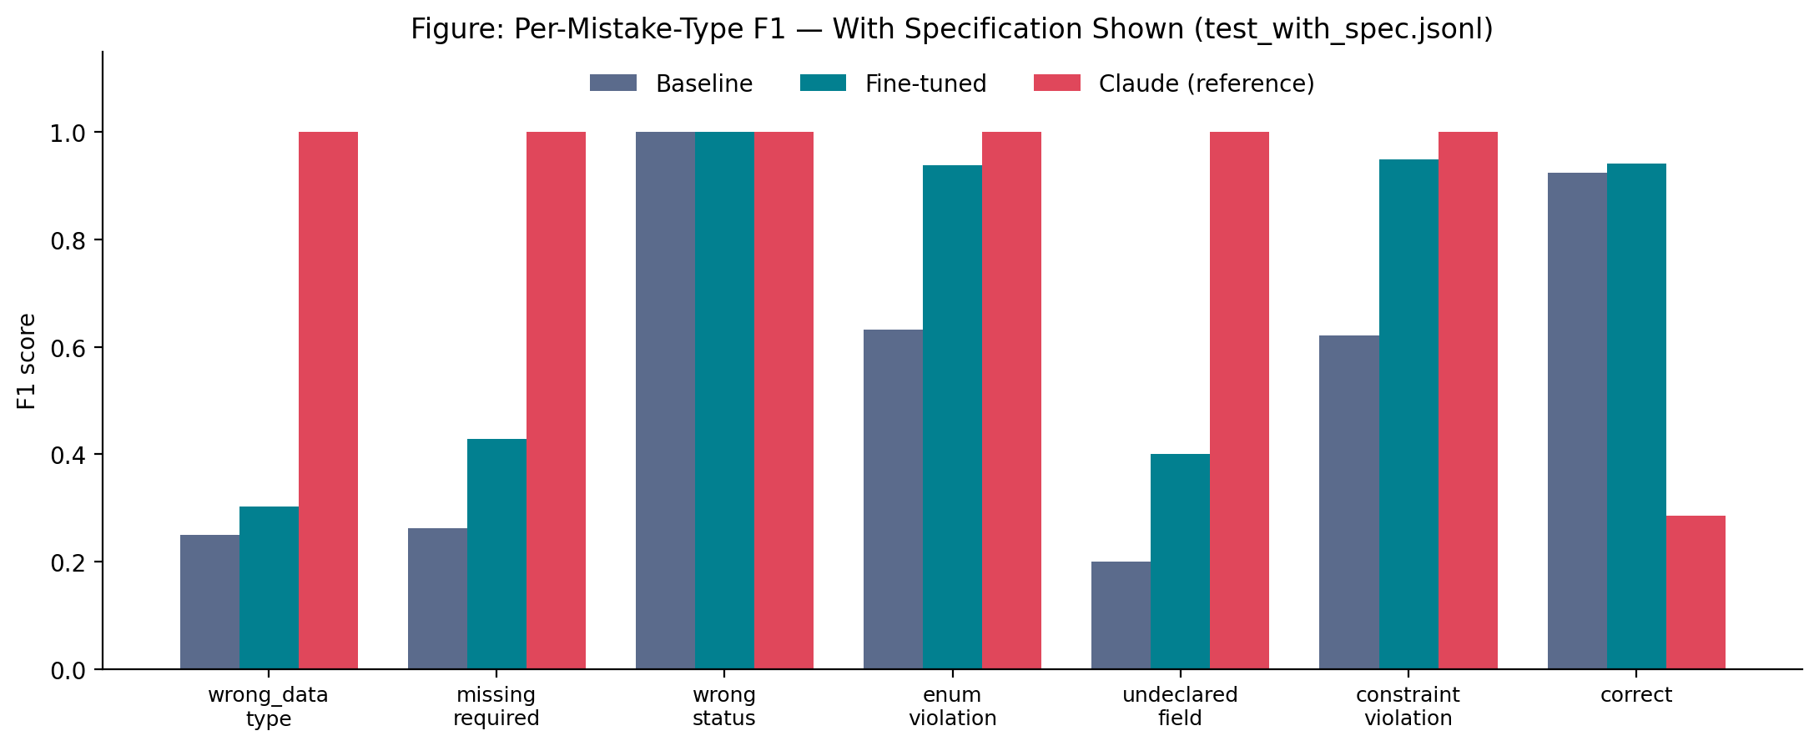
Figure 4.4: Per-category F1 comparison, relevant-field specification shown
Under this condition, fine-tuning improves performance in six of the seven categories rather than two. The overall F1 gain over the untrained baseline (0.168) and accuracy gain (15.9 percentage points) are both substantially larger than in the no-specification condition, where the corresponding gains were 0.032 and 2.2 percentage points respectively. This five-fold increase in F1 gain from one condition to the other is the most informative single finding in this thesis: it confirms that the limited generalization observed without a specification was attributable to the genuine absence of necessary information, rather than to a fundamental weakness in the fine-tuning approach or the base model.
The three categories that showed no improvement without a specification — wrong_data_type, missing_required_field, and undeclared_field — all show genuine improvement in this condition: wrong_data_type improves from 0.194 to 0.303, missing_required_field from 0.167 to 0.429, and undeclared_field from 0.200 to 0.400. This pattern is directly consistent with the error analysis in Section 4.3: these three categories require knowing an API-specific rule (the field's declared type, the list of required fields, or the list of declared fields) that is only available from the specification. Once that rule is provided in the input, the fine-tuned model is able to use it effectively — producing meaningful improvements in all three categories.
The two categories that already showed improvement without a specification — enum_violation and constraint_violation — show dramatically larger improvements in this condition: enum_violation improves from 0.267 to 0.939, and constraint_violation from 0.278 to 0.949. This suggests that while the model was already able to detect some violations in these categories from general patterns alone, having the explicit rule available allows it to make much more precise and reliable judgments. The specification snippet essentially removes ambiguity: instead of inferring that a value looks implausible, the model can directly verify that it falls outside the declared enum or constraint.
The correct category shows a small additional improvement (0.941 → 0.941 for fine-tuned, essentially unchanged) while the reference model's correct-category score rises from 0.054 to 0.286 — still low, but a meaningful increase. This suggests that even the reference model's systematic over-prediction of FAIL is partially corrected when the specification is available, since the model can more confidently identify responses that match the declared schema rather than defaulting to FAIL when uncertain.

Comparing the Two Conditions
Figure 4.5 directly compares the fine-tuned model's own performance across the two evaluation conditions, isolating the effect of specification availability while holding all other factors — the model, the test records, the prompt structure, and the evaluation metrics — constant. This comparison functions as a controlled experiment in the sense described by Wohlin et al. [50]: one variable (presence or absence of the relevant field specification) is changed while everything else remains fixed.
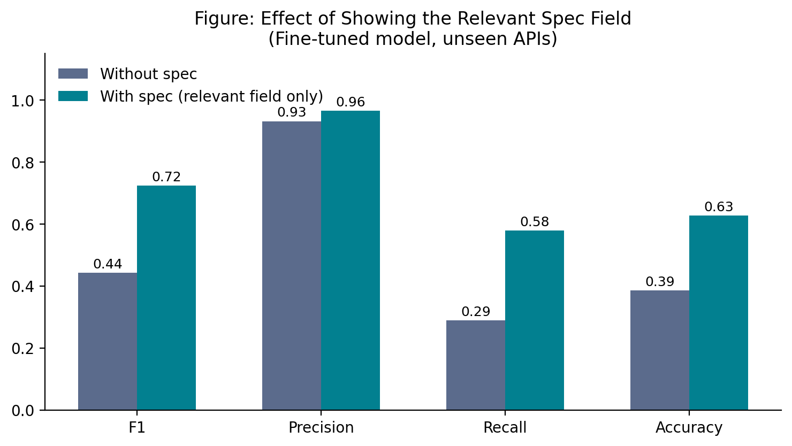
Figure 4.5: Effect of showing the relevant specification field, fine-tuned model
Two observations follow from this comparison. First, showing the relevant specification field improves both the untrained baseline (F1 0.410 → 0.556, a gain of 0.146) and the fine-tuned model (F1 0.442 → 0.724, a gain of 0.282) — but the fine-tuned model's improvement is almost twice as large in absolute terms. This asymmetry is meaningful: it indicates that fine-tuning did not merely improve the model's judgment in isolation, but also improved the model's ability to make effective use of a specification when one is provided. A model that had simply memorized training patterns without genuinely learning to reason about field constraints would not benefit disproportionately from seeing the specification — the larger improvement observed in the fine-tuned model suggests it has learned something about how to interpret and apply field-level rules, not just how to recognize surface-level patterns.
Second, this comparison functions methodologically as a control condition for the results in Section 4.2: it demonstrates that the limited generalization observed without a specification is attributable, at least in substantial part, to the genuine unavailability of API-specific rules — such as business-specific value ranges, required field lists, and declared field sets that cannot be inferred from a response body alone — rather than to a general weakness in the fine-tuning approach or the underlying model. Put plainly: the model is not fundamentally unable to learn this task. It is limited by the absence of information that is genuinely necessary for certain categories of judgment. This distinction is important for interpreting this thesis's contribution honestly: the no-specification condition is hard because it is genuinely hard, not because the approach is flawed.
A third observation concerns the gap to the reference model. Without a specification, the gap between the fine-tuned model and the reference model in overall F1 is 0.474 (0.916 − 0.442). With a specification, that gap narrows to 0.203 (0.927 − 0.724). The specification does not eliminate the gap — the reference model still outperforms the fine-tuned model in aggregate — but it reduces it substantially, confirming that a meaningful portion of the reference model's apparent advantage in the no-specification condition stems from its ability to make cautious, conservative predictions rather than from genuinely superior judgment of individual response correctness.

Why the Reference Model's Advantage Is Not Uniform
The reference model (Claude) achieves the highest F1 and accuracy in both conditions, but this advantage is concentrated specifically in recognizing violations, not in recognizing correct responses. Tables 4.2 and 4.4 show the reference model's F1 for the correct category is 0.054 (no-spec) and 0.286 (with-spec) — in both conditions, substantially below both the baseline and the fine-tuned model on this specific category.
This pattern is explained directly by prediction behavior rather than by inferred intent: across the 226 no-specification test records, the reference model predicted FAIL on 220 occasions (97.3%), compared to a true violation rate of 84.1% in the test set, and predicted PASS only 6 times in total. A model that predicts the positive class on 97.3% of examples cannot, by construction, miss many true positives — which mechanically explains its recall of 1.000 — but will correspondingly perform poorly whenever the true label is the negative class, which explains its low correct-category F1. The fine-tuned model shows the reverse profile: a FAIL-prediction rate of 50.4%, closer to case-by-case judgment, with correspondingly lower recall but markedly higher precision (0.932 vs. 0.844 in the no-specification condition).
This distinction has practical relevance. A judge that flags nearly everything provides limited practical value in a real testing workflow, since developers cannot use its output to prioritize genuine issues over false alarms. The fine-tuned model's higher precision — correct on 96.5% of its FAIL predictions in the with-specification condition — represents a different, arguably more directly useful tradeoff, even though its overall catch-rate (recall) remains lower than the reference model's.
This behavioral asymmetry has a direct implication for how the reference model's overall scores should be interpreted. When a model predicts the positive class (FAIL) on 97.3% of inputs regardless of content, its precision, recall, and F1 on the FAIL class are essentially measuring how prevalent violations are in the test set, rather than how well the model discriminates. Since 84.1% of the test records genuinely are violations, a near-constant FAIL predictor achieves high recall almost by arithmetic necessity. The fine-tuned model's more selective behavior — predicting FAIL on 50.4% of inputs — is therefore a stronger signal of genuine discrimination, even though it produces a lower overall F1. An examiner comparing only aggregate F1 scores across the two models would draw a misleading conclusion; the per-category breakdown and the confusion matrix together tell the more complete story.

Threats to Validity

Internal Validity
Internal validity concerns whether the observed results can be attributed to the independent variable (fine-tuning and specification availability) rather than to confounding factors introduced during data construction or experimental design. Four specific threats were identified during dataset construction and corrected before the reported results were finalized: specification leakage in training inputs, fixed sentinel mutation values, field-selection bias in the mutation operators, and truncation masking of violations in long responses. Each correction was verified through automated, quantitative checks applied across the full dataset rather than by manual inspection of individual records. The correction of field-selection bias is particularly relevant to internal validity: concentrating mutations on a small number of field names (most commonly id and status) would have created a confound between field name and violation type, making it impossible to determine whether any observed improvement was attributable to learning the violation pattern or simply learning to associate specific field names with specific verdicts. The randomized field selection implemented after this issue was identified removes that confound.

Construct Validity
Construct validity concerns whether the measurements used in this study accurately reflect the theoretical constructs they are intended to measure. Two construct validity considerations apply here. First, the relevant-field specification snippet used in the with-specification condition was deliberately restricted to the single field relevant to each record, rather than the full endpoint or document specification. This restriction was necessary to avoid reintroducing specification leakage and to ensure a fair comparison across conditions, but it means the with-specification condition measures the effect of having access to one field's rule, not the effect of having access to a complete API contract. Results from this condition should therefore be interpreted as a lower bound on what full specification access might provide, rather than an exact simulation of a specification-driven oracle. Second, F1 score is used as the primary metric treating FAIL as the positive class. This choice is justified by the class imbalance in the test set (84.1% violations), as argued in Section 2.9.2, but it means that improvements in FAIL detection are weighted more heavily than improvements in correct-response recognition — a tradeoff that is explicitly acknowledged rather than obscured.

External Validity
External validity concerns the generalizability of findings beyond the specific conditions of this study. Two external validity limitations apply. First, the held-out test set comprises three APIs and 226 records — sufficient to detect the reported patterns with reasonable confidence, but a modest sample relative to the full diversity of REST APIs in practical use. APIs were selected to represent different domains (entertainment, finance, library metadata) and different structural characteristics (varying field counts, different enum densities, different nesting depths), but the sample remains small and the findings should be treated as preliminary evidence of a pattern rather than a definitive characterization. Second, all findings are reported for a single base model (Llama-3-8B-Instruct). Whether the same pattern — limited generalization without a specification, substantially broader generalization with one — holds for other small open-weight models such as Qwen2, Mistral-7B, or Gemma is unverified in this study and is proposed as a specific direction for future work in Section 5.2.

Conclusion Validity
Conclusion validity concerns whether the statistical relationship between the variables is reliable and whether conclusions are drawn appropriately from the data. Following the guidance of Dietterich [44], this thesis refrains from claiming statistical significance for the observed performance differences, given that the evaluation is conducted on a single test set of 226 records rather than across multiple independent replications. All findings are framed as empirical observations on this specific test set rather than statistically confirmed generalizations. The consistency of the pattern across five independent training configurations (Section 3.5.1) and across two evaluation conditions (Sections 4.1 and 4.3) provides additional confidence that the reported results reflect a stable underlying phenomenon rather than noise, but formal statistical testing across independent replications is noted as a limitation.

CONCLUSION AND FUTURE WORK

Conclusion
This thesis set out to determine whether a small, fine-tuned language model could learn to judge the correctness of REST API responses without access to the API's specification at inference time, and whether such judgment generalizes to APIs unseen during training.
A complete, reusable pipeline was designed and implemented for constructing labeled training data through real API response collection and controlled, spec-derived mutation, resulting in a balanced dataset of 2,072 records spanning eleven real-world APIs, with three held out exclusively for final evaluation. Several genuine data-quality risks were identified and corrected during construction — specification leakage, fixed sentinel values, field-selection bias, and truncation masking — and each correction was verified quantitatively rather than assumed.
A Llama-3-8B-Instruct model was fine-tuned using QLoRA and evaluated on the held-out, unseen APIs against both its untrained baseline and a large reference model. Without specification access, fine-tuning produced a modest but genuine improvement, concentrated in two of seven violation categories — enum and constraint violations. A second experiment, in which only the relevant field's specification was shown at inference time, produced a substantially larger improvement across six of seven categories, and demonstrated that fine-tuning improves not only the model's raw judgment but also its ability to make effective use of a specification when one is available. This second result also serves as evidence that the limited generalization observed without a specification reflects the genuine unavailability of API-specific rules, rather than a fundamental weakness of the approach.
A further finding, not anticipated at the outset, is that the large reference model's apparent advantage is not uniform: its near-perfect recall is achieved by predicting a violation on the great majority of inputs, at the cost of very poor recognition of genuinely correct responses. The fine-tuned model, by contrast, is more conservative and substantially more precise when it does flag a violation — a different and, in a practical testing context, arguably more directly useful tradeoff.
In summary, this thesis demonstrates that a small, inexpensively fine-tuned language model can learn a genuine, if narrow, capability to judge REST API responses without spec access, that this capability generalizes to unseen APIs for specific categories of violation, and that the same model's capability broadens substantially once relevant specification information is made available — findings that were obtained through, and are strengthened by, a transparent and independently-verified data construction and training process.

Future Work
- Extend the held-out evaluation set to a larger number of APIs and records to strengthen the statistical basis for the per-category generalization findings in Section 4.2 and 4.3.
- Repeat the fine-tuning procedure on additional small open-weight models to determine whether the observed pattern (narrow generalization without spec, broad generalization with the relevant field shown) is specific to Llama-3-8B or holds more generally.
- Investigate targeted data augmentation — increasing the diversity of REASONING phrasing and field coverage specifically within the weaker categories identified in Section 4.2 — as a lower-cost alternative to full specification access.
- Explore a hybrid inference-time design in which the model is shown the relevant specification field only when its own confidence in a no-specification judgment is low, combining the efficiency of the no-spec condition with the accuracy of the with-spec condition.
- Evaluate the fine-tuned model as a component of an actual continuous-integration testing workflow, measuring practical utility (e.g., developer trust and false-alarm rate) rather than classification metrics alone.

REFERENCES

[1] A. Golmohammadi, M. Zhang, and A. Arcuri, “Testing RESTful APIs: A Survey,” ACM Transactions on Software Engineering and Methodology, vol. 33, no. 1, pp. 1–41, Jan. 2024, doi: 10.1145/3617175.
[2] A. Ribeiro, M. Mamede, and C. Ferreira, “Systematic API Testing Through Model Checking and Executable Contracts,” Apr. 2026, [Online]. Available: http://arxiv.org/abs/2604.08633
[3] V. Atlidakis, P. Godefroid, and M. Polishchuk, “RESTler: Stateful REST API Fuzzing,” in 2019 IEEE/ACM 41st International Conference on Software Engineering (ICSE), IEEE, May 2019, pp. 748–758. doi: 10.1109/ICSE.2019.00083.
[4] O. Baniaș, D. Florea, R. Gyalai, and D.-I. Curiac, “Automated Specification-Based Testing of REST APIs,” Sensors, vol. 21, no. 16, p. 5375, Aug. 2021, doi: 10.3390/s21165375.
[5] L. Zheng et al., “Judging LLM-as-a-Judge with MT-Bench and Chatbot Arena,” Dec. 2023.
[6] A. Arcuri, “RESTful API Automated Test Case Generation with EvoMaster,” ACM Transactions on Software Engineering and Methodology, vol. 28, no. 1, pp. 1–37, Jan. 2019, doi: 10.1145/3293455.
[7] Z. Zhao, A. Esmaeili, and F. Fard, “Bias in the Loop: Auditing LLM-as-a-Judge for Software Engineering,” Apr. 2026.
[8] M. Zhang and A. Arcuri, “Open Problems in Fuzzing RESTful APIs: A Comparison of Tools,” Jul. 2022, [Online]. Available: http://arxiv.org/abs/2205.05325
[9] M. Kim, S. Sinha, and A. Orso, “LlamaRestTest: Effective REST API Testing with Small Language Models,” Apr. 2025.
[10] T. Barradas, A. Paes, and V. de O. Neves, “Combining TSL and LLM to Automate REST API Testing: A Comparative Study,” Sep. 2025.
[11] M. Moradi, K. Yan, D. Colwell, and R. Asgari, “An empirical study of LoRA-based fine-tuning of large language models for automated test case generation,” Apr. 2026.
[12] X. Han and H. Zhu, “MASTEST: A LLM-Based Multi-Agent System For RESTful API Tests,” Nov. 2025.
[13] B. Chu et al., “Large Language Models for Unit Test Generation: Achievements, Challenges, and Opportunities,” Dec. 2025.
[14] R. Degiovanni and M. Papadakis, “$μ$BERT: Mutation Testing using Pre-Trained Language Models,” Mar. 2022.
[15] E. T. Barr, M. Harman, P. McMinn, M. Shahbaz, and S. Yoo, “The Oracle Problem in Software Testing: A Survey,” IEEE Transactions on Software Engineering, vol. 41, no. 5, pp. 507–525, May 2015, doi: 10.1109/TSE.2014.2372785.
[16] T. Khan, O. Runge, and R. Heckel, “Visual Contracts as Test Oracle in AGG 2.0,” ECEASST, vol. 47, Jan. 2012, doi: 10.14279/tuj.eceasst.47.728.
[17] D. Corradini, Z. Montolli, M. Pasqua, and M. Ceccato, “DeepREST: Automated Test Case Generation for REST APIs Exploiting Deep Reinforcement Learning,” in Proceedings of the 39th IEEE/ACM International Conference on Automated Software Engineering, New York, NY, USA: ACM, Oct. 2024, pp. 1383–1394. doi: 10.1145/3691620.3695511.
[18] Y. Jia and M. Harman, “An Analysis and Survey of the Development of Mutation Testing,” IEEE Transactions on Software Engineering, vol. 37, no. 5, pp. 649–678, Sep. 2011, doi: 10.1109/TSE.2010.62.
[19] Y.-S. Ma, J. Offutt, and Y. R. Kwon, “MuJava: an automated class mutation system,” Software Testing, Verification and Reliability, vol. 15, no. 2, pp. 97–133, Jun. 2005, doi: 10.1002/stvr.308.
[20] S. Shamshiri et al., “Random or evolutionary search for object‐oriented test suite generation?,” Software Testing, Verification and Reliability, vol. 28, no. 4, Jun. 2018, doi: 10.1002/stvr.1660.
[21] E. J. Hu et al., “LoRA: Low-Rank Adaptation of Large Language Models,” Oct. 2021.
[22] T. Dettmers, A. Pagnoni, A. Holtzman, and L. Zettlemoyer, “QLoRA: Efficient Finetuning of Quantized LLMs,” May 2023.
[23] Meta AI, “Introducing Llama 3,” Meta AI Blog.
[24] B. Rozière et al., “Code Llama: Open Foundation Models for Code,” Jan. 2024.
[25] A. Yang et al., “Qwen2 Technical Report,” Sep. 2024.
[26] A. Q. Jiang et al., “Mistral 7B,” Oct. 2023.
[27] Gemma Team et al., “Gemma: Open Models Based on Gemini Research and Technology,” Apr. 2024.
[28] W. Huang et al., “An empirical study of LLaMA3 quantization: from LLMs to MLLMs,” Jan. 2025, doi: 10.1007/s44267-024-00070-x.
[29] R. Patil, P. Khot, and V. Gudivada, “Analyzing LLAMA3 Performance on Classification Task Using LoRA and QLoRA Techniques,” Applied Sciences, vol. 15, no. 6, p. 3087, Mar. 2025, doi: 10.3390/app15063087.
[30] Y. Cao, Z. Yao, Z. Chen, and Z. Deng, “CatMemo at the FinLLM Challenge Task: Fine-Tuning Large Language Models using Data Fusion in Financial Applications,” Jul. 2024, [Online]. Available: http://arxiv.org/abs/2407.01953
[31] J. Lu, L. Yu, X. Li, L. Yang, and C. Zuo, “LLaMA-Reviewer: Advancing Code Review Automation with Large Language Models through Parameter-Efficient Fine-Tuning,” in 2023 IEEE 34th International Symposium on Software Reliability Engineering (ISSRE), 2023, pp. 647–658. doi: 10.1109/ISSRE59848.2023.00026.
[32] Md. A. Haider, A. B. Mostofa, Sk. S. Bin Mosaddek, A. Iqbal, and T. Ahmed, “Prompting and Fine-tuning Large Language Models for Automated Code Review Comment Generation,” Nov. 2024, [Online]. Available: http://arxiv.org/abs/2411.10129
[33] D. S. Ouchebara and S. Dupont, “Llama-based source code vulnerability detection: Prompt engineering vs Fine tuning,” Dec. 2025.
[34] L. Smith, “A disciplined approach to neural network hyper-parameters: Part 1 – learning rate, batch size, momentum, and weight decay,” Aug. 2018, doi: 10.48550/arXiv.1803.09820.
[35] J. Heaton, “Ian Goodfellow, Yoshua Bengio, and Aaron Courville: Deep learning: The MIT Press, 2016, 800 pp, ISBN: 0262035618,” Genet. Program. Evolvable Mach., vol. 19, Aug. 2017, doi: 10.1007/s10710-017-9314-z.
[36] A. Halfon et al., “Stay Tuned: An Empirical Study of the Impact of Hyperparameters on LLM Tuning in Real-World Applications,” Aug. 2024.
[37] S. Kang, J. Yoon, and S. Yoo, “Large Language Models are Few-shot Testers: Exploring LLM-based General Bug Reproduction,” Jul. 2023, [Online]. Available: http://arxiv.org/abs/2209.11515
[38] J. Liu, C. S. Xia, Y. Wang, and L. Zhang, “Is Your Code Generated by ChatGPT Really Correct? Rigorous Evaluation of Large Language Models for Code Generation,” Oct. 2023, [Online]. Available: http://arxiv.org/abs/2305.01210
[39] H. Huynh, T. Le, T. Nguyen, V. Nguyen, V. Nguyen, and T. N. Nguyen, “RBCTest: Leveraging LLMs to Mine and Verify Oracles of API Response Bodies for RESTful API Testing,” Dec. 2025, [Online]. Available: http://arxiv.org/abs/2504.17287
[40] J. White et al., “A Prompt Pattern Catalog to Enhance Prompt Engineering with ChatGPT,” Feb. 2023.
[41] T. Kojima, S. S. Gu, M. Reid, Y. Matsuo, and Y. Iwasawa, “Large Language Models are Zero-Shot Reasoners,” Jan. 2023, [Online]. Available: http://arxiv.org/abs/2205.11916
[42] M. Sokolova and G. Lapalme, “A systematic analysis of performance measures for classification tasks,” Inf. Process. Manag., vol. 45, pp. 427–437, Aug. 2009, doi: 10.1016/j.ipm.2009.03.002.
[43] D. Powers and Ailab, “Evaluation: From precision, recall and F-measure to ROC, informedness, markedness & correlation,” J. Mach. Learn. Technol, vol. 2, pp. 2229–3981, Aug. 2011, doi: 10.9735/2229-3981.
[44] T. G. Dietterich, “Approximate Statistical Tests for Comparing Supervised Classification Learning Algorithms,” Neural Comput., vol. 10, no. 7, pp. 1895–1923, Oct. 1998, doi: 10.1162/089976698300017197.
[45] A. Vaswani et al., “Attention Is All You Need,” 2023.
[46] T. B. Brown et al., “Language Models are Few-Shot Learners,” Jul. 2020, [Online]. Available: http://arxiv.org/abs/2005.14165
[47] H. Touvron et al., “Llama 2: Open Foundation and Fine-Tuned Chat Models,” Jul. 2023, [Online]. Available: http://arxiv.org/abs/2307.09288
[48] R. Taori et al., “Alpaca: A Strong, Replicable Instruction-Following Model,” Stanford CRFM Blog.
[49] S. Agarwal et al., “Training Language Models to Follow Instructions with Human Feedback,” Aug. 2022, pp. 27730–27744. doi: 10.52202/068431-2011.
[50] C. Wohlin, P. Runeson, M. Höst, M. Ohlsson, B. Regnell, and A. Wesslén, “Experimentation in Software Engineering,” 2012, pp. 123–151. doi: 10.1007/978-3-642-29044-2_10.

APPENDIX A: SAMPLE TRAINING RECORD
A complete PASS record and its corresponding mutated FAIL record, as exported to the training JSONL format described in Section 3.3.7 (specification content, absent from the actual export, is shown separately in Appendix B for the with-specification condition only).
PASS record:
API: petstore
Request:
GET /pet/10201
Response:
HTTP 200
{"id":10201,"name":"Max","category":{"id":1,"name":"Dogs"},"status":"available"}
VERDICT: PASS
BUG_TYPE: correct
Corresponding mutated FAIL record (M3, enum_violation):
API: petstore
Request:
GET /pet/10201
Response:
HTTP 200
{"id":10201,"name":"Max","category":{"id":1,"name":"Dogs"},"status":"UNKNOWN"}
VERDICT: FAIL
BUG_TYPE: enum_violation
REASONING: The spec restricts 'status' to [available, pending, sold].
The value "UNKNOWN" is not a permitted enum value.

APPENDIX B: SAMPLE WITH-SPECIFICATION RECORD
The same FAIL record as shown in Appendix A, under the with-specification evaluation condition described in Section 3.7. Only the relevant field's specification is shown, not the full endpoint or document specification.
API: petstore
Spec (relevant field only):
{"status": {"type":"string","enum":["available","pending","sold"]}}
Request:
GET /pet/10201
Response:
HTTP 200
{"id":10201,"name":"Max","category":{"id":1,"name":"Dogs"},"status":"UNKNOWN"}

APPENDIX C: COMPLETE TRAINING API LIST
# | API | Records contributed (train + val)
1 | GitHub | 310
2 | Rick and Morty | 364
3 | PetStore | 276
4 | Open-Meteo | 280
5 | JSONPlaceholder | 222
6 | Open Trivia DB | 210
7 | Task Manager (custom) | 136
8 | ReqRes | 48
Table C.1: Complete list of training APIs and record counts

